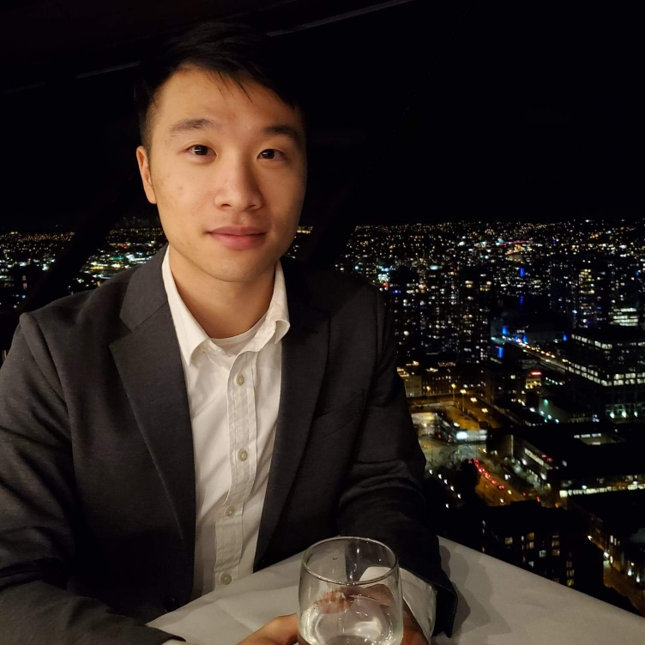 |  | Dear class ENGL301,  Is your team looking for an enthusiastic, reliable writing team member who is always striving for excellence and professionalism? If so, please consider me as a potential candidate for your writing team. I am a fourth-year business student studying real estate and I love reading. Below are my experiences as the president of the Vancouver Housing Market club and a past sponsorship director of YNOTFORTOTS, a children’s charity club.  I was the sponsorship director of YNOTFORTOTS from 2019-20 and I was responsible for cold calling and emailing businesses and managing external relationships with businesses. I have been constantly writing emails to different organizations with the goal of forming a successful partnership. As a result, I have successfully secured three reliable partnerships with Café de Crepe, Aphrodite Organic tea shop and the Mustache in a short period of one month. Our members were able to enjoy discounts when purchasing at their shops. Currently, I am the President of the Vancouver Housing Market club and I manage a team of four executive members and provided real estate knowledge to our members. My main job is to write promotional letters, design brochures and posters, organize and conduct interviews with industry professionals, and collaborate in writing the monthly newsletter.  I may not be the most eloquent writer, but I am always motivated to upgrade myself. I understand that while English is not my first language, I will have to dedicate much more time just to improve my writing skills. That is why I have participated in the roles listed above. In ENGL 301, there will be plenty of writing assignments we have to complete. That is why you should have someone who has the experience in technical writing and have done it multiple times. If you think I will be a good fit, please do not hesitate and contact me.  Sincerely,  Barton Lui

Barton Lui
Professional writing team member

CONTACT
PHONE:
604-715-5568

WEBSITE:
https://www.linkedin.com/in/lui-barton-0a774093/

EMAIL:
Bartonlui.ca@gmail.com

