Ocean Acidification Environmental Report
Bethany Wat
November 21, 2016
GEOG 211 State of the Earth

Intro

Humans have the largest contribution to the globally changing environment and atmosphere through our demands on nature, classified by the Global Footprint Network (2016) as “ecological footprints”. Land-use changes, agricultural practices, fossil fuel burning, and the build up of greenhouse gases are all factors leading to the complex issue of climate change. The sister problem to climate change is the process of ocean acidification, which occurs when oceans absorb a substantial proportion of anthropogenic carbon dioxide (CO₂), which reacts with water to form carbonic acid, making the ocean more acidic (UNEP, 2012). The increase of man-made CO₂ is not only affecting our environment’s atmosphere but also sinking into the ocean and creating real consequences for marine species. Oceanographer and biochemist Rob Dunbar’s does a TED talk on ocean acidification and says that, “Even if you are a hard bitten global warming skeptic, you cannot deny the simple physics of CO₂ dissolving in the ocean” (TED, 2010). The presence of increased carbon dioxide in the ocean is evidence of this environmental issue and is also an indication of the costs this has on aquatic life. Ocean acidification leads to a decline in pH that affects the survival of certain marine organisms and results in “vastly reduced habitat complexity and loss of biodiversity” (Hoegh-Guldberg et al., 2007, p.1740). This paper will analyze scholarly papers by researchers such as Albright et al. (2010), Hoegh-Guldberg et al. (2012), Munday et al. (2009) (2012), as well as gather information from websites and experiments to further discuss how this issue came to light, how we measure ocean acidification, and it’s implications and potential solutions.

History

Ocean acidification is a result of the increase of anthropogenic carbon dioxide in the atmosphere. Over time, CO₂ levels have exponentially grown through various practices such as fossil fuel burning, deforestation, cement production, methane from domesticated animals, agricultural cultivation, and disposal and treatment of waste (Climate Change Information Sheet, 2000). Dunbar adds to these examples of human driven carbon dioxide outputs with land use change, aerosols, and trace gases (TED, 2010). It is evident that this abundance of carbon dioxide is a detriment to the environment with global temperature increases, pollution, and more recently we are finding that it also has implications for the 71% of the earth’s surface covered by our oceans. The GEO5 e-book states that, “mean surface ocean pH has already decreased from a pre-industrial average of around 8.2 to 8.1” (UNEP, 2012, p. 119). The commonly recognized threshold to safely remain under in terms of CO₂ concentration in the atmosphere is 380 ppm, yet research is showing that current atmospheric concentrations are exceeding 380 ppm due to industrial and land use activities of mankind (Feely et al., 2004, Hoegh-Guldberg et al., 2007). Hoegh-Guldberg et al.’s (2007) study retrieved data from the IPCC on climate change (2007) revealing that during the 20th century, increasing CO₂ atm has increased global oceans’ average temperature by 0.74°C and sea level by 17 cm, as well as depleted seawater carbonate concentrations by ~30 mmol kg-1 seawater and acidity by 0.1 pH unit (p.1737). Over the past few decades, carbon dioxide levels have exceeded what our environment is able to absorb and is entering our oceans creating devastating effects for certain marine organisms. “Approximately 25% of the CO₂ emitted from all anthropogenic sources currently enters the ocean, where it reacts with water to produce carbonic acid” (Hoegh-Guldberg et al., 2007, p.1737).

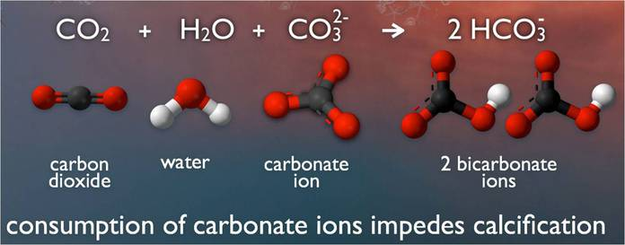
Figure 1. Chemical reaction that occurs when CO₂ reacts with water and carbonate ion.
( http://www.pmel.noaa.gov/co2/story/What+is+Ocean+Acidification%3F )

This carbonic acid reacts differently with different organisms, and many experiments have been executed to determine the impact of high levels of CO₂ on species that build calcium carbonate shells or skeletons. Figure 1. shows a diagram of the chemical reaction that produces OA (ocean acidification). Approximately 25% of CO₂ generated by humans from 2000 to 2006 was taken up by the ocean to produce carbonic acid, decreasing the concentration of carbonate and making it unavailable to marine calcifiers such as coral (Hoegh-Guldberg et al., 2007). Ocean acidification inhibits major ecosystems such as coral reefs from generating to its full potential, creating a chain of devastating effects for other organisms that rely on the coral as their homes. These ecological barriers to successful growth of certain marine organisms will be discussed further in the paper.

Methods & Measurement

There are various methods of measurement that scientists use to determine acidity levels in the oceans. The primary information needed to conduct studies is determining the CO₂ concentrations in the atmosphere and how much is absorbed into the ocean. Munday et al. (2009) reported that oceans have absorbed approximately 30 per cent of additional carbon dioxide released into the atmosphere during the past 200 years due to human activities (as cited in Sabine et al. 2004). Once researchers know the amount of carbon dioxide present in the oceans, they can then proceed to test levels of acidity that this CO₂ produces and how it affects marine organisms. The principal method of measuring ocean acidification is by measuring pH in the water and observing if there is a decrease, then figuring out the rate at which the water is becoming more acidic. Rérolle et al.’s (2012) article indicates the four crucial variables of marine-carbonate chemistry which are: total dissolved inorganic carbon (DIC), partial pressure of CO₂, total alkanity (TA), and pH, stating that if two of these variables are known, one can calculate for the remaining. Many researchers have attested to the precision and accuracy of measuring pH (Rérolle et al., 2012, Waters, 2012) but also acknowledge that certain experiments “require rigorous operator control and have time intensive set up and calibration routines” (Waters, 2012, p.15). Rérolle et al. (2012) presented three core methods of measuring pH of seawater which this paper will brief on and discuss advantages and disadvantages.
The first method is the potentiometric method, which uses a glass electrode and takes a measurement of the electromotive force (EMF) of a cell. “The pH of a sample is defined in terms of EMF measured in the sample (E_{sample}) and a standard buffer solution (E_{buffer}) of assigned pH (pH_{buffer})” (Rerolle et al., 2012, p. 147). Advantages of this method are that it is non-destructive, equipment is affordable, and can achieve a high reading rate. The problem with this method is that is requires regular calibration due to electrode drift, making autonomous measurements problematic (Rérolle et al., 2012). An alternative method to the potentiometric method is the luminescence method, which uses optodes with indicator dyes fixed in a polymer. This technique uses fluorescence-intensity ratio of two luminescent indicators: one, which is pH sensitive with short luminescence lifetime and the other, is not pH sensitive with a longer lifetime (Rérolle et al., 2012). The advantages of measuring pH this way are the high sensitivity and selectivity. Another method is the spectrophotometric method, based on the addition to seawater sample of an indicator dye, which changes color with pH. The dye is an acid-base compound that has different absorption spectra. Issues with accuracy arise with, “ the accuracy of the indicator pK and molar absorptivity values, the accuracy of the temperature and salinity measurements, and the calibration and sensitivity of the spectrometers” (Rérolle et al., 2012, p.155). There are a variety of components when conducting experiments for ocean acidification; a visual example of a spectrophotometric system is shown in Water’s dissertation on the measurement of seawater pH below.
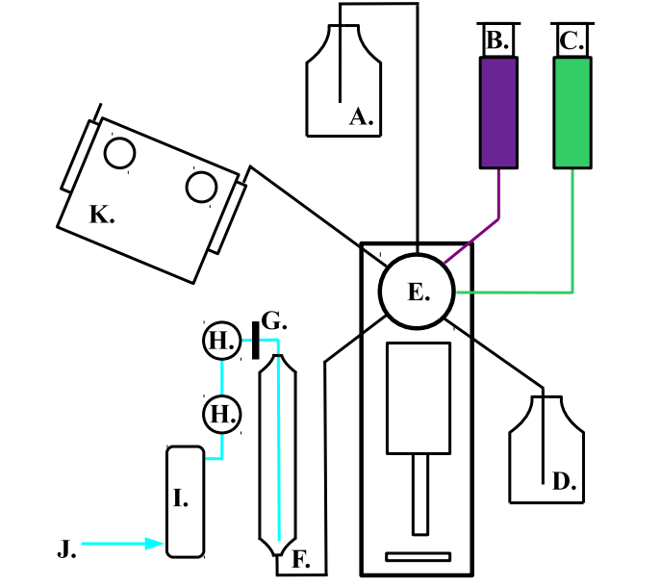
Figure 2. Rérolle et al. 2012.
A representation of the spectrophotometric TA-pH method.
- Sample bottle B. mCP C.
- BCG
- Acid bottle
- Kloehn syringe pump
- Glass Pipette
- 0.45 𝜇m
- Solenoid valves
- Ascarite CO₂ scrubber
- Regulated compressed air line
- Thermostated spectrophotometer cell holder and flow through 10cm cell
- 100 MΩ Pt R.T.D., M. N.I. FieldPoint 1000 Relay controller and R.T.D. units

As observed from the model, measuring the pH of seawater requires many materials and detailed steps. The methods of measuring ocean acidification vary with some yielding higher accuracy; depending on what objects are being experimented on or what information the researcher is hoping to gather. Waters (2012) mentions, “for studies focused on quantifying changes in calcification under different acidification scenarios, using pH and TA is recommended over pH and DIC (as cited in Hoppe et al., 2012).

Studies tested by researchers

Emerging research is being published on the effects of ocean acidification on calcifying organisms and coral reefs, but there is less data for its effects on marine fish. In order to obtain a whole understanding of how ocean acidification is changing marine life, researchers have been posing questions relating to fishes’ tolerances of CO₂ and their phenotypes that help them adapt to these changes. “Our ability to create functional groups of species according to their CO₂ tolerance may be crucial in our ability to predict community change in the future” (Ferrari et al., 2011, p.2980). This mentality has driven different experiments done by oceanographers and marine biologists. First, the study by Munday et al. (2012) aimed to test if variation in individual sensitivity of juvenile reef fishes to elevated CO₂ could lead to selection of CO₂ tolerant phenotypes in nature. They took larvae from the Great Barrier Reef, and adjusted factors such as pH, temperature (°C), Salinity (ppt), TA, and CO₂, and tested on the juvenile fish and observed how they responded to the elevated CO_{2.} Results for this study showed that rapid selection of CO₂ – tolerant phenotypes can occur in nature as treated and untreated fish responded differently to predator signals. They concluded, “if individual variation in CO₂ tolerance is heritable, this selection of phenotypes tolerant to elevated CO₂ could potentially help mitigate the effects of ocean acidification.” (Munday et al., 2012, p.1). A different study by Albright et al. (2010) strived to discover how OA affected three early life stages of coral. They tested fertilization, settlement and post settlement growth at three pCO₂ levels that would represent average conditions during spawning season, as well as the range of pCO₂ increased expected in this century. This study found that all three stages of sexual recruitment of reef-building corals were impacted negatively and impairment of fertilization was exacerbated at lower sperm concentrations. These are two examples of the techniques used by researchers to acquire information about the gaps of knowledge they encounter when studying ocean acidification.

Impacts on society-environment relationships

It is evident that ocean acidification is harming certain marine ecosystems and their services. The United Nations Environment Programme (2012) shows that, “increased ocean acidity affects marine animals with carbonate shells and skeletons, calcareous algae and other organisms” (as cited in Langdon and Atkinson, 2005). We strive to understand the implications of OA in a broader context to grasp the urgency of this issue and comprehend how it affects human life. On the oceanic scale, the increased acidity of the water is affecting the metabolic and developmental processes of certain species and causing a chain of negative outcomes. Coral reefs are fundamental in providing habitats for spawning and creating nursery grounds for many marine organisms. The study done by Albright (2010) concludes that OA will affect three sequential life history phases necessary for successful coral recruitment of larval availability, settlement ecology, and postsettlement ecology. With the inability to properly grow and survive, the futures of coral reefs are facing adversity. The chemistry composed by OA produces hydrogen ions that compete with calcifying organisms for carbonate-ions, forcing these marine animals to exert “more metabolic energy to create and maintain their shells,” (TED, 2010) when they could be searching for food. As carbonate-ion concentrations are being reduced, so is habitat complexity, leading to a loss of biodiversity, “including losses of coral associated fish and invertebrates (Hoegh-Guldberg et al., 2007, p.1740). When reef erosion exceeds calcification this liberates space for the settlement of macroalgae ,which inhibits coral recruitment with their invasion, causing them to compete for space and light. “ (Hoegh-Guldberg et al., 2007). Figure 3 shows examples of different locations of the Great Barrier Reef, each with different ecological structures and anticipated results of OA overtime.

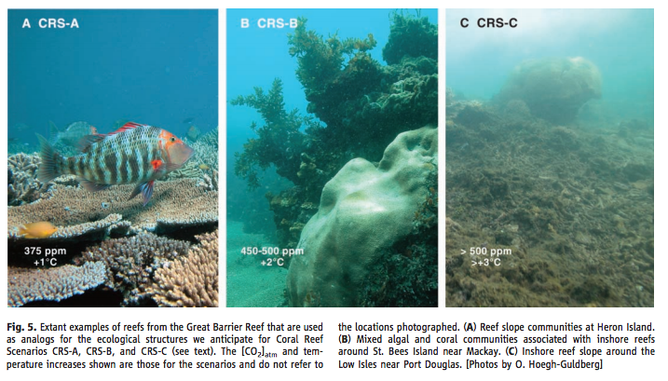
Figure 3. Hoegh-Guldberg et al. 2007.

If this trend continues, there will be critical losses for the entire aquatic system in the future. Emissions of anthropogenic carbon dioxide is triggering higher acidity of our oceans, affecting shellfish such as oysters, clams, shrimp, and other mollusks. This progression will also harm the fish that rely on coral reefs to flourish, then eliminating food sources for larger mammals such as herring, whales, and sharks, and seabirds. Not only is this detrimental to entire functioning of the ocean, OA will consequently affect food resources for humans. Communities that rely on fisheries as their source of income will face challenges in the future as CO₂ emissions rapidly excel.
On November 2012, natural and social scientists from 19 countries met in the Oceanographic Museum of Monaco and discussed the economic impact of ocean acidification on aquaculture. Their findings concluded that fisheries are a vital source of economic opportunities for the 660-800 million people employed by aquaculture, representing 10-12% of the world population (Hilme et al., 2013). They also discussed that small-scale artisanal fisheries employ “90% of the world capture fishers, and are important to food security and poverty alleviation” (p.1). A key consensus that came from this workshop was the lack of data and knowledge regarding OA’s effect on marine food webs and how OA will impact species in high value coastal habitats such as seagrass, mangroves and coral reefs. As this environmental issue is emerging and gaining exposure, it is necessary for more research to reduce uncertainty and evaluate direct economic impacts on society. The society-environment relationship of OA demonstrates the economic downturns should humans continue to produce excessive amounts of carbon dioxide through fossil fuels and other polluting habits. “Major fisheries and aquaculture often occur in areas sensitive to ocean acidification. This puts economies and livelihoods at risk, and requires consideration and action by policy makers” (Hilme et al., 2013, p.1). Ocean acidification has stemmed out of its sister problem of climate change, and will require extensive research and study to expose the consequences it has for our environment and our ecological sustainability.

Potential Responses

Throughout this paper, the process of ocean acidification has been explained and analyzed through data from numerous researchers and websites. By now it should be clear that ocean acidification is a serious environmental problem that stems from the excessive production of manmade carbon dioxide. Though we do lack research of this topic, the decided principle is that the carbon dioxide we produce is not only unsustainable for our ecosystem, but also non-renewable, and results in ecological repercussions for our life on Earth. Therefore, the question arises of how we can respond to this global-reaching issue, and how we as a society can intervene to eradicate or slow down the exponentially increasing CO₂ in our atmosphere and oceans. The goal is to gain ecological resilience for the marine organisms, which is “a measure of the rate at which an ecosystem returns to a particular state after a perturbation or disturbance” (Hoegh-Guldberg et al., 2007, p.1738); however, “modern genotypes and phenotypes of corals do not appear to have the capacity to adapt fast enough to sudden environmental change” (p.1738). In order to slow down the environmental change occurring, we must examine the sources of CO₂ and look for ways to decrease them.
Fossil fuels are the largest source of anthropogenic carbon dioxide and account for about three quarters of mankind’s CO₂ (Climate Change Information Sheet, 2000). By addressing the root of the problem and looking for alternatives of energy production, we could prevent large inputs of CO₂ and hopefully mitigate the issue of ocean acidification. Ediger and Kentel’s (1999) article explores alternative renewable energy resources in Turkey, which can be applied to other geographical locations that have similar environmental features. Biomass, hydropower, geothermal energy, solar energy, and wind energy are all suggested alternatives to fossil fuels. They present solar energy as the “oldest energy source used by mankind” and the “cleanest and most abundant one among others” (Ediger and Kentel, 1999, p.750). They also conclude that it would be a favorable alternative for Turkey given its advantageous geographical conditions. Evidently, these are changes of great magnitude and will require great policies and technological changes in the way our population sources energy. On a more concentrated scale, researchers should continue to study the consequences of increased carbon dioxide and observe the variability of impacted species. “Our ability to create functional groups of species according to their CO₂ tolerance may be crucial in our ability to predict community change in the future” (Ferrari et al., 2011, p.2980). By grasping full knowledge of what ocean acidification is doing to marine ecosystems we can create energy efficient policies to eliminate or reduce the source. We must understand which species suffer most from OA, and which ones hold capacities to adapt to these changes. This will be important for forecasting the future of our oceans and edifying this global environmental problem, as well as passing this knowledge forward to future generations to develop sustainable solutions.

References

Albright, R., Mason, B., Miller, M., & Langdon, C. (2010). Ocean acidification compromises recruitment success of the threatened Caribbean coral Acropora palmata. Proceedings of the National Academy of Sciences, 107(47), 20400-20404. doi:10.1073/pnas.1007273107

Climate Change Information Sheet 22. (2000). Retrieved from http://unfccc.int/cop3/fccc/climate/fact22.htm

Ediger, V. Ş, & Kentel, E. (1999). Renewable energy potential as an alternative to fossil fuels in Turkey. Energy Conversion and Management, 40(7), 743-755. doi:10.1016/s0196-8904(98)00122-8

Feely, R. A., Sabine, L., Lee, K., Berelson, W., Kleypas, J., Fabry, V., & Millero, F. (2004). Impact of Anthropogenic CO2 on the CaCO3 System in the Oceans. Science, 305(5682), 362-366. doi:10.1126/science.1097329

Ferrari, M. C., Dixson, D. L., Munday, P. L., Mccormick, M. I., Meekan, M. G., Sih, A., & Chivers, D. P. (2011). Intrageneric variation in antipredator responses of coral reef fishes affected by ocean acidification: Implications for climate change projections on marine communities. Global Change Biology, 17(9), 2980-2986. doi:10.1111/j.1365-2486.2011.02439.x

Hilmi N, Allemand D, Betti M, Gattuso J-P, Kavanagh C, LacoueLabarthe T, Moschella P, Reynaud S, Warnau M (2013) 2nd International Workshop on the Economics of Ocean Acidification: Bridging the Gap Between Ocean Acidification Impacts and Economic Valuation “Ocean Acidification impacts on fisheries and aquaculture.” Oceanographic Museum of Monaco, 11-13 November 2012

Hoegh-Guldberg, O., Mumby, P. J., Hooten, A. J., Steneck, R. S., Greenfield, P., Gomez, E., . . . Hatziolos, M. E. (2007). Coral Reefs Under Rapid Climate Change and Ocean Acidification. Science, 318(5857), 1737-1742. doi:10.1126/science.1152509

Munday, P. L., Donelson, J. M., Dixson, D. L., & Endo, G. G. (2009). Effects of ocean acidification on the early life history of a tropical marine fish. Proceedings of the Royal Society B: Biological Sciences, 276(1671), 3275-3283. doi:10.1098/rspb.2009.0784

Munday, P. L., Mccormick, M. I., Meekan, M., Dixson, D. L., Watson, S., Chivers, D. P., & Ferrari, M. C. (2012). Selective mortality associated with variation in CO2 tolerance in a marine fish. Ocean Acidification, 1, 1-5. doi:10.2478/oac-2012-0001

Rérolle, V. M., Floquet, C. F., Mowlem, M. C., Connelly, D. P., Achterberg, E. P., & Bellerby, R. R. (2012). Seawater-pH measurements for ocean-acidification observations. TrAC Trends in Analytical Chemistry, 40, 146-157. doi:10.1016/j.trac.2012.07.016

United Nations Environment Programme (UNEP). (2012).Global environment outlook GEO 5: Environment for the future we want [Http://www.unep.org/geo/GEO5_ebook/Chapter4EN/index.html#119/z]. (2012).

Waters, J. F. (2012). Measurement of Seawater pH: A Theoretical and Analytical Investigation (Doctoral dissertation, University of Miami Scholarly Repository) [Abstract]. Open Access Dissertations.

What is Ocean Acidification? (n.d.). Retrieved November 21, 2016, from http://www.pmel.noaa.gov/co2/story/What is Ocean Acidification?

