To Special Rapporteur Astrid Puentes,

We congratulate you on your recent appointment and welcome the opportunity to make a submission to inform the thematic report of the Special Rapporteur on the human right to a clean, healthy and sustainable environment to be presented to the 79th Session of the UN General Assembly in 2024. This submission responds primarily to Key Question 6: “Main challenges for the effective implementation of the human right to a clean, healthy and sustainable environment, including ongoing policies or efforts to overcome these.” We look forward to supporting your critical work and are available to address any questions you may have about this submission.

For decades, policymakers have known the world is in the midst of escalating ecological crises, including an unprecedented deterioration of the abundance and diversity of life on Earth. The United Nations Convention on Biological Diversity (CBD), an multilateral environmental treaty signed by 150 government leaders at the 1992 Rio Earth Summit, “recognizes that biological diversity is about more than plants, animals and micro organisms and their ecosystems – it is about people and our need for food security, medicines, fresh air and water, shelter, and a clean and healthy environment in which to live.” Its specific objectives are the conservation of biological diversity, the sustainable use of its components and the fair and equitable sharing of the benefits arising out of the utilization of genetic resources, including by appropriate access to genetic resources and by appropriate transfer of relevant technologies. It is an essential mechanism to ensure international cooperation to address threats to biological diversity. The UN’s Environment Management Group (EMG) noted that promotion of the right to a clean, healthy and sustainable environment as a human right requires full implementation of multilateral environmental agreements such as the Convention on Biological Diversity (CBD) and called upon international organisations such as the UN to support its attainment.

Yet international plans to halt the rapid erosion of biodiversity have consistently failed; none of the 196 government signatories to the Convention on Biological Diversity (CBD) achieved the 20 targets to which they committed in 2010. Conventional rationales for these failures tend to focus on a lack of political will, financial resources, awareness, and capacity to implement decisions. International and national biodiversity policy documents, including the 2022 Kunming-Montreal Global Biodiversity Framework (GBF), often assume governments have autonomy to take action on biodiversity loss; that the issue is how biodiversity policy-making remains siloed in environmental ministries, and neglected in consequential national decisions on finance, industry, and trade.

Our research group recently explored this question of why do governments struggle to meet agreed-upon targets to protect and restore biodiversity. This research found that while domestic policies support extractive sector expansion, these state decisions are often influenced by pressures stemming from the international monetary and financial system that make extraction necessary to maintain financial stability. The pressures of this system act on all states, but they are experienced unequally, such that countries with the least political-economic power are often the most subject to external pressures. As a result, Global South governments, to a variety of degrees, are constrained in their ability to choose different policy pathways due to their position within the international financial and monetary system, under conditions of financial subordination. These conditions of subordination—in which many governments must contend with an economic and financial order over which they are structurally disadvantaged and politically marginalized—mean that states face exceptional pressure to remain in or expand their role as exporters of extractive commodities due to the heightened risk of financial instability. The risks to financial stability, and their unequal application across countries, are underexplored drivers of global biodiversity loss – and key challenges to implement a right to a heathy environment.

Extractive activities are a main driver of biodiversity loss. Across the planet, governments fail to meet biodiversity targets because the extraction that drives biodiversity loss continues. Extractive land use change —through industries like mining, oil and gas, forestry, and industrial agriculture— is estimated to drive about 90 percent of biodiversity loss globally. The impacts of this land use change are also vastly uneven, often following patterns of extractivism, an economic development model based on largely unfettered resource exploitation with highly unequal distributions of benefits and impacts, both between and within the Global North and Global South. Despite these persistent conditions of extractivism, governments around the world continue to approve, subsidize, and expand the extractive developments that erode biodiversity. Domestic political agendas that privilege elite interests and extractive revenues play an important role in perpetuating these decisions. But less well-recognized is the role of structural, international political and economic pressures.

Our recent research demonstrated that the international financial and monetary system exerts structural pressure on governments to maintain and expand these extractive sectors to maintain “investability,” to earn foreign exchange, and to comply with international financial institutions that manage economic crises. These pressures are structural in that, under this current system, acting otherwise would threaten the financial stability of many subordinated economies—stability that allows regular people to buy food and deposit their paychecks, and that allows governments to pay for key imports like technology and medicine. Consequently, there are significant conflicts between current approaches to creating financial stability and maintaining overall ecological stability. This precarious position drives subordinated states, in particular, to double down on export-oriented extractive industries such as mining, fossil fuels, and industrial agriculture, even against the mandates of their own citizens.

By constraining government policy options on extraction, the organization of the international financial system drives biodiversity loss. Increased Global South financing, domestic policy action, and government accountability are all necessary to reduce extraction. But the research collected here suggests that those efforts will struggle to succeed without action to overhaul the unequal structure of the global financial system. Only international efforts to address these conflicting priorities, undertaken in the spirit of solidarity and collective responsibility, will be able to transform these structures and make viable the path towards ecological stability.

Key Findings

1. Governments support extractive sectors, in part, because they are trying to attract foreign investment to their country and maintain investability. While governments recognize their export-oriented sectors as drivers of biodiversity loss, this report finds that in all 5 cases, they support, enable, and incentivize those same export-oriented industries through domestic policies such as project approvals, subsidies, preferential tax treatment, and loosening environmental standards. They do this to attract and maintain foreign investment, with the aim of promoting development and maintaining financial stability. This reliance on investability can lead governments to favor the interests of extractive companies over the political, social, and environmental rights of their people (“regulatory capture”) or to weaken state responses due to fear of downgraded international credit ratings or international trade litigation (“regulatory chill”).

2. Governments also support extractive sector expansion and continuity to obtain foreign currency. Governments need foreign currency—usually US dollars—to pay for key imports (including energy, food, machinery, technology, and medicines) and to service costly, and at times unfairly imposed, external debts. Exports are the key way that governments earn foreign currency, and in all cases the extractive sectors studied represented a significant proportion of total export earnings. In the current global political-economic system, declining exports and access to foreign currency can pose existential problems for governments. Without inflow of foreign currency, the country risks financial instability, including defaults, credit downgrading, and currency devaluations. While not excusing government inaction on human rights abuses or instances of regulatory capture, these conditions persistently limit what states can do to address environmental injustices despite being signatories to international agreements that demand biodiversity and climate action.

3. International financial institutions (IFIs), such as the International Monetary Fund (IMF) and World Bank (WB), uphold the unequal structures that subordinate states, while often incentivizing and sometimes mandating policy choices that force austerity and supercharge extractivism. When their economies are in crisis, Global South governments often turn to the IMF, WB, and other development banks to access capital and manage balance of payments. The IMF and WB approach to economic crises is to inject capital through loans to deal with immediate outstanding payments, but these loans often come with conditionalities that coerce states to cut public spending (austerity), increase productivity (particularly in export sectors), privatize or otherwise restructure state owned enterprises and other public goods like infrastructure, and quickly expand the economy. The austerity baked into many states due to decades of these neoliberal policies and conditionalities makes it challenging for governments to expand public institutions that could regulate extractive sectors and support alternative economic development. The structural imbalances in terms of power and representation in these governing bodies also mean that subordinated states have little recourse for reform or accessing expanded resources to choose paths beyond austerity and extractivism.

4. Under the current political-economic system, the pursuit of financial stability pushes states towards extractivism, constrains policy options, and is in direct conflict with ecological stability. While pressures to maintain financial stability discipline all states, the policy options become even more limited in subordinated states: those structurally disadvantaged and subsequently facing ongoing economic instability and subject to constant threat of credit ratings downgrades, currency fluctuations, capital flight, and loan defaults. Our case studies show that these conditions make it particularly challenging for governments to undertake policy action that would reduce extractivism, generating strong incentives to expand and deepen the industries most in conflict with countries’ environmental objectives. As a result, governments make the same resource extraction decisions in order to maintain short-term financial stability, but at the expense of long-term ecological stability. To do otherwise—under current structures, and without more intentional efforts towards international solidarity and redistribution—would risk financial stability.

5. Yet in the domestic and international policy venues where biodiversity targets are debated, these international financial structures that expand extraction and constrain action on biodiversity loss and extinction remain largely off the table. Without reckoning with these underlying and long-standing structures, and the ongoing extraction that they incentivize, states continue to be constrained in their abilities to meet biodiversity targets recently agreed upon in the Kunming-Montreal GBF. This points to the need to reevaluate current strategies for meeting biodiversity and climate objectives, and develop an agenda that can transform the pressures that continue to tip the scales towards extinction and ecological crisis.

We believe that the upcoming thematic report of the Special Rapporteur is an important opportunity to highlight the structural drivers of biodiversity loss, including the organization of the international financial system which profoundly constrains government policy choices. We appreciate the opportunity to provide this submission. We welcome further questions, should it be of use to you.

Sincerely yours,

Dr. Jessica Dempsey
Associate Professor
University of British Columbia
Vancouver, Canada

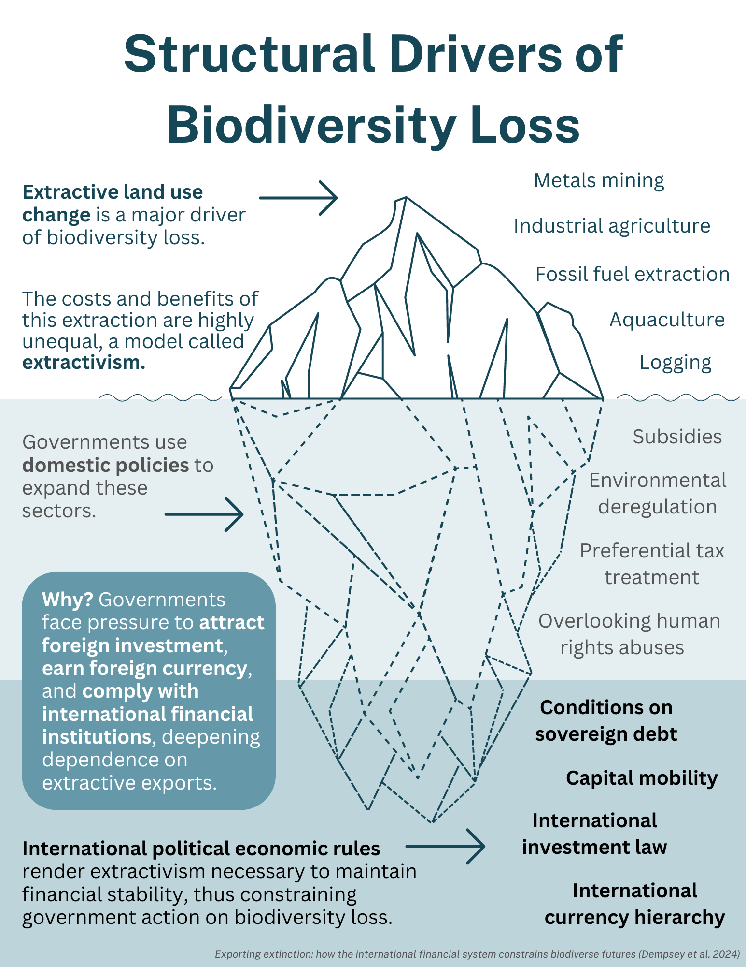

https://www.cbd.int/convention
United Nations, “Advancing a Human Rights-Based Approach to the Global Biodiversity Framework,” (2022), https://unemg.org/wp-content/uploads/2022/12/Advancing-HRA-to-GBF-Dec22.pdf Penelope R. Whitehorn et al., “Mainstreaming Biodiversity: A Review of National Strategies,” Biological Conservation 235 (2019): 157–163, https://doi.org/10.1016/j.biocon.2019.04.016.
Penelope R. Whitehorn et al., “Mainstreaming Biodiversity: A Review of National Strategies,” Biological Conservation 235 (2019): 157–163, https://doi.org/10.1016/j.biocon.2019.04.016.
Jessica Dempsey et al., “Exporting Extinction: How the International Financial System Constrains Biodiverse Futures,” (2024), The Centre for Climate Justice, Climate and Community Project, and Third World Network, https://climatejustice.ubc.ca/news/exporting-extinction-how-the-international-financial-system-constrains-biodiverse-futures
According to Ilias Alami et al., international financial subordination is “a relation of domination, inferiority, and subjugation between different spaces across the world market, expressed in and through money and finance, which penalizes actors in [Developing and Emerging Economies] disproportionally. It expresses itself as constraints on the agency of a multiplicity of social actors, it is directly implicated in the geographical transfer of value across the world market, and it significantly contributes to broader patterns of uneven spatial development.” See: Ilias Alami et al., “International Financial Subordination: A Critical Research Agenda,” Review of International Political Economy 30, no. 4 (2023): 1360–1386, https://doi.org/10.1080/09692290.2022.2098359. Althouse and Svartzman helpfully connect the dots between financial subordination and environmental change, see Jeffrey Althouse and Romain Svartzman. "Bringing subordinated financialisation down to earth: the political ecology of finance-dominated capitalism," Cambridge Journal of Economics 46, no 4, (2022): 679–702. https://doi.org/10.1093/cje/beac018
Bruno Oberle et al., “Global Resources Outlook 2019: Natural Resources for the Future We Want,” International Resource Panel, United Nations Environment Programme, 2019, http://www.resourcepanel.org/reports/global-resources-outlook.
In the report we use the terms Global North and Global South, terms that imprecisely refer to economically wealthy, “developed” nations (North) and economically disadvantaged, sometimes termed “developing” or “Third World” nations (South). While imperfect, the terms do capture enduring uneven political economic processes. For a fulsome accounting of the variety of ways the term Global North and Global South are being used, see: Anne Garland Mahler, “Global South,” in Oxford Bibliographies in Literary and Critical Theory, ed. Eugene O’Brien, (Oxford, Oxford UP: 2017) https://www.oxfordbibliographies.com/display/document/obo-9780190221911/obo-9780190221911-0055.xml.
When we say “Governments” in this report, we are referring to the 5 case study countries. However, we think our research may have applicability to other countries and jurisdictions, including in the Global North.

