**Background information**

In animals, permeability barriers are created to control movement of compounds across various tissues such as the brain, intestine and epidermis. Since permeability barriers protect animals against pathogens, their establishment during development is deemed necessary. In vertebrates, the blood-brain barrier isolates and protects the brain from potential damage from blood-borne growth factors, neural active compounds and ions (Schulte et al.,2003). In *Drosophila melanogaster*, disruption of the blood-brain barrier may cause paralysis, as the permeated potassium from the hemolymph can block action potentials in neurons (Auld et al., 1995). Failure in junction and barrier formation usually leads to detrimental disease or fatality. Since permeability barriers are primarily formed by junctions, the study of junction assembly during development provides vital insight on barrier formation.

Tight junctions (TJs) are present in vertebrate epithelia and form a permeability barrier. In insects, the blood-brain barrier (bbb) serves a similar function as in vertebrates. In insect epithelia, septate junctions (SJs) establish the permeability barrier. While SJs and TJs perform analogous functions, they differ in their ultrastructure (Figure 1A). Interestingly, the core complex SJ proteins are functionally and molecularly conserved to form paranodal myelinated axons’ nodes of Ranvier in vertebrates, while the septate junction in *Drosophila* nervous system is found in subperineurial glia cells (Figure 1C) (Bhat et al., 2001). Hence, understanding SJ formation would provide insight to the formation of paranodal junction.

At the point of contact of three epithelial neighbouring cells, a specialized type of junction, Tricellular junction (TCJ), is formed. At TCJ, TJs or SJs of three neighbouring cells converges in vertebrate and insects respectively (Figure 1B,1D). In the fruit fly *Drosophila*, Gliotactin(Gli), a glia-derived protein, is found to be necessary to the SJ localization at TCJ, and the formation of glial-based bbb (Schulte et al.,2003). Gli contains many conserved domains such as the PDZ binding motif (Figure 2). Previous studies suggested Gli may be essential in associating neighboring glia to complete a glial sheath in *D. melanogaster*. Disruption in Gli expression causes leaks into the bbb as shown by the permeation of ruthenium red dye (Auld et al. 1995).

The expression of Gli in peripheral glia begins at stage 13. By stage 16, Gli expression covers the surface of peripheral glia. As glial wrapping extends to the synaptic terminal to wrap motor axons in larval stages, minimal Gli is expressed on the peripheral glia. However, Gli expression is observed in the wing imaginal disc in larval stages (Auld et al, 1995).

Disc large (Dlg) is a SJ-associated protein, and an evolutionarily conserved tumour suppressor. Dlg contains 3 PDZ domains and an SH3 domain. Dlg’s interaction with Gli is necessary for the formation of TCJ and the localization of Gli. However, their interaction is likely indirect through other intermediary proteins since Gli localization is independent of it’s PDZ binding motif (Schulte et al, 2006). Dlg-mutants also exhibit overgrowth in larval brain and imaginal discs. While the protein interactions with Dlg in SJ formation is not known, previous Dlg knockdown experiments suggest that Gli-Dlg interaction stabilizes Gli (Sharif Khodaei, 2017).

Dlg is also known to be necessary in establishment of cell polarity (Sharif Khodaei, 2017). Cell-polarity and tissue polarity provide structural integrity and suppress malignant phenotypes of mutant cells. Loss of cell-polarity is known to cause tumour initiation (Lee and Vasioukhin, 2008).

In vertebrate studies, the conservation of Gli-Dlg interaction is observed in their respective vertebrate homologs, Neuroligin and PSD-95 (Schulte et al. 2006). Meanwhile, human Disc large(hDlg) is observed to function similarly to *Drosophila* Dlg. Laprise et al. (2003) demonstrated hDlg is required for the assembly of adherens junctions in the epithelia while hDlg1 was shown to reduce expression of invasion human cervical carcinomas (Frese et al, 2006). Since hDlg1 has been studied extensively for its oncogenic function, more is known about its interactome. As conservation of protein interaction is observed, the hDlg interactome can be utilized to extend the interactome of Dlg to investigate which proteins are involved in the formation of septate junctions and possibly the paranodal junctions.

Because manipulation of the peripheral nervous system in stages 13-16 is more difficult than manipulation of imaginal discs in larvae, the effect of gene knock down on septate junction and TCJ formation should be investigated at the wing imaginal disc first. A list of proteins which have been shown to interact with hDlg1 was acquire from UniProt. A NCBI protein blast search was performed to identify potential Drosophila homologs for RNAi screens.

Amino acid analysis revealed some *Drosophila* proteins that exhibit more than 50% identity to hDlg interactome contain the highly conserved domains. Veli, RE30311p, and RE51991p likely interact with Dlg and/or Gli via the PDZ binding domain. Jagar’s SH3 domain likely interacts with the proline rich motif of Gli like the predicted Dlg-Gli interaction. Alpha-actinin and moesin are proteins that interact with the cytoskeleton. Although alpha-actinin and moesin do not contain the conserved domain, they should be screened to investigate the potential that cytoskeletal protein are involved in Gli positioning at the TCJ initially. Proteins that are identified to affect Gli and/Dlg localization at the wing imaginal disc are predicted to also affect Gli and/Dlg localization at SJ. Since the bbb is formed by Glial cells (Limmer et al, 2008), a second screen can be performed to investigate whether SJ formation is affected severely enough to result in permeability in embryonic bbb.

**Hypothesis:**

Part 1) Veli, RE30311p, RE51991p, X11L, Jagar, alpha-actinin and moesin are SJ proteins necessary for Dlg and Gli localization at the *D. melanogaster* wing imaginal disc tricellular junction

Part 2) Proteins necessary for Gli/Dlg localization at TCJ are also necessary for SJ formation to establish the bbb.

**Predication:**

If the interaction between identified Drosophila protein and Dlg is necessary to localize Dlg at SJ in the larval wing imaginal disc, the removal of protein expression during larval stages would cause delocalization of Dlg. Since Gli localization at TCJ is dependent on the association of Dlg at the SJ, delocalization of Dlg from SJ would also likely cause Gli to delocalize from the TCJ. Gli localization at TCJ is essential to TCJ formation, hence Gli delocalization from TCJ could also cause the malformation of TCJ.

Relevance

Permeability barriers have important physiological roles. When permeability barriers break down dramatic consequences occur in both vertebrates and invertebrates. Protection from toxic metabolites, regulation of nutrients, oxygen, ions exchange, and cell homeostasis are disrupted and may result in lethality and pathogenic invasion when barriers are defective. In identifying which proteins are necessary in forming septate junctions during development, one can propose a comprehensive mechanistic model of septate junction and paranodal junction formation. In determining the mechanisms underlying septate junction and paranodal junction formation, one can better understand how the blood brain barrier (bbb) is established, and may contribute to devising ways to bypass it to deliver compounds to the brain. Furthermore, results from this project may allow one devise a method to disrupt permeability barriers in arthropods to develop a pesticide.

**Approach:**

**1) Using the GAL4-UAS to drive RNAi to knock down of candidate proteins in the wing imaginal disc to screen which proteins are necessary for Gli and Dlg localization at TCJ and SJ respectively.**

GAL4/UAS is a yeast drive system that can be used to express RNAi at specific sites within a tissue type. To drive RNAi at the posterior compartment of the wing imaginal disc only while the anterior compartment of the wing imaginal disc would serve as an internal control, the promoter of *Engrailed(eng)* may be utilized.Eng is a protein expressed in the posterior compartment of the wing imaginal disc during *Drosophila* development (Figure 3). GAL4 is a yeast transcription factor which binds to UAS and drives UAS expression. To create knock down mutants, crosses can be set with females flies homozygous for engrail promoter-GAL4(*eng-gal4*), containing Gli and Dlg that are endogenously tagged with YFP and RFP respectively. Male flies for crosses are homozygous for UAS-RNAi specific to each candidate protein (Figure 4). The F1 progeny larvae will express RNAi at the posterior compartment of the wing imaginal disc as F1 will inherit both the *eng-GAL4* maternally and UAS-RNAi paternally. Since the anterior compartment will not express RNAi, the affected protein expression in the posterior compartment can be compared with the normal protein expression in the anterior compartment.

In addition to the internal control, three control crosses would be performed with males homozygous for UAS-mCD8::GFP (mouse CD8 protein tagged with GFP), UAS-DlgRNAi and UAS-GliRNAi. In the cross with UAS-mCD8::GFP, GFP would be expressed on cells subjected to eng-GAL4/UAS system. This is done to demonstrate the differential expression of eng on anterior and posterior compartment, normal Gli and Dlg expression pattern at 3rd instar, and to control for the experimental procedure. Gli and Dlg localization pattern in knock down mutants can be compared to the localization patterns of Dlg and Gli in absence of either protein, as demonstrated in crosses with UAS-DlgRNAi and UAS-GliRNAi.

**2) In embryonic glial cells, *Gliotactin* promoter is used to drive GAL4 expression to induce expression of protein found to that delocalized Gli and/or Dlg in wing imaginal disc. Observe if the bbb is disrupted.**

After identifying which proteins are necessary in Dlg, Gli localization in the wing imaginal disc, a secondary screen can be performed to investigate if those proteins are necessary in establishing the bbb as well. In this experiment, instead of using the promoter of *eng,* the promotor for *Gliotactin* is used to drive expression of GAL4 in glia in embryonic stages. Similarly, the F1 of the cross between *Gli-GAL4* females and UAS-RNAi males would express RNAi to knock down protein expression in the glia. A cross with UAS-mCD8::GFP males is performed. GFP localization demonstrates which cells will be subjected by Gli-GAL4/UAS system. To observe whether the BBB has been disrupted by the knock down, wildtype embryos and knock down mutant embryos are exposed to a ruthenium red dye.

**Possible results/Discussion:**

In the first screen, localization of Gli and Dlg, endogenously tagged with YFP and RFP respectively, can be visualized in *Drosophila* larvae wing imaginal disc with fluorescence microscopy. If gene knock down with RNAi does not affect Gli/Dlg expression, RFP and YFP signals will be similar in the anterior and posterior compartment of the wing imaginal disc. If RNAi knock down affects Dlg or Gli localization, RFP and YFP signals indicating wildtype expression in the anterior compartment will differ from the affected Gli/Dlg expression in the posterior compartment.

Since delocalization of Dlg from SJ likely delocalizes Gli as well, the resultant Gli and Dlg expression is predicted to be comparable to that in Dlg knock down mutants as demonstrated in the UAS-DlgRNAi control cross. In addition to improper SJ/TCJ malformation due to Gli delocalization, Dlg knock down could also cause an overgrowth in wing imaginal discs and/or failure to polarize cells as well.

If the candidate protein only affects Gli delocalization, Gli may be observed outside of TCJ. While TCJ may be malformed, Dlg localization at SJ between plasma membrane of two neighbouring cells may remain unaffected. The expression of Gli and Dlg, and the morphology of cells, is predicted to be like Gli knock down mutants as observed in a UAS-GliRNAi control cross.

Assuming SJs in the wing imaginal discs and glial cells are formed in the same manner, proteins that affect SJ/TCJ formation in the wing imaginal disc are predicted to affect the formation of SJ and Trimembrane junction in the glial cells as well. There are two possible results from the second screen. Proteins that are found to affect Gli/Dlg localization at the wing imaginal disc do not affect SJ formation severely enough to disrupt the BBB, and the intact BBB blocks the permeation of ruthenium red dye into the developing brain. The absence of dye in the developing brain should be comparable to the wildtype control. However, if the dye has permeated into the developing brain, BBB formation has been disrupted as indicated by the permeability of the dye across BBB. It is also possible that some desired knock down genotypes will not be viable. Since proteins may play more one role in development, the effect of the knock down may severely compromise the development in the tissue of interest and other tissues, resulting in lethality.

Subsequent to identifying proteins involved in forming the SJ and TCJ, a model can be developed to deduce how proteins interact with each other and the hierarchy of expression at these junctions. In future studies, a rescue experiment can be performed to investigate whether the expression of putative homologous human proteins is sufficient to rescue *Drosophila* knock down mutant phenotypes.

**Figures**

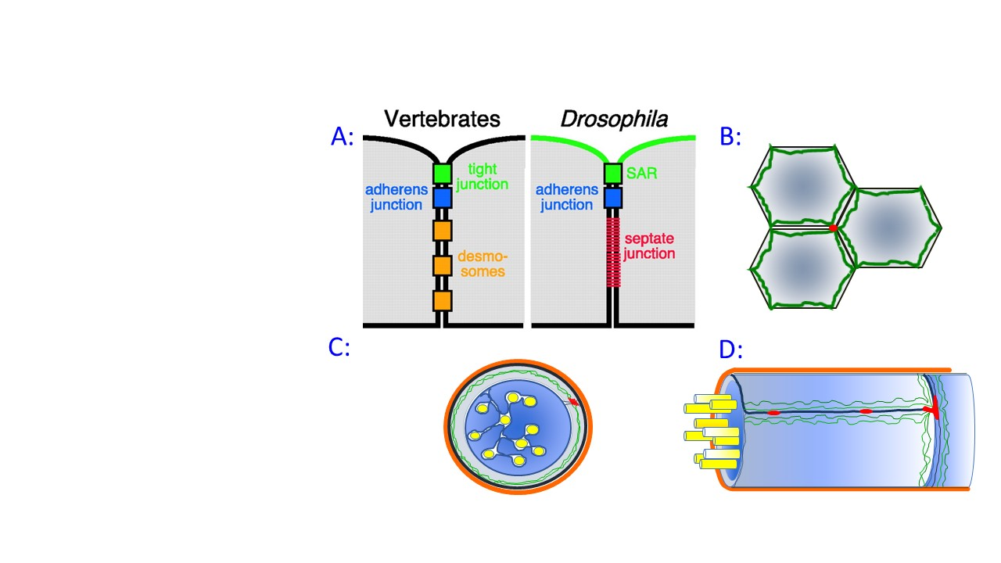

Figure 1. **Junction locations** A) In Drosophila, ladder-like septate junction adheres adjacent membranes basal to adherens junctions. In vertebrates, tight junctions apical to adherens junctions form kissing points between adjacent plasma membranes(Schulte et al., 2003). Image modified from Cox (2004). B) Tricellur junction. C) Septate junction in the subperineurial glia D) Trimembrane junction in Drosophila glia.

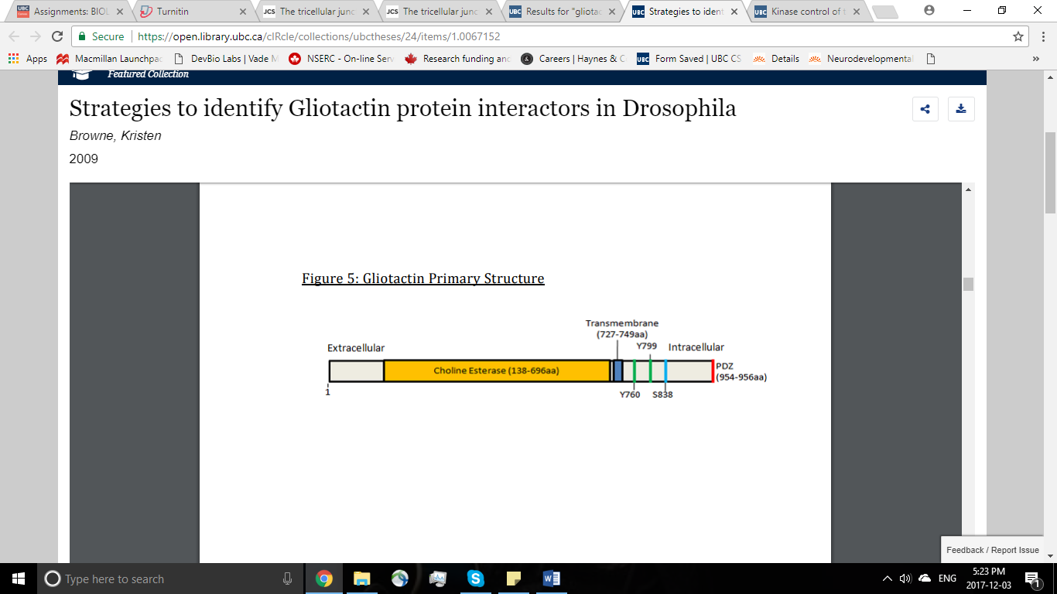

Figure 2. **The primary structure of Gliotactin**. Gliotactin is a transmembrane protein at TCJ. It contains a number of domains that are well-conserved across arthropods. Conserved domains include the N-terminal choline-esterase-like domain, 2 putative phosphotyrosine motifs(pY), the kinase C phosphoserine motif (PKC) and the C-terminal PDZ binding motif. Image modified from Browne (2009)

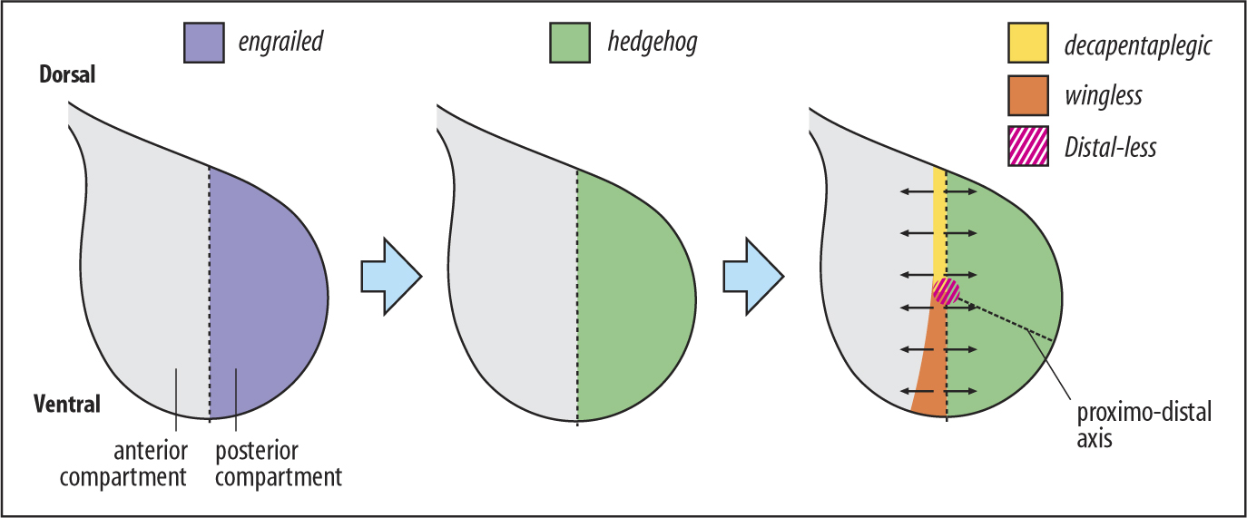

Figure 3. **Expression pattern of engrailed in the wing imaginal disc.** Engrailed is expressed in the posterior comparment in *Drosophila* larval wing imaginal disc.

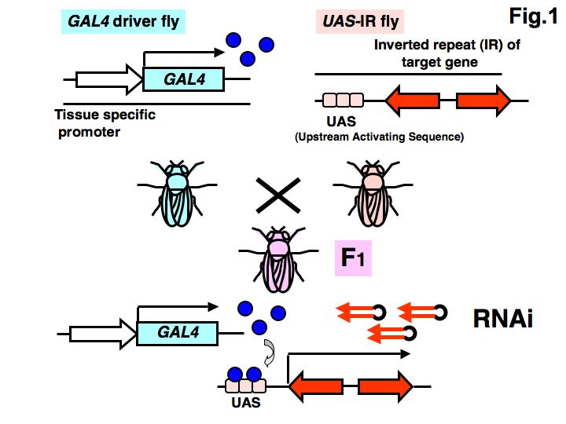

Figure 4. **Schematic depicting the Gal/UAS-RNAi driver system.** The F1 expresses RNAi which blocks the expression of a targeted gene at tissues expressing GAL4. Image adapted from Shoko (2014)

References

Auld, V. J., Fetter, R. D., Broadie, K. and Goodman, C. S. (1995). Gliotactin, a novel transmembrane protein on peripheral glia, is required to form the blood-nerve barrier in Drosophila. Cell 81, 757-767.

Bhat, M. A., Rios, J. C., Lu, Y., Garcia-Fresco, G. P., Ching, W., St Martin, M., Li, J., Einheber, S., Chesler, M., Rosenbluth, J., et al. (2001). Axon-glia interactions and the domain organization of myelinated axons requires neurexin IV/Caspr/Paranodin. Neuron 30, 369-383.

Browne, K. (2009). Strategies to identify Gliotactin protein interactors in Drosophila (Unpublished master's thesis). Thesis / Dissertation at the University of British Columbia.

Cox, E. A. (2004). Cell adhesion receptors in C. elegans. Journal of Cell Science, 117(10), 1867-1870. doi:10.1242/jcs.01177

Frese, K. K., Latorre, I. J., Chung, S., Caruana, G., Bernstein, A., Jones, S. N., Javier, R. T. (2006). Oncogenic function for the Dlg1 mammalian homolog of the Drosophila discs-large tumor suppressor. The EMBO Journal, 25(6), 1406-1417. doi:10.1038/sj.emboj.7601030

Laprise, P., Viel, A., & Rivard, N. (2003). Human Homolog of Disc-large Is Required for Adherens Junction Assembly and Differentiation of Human Intestinal Epithelial Cells. Journal of Biological Chemistry, 279(11), 10157-10166. doi:10.1074/jbc.m309843200

Lee, M., & Vasioukhin, V. (2008). Cell polarity and cancer - cell and tissue polarity as a non-canonical tumor suppressor. Journal of Cell Science, 121(8), 1141-1150. doi:10.1242/jcs.016634

Limmer, S., Weiler, A., Volkenhoff, A., Babatz, F., & Klämbt, C. (2014). The Drosophila blood-brain barrier: development and function of a glial endothelium. Frontiers in Neuroscience, 8. doi:10.3389/fnins.2014.00365

Schulte, J., Charish, K., Que, J., Ravn, S., MacKinnon, C. and Auld, V. J. (2006). Gliotactin and Discs large form a protein complex at the tricellular junction of polarized epithelial cells in Drosophila. Journal of cell science 119, 4391-4401.

Schulte, J., Tepass, U. and Auld, V. J. (2003). Gliotactin, a novel marker of tricellular junctions, is necessary for septate junction development in Drosophila. The Journal of cell biology 161, 991-1000.

Sharif Khodaei, Z. (2017). Tricellular Junction Regulation, Signaling and Scaffolding by ( pending publish doctorate thesis). University of British Columbia.

Shoko, N. (2014, February 24). [Heritable and inducible RNAi knockdown system in Drosophila]:Glycoscience Protocol Online Database. Retrieved December 03, 2017, from http://jcggdb.jp/GlycoPOD/protocolShow.action?nodeId=t32

the blood-nerve-barrier (BNB) of invertebrates is formed by several glial wraps which surround individual axons then bundle them together (Figure 1b)(Stork et al. 2008). One such layer, the perineurial glia, separates the open circulatory system from the nerve by forming an SJ (Stork et al. 2008). Failure to form this SJ in nrx IV mutants results in paralysis and embryonic lethality due to BNB disruption (Baumgartner et al. 1996). Similarly, TJ mutations have been related to diseases related to barrier function such as Alzheimer’s and Multiple Sclerosis in vertebrates (Hawkins and Davis 2005).