**Feasibility Analysis of New Business Practices**

**to Increase Market Engagement**

**for Shou-Yu Liang Wushu Taiji Qigong Institute**

For Chenhan Yang

President of Shou-Yu Liang Wushu Taiji Qigong Institute

Vancouver, British Columbia

Written by Brendan Chan

ENGL 301 Student

July 14, 2021

**LETTER OF TRANSMISSION**

5892 Ross Street

Vancouver, BC V5W3L4

July 15, 2021

Chenhan Yang

President

Shou-Yu Liang Wushu Taiji Qigong Institute

220 Jackson Avenue,

Vancouver, BC V6A 3B3

Dear Mr. Yang,

Here is my report on the Feasibility of New Business Practices to Increase Market Engagement for Shou-Yu Liang Wushu Taiji Qigong Institute. To prepare this report, I’ve learned a lot about the school’s current offerings, as well as a great deal on the current state of martial arts among young adults in our community. I’d like to thank you for allowing me to interview various staff members for this report.

Currently, while Shou-Yu Liang continues to offer various online classes, COVID-19 has greatly affected martial arts classes for our school. I believe that as we re-open the school in this coming fall, there is a great opportunity for the school to evolve and adapt to capture a new potential audience. As one of your long-time students, I firmly believe that while the school is a great place to learn, there is still room for the school to grow and improve. By implementing new business strategies, I believe the school will grow to be better, and greater than ever.

I’ve greatly enjoyed my time working on this project, and would be happy to answer any questions or concerns you have. Please contact me at 604-338-3082 or at bchan98@student.ubc.ca

Sincerely,

Brendan Chan

**Table of Contents**

|  |  |
| --- | --- |
| I. LETTER OF TRANSMISSION | 1 |
| II. ABSTRACT | 3 |
| III. INTRODUCTION | 4 |
| IV. DATA SECTION | 5 |
| Summary of Interview with Assistant Instructor at SYL | 5 |
| Recent Popularity of MMA | 7 |
| Survey Results | 8 |
| Possible Flaws in Survey Results | 11 |
| Analysis and Interpretation of Data Sources | 11 |
| V. CONCLUSION | 17 |
| VI. APPENDIX | 19 |
| Interview Questions | 19 |
| Survey Questions | 22 |
| VII. REFERENCES | 25 |

**Figures and Tables**

|  |  |
| --- | --- |
| Figure 1 | 8 |
| Figure 2 | 9 |
| Figure 3 | 10 |
| Table 1 | 13 |

**ABSTRACT**

Due to the COVID-19 pandemic, many different sports and extracurricular activities have been put into disarray. As the Shou-Yu Liang Wushu Taiji Qigong Institute will soon finish its pandemic-imposed hiatus this fall, improvement student enrollment should be done to recover from any possible loss of students caused by this hiatus.

Currently, the Shou-Yu Liang Wushu Taiji Qigong Institute has a limited offering of classes, and has very little advertisement for the school itself. Online surveys have revealed that young adults are currently disinterested in class offerings given by the school, and are instead interested in self-defence classes for mixed-martial arts. Survey participants also show relative disinterest in finding schools on forms of social media, instead turning to Google searches.

To improve student enrollment, these are some recommendations to follow:

1. Implement a new self-defence class to take advantage of MMA’s growing popularity in young adults
2. Add instructional content on YouTube or various other sites to help improve online presence.

**INTRODUCTION**

The arrival of the COVID-19 pandemic has caused a significant disruption in participation of physical recreational activity. Specifically, recreational activities that involve groups of people, such as team sports, or martial arts have seen a significant decrease if not outright halt in activity due to the necessity of quarantine (Moody, 2020). This is a significant issue for out-of-school clubs and organizations, that rely on member payment fees to remain afloat. For Shou-Yu Liang Wushu Taiji Qigong Institute (hereafter referred to as SYL), the school in particular has been significantly affected by this pandemic, with in-person classes being put on temporary hiatus since May of 2020.

The purpose of this report is to determine possible offerings and new advertisement methods to target the growing industry of mixed martial arts (hereafter referred to as MMA). Looking for new methods to attract a new audience could result in a significantly larger enrollment overall.

To help determine the best method of action for SYL, this report will analyse several data sources. For primary data sources, an anonymous survey to determine market sentiment on various aspects of martial arts classes was conducted. Additionally, one assistant instructor at SYL was interviewed on the current class methodology as well as current forms of advertisement present. For secondary data sources, various articles and websites detailing social media and advertisement techniques will be analysed to aid in forming a concrete proposal.

**DATA SECTION**

Two methods were employed to gather primary data for this report. First, was an interview conducted with an assistant instructor. This interview was done fairly informally, with 12 prepared questions beforehand to determine the current state of SYL. A full transcript of the interview can be found in the appendix. The second method of data gathering was via an anonymous online survey, sent out by posting the survey online in six different chatrooms, with the majority of members being aged 18-25. Additionally, I requested that no students currently enrolled at SYL answer these questions. The full survey can be found in the appendix.

**Summary of Interview with Assistant Instructor at SYL**

Currently, the large majority of students enrolled at SYL are over the age of 25. There are currently 22 students in the youth class, with a range of ages from 5-19. The other students are adults, who attend the semi-weekly Wushu classes. Many students at the school participate in multiple programs simultaneously, attending these classes on different dates.

Programs taught at the school include traditional Wushu, Taiji (more commonly known as Tai Chi), Qigong, as well as a few supplementary programs, such as the Sanshou program. Currently the school has 9 instructors, and 7 assistant instructors. Prior to the pandemic, around two hundred students were enrolled in the main Wushu class, with a large majority of these students also attending either the Taiji or Qigong classes. In addition to the in-person classes the school has previously offered in non-COVID times, the school offers instruction via video conferencing in Zoom, often varying from 10-30 students per session.

The school itself is held within a large gym, roughly 6500 feet squared. However, the school is currently moving to a new location in Richmond, with two floors. The first floor is roughly 5500 feet squared, with a second floor being divided into two offices and one classroom. Prior to the COVID-19 epidemic, Wushu classes were held twice a week, on Friday and Saturday for 3 hours sessions each. Qigong and Taiji classes were held on Tuesdays, Thursdays, and Saturdays for 3-hour sessions each.

Regarding specific forms of advertisement, the school has generally relied on word-of-mouth recommendation to gather students. The head instructor, Shou-Yu Liang has in the martial arts society in Asia holds a relatively large amount of fame in the Asian martial arts sphere. Master Shou-Yu Liang was a gold medalist in various martial arts competitions during his youth, and also served as a coach for a variety of Wushu teams. His success in various competitions both as a competitor and a coach has led to being fairly well known in the wushu circle in China. As a result, many students who come to the school do so from word-of-mouth advertising, telling people about the school. Additionally, several of the senior teachers, such as Shou-Yu Liang, Helen Liang, and Chenhan Yang have released several instructional videos via DVD and YouTube to help teach martial arts. These have served as an indirect form of advertising by bringing out the school’s name. Additionally, the school has a Facebook page where they post advertisements for the various online offerings for Taiji and Qigong classes, as well as photos of students training.

Currently, pricing for Wushu, Qigong, and Taiji classes at SYL is $100 per month for each student. Each class has a separate fee, requiring multiple payments for multiple classes. As instructors teach at SYL as volunteers, all proceeds go towards paying rental fees for teaching spaces.

**Recent popularity of MMA and SYL**

In recent years, viewership for MMA has seen an explosive growth, most notably due to the COVID-19 pandemic. Over the course of four different events in 2020, each event averaged around 1.2 million viewers (Impey, 2020). MMA has outperformed similar combat sports such as boxing, where large events only averaged around 200 thousand viewers. Of this demographic, 40% of the audience falls between the age of 18-35 (Badenhausen, 2018). This increase in popularity of MMA thanks to the UFC has resulted in popularity of martial arts classes across North America (Vasquez, 2021). As previously mentioned with the interview, SYL currently has an informal Sanshou class offered in the school. Sanshou, or Sanda, is a form of martial arts developed by the Chinese military which incorporates aspects of both traditional Kung Fu, kickboxing, and wrestling. Given the incorporation of various fighting techniques, a Sanshou class offering at SYL would likely serve to prove attractive towards fans of MMA.

**Survey Results**

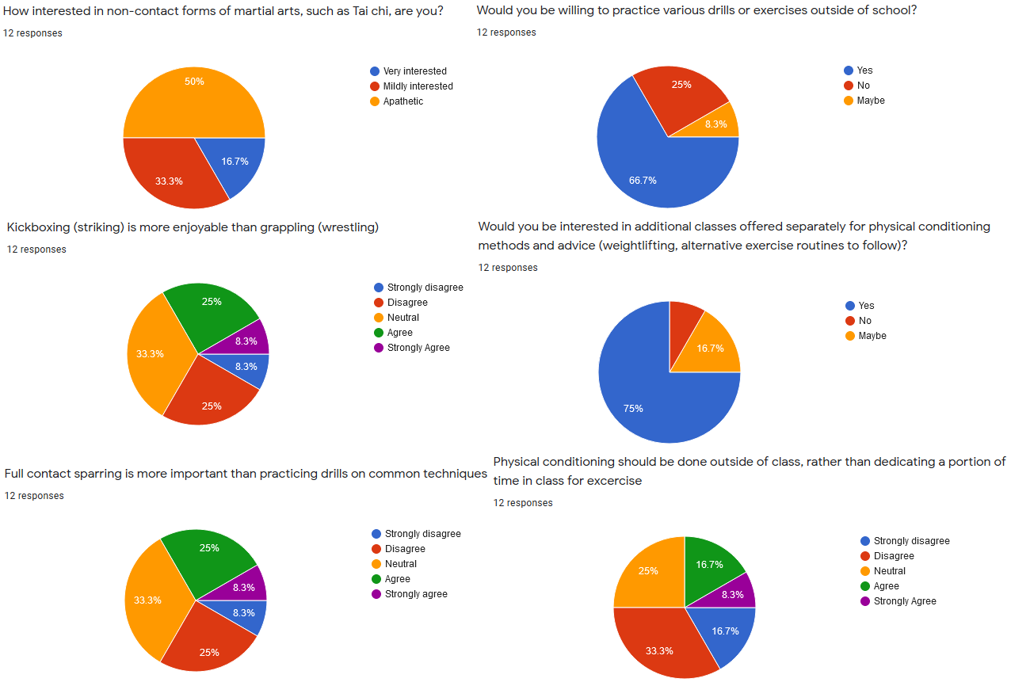

***Figure 1****. Poll results concerning types of preferred topics covered within a class*

A large number of survey participants reported disinterest in non-contact forms of martial arts. This would confirm our initial hypothesis of young adults being fairly disinterested in more recreational forms of martial arts, rather than direct contact.

When asked for preference of kickboxing (striking) over grappling, a large majority of surveyors resulted neutrality or disagreement with this statement, with a minority answering in agreement.

When asked about preference of sparring versus drilling, results for this were mixed. There is roughly an equal number of surveyors who agree and disagree with this statement. Drilling each technique should not see overwhelming unpopularity, but should be mixed in with sparring to allow students to apply their techniques and see the results of their drilling. Additionally, the majority of survey participants reported willingness for practice drills outside of class.

The majority of participants disagreed with exercise being limited to outside of class. Additionally, a majority of participants indicated interest in classes specifically for physical conditioning.

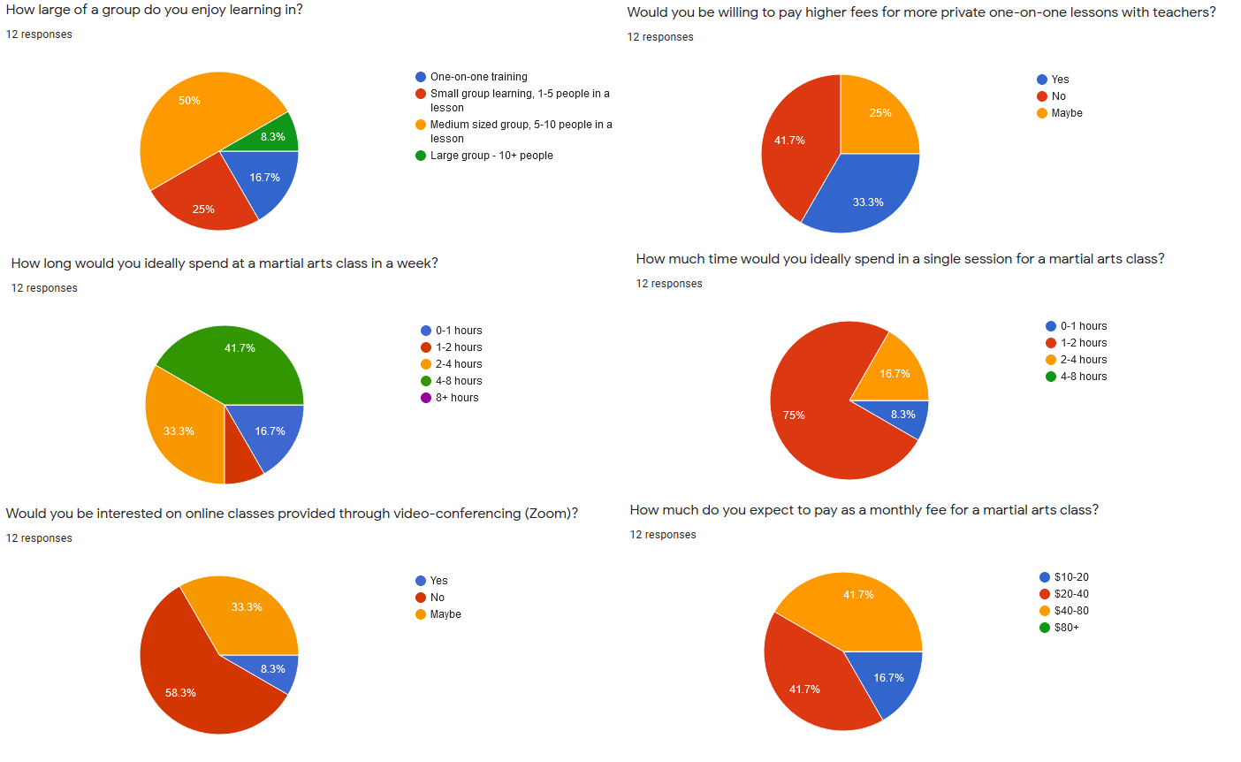

***Figure 2****. Poll results concerning class session design*

A large majority of surveyors preferred a medium sized group of 5-10 people, with very few individuals preferring a large group. Classes should be held in sessions in hourly blocks to accommodate for this. Responses on extra one-on-one classes was not very well received, with few students willing to take such classes.

The large majority of students indicated they would be willing to pay between the $20-$80 range monthly, with no students indicating interest for $80+.

A majority of students responded they would prefer 4-8 hours a week, while a smaller majority indicated 2-4 hours weekly. Additionally, the majority of students reported they would like to spend 1-2 hours in a single session. A majority of students reported they would not attend video-conferencing classes.

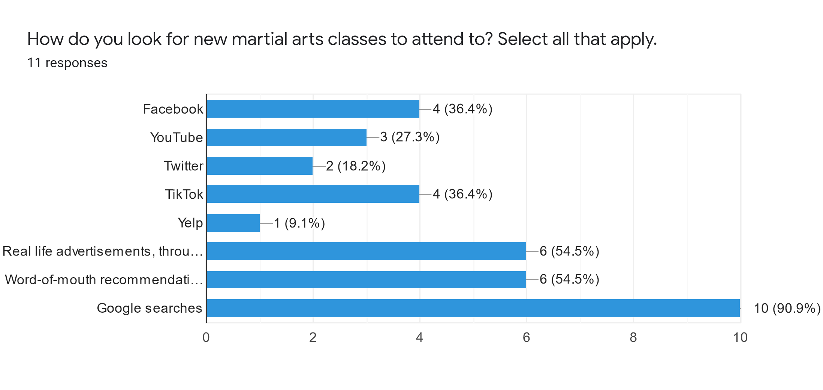*Figure 3. Poll results concerning advertisement venue popularity*

The most popular avenue used to find potential martial arts classes is via Google searches. The next most popular methods were through real-life advertisements, and word-of-mouth recommendations. Very few participants reported using Yelp as a possible source of information. The popular social media platforms, Facebook, Twitter, TikTok, and YouTube did not have significant amounts of popularity.

**Possible Flaws in Survey Results**

Several possible flaws could exist within this survey. First, this survey was targeted towards young adults aged 18-25. However, as age was not asked within the survey, it is possible that some survey participants were older or younger than the targeted audience. Additionally, the survey had fairly low responses – it is possible that due to small sample size, results are not entirely accurate. The survey in question has been included in the appendix**.**

**Analysis and Interpretation of Data Sources**

*Analysis on student demographics and interests*

Based on the data obtained from the primary data sources we have gathered, we can see that one possible cause of SYL’s lack of younger students is largely due to the current school’s focus on the Taiji and Qigong programs. An overwhelming amount of survey participants indicated a willingness to participate in more practical self-defence forms of martial arts, with large amounts of apathy towards Taiji or Qigong. Many participants also noted a desire to participate in physical conditioning. It is possible that many young individuals view Taiji and Qigong as impractical methods of exercise and self-defence, due to the movements generally being much slower and tamer than activities like kickboxing and wrestling. Additionally, while Taiji and Qigong classes have proved popular for video-conferencing classes, Zoom classes for Sanshou have been shown to be unpopular for the younger audience. This could be due to difficulty in practicing drills or techniques without any equipment or training partners.

From the interview with the assistant staff, the staff member noted that an additional self-defence class was offered by some instructors on a semi-regular basis. This form of Wushu, known as Sanshou Dao, is a fighting system that includes full-contact kickboxing, wrestling. As this class is already being taught at SYL, using this class to attract new students could be a viable option.

*Proposal for Sanshou classes*

Reforming the Sanshou class to a full-time basis could attract the younger audience to enroll within SYL, due to MMA’s high popularity with young adults. Taking in to account survey results, I propose that a Sanshou class should be held on a semi-weekly basis, each session lasting 2-3 hours from start to finish. Class sizes should be held ideally to a group of 10 in each class, with one instructor to teach each session. For class design, the class should start with a physical conditioning session as warmup. The class should alternate drilling techniques with sparring to encourage application of techniques once practiced. Instructors should recommend several training regimens for out of class exercise. Each class should hold a monthly fee of $50 to allow for recoup of rental fees for space.

*Issues and Limitations for Proposal for Sanshou Classes*

There are two issues for the Sanshou class. First, is an issue of finding instructors. Current instructors of the Wushu and Qigong classes work on a volunteer basis, and do so in their spare time. It would be difficult to find new instructors willing to contribute additional time to teaching another class, considering they would be teaching multiple classes simultaneously. This could be possibly remedied by promoting additional students to assistant instructor. Currently, the number of full-time instructors outnumbers the assistants. Holding a pilot program for the full-time Sanshou class would allow the training of new instructors.

The second issue is the issue of finding time and space to hold the class. Currently the gym is occupied on Tuesdays, Fridays, and Saturdays. This leaves Mondays, Wednesdays, Thursdays, and Sundays as possible times to hold the classes. As the gym is unoccupied during these times, this would allow enough space to hold the class, without intruding on the currently implemented classes.

*Table 1 – Potential Timeslots for Sanshou Classes*

*Issues with currently implemented advertisement strategies*

The large issue with SYL’s current advertisement strategy, is the low level of advertisement. As previously mentioned within the instructor’s interview, the school uses four primary methods of advertisement. Upon inspection of the school’s Facebook page, updates are very sporadic, and have little mention of in-person classes, or training schedules. Upon inspection of the SYL YouTube channel, the channel lacks any instructional videos or guides, instead posting occasional performances done by teachers and students every few months.

*Actions to take for increasing advertisement strategy*

From the primary data gathered with the anonymous survey, the most primarily used source for seeking martial arts classes is via Google search. According to the Google website, local rankings for search are dependent on relevance, distance, and prominence. Relevance refers to whether the search query reflects the website contents. Distance refers to the estimated distance from your geographic location to the primary address found on the website. Prominence, refers to how much information Google holds on a website, from mentions on other links, articles and directories. As distance is something that cannot readily be improved, this aspect will be excluded for the purposes of this report.

According to Michigan Tech University (2021), one primary metric for relevancy measured within Google searches is content updates. Another important metric is to consistently publish content that continuously uses a specific keyword phrase for your target. For SYL, important key words likely include the following: “Vancouver”, “Kung Fu”, “Wushu”, “Classes”, “Martial Arts”.

To increase search engine relevancy, I propose implementation of a consistent YouTube series for self-defence techniques that would have its video embedded within the original SYL website. Having a consistent web series would allow for the implementation of consistent content updates. Additionally, consistently posting videos within the same series would allow for key words to be populated within the SYL website. These videos would be present at three sources: The original SYL website, the YouTube channel, and could be reposted on the Facebook page. Having consistent content updates within three different sources would fulfill the prominence requirement for Google’s search rankings, due to the increase in both the amount of content on each website, and the number of times SYL appears on the internet. Additionally, having a preview on various techniques and topics could attract potential students to the school, if they hold interest with the techniques demonstrated on video.

*Issues with implementation of advertisement strategy*

Several possible issues exist with this advertisement strategy. First, would be the costs related to implementing a new strategy. While posting videos on YouTube and Facebook are free, additional camera work as well as video editing are required to output professional content on a regular basis. While SYL does currently post edited videos, these postings are infrequent, generally occurring monthly. Discovering additional costs regarding to this aspect should be pursued in a future report. Additionally, it is possible that some potential students will rely only on videos to learn martial arts, and not attend school. This is however unlikely to occur – the importance of a school is it allows for critique and differing perspectives (Insala, 2019). A coach acts as a third-party participant, and the guidance they give is the most valuable part of schooling.

**CONCLUSION**

**Summary of Findings**

Currently, the SYL enrollment demographic holds to be overwhelming older adults, above the age of 35. The younger demographic is a smaller minority, roughly ten percent of the enrolled students. The school currently has three main offerings: Wushu, Taiji, and Qigong. The school also currently offers an informal self-defence class in the form of Sanshou.

In the past five years, MMA has recently seen a large increase in popularity among young adults. This increase is likely driven by the growing popularity of the UFC, a league dedicated for MMA competition. Within the tested younger demographic of ages 18-25, self-defence classes prove to be of significantly higher interest than of non-contact martial arts such as Taiji or Qigong. Survey participants noted interest in training drills, contact sparring, and physical conditioning. Survey participants had fairly consistent opinions on training time, frequency, and cost. Current forms of advertisement strategy as noted by staff within SYL are four-fold: Facebook advertisements, YouTube Channel, Instructional DVDs, and word-of-mouth recommendations.

**Interpretation of Findings and Recommendations**

To improve SYL’s enrollment, consider the following suggestions:

1. Targeting a new, younger audience by advertising the currently informal Sanshou classes. These classes teach a mix of kick-boxing and wrestling. These classes should be held biweekly, each session lasting around 2-4 hours. Pricing should be around $50 to avoid alienating any students who may be excluded by price of entry.
2. Implement a new advertisement strategy in the form of a YouTube series. This YouTube series would serve to be a preview of classes offered at the school, as well improve the school’s search ranking on sites such as Google due to increased online presence.

**APPENDIX**

**Interview with Megan, Assistant Instructor at SYL**

This interview was conducted with an assistant instructor working at SYL, Megan Chan. I requested that she answer these questions to help an audience who does not know anything about SYL. Questions were prepared ahead of time, with responses being recorded ad verbatim.

*Question 1 – How large is enrollment in SYL right now?*

Ans: It’s really hard to say, because there’s a lot of students who haven’t done the online classes. If we’re talking just pre-COVID in person numbers, there were around 200 people, give or take ten or so.

*Question 2 – How large is the youth class right now?*

Ans: Again, there’s a bunch of people who didn’t attend online classes, but pre-COVID there were 22 people in the youth class.

*Question 3 – How many instructors are there, and how are they organized?*

Ans: Well, there’s *sifu*, (Shou-Yu Liang) at the top, and Chenhan and Helen under him. Under them there’s Big Derek (Derek Cheng), Little Derek (Derek Lau), Michael, Mo, Tjong, and Xiao Hong. So that’s nine total. But *sifu* doesn’t teach personally often these days. There’s also us, the assistant instructors: Anna, Daniel, Emily, Josie, Marco, Sveta and me for seven assistants.

*Question 4 – How were classes organized pre-COVID? How much does each class cost, and what are class sizes like?*

Ans: Well, all classes are around 3 hours long, twice a week. Wushu on Fridays and Saturdays, Taiji on Tuesdays and Fridays, Qigong on Tuesdays and Saturdays. Class size really depends on classes – Generally, there is some overlap between classes, but the main Wushu class is the most popular. Taiji and Qigong aren’t very far behind though. Each class costs $100, but the Qigong class requires you to pay for the entire year all at once. It’s still $100 per month though, so $1200 upfront cost.

*Question 5 – Currently, SYL offers online classes, how do they work?*

Ans: It’s like a video tutorial with some commentary I guess. Usually Derek leads and does his stuff on camera, and we take turns using our cameras to show ourselves for critique.

*Question 6 – How many people actually attend online classes?*

Ans: Each class is around 18-30 people depending on how many attend. The classes are pretty popular though, there’s a lot of different class times for the Taiji and Qigong stuff.

*Question 7 – So you guys are moving to a new gym – what’s it like in comparison to the old one?*

Ans: Well, the old gym was pretty big, but we only had the one floor. The new place has two floors we can use, even if the building itself is slightly smaller than previous

*Question 8 – How large would you say the old gym is in comparison to the new one?*

Ans: The old building was around 6500 feet, but the new one is like 5500.

*Question 9 – What forms of social media are used at SYL?*

Ans: We don’t really use social media really. We have the Facebook and Youtube pages, but those are just to post the occasional competition performance, or big demonstration done by the teachers. I know they advertise some Taiji and Qigong classes on Facebook

*Question 10 – What do you think is the primary method how students find SYL?*

Ans: It’s really word-of-mouth, or people who have known *sifu*. Generally our newer students are friends of our older students, or people who are coming into Vancouver and have heard of *sifu*. Oh, there’s also the instructional DVDs. They used to have this show where Helen and *sifu* would do Taiji on video, and they published a buch of DVDs to go along with it.

*Question 11 – Are you paid as an assistant instructor?*

Ans: No, I’m volunteer. Everyone is a volunteer. The fees just go to renting the building, or publishing the DVDs or books *sifu,* Helen, or Chenhan occasionally write.

*Question 12 – How would you say the Sanshou classes are offered at SYL?*

Ans: We don’t really officially offer Sanshou, it’s more of an informal thing after the main Wushu class finishes on Saturday. The teachers usually stay a bit later to give some additional advice to some students who want it, so some teachers use the extra time to run a quick thirty-minute class with various drills or sparring. What class covers is really just up to what the teachers want to do, or what students want to an extent.

**Survey Questions**

The follow questions were given online via Google Forms. The link can be found here: <https://docs.google.com/forms/d/e/1FAIpQLSfTEaV9bi9tHmfOV8CXKyMCS-wUrVxdRbJ7Tt6ehDL53Tb2vw/viewform>

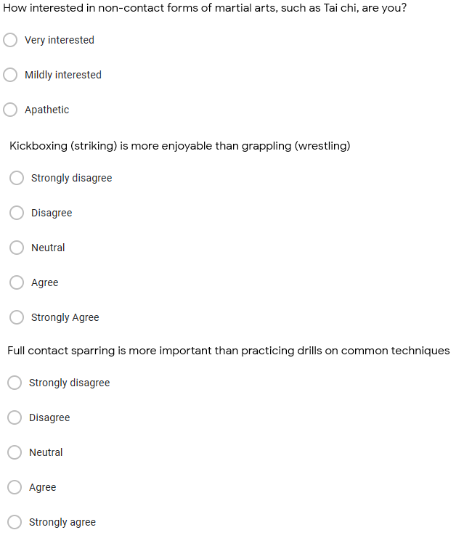

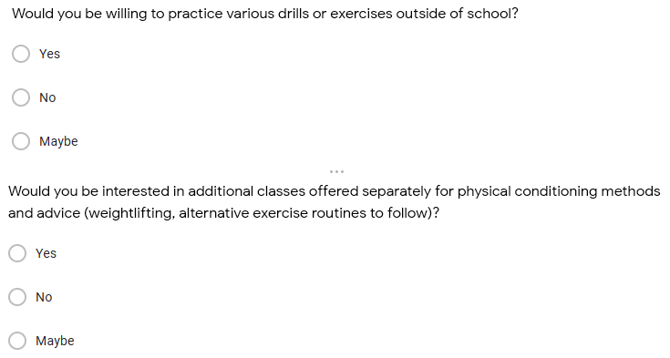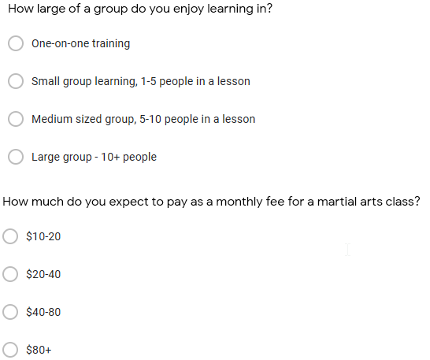

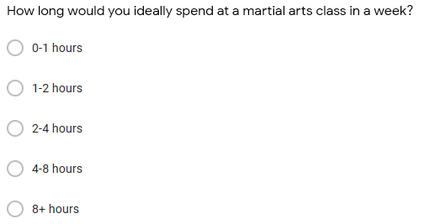

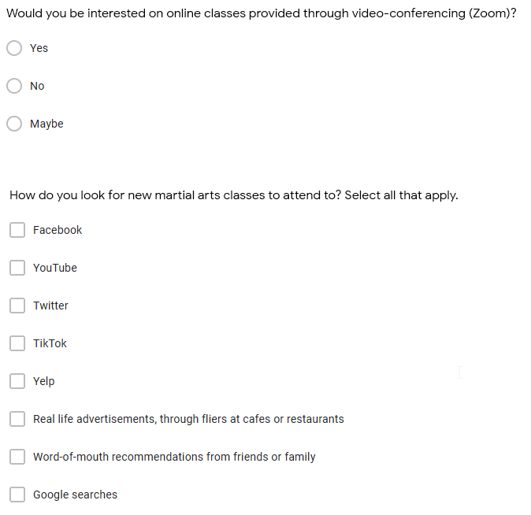

**REFERENCES**

6 Benefits of Coaching for Individuals. (2019, May 20). *Insala*. https://www.insala.com/blog/6-benefits-of-coaching-for-individuals

Badenhausen, K. (2018, December 28). The New Fight Game: How An MMA Startup Wants to Capture The Sport’s 450 Million Global Fans. *Forbes*. https://www.forbes.com/sites/kurtbadenhausen/2018/12/28/the-new-fight-game-how-an-mma-startup-wants-to-capture-the-sports-450-million-global-fans/?sh=75db281139e8

Impey, S. (2020, August 26). UFC nets higher ESPN viewership amid Covid-19 pandemic. *SportsPro*. https://www.sportspromedia.com/news/ufc-espn-ppv-viewership-mma-dana-white-coronavirus

Michigan Tech. (n.d.). *Five Ways to Improve your Site’s Rankings (SEO).* *https://www.mtu.edu/umc/services/websites/seo/*

Moody, J. (2020, August 21). How Covid-19 Is Upending Extracuricculars. *US News*. https://www.usnews.com/education/best-colleges/articles/how-coronavirus-is-upending-high-school-extracurricular-activities

Vasquez, D. (2021, February 9). Mixed martial arts strikes high in popularity. *The Poly Post*. https://thepolypost.com/sports/2021/02/08/mixed-martial-arts-strikes-high-in-popularity/