Reducing Usage of Single-Use Plastics at UBC Food Vendors

for
All owners of UBC food vendors

by
Brent Hanover
ENGL 301 Student

March 15, 2019
Contents
Introduction 3
Effect on the environment 3
Data collection 4
Data interpretation 7
Alternative methods 8
Supply Chain Management 10
Potential cost savings 11
Conclusion 12
Appendix A: Works Cited 13
Appendix B: Survey 15

Introduction

Of the 9.2 billion tons of plastic produced since 1950, more than 6.9 billion tons of it has become waste. Of that waste, 6.3 billion tons of it has never been recycled (Parker, Plastic or Planet?, 2018). Of all of that plastic produced, 50% of it is single-use: intended to be used once and discarded (Plastic Oceans International, 2018). Because of the massive amount of plastic intended for single use that is not recycled, the oceans are being polluted, CO₂ levels are at an all-time high, and massive amounts of energy produced by non-renewable resources are being wasted. In order to combat this crisis, it is imperative that worldwide plastic dependency is reduced, which can should be started on a local scale.
This report intends to outline how much plastic waste is produced by UBC food vendors and illustrate methods of plastic waste reduction. This will be done by conducting surveys to see what the average food vendor at UBC uses for food packaging. Out of the 43 UBC food vendors, 5 will be surveyed to see what single use plastics are used daily. Recommendations for replacements can then be made that will strive to maximize three criterions: eco-friendliness, reusability, and cost-effectiveness.

Effect on the environment

There is an approximately units by weight of CO₂ produced for every unit of plastic produced (Blue, 2018). Because 300 million tons of plastic are produced each year, and single-use plastic accounts for 50% of all plastic produced, single-use plastic produces 450 million tons of CO₂ each year (Plastic Oceans International, 2018). Compared to the 76 billion tons of CO₂ produced yearly, we can conclusively say that single-use plastic produces about .6% of all global CO₂ emissions (The Associated Press, 2012).
It’s not just CO₂ that is polluting the earth; the plastic itself is polluting our land and oceans. This is massively detrimental to marine life, killing seabirds, fish, and turtles indiscriminately by starving them to death after ingesting pieces of plastic or restricting their growth by wrapping around them. It is estimated that 90% of all seabird have plastic in their stomachs (Parker, Nearly Every Seabird on Earth Is Eating Plastic, 2015). This is affecting humans as well, because fish are ingesting plastic, we are ending up with these pieces of plastics inside of us (Bharanidharan, 2018). Humans are also drinking plastic because 80% of water samples over 5 continents have been shown to be containing microplastics (Virgin Unite, 2018).
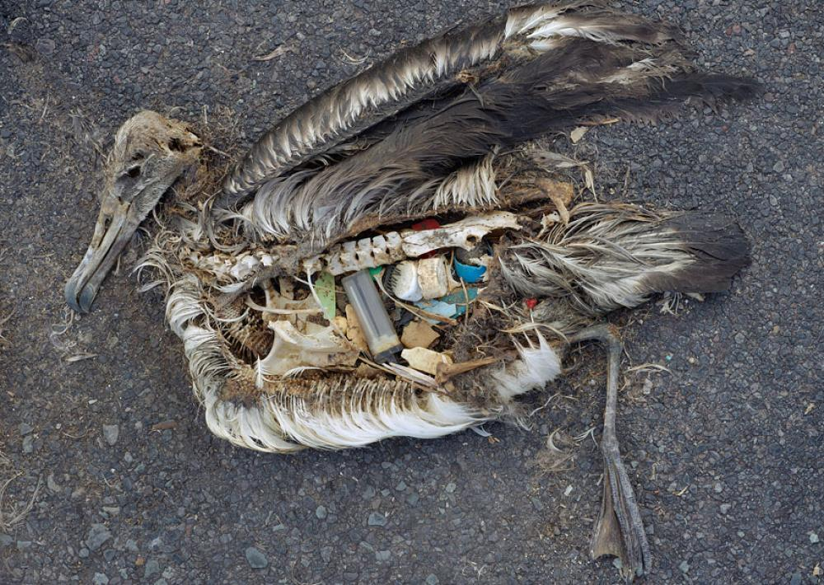
Figure 1: Dead albatross found with plastic in its stomach
In addition to plastics polluting the earth, they also require a massive amount of energy and both renewable and non-renewable resources, which is an unsustainable practice. About 22 gallons of water is required to make one pound of plastic, so about close to 2.5 quadrillion litres of water has been used just to manufacture single-use plastics since 1950 – enough water for supply every Canadian for over 650 years (Parker, Plastic or Planet?, 2018) (Grace Communication Foundation, 2017). 1.4% of America’s total petroleum consumption and .9% of their total energy consumption goes to making single-use plastics.

Data collection

Data will be collected by survey; see appendix XXXXX for the survey. Food vendors will be asked to show all of their single-use food packaging, including but not limited to plates, cups, cutlery, straws, bowls, and takeout containers. Each piece of food packaging will then be researched to find an approximate cost, and will be rated by cost, eco-friendliness, and reusability, recyclability and biodegradability. Daily and yearly usage can be approximated, and from these approximations we can glean the total single-use food packaging materials used at a food vendor per year.
Data interpretation:
- Plastic non-recyclable – plastic items without a recyclable symbol on them
- Plastic recyclable – plastic items with a recyclable symbol on them
- Plastic reusable – plastic items intended for multiple uses
- Biodegradable – items made of paper, wood, bamboo, avocado, etc
- N/A – food vendor does not offer this product
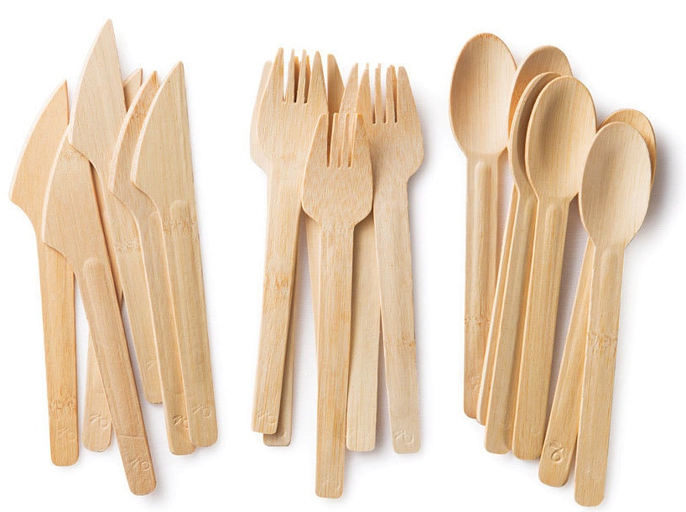
Figure 2: Bamboo cutlery used at Pacific Poke
Agora café used the least amount of plastic at zero pieces; all of their disposable items are biodegradable. They also offer incentives for people to bring reusable containers and cups – they offer a $.25 discount if you bring your own cup or mug, and they charge a $2.50 “green fee” for takeout containers.

Table 1: Data acquired on single use food items at Agora Cafe
Agora Café | Straws | Hot cups | Cold cups | Cutlery | Chopsticks | Plates | Bowls | Food bags | Ramekins | Takeout boxes | Takeout bags
Plastic non-recyclable
Plastic recyclable
Plastic reusable
Biodegradable |  | X | X | X |  |  | X | X |  | X
N/A | X |  |  |  | X | X |  |  | X |  | X

Pacific Poke is progressive in that they use bamboo chopsticks and cutlery, but all of their takeout containers are plastic and all of their dishes are served in them.
Table 2: Data acquired on single use food items at Pacific Poke
Pacific Poké | Straws | Hot cups | Cold cups | Cutlery | Chopsticks | Plates | Bowls | Food bags | Ramekins | Takeout boxes | Takeout bags
Plastic non-recyclable
Plastic recyclable |  |  |  |  |  |  | X |  | X | X
Plastic reusable
Biodegradable |  |  |  | X | X
N/A | X | X | X |  |  | X |  | X |  |  | X

Starbucks uses some eco-friendly materials for their cups and stir sticks, but a lot of their food is wrapped in plastic, and all of their cold drink cups and straws are plastic. Even worse is that they instituted a new no-straw policy which is not only being followed, but their solution of a straw/lid hybrid actually uses more plastic than usual.
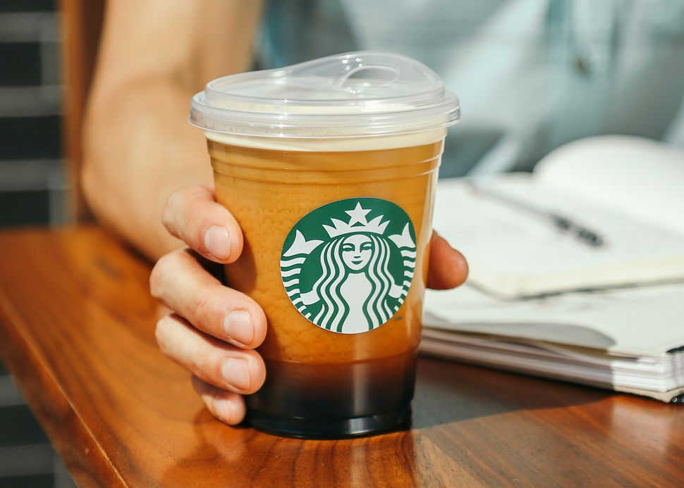
Figure 3: Starbucks' strawless lid that actually features more plastic than a standard lid and straw

Table 3: Data acquired on single use food items at Starbucks
Starbucks | Straws | Hot cups | Cold cups | Cutlery | Chopsticks | Plates | Bowls | Food bags | Ramekins | Takeout boxes | Takeout bags
Plastic non-recyclable | X |  |  | X |  |  |  |  |  |  | X
Plastic recyclable |  | X | X |  |  |  |  |  | X
Plastic reusable
Biodegradable |  | X |  | X |  |  |  | X
N/A |  |  |  |  | X | X | X |  |  | X

It was disappointing to see Ike’s café using plastic containers to house their food because they used to serve chicken and pasta in biodegradable containers. They recently removed plastic cutlery and straws from their facility but have taken a step backwards with their takeout containers, which in general are the largest single-use plastics at restaurants.

Table 4: Data acquired on single use food items at Ike's Cafe
Ike’s Café | Straws | Hot cups | Cold cups | Cutlery | Chopsticks | Plates | Bowls | Food bags | Ramekins | Takeout boxes | Takeout bags
Plastic non-recyclable | X
Plastic recyclable |  |  |  |  |  |  |  |  | X | X
Plastic reusable
Biodegradable |  | X |  | X |  |  |  | X
N/A |  |  | X |  | X | X | X |  |  |  | X

The worst offender is Bento Sushi, which uses plastic takeout containers, plastic ramekins, plastic soup cups, they wrap their bamboo chopsticks in plastic, and the takeout is served in a plastic bag.

Table 5: Data acquired on single use food items at Bento Sushi
Bento Sushi | Straws | Hot cups | Cold cups | Cutlery | Chopsticks | Plates | Bowls | Food bags | Ramekins | Takeout boxes | Takeout bags
Plastic non-recyclable |  |  |  | X | X |  |  |  |  |  | X
Plastic recyclable |  |  |  |  |  |  | X |  | X | X
Plastic reusable
Biodegradable |  |  |  |  | X
N/A | X | X | X |  |  | X |  | X

Data interpretation

A study from Carnegie-Mellon University found that an average of 20.1 patrons visited a café per hour. For this report, 20 patrons per hour will be used for calculating yearly usage of disposable products (Bondigas, 2018).
Table six was calculated using this piece of data. Then, the percentages of patrons using each product was estimated. For example, the 2 for Bento Sushi’s ramekin usage means that each patron uses an average of two ramekins per order. If an item has a 0, that means that it is not a plastic item and so is not considered. The data in table seven shows the weight per plastic item, and the number in each column under the respective food vendors shows total yearly plastic usage per item in kilograms. The total plastic usage in kilograms is summarized in table eight.
Table 6: Estimated patrons per year and estimated usage per patron
 | Bento Sushi | Ike's café | Pacific Poke | Agora café
Hours opened/week | 60 | 84.5 | 45 | 27.5
Yearly hours open minus stats | 3000 | 4225 | 2250 | 1375
Yearly patrons | 60000 | 84500 | 45000 | 27500
Straws | 0 | 0.2 | 0 | 0
Hot cups | 0 | 0 | 0 | 0
Cold cups | 0 | 0 | 0 | 0
Cutlery | 0.2 | 0 | 0 | 0
Chopsticks | 1 | 0 | 0.8 | 0
Plates | 0 | 0 | 0 | 0
Bowls | 0.5 | 0.2 | 0 | 0
Food bags | 0 | 0 | 0 | 0
Ramekins | 2 | 0.5 | 0.5 | 0
Takeout boxes | 2 | 0.5 | 1 | 0
Takeout bags | 1 | 0 | 0 | 0

Table 7: Plastic weight per item and total yearly plastic consumption per food vendor
 | Plastic weight [kg] | Bento Sushi | Ike's café | Pacific Poke | Agora café
Straws | 0.002 | 0 | 33.8 | 0 | 0
Hot cups | 0 | 0 | 0 | 0 | 0
Cold cups | 0.03 | 0 | 0 | 0 | 0
Cutlery | 0.08 | 960 | 0 | 0 | 0
Chopsticks | 0.001 | 60 | 0 | 36 | 0
Plates | 0 | 0 | 0 | 0 | 0
Bowls | 0.025 | 750 | 422.5 | 0 | 0
Food bags | 0 | 0 | 0 | 0 | 0
Ramekins | 0.004 | 480 | 169 | 90 | 0
Takeout boxes | 0.055 | 6600 | 2323.75 | 2475 | 0
Takeout bags | 0.001 | 60 | 0 | 0 | 0

Table 8: Total yearly plastic usage per food vendor
Bento Sushi | Ike's café | Pacific Poke | Agora café
8910 | 2949.05 | 2601 | 0

It is obvious that UBC food vendors are producing thousands of kilograms of plastic waste, and if global percentages can be assumed, 90% of this plastic will not be properly recycled (Parker, Plastic or Planet?, 2018). Even if UBC is much better at recycling than other places in the world, it is naïve to think that there are not significant quantities of plastic ending up in landfills.

Alternative methods

Alternative solutions to single-use plastics is imperatives because the need for these products will not simply disappear if they are banned. Recyclable materials should be considered as an absolute minimum, but compostable would be much preferred as they break down naturally. Recycling plastic containers can work, but the reality is that over 90% of plastic waste is not recycled (Parker, Plastic or Planet?, 2018). Even if they are recycled, our recycling technology is not good enough to boast anywhere even close to 100% efficiency. The best and only truly viable solution is to implement reusable products. Restaurants should have reusable options just like how most grocery stores are offering reusable bags.
Recyclable alternatives are a step in the right direction from non-recyclable materials like Styrofoam, but there are much better options. Biodegradable containers break down naturally and do not significantly harm animals that ingest them. Even if they were dumped into the ocean, they would eventually break apart, biodegrade, and be incorporated back into the earth. There are two main types of biodegradable containers: paper and compostable. Paper products can be made from recycled materials, but have a worse impact in production because significant amounts of CO₂are produced when making paper products, and the chemicals needed to make them impose significant damages to the environment (Spec's Waste Committee, 2014). Compostable products can be made from a variety of materials like plants, starch-based materials, bagasse, or microbial source materials. These have the least environmental impact of any material, but they unfortunately cost the most. It is hopeful that the cost of these products will be substantially reduced in the future so companies will be able to save money while simultaneously protecting nature.
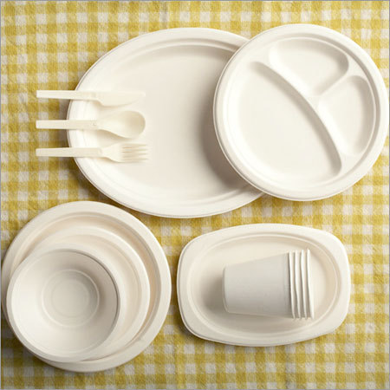
Figure 4: Compostable plates, bowls, cups, and cutlery all made from bagasse
The best alternative to using single-use plastics is to use none at all. This produces the least amount of CO₂, pollutes the least, and dumps the least amount of waste into the oceans. One issue with reusability is feasibility and availability. If UBC instituted standardized, reusable containers to be used at all food vendors, the cost, waste, and pollution would drop considerably. UBC could implement a deposit system where the customer pays an extra dollar or so when they buy food for takeout, but would get that money back when they return the takeout container. Restaurants where the food is intended to be eaten in-house should all have all products in reusable containers.
With reusable containers, it is important to note that if a reusable container is only used once or twice, it is generally worse than using a single-use container because the reusable container is made from heavier materials in order to last longer. The Costco or Ikea bags are a good example of this; each bag takes probably 50 times the plastic to make compared to a standard plastic grocery bag, so the bag must be repeatedly used to be considered environmentally friendly. Plastic may actually be a better option in some cases because it is substantially more durable than cardboard and can last for many more uses than a paper or cardboard substitute (Carbon Commentary, 2010). Alternatively, the material may not necessarily be better just because it is biodegradable. Compostable materials, unlike paper, require oxygen to break down and so cannot biodegrade when they are buried in landfills.
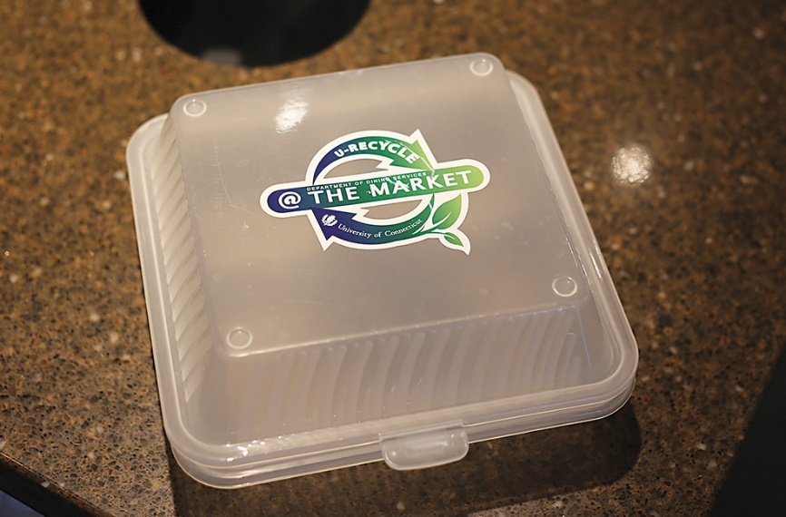
Figure 5: Discounts are available at the University of Connecticut if the customer brings back these reusable takeout containers

Supply Chain Management

Small businesses often suffer from poor supply chain management as they are not a large enough purchaser to merit discounts for high volumes of products. Larger corporations like McDonald’s or Starbucks have corporate offices with procurement engineers that can source the best products at the lowest prices instead of simply picking products off of a website. For this reason, only the four local food vendors will be considered when discussing supply chain management because it is assumed that Starbucks already has the lowest costs available.
No product is every set at a fixed price. If a company is going to be purchasing quantities of a product in the thousands or tens of thousands per year, the cost can be negotiated to a lower one. If UBC standardizes all of their single-use food items, they can be made available to each food vendor at a lower cost. UBC will be able to provide them with not only lower cost single-use items, but they will be able to provide better compostable materials.
Proof of this can be seen in the price comparisons for takeout containers. Discounts of 5-10% can be seen for website customers on takeout containers when larger quantities are ordered (Supply Box, 2019). With the help of a procurement engineer, those prices could be negotiated down even further. Alternatively, for cardboard products, the Great Little Box Company offers their best discounts on orders of 50 000ft² of cardboard. Small orders can be on the magnitude of double, triple, or even five times the most heavily discounted price.

Potential cost savings

For cost savings this paper will focus on takeout containers as they are the majority of plastic waste at food vendors, and they have the largest cost associated with them. There are a few main materials used for takeout containers: Styrofoam, single-use plastic, reusable plastic, and single-use paper. It is an unfortunate reality that a better compostable material is not currently available on the market for a feasible price. In table nine, it is shown that the cheapest option is Styrofoam by far, with single-use plastic and paper being about the same in second place, and reusable plastic being the most expensive. Reusable plastic differs from single-use plastic because it is made from thicker material to provide better durability.
Table 9: Comparison of costs of equal sized takeout containers made from different materials
Container material | Box quantity | Box price | Unit price | Citation
Styrofoam | 150 | 18.95 | 0.1263333 | (Supply Box, 2019)
Single-use plastic | 200 | 62.95 | 0.31475 | (Supply Box, 2019)
Reusable plastic | 150 | 58.99 | 0.3932667 | (Supply Box, 2019)
Single-use paper | 200 | 59.99 | 0.29995 | (Supply Box, 2019)

If single-use paper containers are in the same price range as single-use plastic, there is no reason to be using a non-compostable material.
It is unfortunate that while UBC does not allow food vendors to have non-recyclable food packaging items, other places at UBC and around Vancouver do. It is easy to see why, non-recyclable containers, mainly Styrofoam, are significantly cheaper than recyclable or biodegradable alternatives. A 500 count box of 16oz Styrofoam soup cups costs $41.99 while the half the number of biodegradable cups in the same size costs $92.99 (Supply Box, 2019) (Supply Box, 2019). The city of Vancouver should follow in the steps of UBC banning non-recyclable materials and disallow the purchase and use of these materials in the entire city. That would be a step in the right direction to minimizing our reliance on plastic materials.
The clearest choice is to institute reusable plastic containers. The cost savings for supply chain management solutions are nothing to scoff at, but every single additional use that a reusable container gets drops the cost when compared to a single-use container. A reusable container only has to be used twice in order to be cheaper than a recyclable single-use plastic container or a biodegradable single-use paper container, and it only has to be used four times in order to be cheaper than a non-recyclable Styrofoam container.

Conclusion
Because of the massively negative environmental effects that single-use plastics have on the environment, it is essential to investigate alternative materials to implement at food vendors. UBC vendors use a variety of single-use food items that are both recyclable and compostable, but very few of them utilize reusable ones. It may seem counter-intuitive to implement thicker plastic containers at food vendors, but these reusable containers have found to be not only cheaper, but generate less CO₂, require less energy to produce, and overall have a lower negative environmental impact after being used only four times. Implementing standardized plastic takeout containers across UBC campus will reduce the negative environmental impact that UBC food vendors have and could establish a model for other universities and cities to copy.

Appendix A: Works Cited
Bharanidharan, S. (2018, October 23). Tiny Plastic Pieces Are Finding Their Way To Your Stomach, Study Finds. Retrieved from Medical Daily: https://www.medicaldaily.com/tiny-plastic-pieces-are-finding-their-way-your-stomach-study-finds-428191
Blue, M.-L. (2018, June 11). What Is the Carbon Footprint of a Plastic Bottle? Retrieved from Sciencing: https://sciencing.com/carbon-footprint-plastic-bottle-12307187.html
Bondigas, A. (2018, April 5). The Average Number of Patrons for a Coffee Shop. Retrieved from azcentral: https://yourbusiness.azcentral.com/average-number-patrons-coffee-shop-26736.html
Carbon Commentary. (2010, March 31). Plastic v cardboard: which is greener? Retrieved from The Guardian: https://www.theguardian.com/environment/2010/mar/31/plastics-cardboard
Grace Communication Foundation. (2017, July 1). The Hidden Water in Everyday Products. Retrieved from Water Footprint Calculator: https://www.watercalculator.org/water-use/the-hidden-water-in-everyday-products/
Parker, L. (2015, September 2). Nearly Every Seabird on Earth Is Eating Plastic. Retrieved from National Geographic: https://news.nationalgeographic.com/2015/09/15092-plastic-seabirds-albatross-australia/
Parker, L. (2018, June). Plastic or Planet? Retrieved from National Geographic: https://www.nationalgeographic.com/magazine/2018/06/plastic-planet-waste-pollution-trash-crisis/
Plastic Oceans International. (2018, May). The Facts. Retrieved from Plastic Oceans: https://plasticoceans.org/the-facts/
Spec's Waste Committee. (2014). Sustainable To-Go Food Containers. Vancouver: Society Promoting Environmental Conservation. Retrieved from http://www.spec.bc.ca/Resources/Documents/Waste/G2G/Green%202%20Go%20Report%20FINALFINAL.pdf
Supply Box. (2019). Dart - 16MJ32 - 16 Oz Foam Soup Container, White - 500/Case. Retrieved from Supply Box: https://supplybox.ca/take-out-food-containers/plastic-foam-soup-containers/dart-foam-soup-bowls-and-lids/foam-soup-containers/dart-16mj32-16-oz-foam-soup-container-white-500-case/
Supply Box. (2019). Genpak Harvest Fiber - HF240 - 8" x 7.8" x 2.5" - Compostable Medium Hinged Container - 200/Case. Retrieved from Supply Box: https://supplybox.ca/take-out-food-containers/eco-friendly-hinged-containers/genpak-harvest-fiber-hf240-8-x-7-8-x-2-5-compostable-medium-hinged-container-200-case/
Supply Box. (2019). Maple Leaf - L924 - 24 oz Microwaveable Black Rectangular Container Base + Clear Lid - 150 Sets. Retrieved from Supply Box: https://supplybox.ca/disposables/take-out-food-containers/plastic-microwavable-containers/maple-leaf-l924-24-oz-microwaveable-black-rectangular-container-base-clear-lid-150-sets/
Supply Box. (2019). Pactiv YHLW-0901 - Foam Hinged Container - 150/case. Retrieved from Supply Box: https://supplybox.ca/take-out-food-containers/foam-hinged-take-out-containers/pactiv-yhlw-0901-foam-hinged-container-150-case/
Supply Box. (2019). Placon - CS32 - Crystal Seal 32 oz Clear Hinged Container - 200/Case. Retrieved from Supply Box: https://supplybox.ca/take-out-food-containers/deli-containers/hinged-deli-containers/placon-cs32-crystal-seal-32-oz-clear-hinged-container-200-case/
Supply Box. (2019). Solo - KHB16A-2050 - 16 oz White Paper Soup Container + Vented Lids Combo - Plain (white) - 250 Sets. Retrieved from Supply Box: https://supplybox.ca/take-out-food-containers/paper-soup-containers/solo-khb16a-2050-16-oz-white-paper-soup-container-vented-lids-combo-plain-white-250-sets/
The Associated Press. (2012, December 2). Carbon dioxide emissions rise to 2.4 million pounds per second. Retrieved from CBS News: https://www.cbsnews.com/news/carbon-dioxide-emissions-rise-to-24-million-pounds-per-second/
Virgin Unite. (2018, November). Marine Plastic Pollution. Retrieved from Ocean Unite: https://www.oceanunite.org/issues/marine-plastic-pollution/

Appendix B: Survey

Single-use plastic usage for UBC food vendor _________________

Hi, I am an undergraduate student at UBC tasked with a technical writing project. This survey is intended to collect data for a report that aims to reduce plastic waste at UBC food vendors. The report will be addressed to all owners of UBC food vendors on UBC campus. The data from this survey will provide me with the amount of plastic waste that each vendor produces per year so I can suggest alternatives that will reduce that amount. This survey contains tabular values to fill out based on what kind of plastic disposable items are used. Your response is voluntary and personally anonymous, but your answers will be linked to the food vendor you represent. Thank you for taking the time to take this survey.

Takeout containers
- Material: ________________
- Recyclability: ________________
- Cost: ________________

Cutlery
- Material: ________________
- Recyclability: ________________
- Cost: ________________

Cups
- Material: ________________
- Recyclability: ________________
- Cost: ________________

Straws
- Material: ________________
- Recyclability: ________________
- Cost: ________________

Plates/bowls
- Material: ________________
- Recyclability: ________________
- Cost: ________________

Other
- Type: ________________
- Material: ________________
- Recyclability: ________________
- Cost: ________________

