Culture Jam Assignment

By: Brooke Manchester

GRS J 300

Walmart Original Add:

[](http://corporate.walmart.com/)

<http://corporate.walmart.com/>

Written Analysis:

This is the original ad from Walmart. It implies that by shopping at Walmart you will have a better life. However, what is a better life? And how do you attain that? This ad raises many questions in my mind, such as, where does Walmart buy their food from? And who is producing this food for such cheap prices? And Who is being exploited so that we can shop for cheaper products? Walmart introduced an advertising campaign entitled "The Real Walmart." This campaign was targeted at people in all walks of life. The slogan for the campaign was "Save money. Live better." Walmart attempted to show how well they treat their employees and value them as customers of this superstore. “We have wanted to do this for a long time, because we know that people trust Walmart even more when they understand the opportunities we provide our associates, who are the customers that shop with us and how we deliver low prices,” said Bill Simon, president and CEO of Walmart U.S. “Every month more than 60 percent of Americans shop at Walmart and we are proud to help them save money on what they want and need to build better lives for themselves and their families.” (Walmart Launches National Advertising Campaign to show "The Real Walmart", 2017)

Walmart customers are able to invest in themselves and their families in real and meaningful ways with the money they save by shopping there. They can use this money to build their children's education fund or invest in braces. Walmart customers are economically and ethnically diverse coming from every walk of life and every occupation. Walmart provides these customers with more shopping choices than ever before and helps them save money and balance their budgets (Walmart Launches National Advertising Campaign to show "The Real Walmart", 2017). With my jamming I will be addressing the problems inherent in the Walmart slogan itself and how Walmart is appealing to customers in First World countries while exploiting people in third world countries.

Jammed up Version of Walmart Add:

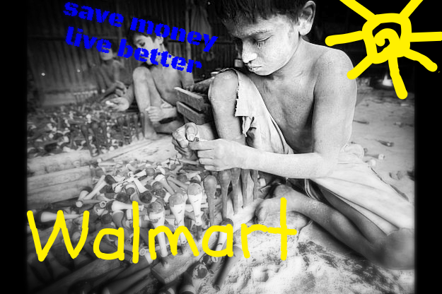

Jamming Philosophy:

Walmart is a multinational company that has been charged with engaging in illegal and unethical behavior. They use bargaining power and market control to pressure countries to condone environmental degradation and violation of National Labor Laws. Overseas the company has been entangled in a series of scandals including multiple cases of bribery. Walmart has been connected to the deaths and injuries of hundreds of people in workplace accidents in countries where low-skills and low-wage marketing predominates. While Walmart exploits people in other countries their CEO Mike Duke got a 14% pay raise in 2012 (making his wage 20.7 millions) while they pay their workers in foreign countries 37.00 a month (Sethi, 2013).

I attempted to show with my add the destruction that Walmart is having on people around the world. Walmart advertises to people that they will save money on their products and in turn live better, but at what expense? Walmart sells food and clothes and many other products much cheaper than other businesses can afford to sell them. This makes it a very desirable place to shop, however, when many of us shop there we don't think about the effects we are having on the third world and the suffering that we are causing. Our consumerism and need for cheap products is destroying families and the environment in other countries. The National Labor Committee Reported in 2006 that 200 children, 11 years or younger were sewing for Walmart among other companies. The children were routinely being slapped and beaten and sometimes would fall down from exhaustion after being forced to work 12-14 hour days. Sometimes they were even forced to work all night, 19-20 hour shifts for wages as low as 6 ½ cents an hour. The workers said that if they could earn 36 cents an hour they could climb out of misery and into poverty (Labour and Worklife, n.d.). I have attempted to show the hypocrisy in this advertisement in my jammed up version. It will hopefully demonstrate the destruction this giant superstore is causing in the world and make people aware what the human cost of these low prices are.

# Bibliography

*Labour and Worklife*. (n.d.). Retrieved from Children found sewing clothing for Walmart, Hanes & other European Countries: http://www.law.harvard.edu/programs/lwp/index.html

Sethi, S. (2013, 05 08). *The World of Walmart* . Retrieved from Carnegie Council for Ethics in International Affairs: http://www.carnegiecouncil.org/publications/ethics_online/0081

*Walmart Launches National Advertising Campaign to show "The Real Walmart"*. (2017). Retrieved from Walmart: (http://corporate.walmart.com/_news_/news-archive/2013/05/04/walmart-launches-national-advertising-campaign-to-show-the-real-walmart)