Nursing Positions and Qualifications:
RN New Grad Guarantee:
- Description: work as a nurse for an extended orientation period of 12 weeks with an guaranteed opportunity to bridge into full-time employment to meet your nursing goals faster.
- Qualifications:
  - Registration with the College of Nurses of Ontario within the last twelve months
  - Competent to perform CPR at the Basic Cardiac Life Support Level.
  - Proven ability to work in acute medicine or surgery inpatient unit
  - Successful completion of CCU 1 (or equivalent) or agreement to complete within 6 months
RN Enroute to OR – A Perioperative Sponsorship: FT/PT
- Description: Scarborough Health Network surgical program is offering a sponsorship opportunity to Registered Nurses interested in the Operating Room who are registered with the College of Nurses of Ontario (CNO). Selected candidates will attend a full-time Operating Room course. This course would include theory, 2 observation days and 5 weeks of scrubbing and circulating with a preceptor
- Qualifications:
  - Current RN Certificate of Registration from the College of Nurses of Ontario
  - Minimum 1 year of recent medical/surgical nursing experience (consideration will be given to new grads with recent clinical placement in acute care)
RN Critical Care Sponsorship: FT/PT
- Description: 11-week course in collaboration with Humber College
- Qualifications:
  - Current BCLS and ACLS (or willing to obtain within 6 months of employment)
  - 1-2 years of medical/surgical experience in an acute care setting
RN PACU and Same Day Surgery: FT/PT
- Advanced Cardiac Life Support (ACLS) plus PALS (Paediatric Advanced Life Support)
- Critical Care Course required
- 2 years recent critical care experience in an acute care setting
- Current PACU experience
- Critical care skills and concepts of Peri-operative care including cardiac monitoring, respiratory, and neurological signs
RN and RPN Medicine: FT/PT
- Asset: inpatient medicine experience
RN and RPN Emergency Department: FT/PT
- Current ACLS and PALS certification or within 6 months of hire
- Non-Violent Crisis Intervention (CPI) Certification within 6 months of hire
- Coronary Care 1 certificate or within 6 months of hire
- Minimum of (1) year of current Emergency and/or (2) years current Medical/Surgical nursing experience
RN Cath Lab: FT/PT
- Current certification in Advanced Cardiac Life Support (ACLS) and Basic Cardiac Life Support (BCLS)
- BSCN preferred
- In process of completing the Critical Care or Cardiology Certificate (coronary care 1,2&3)
- Recent Catheterization Lab experience within 2 years
- Minimum 2 years current critical care experience or equivalent
RN and RPN Mental Health
- Minimum of 2 years experience in Inpatient Mental Health or recent related clinical placement
- CPI certification or successful completion of CPI certification within 6 months of hire
RN NICU: FT/PT
- Qualifications:
  - Breastfeeding certification course
  - Current STABLE certification
  - Experience working in Neo-natal Intensive Care Level II or completed course required including mechanically ventilated infant and/or successful completion of a Certificate in Neonatology
  - Previous care experience with infants requiring mechanical ventilation
RN and RPN Family Maternity Centre (Labour and Delivery and Post-Partum): FT/PT
- Current Certificate in Neonatal Resuscitation (HSFO, NRP)
- Basic Fetal Monitoring Course
- Breastfeeding Course or recent experience in this area
- Minimum 2 years current family centered labour and delivery experience
- Minimum 1 year current experience in family centered maternal/newborn nursing
- Certificate courses in maternal/newborn care, neonatal assessment
RN Pediatrics: FT/PT
- Current Paediatric Advance Life Support Certificate (PALS) and BCLS
- Current paediatric knowledge and experience related to paediatric disease process and paediatric family-centered care (medical / surgical / mental health)
- Experience with Adult Medical Patients
Contact Information: if any questions or issues applying please email:
Rebecca Barnard RN (SHN Nursing Recruiter): rbarnard@shn.ca
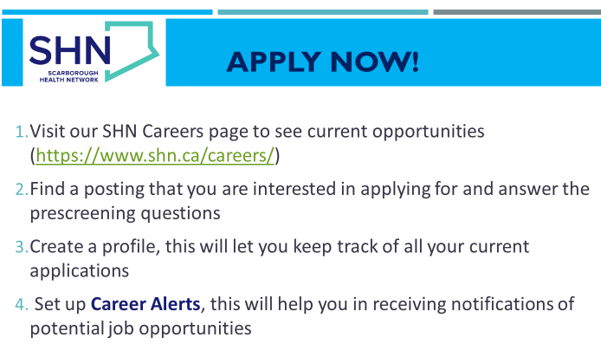
Twitter follow: @SHNCareers
Facebook Search: Scarborough Health Network
Instagram Follow:
shncareers
shncares
Stay Connected with SHN

Scarborough Health Network
- Across our three hospitals and eight satellite sites, our programs and services are designed around the needs of one of Canada’s most vibrant and diverse communities. We offer full-service emergency departments, diagnostic, surgery, rehabilitation, and geriatric care, as well as advanced birthing centres for moms, newborns, and growing families. We are leaders and partners in specialty paediatric, mental health, and oncology services.
- Our care also goes well beyond our borders. We have North America’s largest nephrology program and regional community-based cardiovascular rehabilitation service. In addition, we are the Central East LHIN designated cardiac centre and centre for spine surgery.
- We are also proud to be a community-affiliated teaching site for the University of Toronto, and a partner with a number of other universities and colleges, helping to train the next generation of health care professionals
What Makes SHN a Great Employer:
- Employee and Family Assistance Program
Confidential counselling program that is specialized to provide service to our staff and their families. This program connects staff to services such as legal advice and financial guidance. This service is offered in different languages to address the needs of our staff, nurses, physicians and midwives diverse families.
- Leadership Development, Learning Opportunities, and Tuition Assistance Program
Supports professional growth internally.
- Benefits Coverage
FT includes comprehensive medical and dental coverage and a defined pension plan through HOOPP.
- Employee and Family Assistance Program Confidential counselling program that is specialized to provide service to SHN staff and their families.
- Employee Referral Program
A bonus up to $2000 for referring individuals who get hired into specific FT/PT permanent positions.
- New Graduate Nurse Educational Opportunities
We currently offer an educational program for new nurses to grow their skills in a 12-week mentoring program.
- Staff Wellness Program
Best practice wellness programs to support your physical, psychological, spiritual, social health and well-being.
- Wellness Activities
On-unit wellness rounding activities (such as stretching and exercise breaks) and Well-Being Wednesdays – virtual sessions to empower and inspire your well-being while at
work and at home.
Nursing Resume Example
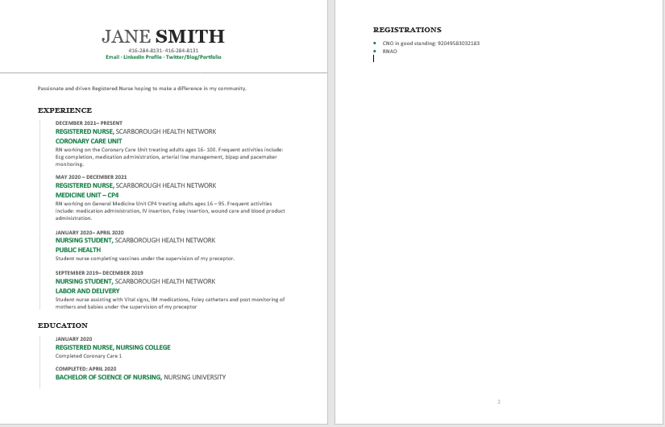
How to Prep for Interviews:
- Identify questions that they will likely ask you based on the position
- Prepare examples
- Pick a business casual outfit
- Arrange your transportation
- Arrive 5 minutes ahead of time
- Make sure to RSVP

Scenario Example:
You patient complains of chest pain, what would be included in your assessment of this patient?
- PQRST:
  - provocative (what brought it on walking, resting)
  - quality (stabbing, aching, burning),
  - region or radiation (location of the pain: jaw, chest, arm)
  - severity (out of 10)
  - timing and duration (when did it start)
- Vital signs people often forget this
- Any respiratory symptoms (SOB, use of accessory muscles)
- Any GI symptoms (nausea or vomiting)
- Reviewing patient’s history
- For RPN: Seek collaboration with the RN if the patient becomes more unstable
What interventions would you anticipate?
  - Ecg
  - Bloodwork: Trop, CK
  - Meds: ASA, Nitro, Morphine
  - Oxygen (remembering acronyms MONA- morphine, oxygen, nitro, asa)
  - Notify physician using STAR approach: situation, task, action, results (did the pain improve with nitro etc)

