How to take a photo of your artwork
(at home with your phone camera in 3 steps!)
STEP 1 – Find the best lighting and a place to lie your artwork flat.

Use natural light. Go outside. But not in direct sunlight.  Find shade on your porch, balcony or walkway if you have one. | 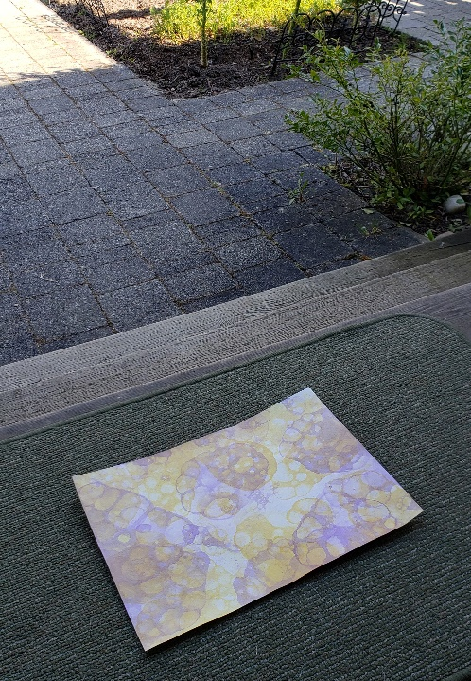
If going outside is not possible then place your artwork right by a window on a table or other surface during the day. Not in direct sunlight.
But it’s 11:55pm and dark and raining and my assignment is due!
Tips:
- Avoid casting a shadow on your artwork. Reposition any lamps as necessary.
- Tape it to a wall if possible to avoid shadows. Use masking or painters tape to avoid marking the paint on the wall.
My best advice in this scenario is to submit the best photo you can but then resubmit a better photo with good light in the morning. Your teacher will see you submitted it on time and also see the better submission in the morning in Teams.

STEP 2 – Position your phone camera directly over and centered on your artwork.
Note where the camera lens is and place that in the centre.  This is good… | 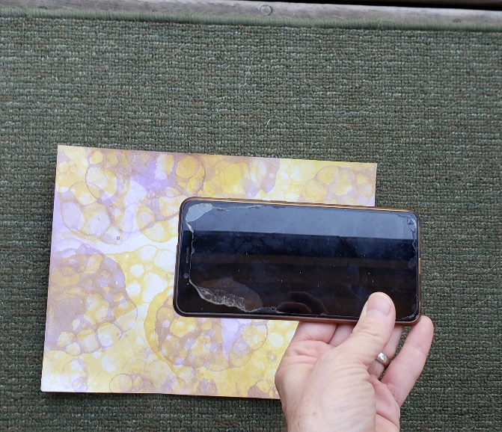
Because you get a nice squared image like this… | 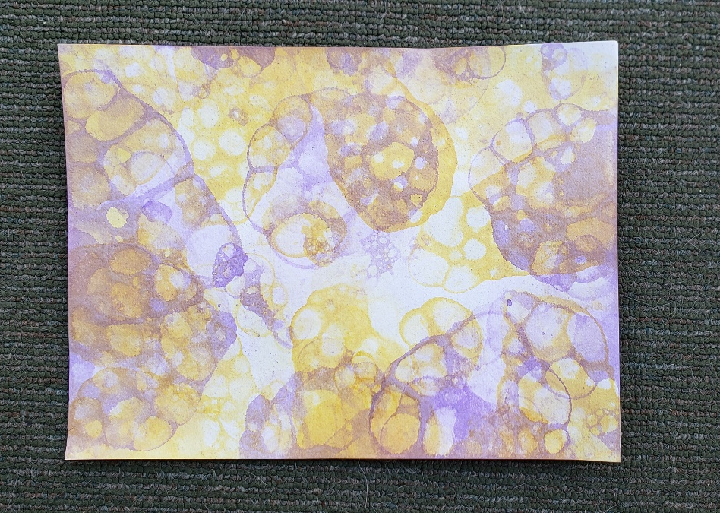
This is bad… | 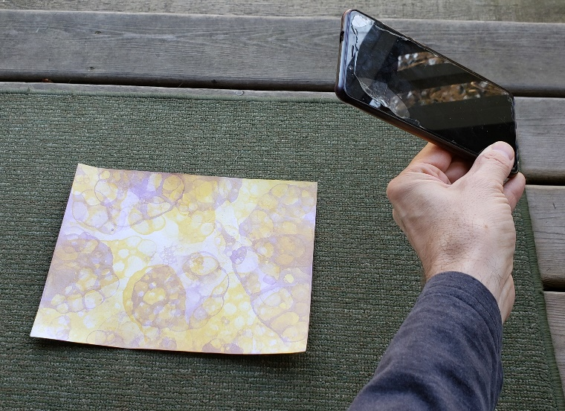
Because you get distortion like this.  The artwork is not a rectangle anymore! | 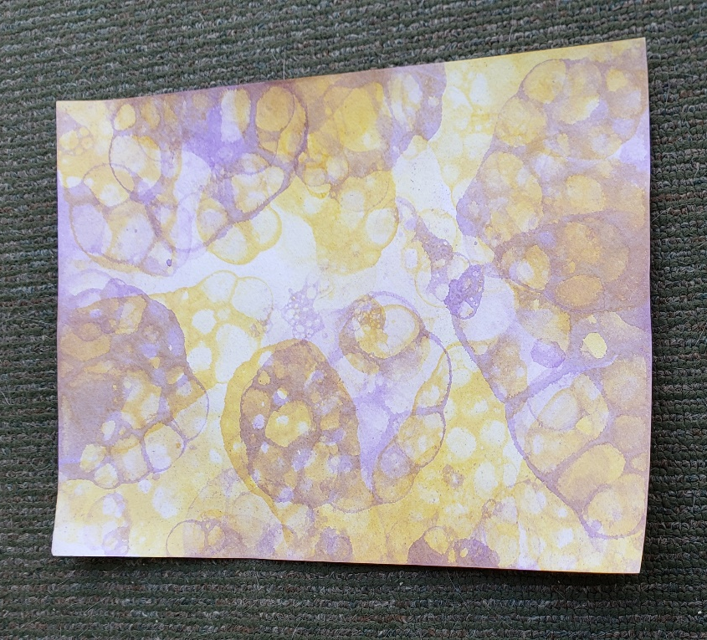
STEP 3 – Crop the photograph
Use the gallery or photo app you have on your phone to crop the photo to eliminate all borders.  There are too many options to cover them all so if you can’t find the function on your phone you may need to search for instructions for the app you are using.  The end. | 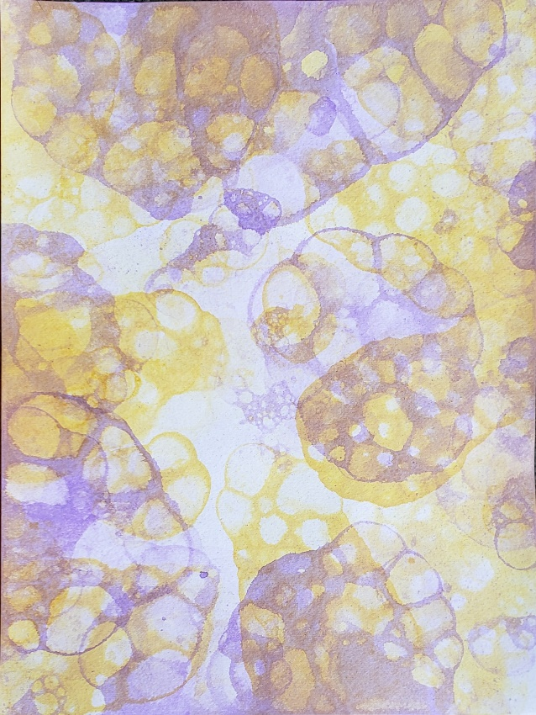

Teaching resource by Bryan Lunny 2020

