The objective of this assignment is to provide the definition of a single term in three different ways. In doing so, we will be able to reach a wider audience by presenting the definition in three levels of technicality.

Situation and audience: A professor is explaining the Prisoner's Dilemma in his Game Theory class.

Definitions

*Parenthetical Definition*

A “Prisoner’s Dilemma” is a decision analysis used in game theory.

*Sentence Definition*

Term: Prisoner’s Dilemma

Class: Game Theory

Distinguishing Features: Explanation of the thought process between two rational individuals; it is distinguished by the individuals being unable to predict one another’s choices and showing how they may not cooperate, instead pursuing their own choice of best interest, and deviating from the supposed ideal outcome.

A “Prisoner’s Dilemma” is the explanation of the thought process between two rational individuals, who are unable to predict each other’s choices. As a result, each individual picks the choice that suits their best interest, even though cooperating may seem like the most ideal outcome.

*Expanded Definition*

**What is the Prisoner’s Dilemma?**

A “Prisoner’s Dilemma” is a decision analysis involving two individuals who are unable to predict each other’s choices. It results in both individuals acting on their own best interest, even if cooperating seems like the most ideal outcome. In the dilemma, the individuals, “A” and “B”, are given the same scenario: If “A” confesses and “B” remains silent, “A” will be set free (0 years) and "B" will receive 20 years, and vice versa. However, if they both remain silent, they will both receive a 1 year, and if they both confess, they will each receive 5 years. The ideal scenario would be both parties to plead guilty and sharing a regular sentence together; however, the theory suggests that both “A” and “B” would act towards their own self-interest – each pleading not guilty, thus maximizing both of their sentences.

[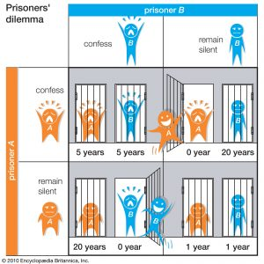](http://engl301-arts.sites.olt.ubc.ca/files/2017/09/prisoners_dilemma.jpg)

Figure 1:

A graphical representation of the prisoner’s dilemma from the Encyclopedia of Britannica, which depicts how the mutually beneficial outcome of remaining silent may not be the outcome. In the theory, each individual would pursue the best choice of interest: confessing in hopes of receiving zero years, but ultimately both receiving the sentence of 5 years.

Examples: **Points for the Final Grade**

In this example by Dr. Julien Picault, he conducts an experiment on the students in his microeconomics class. He proposes a simple game between two randomly selected students, who can either play it "safe", or play it "hard".

If both play "safe": both win 0.5 points towards their final grade.

If both play "hard": both lose 0.75 points towards their final grade.

If one plays "safe" and the other plays "hard": the one that plays "hard" wins 2 points, the other loses 1 point.

[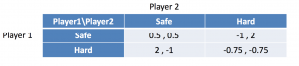](http://engl301-arts.sites.olt.ubc.ca/files/2017/09/Screen-Shot-2017-09-29-at-下午6.24.59.png)

In the ideal outcome, both students would choose "safe". However, because the students are unable to predict each other's outcomes, according to the theory, both would play "hard" and get -0.75.

References:

Picault, J. *Chapter 4: Basic Concepts in Noncoooperative Game Theory* [PowerPoint slides]. Retrieved from Lecture Notes Online Web site: https://sites.google.com/site/julienpicault/teaching/econ-386

Prisoner's Dilemma. (2009, November 19). Retrieved September 22, 2017, from http://www.investopedia.com/terms/p/prisoners-dilemma.asp

The Editors of Encyclopaedia Brittanica. “Prisoner’s Dilemma”. Encyclopaedia Brittanica. <https://media1.britannica.com/eb-media/55/91955-004-AF92CB6A.jpg>