Feasibility Analysis of Expediting FSW-inland applications

for
Sean Simon Andrew Fraser
the Minister of Immigration, Refugees and Citizenship
Ottawa, ON

by
Carol Li
Student ENGL 301

read by
Anna Li
Member of Team Li

March 16, 2022

1 Introduction
A. Background on FSW-inland applicants
Federal Skilled Worker (FSW) is a category of Express Entry, and “this program is for skilled workers with foreign work experience who want to immigrate to Canada permanently” (IRCC). Although it is foreign work experience category, many applicants are in Canada. So, we called these applicants “FSW-inland”.
Since the outbreak of COVID-19 in early 2020, the Department of Immigration, Refugees and Citizenship Canada (IRCC) has reduced staff at the office and transitioned into the mode of working from home. The shortage of financial support and staff leads to massive application backlogs and delays, especially the application of the Federal Skill Worker (FSW) category. According to data received from IRCC, Canada had a backlog of nearly 1.8 million immigration applications as of Oct. 27, 2021, including 548,195 permanent residence applications where about 49,000 FSW applicants fall under. A recent memo from IRCC indicated that the average waiting time of FSW applicants is about 20-36 months, compared to 6 months before the pandemic.
In comparison, the processing time of some categories has been speeding up, such as the Canadian Experience Class (CEC) and IRCC explains that those applicants are working in Canada so they should be prioritized. However, many applicants who fall under the category of FSW are also staying in Canada, working hard to contribute to the recovery of the Canadian economy. The situation of FSW applicants and the lengthy waiting period have significantly affected thousands of lives in Canada.

B. Purpose of this report, and Intended Audience
It is hoped that through this report, IRCC can understand the plight of applicants in the long waiting period, to adopt various means to speed up the processing of FSW-inland.
The target reader is Sean Simon Andrew Fraser, and he is the current Minister of Immigration. He is responsible for all Canadian immigration, refugee, and citizenship affairs. He has the power to make immigration policies, immigration targets, and respond to the public.

C. Method of Inquiry
My data come from IRCC official website; surveys and interviews with the applicants who are still under this painful waiting period; inquiry letters to RCICs; my own experience and observations in the past 2 years. These will show the necessity of prioritizing FSW-inland applications and better understanding the effectiveness of the proposed plan.
Secondary sources will include academic studies on the processing technologies used by IRCC and their annual financial allocation. These help to understand how much financial support IRCC needs and its feasibility.

D. Limitation of the study
The content of the questionnaire in this survey is only for applicants, and no staff were found to conduct interviews or surveys. The data of the staff's work content and workflow can only rely on the Internet, so the timeliness may not be strong.
The number of samples in this survey is not large, and the number of survey respondents is limited, which is the second limitation of this report.

E. Statement of the problem
IRCC asserted that the huge delay was resulted from the pandemic and is prioritizing those applicants who are working in Canada so the CEC applicants, vulnerable Afghans, and parents sponsorship applicants are selected and prioritized. This situation put FSW applicants who are also working in Canada into a dilemma as they feel stuck in limbo and left out. It keeps families apart, makes applicants lose jobs, and forces them to be paralyzed in their lives seeing no future. If IRCC could give attention to this fact, and reconsiders policies to solve this problem, we can help restore the credibility of government departments and enable these applicants to start a new life in Canada.

F. Scope of this inquiry (topics listed in logical order)
To assess the feasibility of the proposed plan I intend to pursue five areas of inquiry:
- How does IRCC review immigration cases now? How many reviewing stages are there in the proceedings?
- What is the average time for IRCC staff to review cases?
- How long will the applicants need to wait to get responses from IRCC if they launch an information request?
- Regarding the current processing technologies, what needs to be improved from the viewpoint of applicants and reviewers?
- How does the delay affect the applicants? Why do they need approval desperately?

G. Conclusions of the Inquiry
Through the investigation, it is found that applicants currently wait a long time for the application result; during this period, although they took the initiative to contact IRCC in various ways, it was difficult to contact IRCC, and the waiting time for a reply was long; and the long waiting time caused negative effects on their own lives. Influence, such as finding a job, applying for university for further study, etc.

2 Collected Data
A. Surveys completed by applicants – applicant’s waiting time, needs
In order to determine the current situation of FSW-inland applicants, I sent a ten-question questionnaire, including 10 multiple choice questions. I use a social networking site to post a link to the questionnaire.
There were 45 responses in total, highlighting four themes. a. Waiting time after application; b. The convenience of contacting IRCC during the waiting period; c. The impact of longer waiting period on one's own life; d. Satisfaction with the current application system.

a. Waiting time
According to the first question: How many months has your application been processed since you received an Acknowledgement of Receipt (AOR)? (as of February 2022)
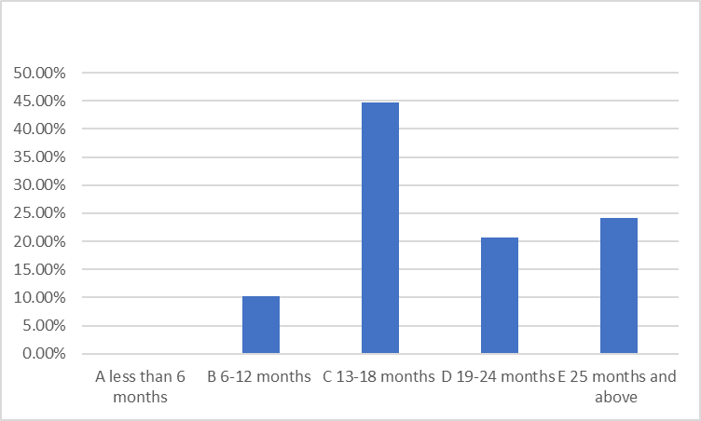

We can see that no one’s waiting period less than 6 month, and only 10% of applicants have waited for 6 - 12 months, nearly half applicants have waited for 13 – 18 months, and the rest of applicants have waited 19 – 24 months or even more than 2 years.
From the data above, it’s easy to see that most of FSW-inland applicants have waited for a long time, and this timeline is almost in sync with Covid, so we can say that since the Covid epidemic started, the FSW trial has been suspended and has not yet fully started.

b. The convenience of contacting IRCC
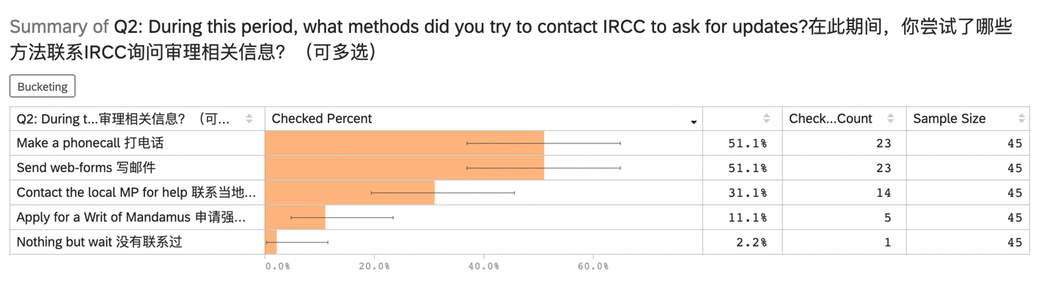
From Figure 2 we know that except for 2.2% of applicants who did not contact IRCC in any way, all other applicants tried to contact IRCC using more than one contact method. The most common methods are phone calls and emails, so we can contact questions 3-5 of the questionnaire to analyze the effectiveness of these two contact methods.
Question 3 is “When you call IRCC to inquire about the progress of your application, how many times do you dial to access it?” From the figure below we can see that nearly 50% of the applicants need to make more than 6 phone calls to be connected, and only 10.3% of the applicants can be connected in 1or 2 times phone call.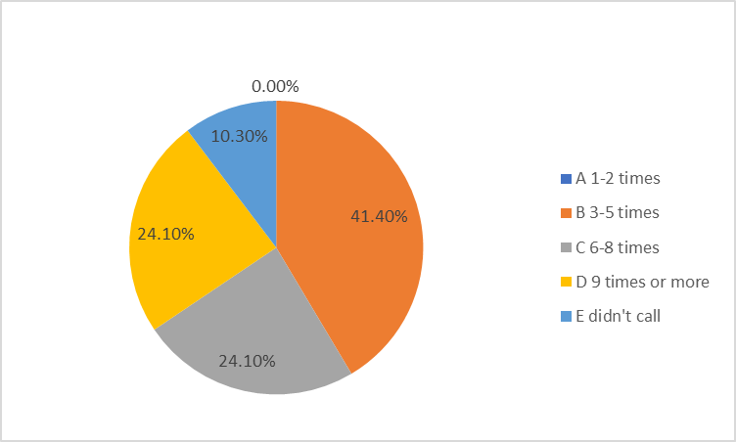
But, connected in doesn’t mean that you can talk to the operator, you need to wait someone to pick up your phone. And this waiting period we can get from the figure below. Less than 30 min has 0%, which means that’s impossible. Over 50% of applicants need to wait 30-60 min, and nearly 30% of applicants wait 60–120 min, besides there are nearly 10% of them wait more than 120 min.

From the above data and analysis, we can see that contacting IRCC is not an easy task. Applicants need to make multiple calls and wait 1-2 hours each time to ask questions about their case.

c. The impact of longer waiting period
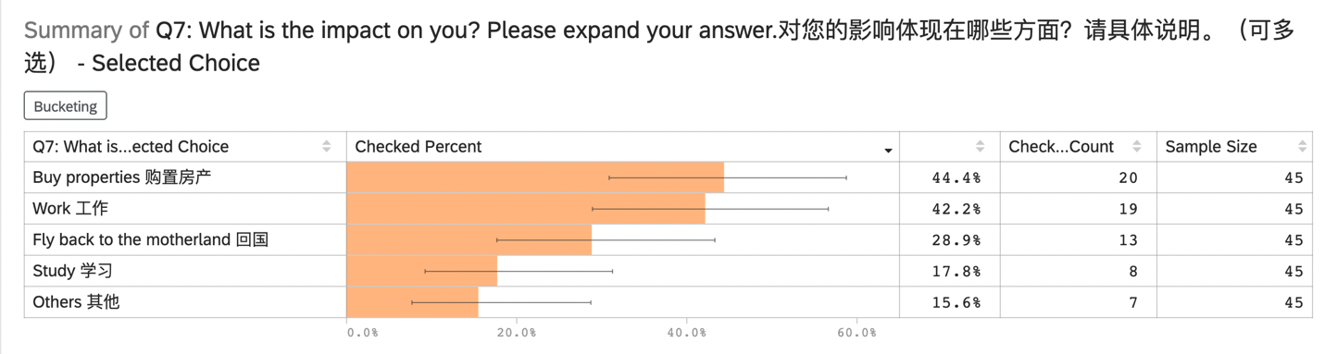
According to the 45 answers, 20 of them pointed out that the prolongation of the process of waiting for the trial has a negative impact on the purchase of real estate and settling in Canada. 19 people think that it has also made it difficult for them to find a job, and 13 people said that it makes it difficult for them to return to China. Not only that, but staying in Canada requires extending their existing visas or replacing them with new ones, which is also a concern for some applicants.

d. Satisfaction with the current application system
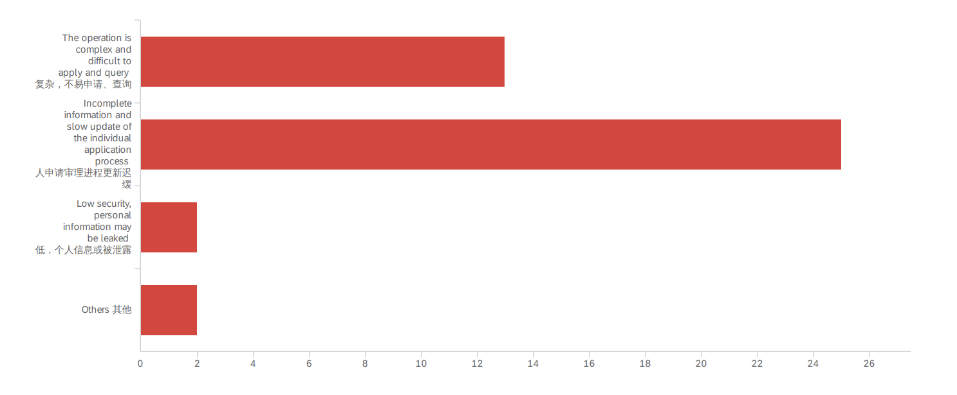
Regarding the applicant's satisfaction survey on the existing application system, it is not difficult to see that the main dissatisfaction is concentrated in “The operation is complex and difficult to apply and query” and “Incomplete information and slow update of the individual application process”, with 13 and 25 people choosing respectively.

B. Searching IRCC website – Staff’s workflow, workload
3 Conclusion
- Summary of the results from the study
- Future recommendations and additional suggestions for future studies
The huge delay can be improved by three complementary phases: (1) separating inland and outland applicants who fall under the FSW category and prioritizing inland ones, (2) necessary staffing changes and increasing employment, (3) improving outdated processing technologies.
- Separating and prioritizing FSW-inland applications. First, according to whether the applicant is in Canada or not, the applicant’s case in Canada shall be given priority, especially for the FSW-Inland applicants. The processing shall be conducted in an orderly manner, based on the time sequence of application.
- Necessary staffing changes and increasing employment. Second, adjust the focus of work and send more officers to process FSW cases. Hire more employees to work on the updates and responding to information requests;
- Improving outdated processing technologies. The processing should be more transparent and be updated more frequently. This includes:
- Improving technology and digitizing its operations;
- Providing more access for the applicants to see the process of their cases.

Work Cited
https://www.canada.ca/en/immigration-refugees-citizenship/services/immigrate-canada/express-entry/eligibility/federal-skilled-workers.html#works

可以补充：
最近历年的抽选分数，大约学历➕工作时间，预估一下在等待期的小伙伴们大致的年龄和状态。

