Feasibility Analysis of Implementing Mid-term Student Evaluations of Teaching at the University of British Columbia

for
Jessica Iverson
Academic Governance Officer
UBC Vancouver Senate
Vancouver, British Columbia

by
Catherine Yu
University of British Columbia
ENGL 301 Student

November 16, 2021

TABLE OF CONTENTS

INTRODUCTION........……...…...…………..…………..…………..……...…….……..…….1
- Background……….....…………………..…………..…………..………..……….……1
- Statement of problem....……………………..…………..………………..…...…...…....1
- Purpose of this report and intended audience...…………………..………..……..…….2
- Description of data sources……..…………....…………………..………...……..…….2
- Scope of inquiry……..…………………..…………..……………...………….………2

DATA SECTION….....…………..…………..…………..…………..………….……..………3
- Literature Review….....…………..…………..……………..………….……..………..3
  - Student evaluations of teaching.……..……………..………….……..………...3
  - Usefulness of evaluations as feedback for teaching performance.…..………....3
  - Student participation and perception on student evaluation..….……..…….…..3
  - Mid-term evaluations of teaching..……..……………..………….…….………4
- Survey Results.….........…………..…………..……………..………….……..………..5
  - Area of focus and inquiry...…………..……………..………….……..………..5
  - Current participation and perception on student evaluations.….……..………..5
  - Improving the student evaluation system.…………..………….……..………..9
- Proposed Solutions.......…………..…………..……………..………….……..……....11
  - Mid-term evaluations.……..…………..……………..………….…………….11
  - Optional mid-term evaluations...………..……………..………….…..……….12

CONCLUSION..…........………..…………..…………..…………..………….……..…….…14
- Summary and interpretation of results...………..……………..……………..……….13
- Recommendations.......…………..…………..……………..………….……..……….13

REFERENCES..….....…………..…………..…………..…………..………….……..…….…14

INTRODUCTION
A. Background
The UBC Vancouver Senate introduced the Policy on Student Evaluation of Teaching in May 2007 as a part of a larger strategy to foster quality teaching and learning at UBC. The student evaluation of teaching was developed as a student-centred experience with the ultimate goals of continuously improving the student’s learning experience and providing teachers with information on their teaching performance to further enhance the quality of their teaching.

Students are invited to complete one evaluation for every course at the end of each semester. Evaluations are centrally administered using a web-based evaluation platform. Data collected in the surveys is confidential and typically consists of an average numerical rating of an instructor’s teaching performance together with any written comments from students. Faculty members can then use student evaluations of teaching to inform and improve their teaching practice. Student evaluations of teaching are arguably the most important tool for students to provide reliable, honest feedback on their learning experience and for professors and teaching assistants to seek formative feedback on their teaching performance.

Student evaluations are an avenue for students to directly inform instructors on how their learning experiences could have been improved. However, with teaching evaluations occurring so late in the term, students are unable to benefit from any feedback or changes that could have improved the quality of their learning environment.

B. Statement of problem
Even though student evaluations are incredibly valuable for students and instructors alike, the completion rates of student evaluations at UBC have been declining in recent years. The current system of term-end evaluations is an excellent tool for instructors to receive feedback on their teaching but serves no use for students who would wish to actively improve their own learning experience and express constructive feedback that can be immediately addressed by their instructor. With the current system, students may be discouraged from completely evaluations as they are not likely to take a course with the same instructor again and their feedback no longer applies to their personal learning experience.

C. Purpose of this report and intended audience
This report aims to address the declining completion rates of student evaluations and to assess the feasibility of implementing mid-term evaluations to improve student engagement with the evaluation system. Since continuously improving the student learning experience is one of the major priorities for the UBC Vancouver Senate, the main goal of this report is to provide reasonable recommendations to help support and foster quality teaching and learning at UBC. This report is intended for Jessica Iverson, Academic Governance Officer of the UBC Vancouver Senate. As a member of the Vancouver Senate Committee, Ms. Iverson oversees the Academic Policy portfolio, including the Policy on Student Evaluations of Teaching.

D. Description of data sources
To determine the current student perspective on student evaluations and to assess the feasibility of introducing mid-term evaluations, this report considers primary sources of data which includes surveys with UBC students. An anonymous survey was presented to 20 current UBC students. Secondary sources for this report include a review of literature pertaining to the current state of student evaluations of teaching and the benefits and drawbacks of different systems of evaluations used in university settings.

E. Scope of Inquiry
This report is focused on increasing engagement with student evaluations of teaching amongst students at UBC. These findings may be applied more generally to improving student engagement in student evaluations of teaching at post-secondary institutions, although the primary sources used in this report surveys UBC students only.

DATA SECTION
A. Literature Review
a. Student evaluations of teaching
Student evaluations of teaching are used at most universities and colleges around the world to measure teaching effectiveness. Along with its extensive use in classrooms, there is a plethora of literature examining the reliability and validity of these evaluations. Student evaluations of teaching serve three basic purposes: to provide feedback to instructors for faculty and course development, to measure student engagement and learning via self-reflections, and for use in tenure, merit and promotion decisions (Kelly 4). Although these evaluations are available at most institutions, it is typically not mandatory for students to fill them out. Given that there are plenty of factors that may impact the legitimacy of student evaluations, there has been much debate as to the value and efficacy of student evaluations as a measure of teaching effectiveness.

b. Usefulness of evaluations as feedback for teaching performance
As students are typically far removed from the process of making tenure or promotion decisions, most students understand evaluations of teaching as ways to provide feedback for faculty members to improve their teaching practices. Although this is a formative use of these evaluations, professors may not actually put this feedback into practice. Several studies have found that professors feel that the student evaluations of teaching offered at their institution is too poorly designed to be implemented as feedback (Beran & Rokosh 498). In another faculty survey, it was found that less than one-third of respondents used the feedback from student evaluations to make meaningful changes to improve teaching performance (Kelly, 2012).

c. Student participation and perception of student evaluations of teaching
Many studies have found that students do not fill out student evaluations of teaching as they feel the evaluations are not valuable (Kelly 8). While examining student perceptions of evaluations, Brown (178) found that most students feel these evaluations can provide an accurate measure of teaching effectiveness, but that students do not feel that administrators take the evaluations seriously.

If students feel their feedback is not valued or that evaluations are not used to improve teaching performance, they are less likely to complete the evaluations. Studies have also found that the perception of student evaluations of teaching changes as a student progresses through university, with upper year students expressing more disinterest than lower year students (Chen & Hoshower, 72). Resultingly, participation rates tend to be higher in first-year classes (Chen & Hoshower, 72).

d. Mid-term evaluations of teaching
Most post-secondary institutions offer student evaluations of teaching at the end of the term. However, the timing of term-end evaluations may be problematic as many instructors cannot make changes for the course in which they are being evaluated (Kelly 6). Moreover, delayed evaluations may not be as accurate as students may forget specific details (McNulty et al., 213).

Research also finds that instructors who offer mid-term evaluations of teaching perform better on evaluations (Kelly 7). Mid-term feedback may improve term-end feedback as any issues or adjustments have already been addressed. However, research also shows that the offering of these evaluations may skew student perceptions regardless of teaching ability. Instructors who offer mid-term evaluations are perceived by students to be more committed to teaching and to value their students (Brown 179). This may be because students believe the instructors want students to benefit directly from changes implemented from their feedback.

Studies have also shown that students who completed evaluations earlier in the term were more likely to leave longer and more substantive comments that included significantly more issues than late evaluators (McNulty et al., 214). If the purpose of student evaluations was to better inform teaching abilities, these results suggest that the earlier the student evaluates, the more useful student comments are for faculty to make adjustments.

B. Survey Results
a. Areas of focus and objective
UBC students were surveyed to determine the current level of engagement with student evaluations of teaching and gather common perceptions on the usefulness of these evaluations. The survey asked students about their current participation habits and asked respondents to identify reasons for not participating in term-end evaluations. Students were also asked about various components of student evaluations that would improve their learning experience.

b. Current participation and perception on student evaluations
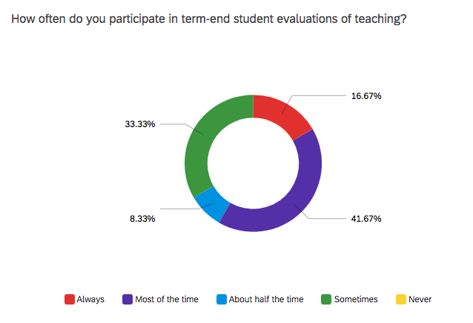
Figure 1. Current levels of participation in student evaluations

The majority of survey respondents said that they participate in term-end student evaluations at least half the time when they are offered (Figure 1). However, only 8.33% of respondents said that they always participate in student evaluations (Figure 1). When prompted about why they did not always participate in term-end evaluations, students stated that timing of evaluations is an issue as they “forget to do it because exam season is so busy” and that “evaluations do not benefit my learning as I will likely never encounter the same professor or take course again”. The current timing of student evaluations may negatively impact the completion rate of student evaluations as students become overwhelmed during exam season and completing evaluations drop to the bottom of their priority list. Students mentioned that evaluations are “time-consuming” and as a result they tend to “usually just do it if there were any positive or negative experiences in the course”.
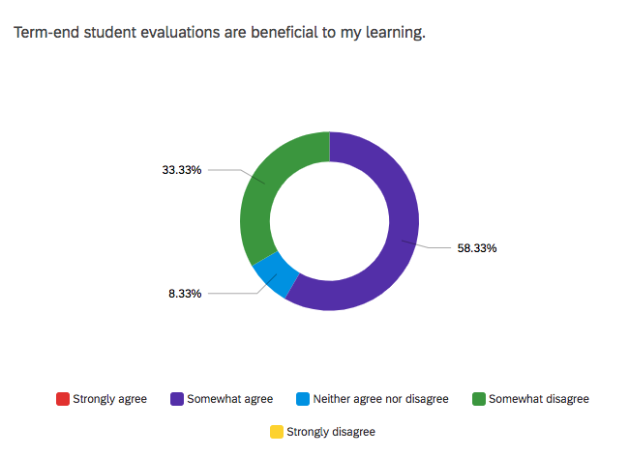
Figure 2. Current perceptions of student evaluations and usefulness for enhancing learning

According to the data, 58.33% of students somewhat agreed that term-end student evaluations were beneficial to their learning (Figure 2). None of the students strongly agreed that term-end evaluations enhanced their learning, with 33.3% of students even somewhat disagreeing that current term-end student evaluations are beneficial at all to their learning experience (Figure 2).

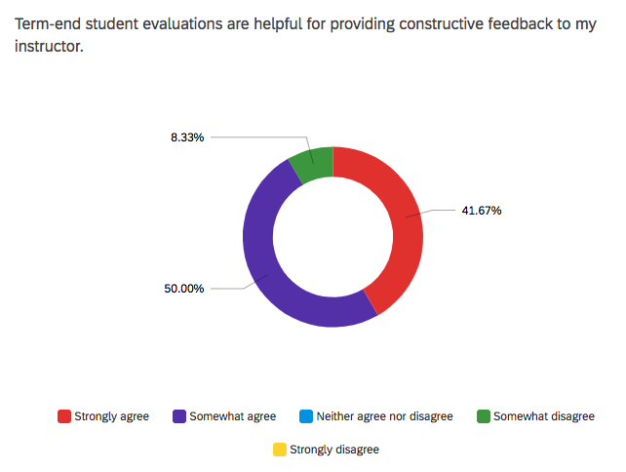
Figure 3. Current perceptions student evaluations and usefulness for providing feedback

As indicated above, most students believed term-end student evaluations are helpful for providing constructive feedback for their instructors, with 91.67% of respondents selecting somewhat agree or strongly agree (Figure 3).

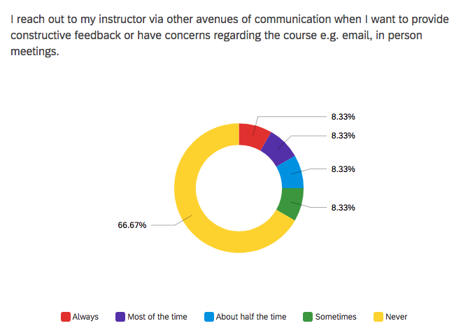
Figure 4. Percentage of students who provide feedback outside of student evaluations

The data also shows that the majority of students never reach out to instructors outside of the evaluation period (Figure 4). These results suggest that most students rely on the student evaluation system to provide feedback or express concerns to professors and teaching assistants (Figure 4).

c. Improving the student evaluation system
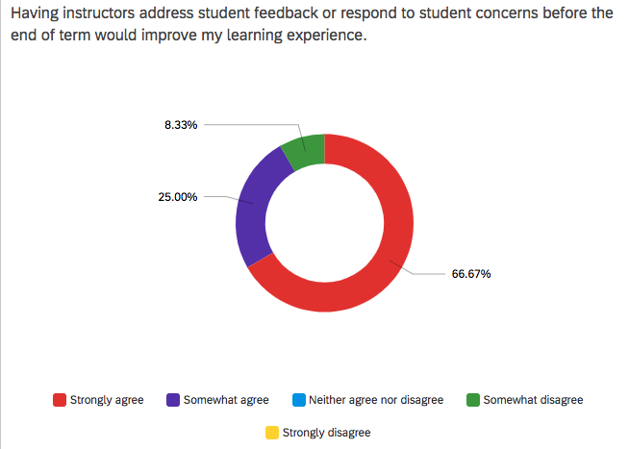
Figure 5. Preference for instructors to address student feedback

The majority of students strongly agree or somewhat agree that having instructors address student feedback or respond to student concerns before the end of term would benefit their learning experience (Figure 5). Only 8.33% of surveyed students expressed disagreement with this statement (Figure 5).
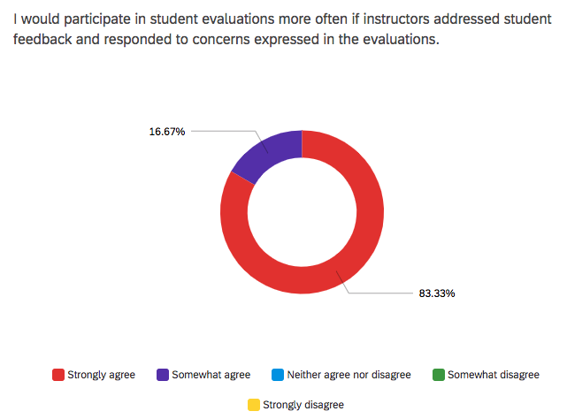
Figure 6. Effect of addressing student feedback on student likelihood to participate in student evaluations

It was also found that all of the surveyed students would participate in student evaluations of teaching more often if instructors addressed feedback or responded to concerns expressed in the evaluations (Figure 6). None of the respondents indicated that addressing student feedback before the end of term would result in lowered interest in completely evaluations or students being less likely to participate in student evaluations (Figure 6).
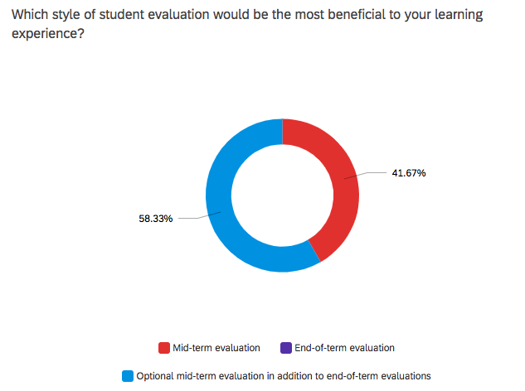
Figure 7. Preference for timing of student evaluations

According to survey results, all students elected for either mid-term evaluations or an optional mid-term evaluation in addition to end-of-term evaluations (Figure 7). The surveyed population was split quite evenly with 41.67% selecting mid-term evaluations and 58.33% selecting optional mid-term evaluations (Figure 7). None of the surveyed students felt that end-of-term evaluations were the most beneficial to their learning (Figure 7).

C. Proposed solutions
- Mid-term evaluations
Switching from a term-end model of student evaluations of teaching to a mid-term model is welcomed by students and is a feasible way of increasing student engagement with the evaluation system. Students are driven by the desire to improve their personal learning experiences and are more motivated to complete evaluations if they know professors take their feedback seriously and are willing to address comments or concerns before the end of term. From the data presented in this report, it is evident that students appreciate knowing their comments have value to curricular and faculty development (Figure 5, Figure 6). Another issue that may have negatively impacted the completion rate of student evaluations is that current student evaluations are held in the midst of the busy final exam season. Offering mid-term evaluations will allow students ample time to complete evaluations for every course and generate meaningful responses that reflect their typical learning environment rather than their experience during high-stress examination periods.

As the actual content of student evaluations of teaching were not evaluated in this report, there are no recommendations for improving the evaluation questions itself. The current survey used during term-end evaluations can still be used for mid-term evaluations. Mid-term evaluations can be administered using the same web-based platform as well. Though the initial shift to mid-term evaluations may be a big change to students and faculty alike, implementing mid-term evaluations will increase completion rates of student evaluations and improve the student learning experience in the long run.

- Optional mid-term evaluation in addition to term-end evaluations
Instead of completing switching to a mid-term evaluation system, an optional mid-term evaluation period can be implemented in addition to term-end evaluations. The majority of students surveyed in this report actually preferred an optional mid-term evaluation instead of switching over to only mid-term evaluations (Figure 7). Providing an opportunity for students to provide meaningful feedback or confidentially raise concerns about an instructors’ quality of teaching is important to ensuring the highest standard of education. An optional mid-term evaluation period will provide the necessary platform for students to leave constructive comments without wildly changing the current system. Students will have the opportunity to assess the course as a whole at the end of the term while being able to provide rich qualitative information to inform the instructor’s teaching. Since the majority of students do not reach out to instructors to provide feedback outside of evaluation periods, optional mid-term evaluations are important for students to directly communicate with faculty members outside of this time (Figure 4). Mid-term evaluations can also be administered through the same web-based platform as term-end evaluations.
CONCLUSION
Students at UBC are in need of an improved system for student evaluations of teaching. The current system of term-end evaluations does not recognize students’ comments as having value to faculty development and does not motivate students to complete evaluations of teaching for every course. As an important resource to aid student learning and inform teaching practices, inspiring more students to complete evaluations is a goal that is important for everyone.

A. Summary and overall interpretation of results
Based on data collected from students at UBC, there is a strong desire for instructors to address feedback and comments raised in student evaluations. Students feel their learning experience is more enhanced when instructors recognize the value of student comments and are more motivated to complete evaluations of teaching if faculty members are willing to address student feedback. As the university could gain from more students participating in student evaluations of teaching, the data generated in this report should be used as a resource to improve evaluation participation.

B. Recommendations
This report assessed the feasibility of introducing mid-term evaluations to increase participation in student evaluations of teaching. Switching to a mid-term evaluation system or implementing an optional mid-term evaluation in addition to term-end evaluations were both deemed to be reasonable methods to boost participation rates and enhance the student learning experience. In general, a greater focus on addressing student feedback and concerns is important to making students feel valued and engaged with the course. Whether these principles are applied at a university-level or by independent professors at their own accord, addressing student feedback is an integral part to improving student satisfaction and maximizing the learning and teaching experience for students and faculty alike.

REFERENCES

Beran, Tanya N., and Jennifer L. Rokosh. “The Consequential Validity of Student Ratings: What Do Instructors Really Think?” Alberta Journal of Educational Research, vol. 55, no. 4, University of Alberta, Faculty of Education, Winter 2009, pp. 497–511.

Brown, Michael J. “Student Perceptions of Teaching Evaluations.” Journal of Instructional Psychology, vol. 35, no. 2, George Uhlig Publisher, June 2008, pp. 177–82.

Chen, Yining, and Leon B. Hoshower. “Student Evaluation of Teaching Effectiveness: An Assessment of Student Perception and Motivation.” Assessment & Evaluation in Higher Education, vol. 28, no. 1, Jan. 2003, pp. 71–88. DOI.org (Crossref), https://doi.org/10.1080/02602930301683.

Kelly, Mary and Council of Ontario Universities. Student Evaluations of Teaching Effectiveness: Considerations for Ontario Universities. Council of Ontario Universities, 2012. Open WorldCat, https://www.deslibris.ca/ID/233682.

McNulty, John A., et al. “Are Online Student Evaluations of Faculty Influenced by the Timing of Evaluations?” Advances in Physiology Education, vol. 34, no. 4, American Physiological Society, Dec. 2010, pp. 213–16. journals.physiology.org (Atypon), https://doi.org/10.1152/advan.00079.2010.

