Cathy Liu
June 12, 2020
Revised Definition of Deindividuation
Introduction: The purpose of this assignment is to focus on writing for a specific audience. When teaching an audience new information, it is important to write in a manner that is comprehensible and efficient. If the reader is confused, then you have missed your goal. For this assignment, I intend to teach a new term in a direct fashion. The term that I have chosen to define for a non-technical audience is one that is used in social psychology: deindividuation. I will provide three types of definitions for this term: parenthetical, sentence, and expanded.
The situation: A professor explaining deindividuation to his students in a social psychology course at UBC.
Parenthetical definition: Deindividuation (a decrease in self-awareness and control in a group setting) has been observed in experiments by many social psychologists.
Sentence definition: Deindividuation is a concept explored in social psychology that examines how individuals can experience a decrease in self-awareness and control in a group setting. This phenomenon is characterized by an individual’s sudden participation in violent or antisocial actions due to a belief that they can not be held accountable for their actions.
Expanded definition:
History: Deindividuation theory was first termed in the 1950s by Leon Festinger to describe what happens when individuals experience group mentality. However, this idea was first explored much earlier by Gustave Le Bon in the 19th century where rioting was a common occurrence in France (Douglas). Le Bon believed that being a part of a crowd promoted impulsive behaviour in individuals that resulted from a decrease in self control and feeling of responsibility (Douglas). This laid the groundwork for deindividuation which American psychologist William McDougall further explored, stating that large crowds draw out emotions such as anger and fear. These basic emotions, which are experienced by everyone, are then able to transfer quickly to each individual the moment people begin to express them, causing anger or fear to be the driving factor for their actions (Douglas).
Required Condition: For deindividuation to occur, there are a couple factors that must be in place. As listed by psychologist Philip Zimbardo, along with being a part of a group or crowd, other factors include: having anonymity within the group, a decrease in feelings of responsibility, experiencing heightened physiological arousal such as feeling adrenaline, or being influenced by drugs or alcohol (Hopper).
Example: An easy and relevant example of deindividuation occurs in riots. In this large crowd, emotions of anger travel quickly throughout each individual, causing an increase in physiological stimulation such as a rush of adrenaline. Riots often happen outdoors with a group of strangers which allows for anonymity to play its role in decreasing feelings of accountability while increasing the belief of no consequences to be had. With these factors in place, individuals get caught in the midst and begin partaking in dangerous actions such as looting or damaging property.
Visual:
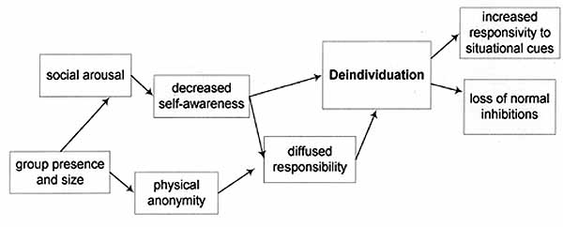
Figure 1. Demonstrates the process in which different factors lead to deindividuation (Perry).

Works Cited:
Douglas, K. M. (2019, January 4). Deindividuation. Retrieved from https://www.britannica.com/topic/deindividuation
Hopper, E. (2020, February 29). What Is Deindividuation in Psychology? Definition and Examples. Retrieved from https://www.thoughtco.com/what-is-deindividuation-in-psychology-4797893
Perry, M. (1998). Deindividuation. Retrieved from https://www.units.miamioh.edu/psybersite/fans/deindividuation.shtml

