Improving Our Practice Together

Intended Learning Experience
Design a sequence of learning activities that foster student engagement and choice in products / projects that demonstrate student learning.

Tools Used
- Web link to Gagne’s 9 events to guide design
- Post It Notes
- 11 x 17 paper

Workflow for Using the Tool(s) and Sharing It with Students
- Review course description and outcomes
- Design assignments and map them to outcomes and timeframe
- Considered texts / resources
- Considered “lecture” content and student responses
- Considered how to students could demonstrate their learning and work collaboratively
- Map activities and look for flow and variety
- Edit activities (tasks, readings, blog posts, etc.) against Gagne and other experiences with online or blended

Support for Use
I am comfortable with this process and have done a number of workshops using it.

Gagne’s nine events are as follows (http://www.icels-educators-for-learning.ca/index.php?option=com_content&view=article&id=54&Itemid=73)
- Gaining Attention
- Informing Learners of the Objective
- Stimulating Recall of Prior Learning
- Presenting the Stimulus
- Providing Learning Guidance
- Eliciting Performance
- Providing Feedback
- Assessing Performance
- Enhancing Retention and Transfer
Activities (examples of demonstration of learning options)
- Instant messaging, multiple varieties
- http://www.tiki-toki.com/
- http://www.dipity.com/
- http://www.zentation.com/
- Prezi - http://prezi.com/
- Voice Thread - http://voicethread.com/
- Camtasia - http://www.techsmith.com/camtasia.html

Example

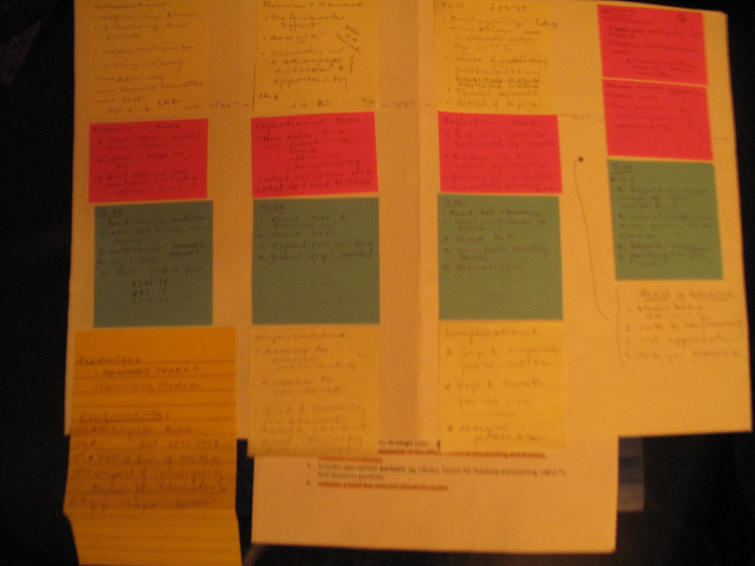

Tips
Mapping the course out to “see” repetition and variety of activities really helps with flow and interaction. It also allows for course revision based on student feedback / evaluation.

Emerging questions / ideas I have gained
How might I use new and emerging social software and tools to enhance student engagement – academic, social, and intellectual.

Your Name and the Course In Which You Used This Experience
Susan Crichton
ETEC 556

Tags / Keywords
Instructional design to encourage interaction and engagement

