A Value of a Documentation Panel to Foster Reflection

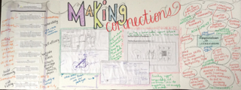

Each group is asked to create a documentation panel to record and foster reflection on their design thinking, tinkering, and making process. We view making the panel as a way of helping to make the group’s “thinking visible” (Eisner, 1998). For many of you, documentation aligns with the Reggio Emilia approach (http://ecrp.uiuc.edu/v13n2/wien.html) which views documentation as a type of design process. It suggests documenting as a visual way of capturing thinking and learning activities and inviting discussion about what is collected and how it is portrayed on the panel. This form of curating content supports the reflective practice that is so important for educators during professional development activities.

For Maker Day, we believe the panels are essential to support a group’s progress through the design thinking process: define, research, ideate, prototype, choose, implement, and learn.

While each group should be encouraged to exercise their creative license in the production of their panel, we suggest that each panel should have a minimum of three components. To facilitate the panel design, we suggest purchasing the cardboard, trifold display panels from a store such as Staples. Because of the short timeframe available to make the panel, we cut each trifold in half, horizontally, and found that groups had adequate space to document their work.

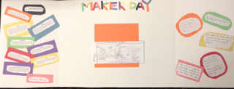

Suggested panel structure:
- 1 panel should annotate the group’s copy / version of the Maker Manifesto
- 1 panel should elaborate on the group’s design process / prototype
- 1 panel should share how the group imagines they could integrate Design Thinking and Making in their professional practices in their schools

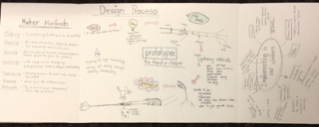

Reference

Eisner, E. (1998). The kind of schools we need: Personal essays. Portsmouth, NH:Heinemann

Wine, C., Guyevskey, V., & Berdoussis, N. (2011). Learning to Document in Reggio-inspired Education. Retrieved from http://ecrp.uiuc.edu/v13n2/wien.html

