A Bandsaw box KIDS can make
by stumitch
Download
9 Steps
Collection I Made it!
Favorite
Share

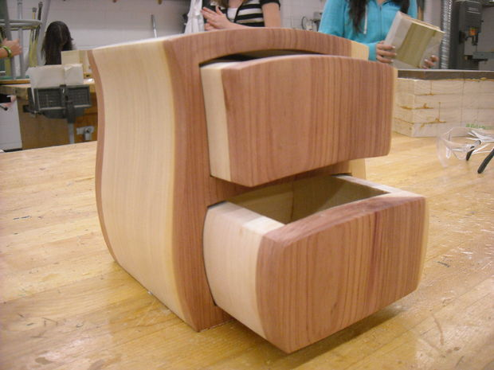

I've tried all sorts of box projects with kids. Some are pretty good, some not. What most kids want is a small box with drawers in it. The bandsaw is perfect for this but most designs I've tried are really tough for kids to do. One of the main limitations I've found is that the box designs require sharp corners which most kids find really tricky because they're inclined to just TURN the piece rather than push and turn. Go figure!
This method seems messy and not too efficient for an adult but it works really well for kids because the cuts are all pretty straight. The project is also really easy on materials because the kids cut it out from one big piece... Drawers and all.
In this Instructable I'll go through all the steps you need to make this work for a class of kids. I've been doing this project with grade 8's. I'll make suggestions on setup and give lots of tips and tricks that I've learned through the years to make it work with students in a safe way that will result in a really nice project that the kids will be proud of.
Learning Objectives:
-The student will learn to creatively solve a design problem... How to use little space in an interesting way to design a small box with drawers. The student will than learn ways to transfer and apply that design to wood.
-The student shall demonstrate the safe use of the band saw.
-The student will learn how to use clamps effectively.
-Once the student has learned to use the clamps that knowledge will be applied to use clamps of different styles to be able to glue a complex shape together.
Materials:
-Light softwood (pine, poplar) approx 1" thick, 6" wide and 30" long.
-Dark Contrasting wood (aromatic cedar, black walnut) approx 3/8" thick, 6" wide and 15" long.
Tools:
-Paper, carbon paper for layout.
-Bandsaw.
-Sandpaper of grits from 80 to 220.
-Clamps of different styles.
-Wood glue
Submitted by HD Stafford Middle School for the Instructables Sponsorship Program
Remove these ads by Signing Up

Step 1: Glue up the Blanks

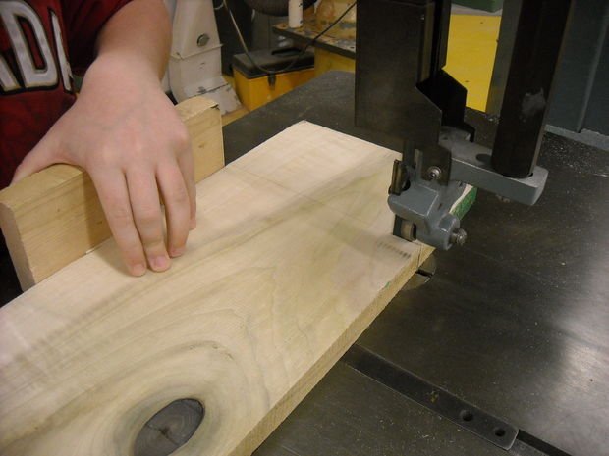

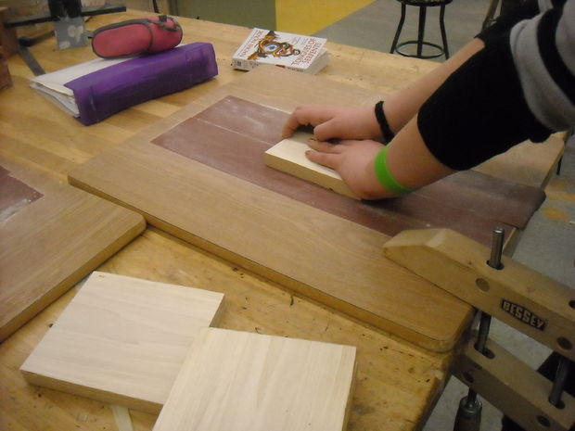

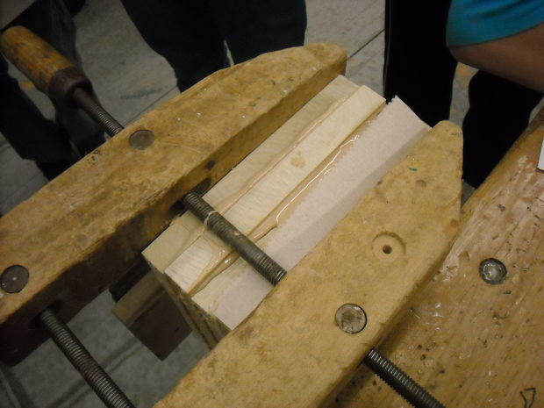

I rough cut the lighter colored softwood into pieces about 5-8" wide, 1" thick and of all sorts of different lengths. This project is good for all the dumpster diver shop teachers out there because you can use any scraps available.
Show the kids how to layout 4 pieces of wood from 1 long piece using the bandsaw to cut them out. Really, you can use any saw you want... the end goal is to have 4 pieces of wood all about the same size.
Use a piece of sandpaper board to get the pieces of wood flat before gluing. I use strips of paper from a big belt sander i have. I used contact cement to glue them to a flat piece of board. Old desktops work well.
Glue up the wood, clamp well and let it sit. Make sure the kids clamp all the way around the perimeter... I've noticed that kids will often just clamp in the middle and leave it to dry without ensuring a tight joint all the way around the block. I've even had kids cut and glue carefully than leave it to dry in the middle of the table... unclamped...
:-)

Step 2: Designing and Layout

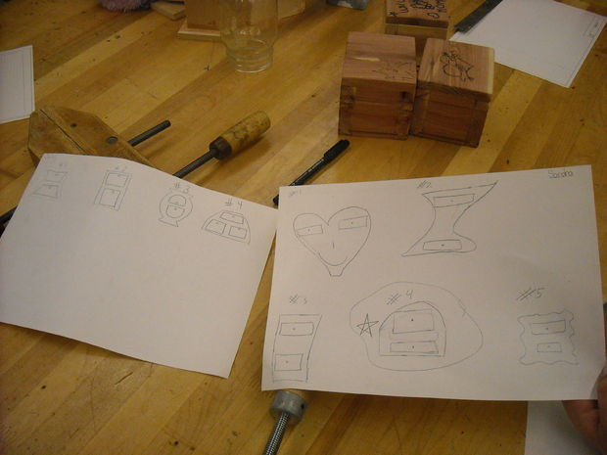

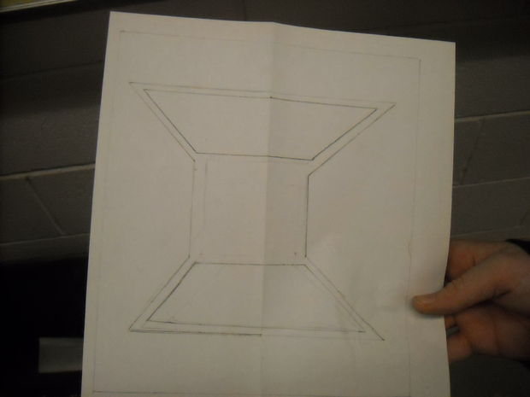

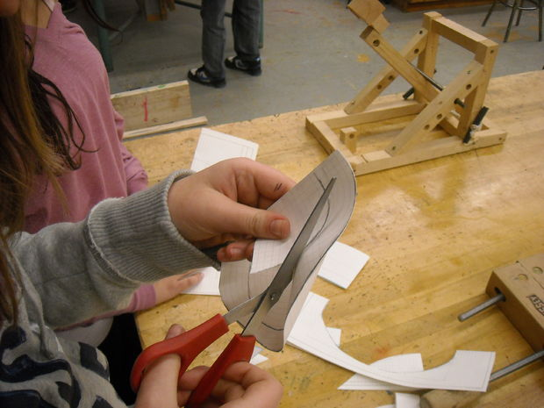

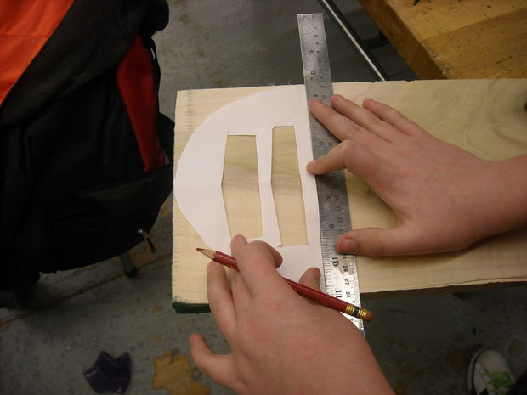

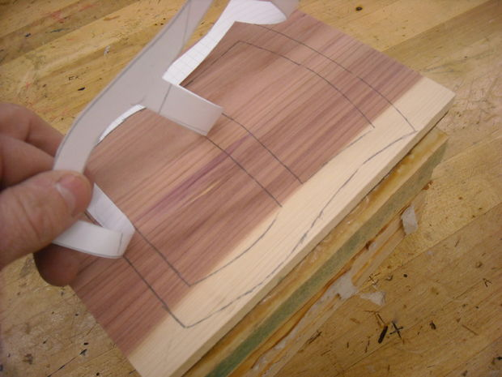

Talk with the students about what makes a box look cool. Take ideas and draw them on the board.... explain that no ideas are "wrong" and that even really crazy ideas can be worked with to make an interesting design. Have the kids all come up with at least 6 ideas each. Don't let them get stuck in a rut with only one idea. Just do small sketches at this point. Some teachers use brainstorming on the board or get kids to swap designs and add to each others work or offer "1 good, 1 critical" idea. Do what works for you.
I take the time at this point to explain symmetry. Its amazing how many kids don't know what this means. I explain that if they are going for an asymmetrical design that they should over-emphasize that it is not symmetrical or it just looks like they made a mistake. Kids really understand it if you take a piece of paper, draw a basic design, fold it than cut it out. I cut out the drawer designs at the same time so the students understand symmetry.
Once they have a design you are both satisfied with demonstrate using carbon paper to transfer the design or just trace out the design using a pencil. Keep things simple... you don't want to discourage creativity but you want the kids to have success.
Trace the design front onto a piece of thin contrasting wood. Glue it onto the block that's been made already. Don't glue on the back at this point.

Step 3: Start Cutting

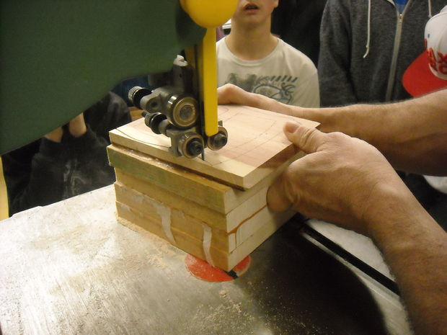

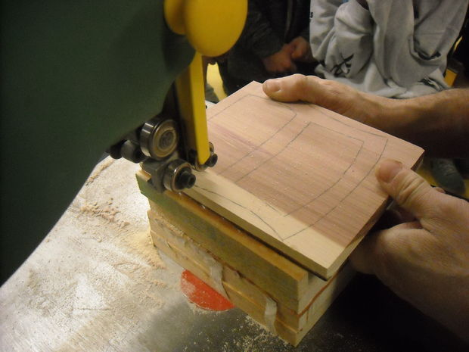

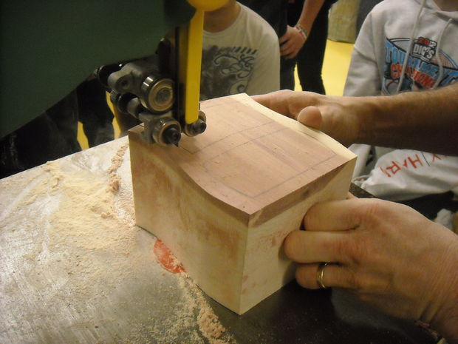

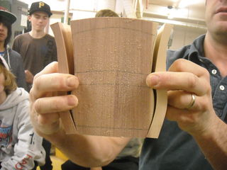

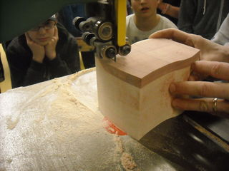

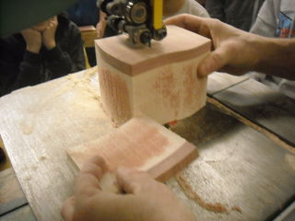

Show All 7 Items
After the kids have transferred the design to the contrasting front piece of wood and glued it onto the big block you can demo the bandsaw. I like the "5" rule which is:
-Keep the guide 5mm above the workpiece
-Keep fingers 5cm from the blade
-keep 5 digits on each hand. (if you say 5 fingers some wise cracker will correct you saying you only have 4 fingers on each hand)
before you start cutting its a good idea to mark all the lines where you'll have cuts or label things so it goes back together...
I've included all sorts of pictures here so you can follow along. The cutting sequence I like is:
-Cut out the outside lines first. If a kid wants to make a really crazy design with lots of curves or angles it is often better to leave this step to last. It makes it easier to clamp.
-Cut the lengths next. Keep a smooth line that curves with the sides of the drawers. SAVE the pieces.
-Cut across the piece from side to side... Follow the drawer tops and bottoms starting at one end and moving to the last. If some drawers are small cut them first so that you have something left to hold onto at the end. Use a push stick if fingers are getting close.
Be sure to remind kids about "pop-thru" which is where the pushing resistance is high until the very end... when all of a sudden the blade pops through the wood and cuts off something vital.
Like a finger.

Step 4: Glue-Up

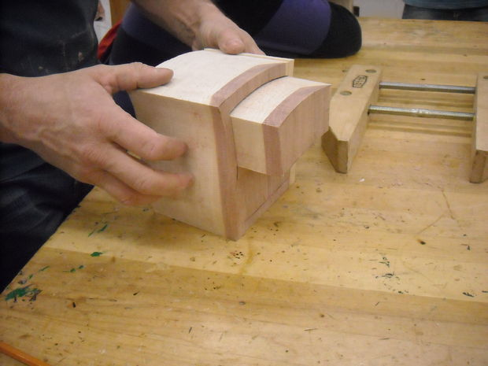

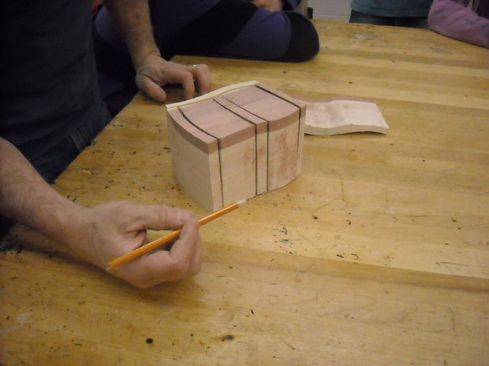

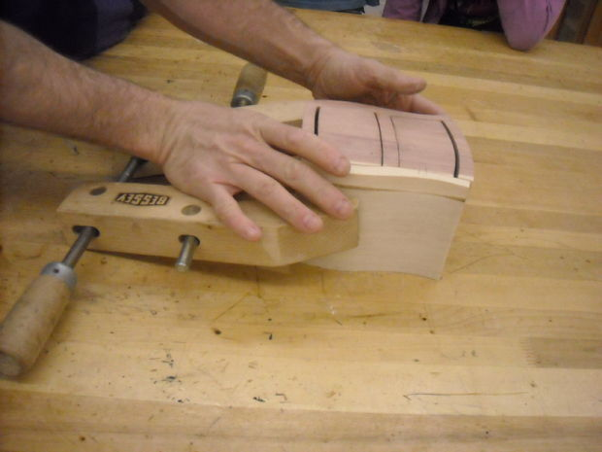

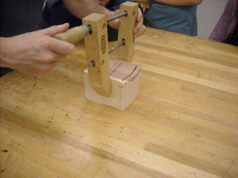

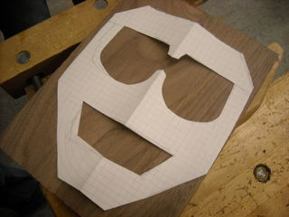

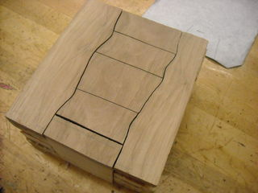

This is where things can get a bit weird. If you have group of unruly beasts now is the time to rein them in and make sure they stop and think what they're doing. I explain that this is the "make or break" point. If they slow down, take a breath and do each step carefully the project will be great. If not... well..
Each student will need at least 3 clamps. I like Jorgensen clamps as well as those cheapie kinds that slide and open way up. Some masking tape is also pretty handy, too.
Make sure the students all blow off the dust and carefully dry fit everything first. Get them to clamp it all together before putting on glue. Once they are ready to glue emphasize that they cannot get glue on the drawers. A very thin line of wood glue that is well spread out with your finger on each joint is good. Sometimes if the glue is soaked up you can add a bit more but be careful... it often seeps under and glues in the drawers.
Why glue with the drawers IN you may ask... I've tried it with the drawers outbefore but what i've found is that it is really tough to line everything up so that the drawers can move in and out. Try both and see what works for you.
Apply a ton of clamps. Sometimes it is easier to use masking tape to hold the joints tight and in line before clamping. Its up to you. I wouldn't suggest just giving the tape out. I once had a group of kids tape a buddy to the underside of a table. It took a really short amount of time. Make sure that the edges are absolutely in line and perfect... if they are out a very small amount it can make the drawers really sticky. Sometimes after clamping you can gently tap out the drawers without the whole thing falling apart. Try and if you can, go for it.
i've added some pictures of boxes kids were gluing up today. It gives an idea of what a 13 year old kid can come up with!

Step 5: Removing the Drawers

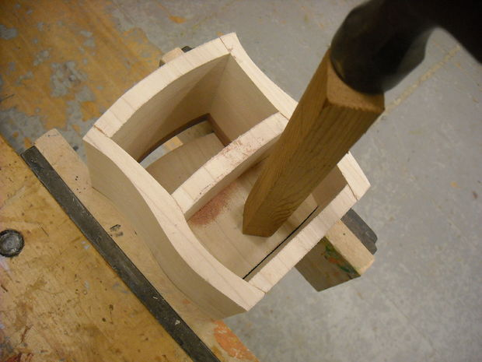

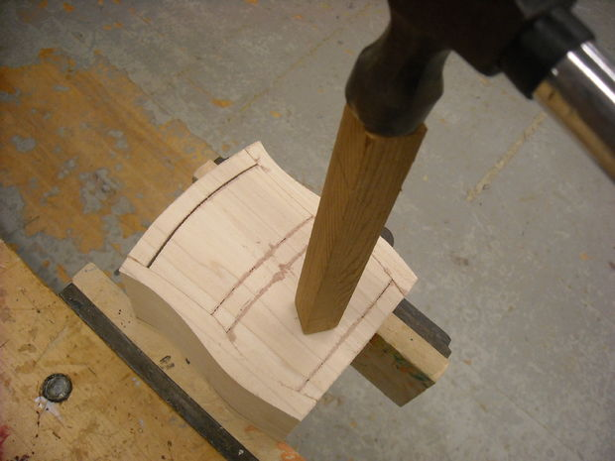

I thought it would be good to throw in my method for removing drawers that get stuck...
Support the box face down on a vice. Open it enough that the jaws don't touch the drawers.
Gently tap the drawers out with some soft wood and a hammer..
Worst case scenario is that you'll have to go back with the kid and use the bandsaw to re-cut the lines.

Step 6: Cut the Drawers

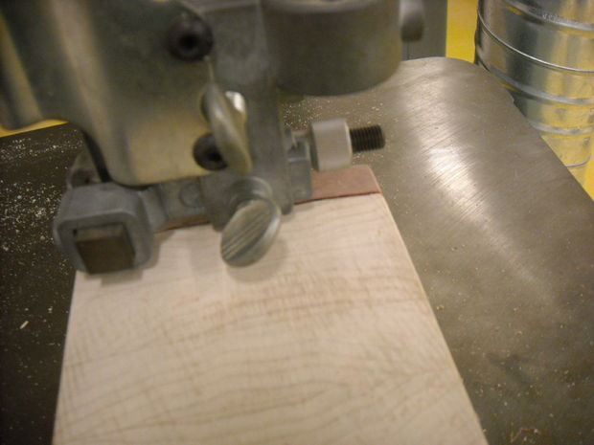

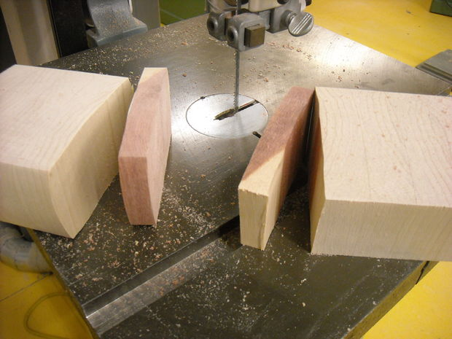

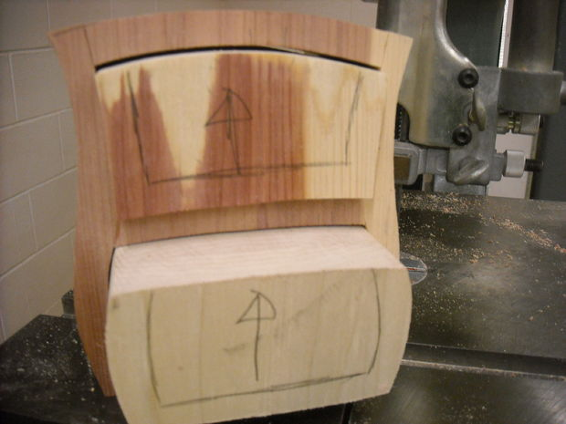

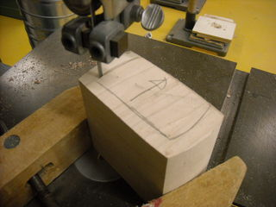

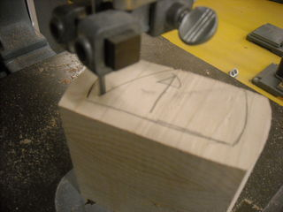

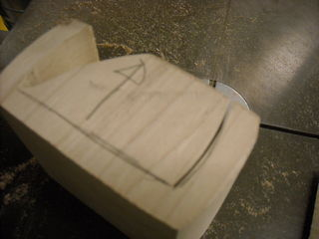

Show All 10 Items
Make sure the drawers move in and out smoothly. If they don't you can get the kids to wrap a piece of 120 Grit sandpaper around a ruler to smooth out the inside a bit. You could also sand the drawers but I don't let the kids use machines at this point because they ALWAYS sand off too much. The sanding board works best.
Now do another demo on the bandsaw. I get the kids to hold the drawers with a jorgensen clamp while they are cutting out the drawers but make sure they don't pinch the wood at the cut... it will bind and create problems.
The first thing to do is to cut the front off. You want the kids to just slice off the thin contrasting piece along the glue line. Now cut off a thin slice from the BACK of the drawer. About 1/4" is good. SAVE these pieces and label them.
Now draw the drawer spaces. Some kids can cut a thin walled drawer but usually things are safer if the kids leave at least a 3/8" to 1/2" wall thickness. Make sure they actually label "up" with an arrow while the drawer is in place.
I've included a sequence i use for cutting. Kids tend to try and do sharp corners with the saw and a visual really helps.
First cut a short line in on one side. Don't go to far because backing out with a bandsaw is not wise.
Now cut in on an angle ending at the end of the last cut you made. Remove the piece.
Step 3... cut another short line on the opposite side.
Lastly, cut from the first piece you removed to the end of the cut you just made.
Use a sander to clean it all up inside and out!
Now glue the front and back piece back on that you cut off earlier. Be really careful to line up the edges... if they DON'T line up they won't fit back into the box. HEY PRESTO! you now have a drawer with a space to hold stuff.

Step 7: Don't Forget The Back...

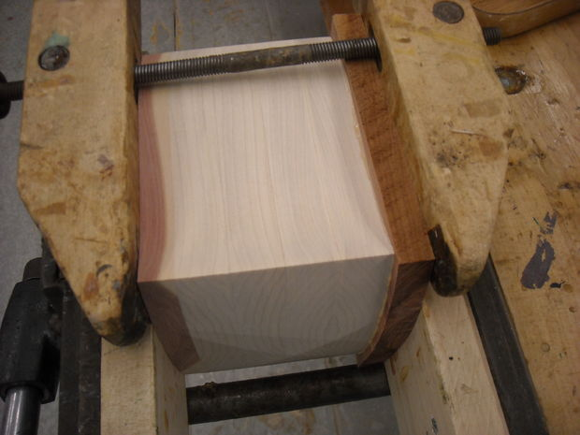

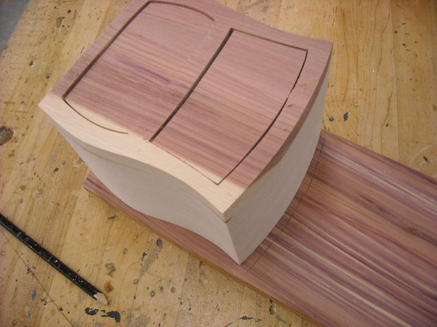

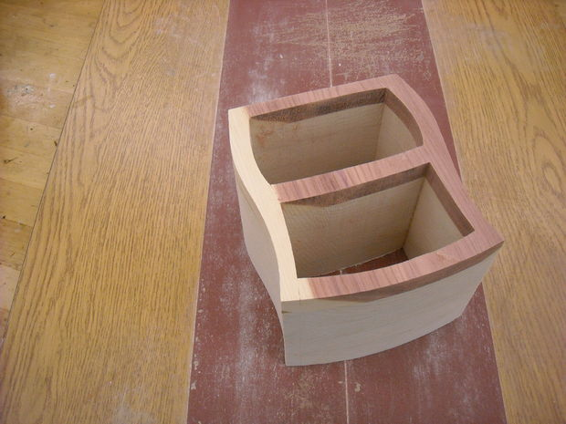

Nows a good time to attach a back to the box. Use the same thickness and type of wood unless you're going for a different look. I rough cut a piece, apply glue to the back of the box and clamp it well. Don't glue it with the drawers in. If a kid DOES do that, the best option is to drill a hole in the back, stick in a dowel and tap (or POUND) the drawer out.
Once the glue is dry use the bandsaw to flush cut the back down.
I let the kids use a spindle sander with a big (3") sleeve attached at this point. Hand sanding works well too.

Step 8: Sanding and Finishing

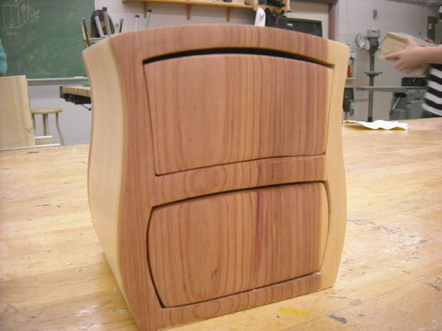

Most of us know how to sand but kids... well, not so much. Usually they jump right into using 320 Grit, sand furiously for 30 minutes and marvel at how smooth it is... What they don't know is how rough it will look as soon as they put on the finish.
Heres a good analogy I came up with at one point. I ask the kids if they have ever seen someone try to mow a lawn thats really really deep. I go into detail about the wet grass spewing out the mower until it clogs up and how horrible it looks once its all done... I than ask them if they've noticed how the wheels on the lawnmower go up and down so that the mower will take off less at a time... would it make more sense, i ask, if they would raise the mower as much as possible, cut the long grass than lower the mower and maybe even do it 3 or 4 times lowering it each time? They all nod and agree so at just the right moment i strike! HA (i say) THAT is EXACTLY what SANDING is like!!! They often look confused until i explain that the grains on the wood all stand up and starting with a high number grit like 320 or 220 is like cutting long grass with a low mower. They need to start at a rough grit like 80 than sand like crazy with the grain until all the scratches are gone. The wood won't be smooth until they move up through the grits from 80 to 120 to 150 or 180 and final finish with a 220 or a 320.
While i'm telling the story I am sanding a piece of wood through all the levels... not making a big deal of it but casually mentioning details as i go along... The last step is the finish. I like to use beeswax because its non toxic and smells good.
I pull out the rag, give the wood I'm working on a buff with the wax and man you should hear the students. They oooohh and aaahh and than they all start asking to touch it. Amazing results and the kids are inspired to do a really good job.
Teaching is so cool.
Well I hope this instructable has inspired you to try this project with your students!
On the last page is a marking sheet i use so teachers if you would please turn the page...

Step 9: Marking
I thought i'd add a marking sheet for the teachers in the audience... The trick with wood working is to make objective assessment which is tough to do. This marking rubric makes it easier. The kids like it because they know exactly why they got the grade they did. I also give students the chance to go back, fix things and re-submit. In our district we're not allowed to mark subjectively so this sheet helps that (hopefully) by making assessment based on a set criteria. Thorny issue to say the least.
Bandsaw Box Project Marking Sheet
NAME:____________________________Div:_______Mark of /40

Area: | 0-10 | 11-15 | 16-20
Appearance and finish work | Minimal sanding, cracks at cut points, off center drawers | Sanding okay, not shiny with polish, design like drawing, tiny cracks but not bad | Well sanded, polished shiny and smooth. No cracks
Drawers | Big gaps, hard to pull out or very loose and wiggly, no backs, no sanding evident. Not flush with front | Pull out fairly smoothly, minimal wiggle, flush with front but not perfect, no BIG cracks. | Pull smoothly, no wiggle at all. Sanded inside and out. Flush with front no gaps.

Grade 7 Cutting Board Rubric Place a checkmark in each box that you feel best describes the work you did on the cutting board. Then get Mr. Cummins to review your assessment and offer feedback.
Dimension/Level of Performance Beginner Acceptable Proficient Mastery Cutting board is no more than 10” x 12” in area Attempted Large no more than ½” in either dimension Larger no more than ¼” in either dimension Exactly or less than 10x12” Cutting board is no less than 5/8” thick Less than 5/8” thick More than 5/8”thick Less or more than ¾” thick. ¾” thick Both glue lines are tight with no gaps between the boards Attempted/boards uneven Many gaps Few gaps No gaps All edges are sanded smooth Attempted/no sanding Many missed edges Few missed edges No missed edges All surfaces are sanded smooth Attempted/no sanding A lot of visible scratches A few visible scratches/pencil marks No visible or tangible scratches Oil finish is applied evenly with no sags or build up Attempted/no finish Finished applied Finish applied consistently Finish is polished and smooth In order to achieve Mastery overall, mastery must be indicated within each dimension of performance. Overall level of performance________________________________ Project Verified by Mr. Cummins_____________________________________ STUDENT FULL NAME_____________________________________

