Mikes Three Week Community Field Practicum Reflection
With: Growing Chef’s
Day one: Monday, April 25th –
I was partnered up with Georgia another UBC teacher candidate and we were sent to Sir William Macdonald Elementary - Kye Smith's class, unfortunately she was away and so were her educational assistants; nevertheless the ran smooth. Our team consisted of Heather, Lindsay, and Nicolas from Growing Chefs and the two of us from UBC; Lindsay is a pro she has been with Growing Chefs for about 4 years and knows the curriculum very well. The class consisted of only 15 students, sadly a few had behavioural issues and had troubles participating in the activities. We had the children circle up and conducted a vegetable sharing exercise were they talk about their favorite vegetables and how the best liked to eat them, after the children sampled a variety of vegetables and shared their thoughts about that experience. Compost was the next topic that we introduced to the children, in the form of a story we delivered the importance of giving back to the earth. The class time went by very quickly, I enjoy my first day with this age group, they are happy, excited, curious, and best of all most had smiley faces.
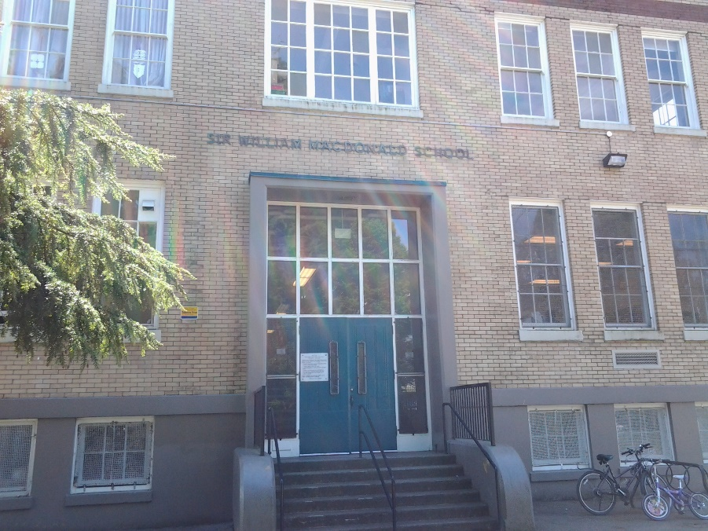
Picture of outside of Sir William Macdonald Elementary (a lovely old brick building)
In the afternoon all the teacher candidates had a meeting with Amanda Adams the Growing Chefs program coordinator, she went over the layout of our three week practicum (schedules and agenda), and Amanda also explained some noninstructional projects that she would like us to engage with. I think Amanda is going to be reasonable to work with and I will have a positive experience.

Memorable Teaching Moment:
When teaching things do not always go to plan. For today’s lesson the students were to bring in a vegetable from home and talk about it, unfortunately not many students brought one in. Consequently Chef Lindsay altered the planned activity by saying to the students that they could ether talk about the vegetable they brought in or talk what their favourite vegetable is and how they like it cooked. As a teacher it is always an asset when you can adapt to a situation quickly.

Day Two: Tuesday, April 26th–
Today was a great day I was able to experience a well-run grade 3/4 split class at Graham Bruce Elementary School, The teacher Mr. David Lafond was very organized and the layout of his classroom was exceptionally well thought out. . Our team consisted of Christina, Anna, and Stania from the Growing Chefs plus Georgia and myself and 22 students in total. David believes in accentuating the positive in his students he does this by highlighting good behaviour with a reward system, students are given “good behaviour bucks” throughout the week and on Friday’s they can trade them in for treats. The fantastic 5 is the class name which the class as a whole came up with along with a set of rules for the classroom and each student signed in agreement. Another system David has in place with his students is each one is responsible for a task in the classroom from taking attendance to organizing the book shelfs; this approach holds students accountable and gives them a sense of ownership in the place in which they learn. Some of David’s students have trouble sitting still so he employs the use of balance cushions to help these student focus and control their own movement. Each class we visit this week will have lesson three of the Growing Chefs seven lesson set taught to them, so it was interesting to compare the delivery style of the previous days teaching chefs, both were good just different.

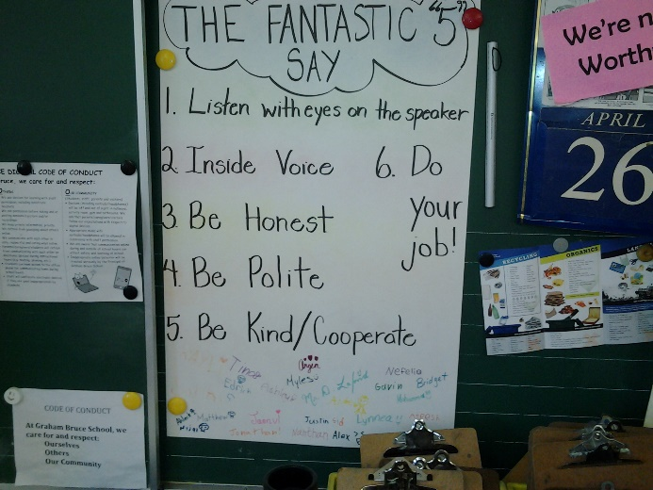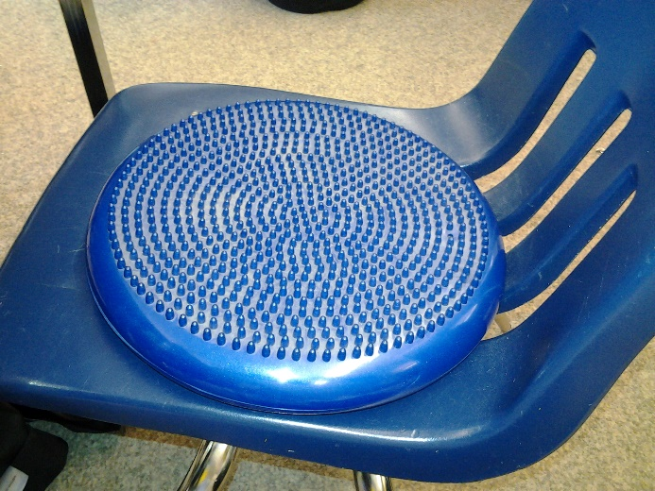

Memorable Teaching Moment:
Chef Christina engaged the whole class including the other chefs and the teacher with a music sing along. The students played simple hand held music instruments as Christina played the guitar and sang a song they had learned the previous time they were in. The children loved this activity, music is a powerful tool and if used right could be away of including all the students in a class, in the future I am going to try to incorporate music into my teaching.

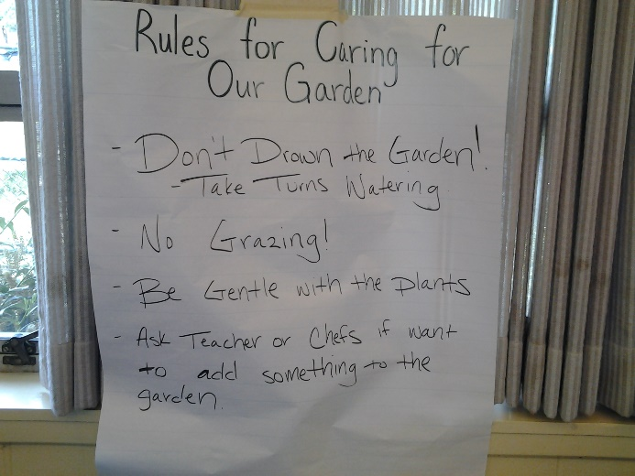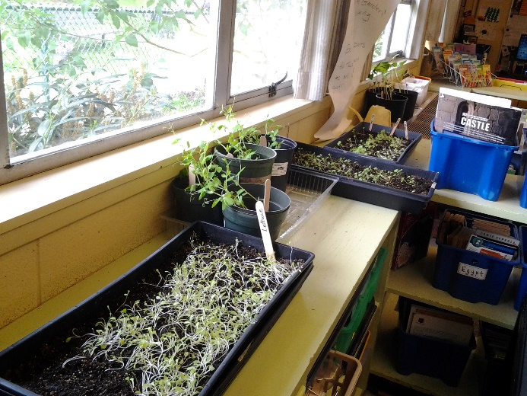
The students of this class are proud of their little garden and have memerized the rules around the caring for the plants.

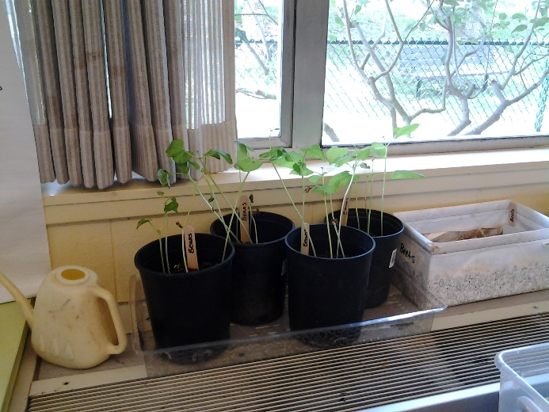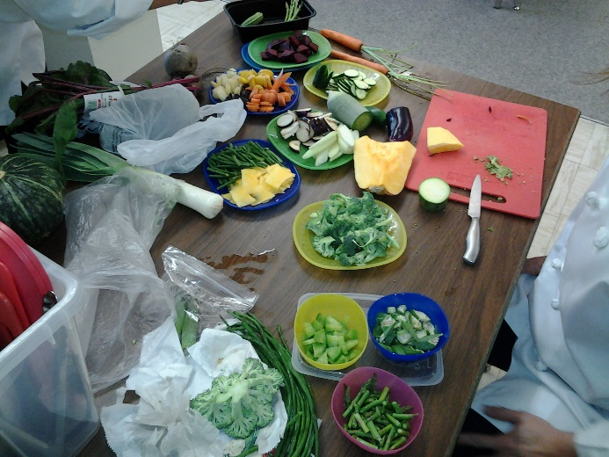
Some of the plants have grown tall and need to be staked / which the chef will do at the end of this lesson. Today the student sampled the vegetables that they and the chefs brought in, this group of students were fairly adventurous and tried most vegetables.

Day Three: Wednesday, April 27th–
Today I visited Hjorth Road Elementary school in Surrey alone (each UBC teacher candidates were sent to different schools) the teacher was Mr. Clayton Stephens and the Growing Chefs were: Ryan, and Harpreet two chefs Cam and Travis were away. Ryan works for Growing Chefs, therefore he knows the curriculum extremely well. The day started with student gathering in a circle to share information about the vegetable they brought in from home, chef Ryan was prepared for students that did not bring a vegetable by bringing extra. Prior to our arrive Mr. Stephens had the students complete a work sheet on their vegetable, explaining: country of origin, how to cook it or not, nutritional information, and such. This class was a little tight for time as the scheduled time was slightly shorter than other schools, however all of the lesson plan material was covered. The garden in this class was growing particularly well, the teacher had already stacked the bean and pea plants before our visit.

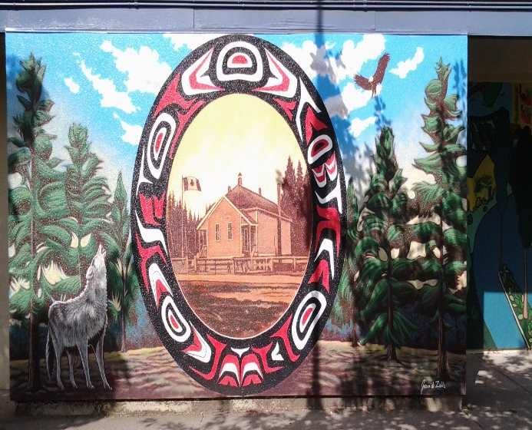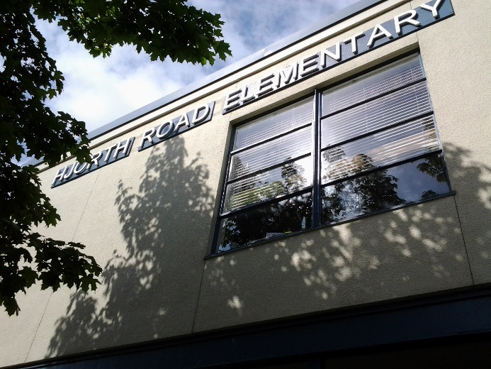
The outside the school there was a nice set of murals which added to the ecstatic’s of the school.

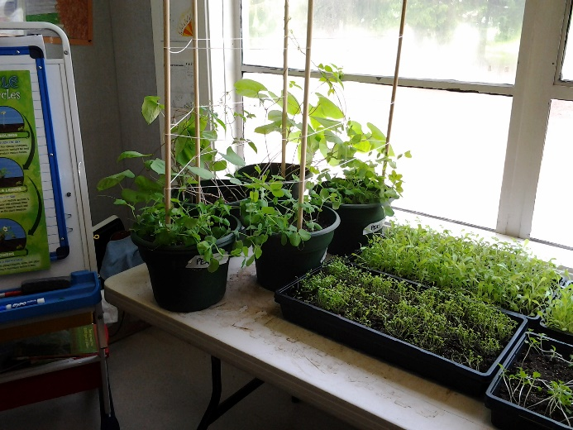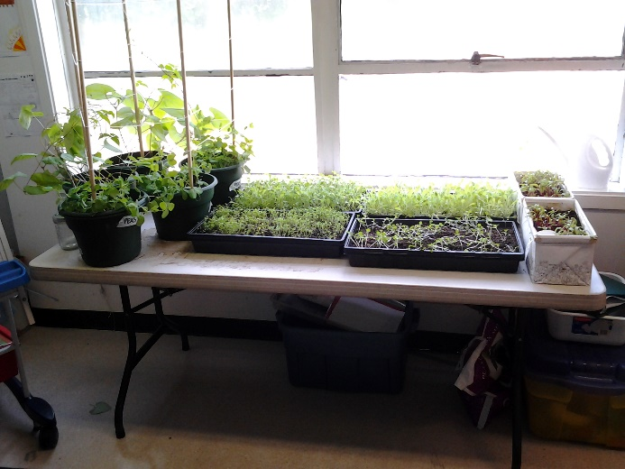
The plants are growing well.
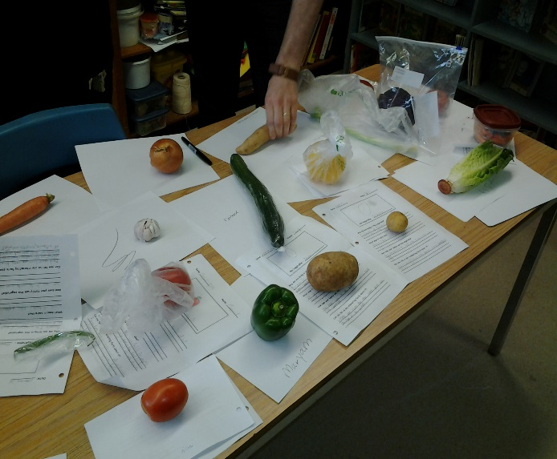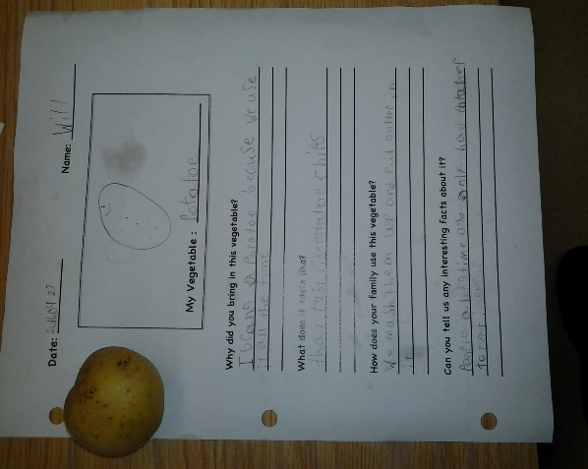
The students work sheets with vegetables. Student vegetable work sheet.
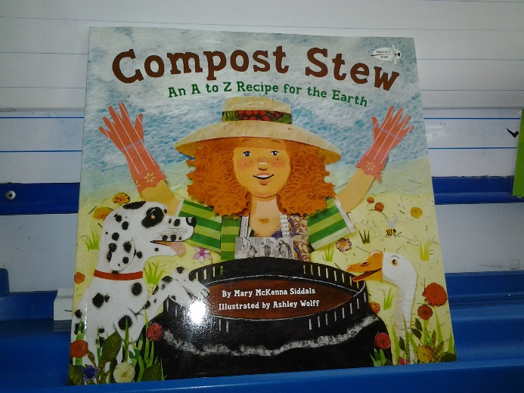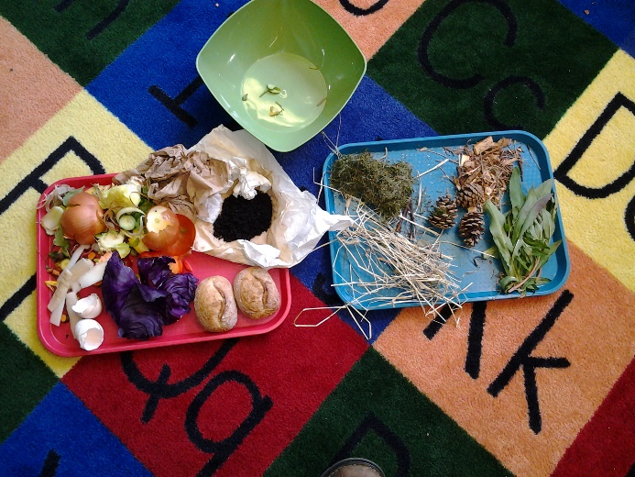
The story book that is read to students about ingredients that go into a compost bin, examples of compostable items.
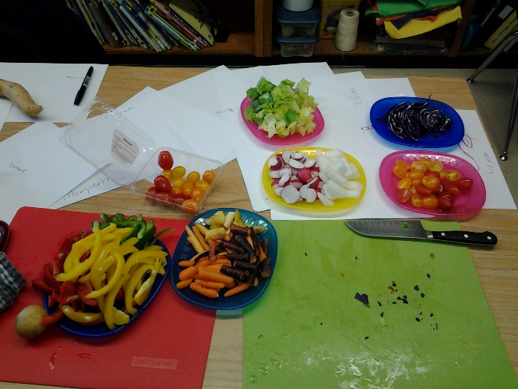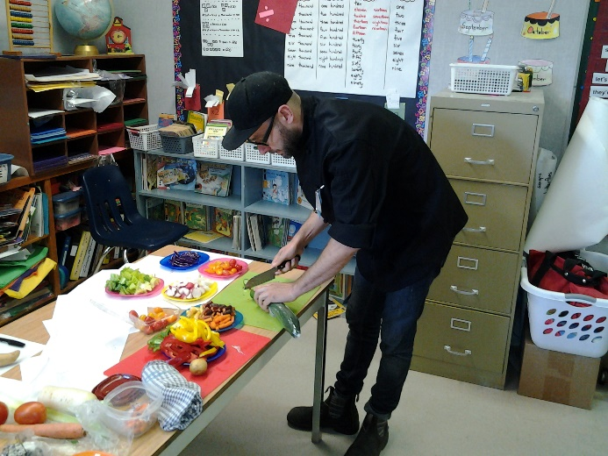
Chef Ryan prepared the vegetable for the children to sample.

Memorable Teaching Moment:
Mr. Stephens had prepared his students well for our visit by having student fill out a work sheets and having them continually monitoring the plants. I noticed the similarities and differences between the previous classrooms I visited; what a great opportunity to compare and contrast what works and what does not. One plus in Mr. Stephens class was his approach to the vegetable circle sharing activity; all the student had to present a vegetable however some of the student were shy or not ready to present so they were allowed to pass once, know at the end of the other students sharing they would have to present their vegetables. I felt this worked well due to the fact that students had control over the situation and could relax a little before presenting.
The day before Mr. Lafond employed the use of a balance cushions to help students sit still and focus and I noticed a similar device in Mr. Stephens class a balancing stool.

Day Four: Thursday, April 28th –
The UBC teacher candidates (Matt, Georgia, Etal, Joanne, Charlie, and myself ) worked out of Amanda Adams house (Program Coordinator) we discussed next week schedule and learned the Monday is a Pro-D Day in the Vancouver school district and that we have an opportunity to fill our time commitment on Saturday may 7th at a stone soup festival held at Britannia Community Centre, 1661 Napier Street, which is annual event that is a celebration of food, art, environment and community. People worked individually on self -directed project and in collaborative groups. I personally am working on a Chefs recipe blog, due to my culinary back ground I thought it would be good to post a recipe of the month. I will provide Growing Chefs with between 10 – 12 recipes that they can use throughout the year high lighting special seasonal holidays; I enjoy cooking with my children and believe if parents spend time with children in the kitchen many positive life long memories can be formed.

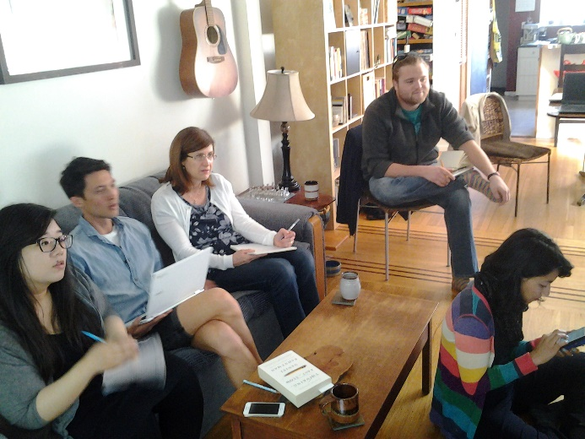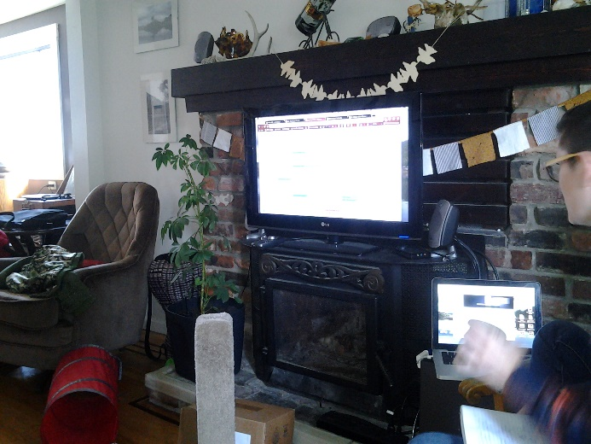
UBC colleges going over schedule with Amanda.

Day Five: Friday, April 29th–
Georgia and I were partnered up again and this time we were sent to Tecumseh Elementary school in Vancouver the teacher is Ms. Debby Meyer and the Growing Chef were: Linda, and Marissa a third member Danielle was away due to illness. It was a treat to meet Debby and learn a little about her story, she did not start teaching until she was fifty, and as fate would have it her first school was Sir William Macdonald Elementary the first school I visited with growing chefs. Debby told me that she will keep teaching until she is seventy as long as her health is good, coincidentally I have the same goal. Debby is a caring and compassionate educator she teaches a grade one class, besides reading, written, and arithmetic she tries to teach her students to be good citizens in and out of the classroom.
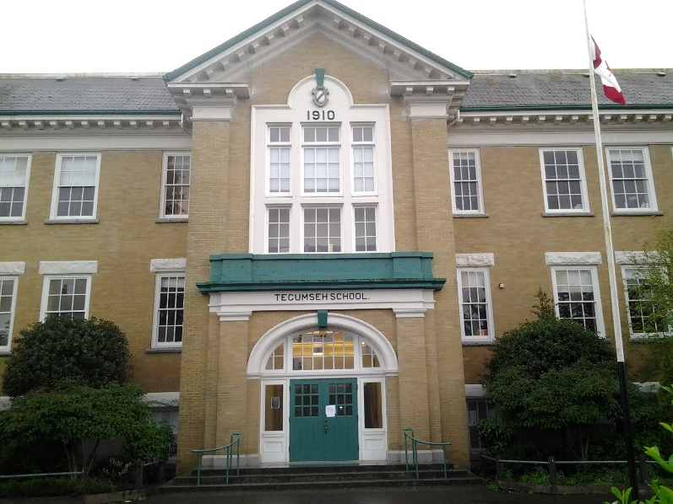
Tecumseh Elementary School in situated in a beautiful old brick building.

Memorable Teaching Moment:
Debby’s use of powerful and positive messages throughout her classroom was inspirational to me. If young people hear and see the appropriate why to conduct one’s self in a civilized society they will hopefully adopt this way of behaving. I still remember my grade one teacher, she was a firm but fair and expected the class to act in a certain way; she would say “you are not babies any more, you are in grade one and must act like grade ones”; Debby’s students will remember long after their grade one year.

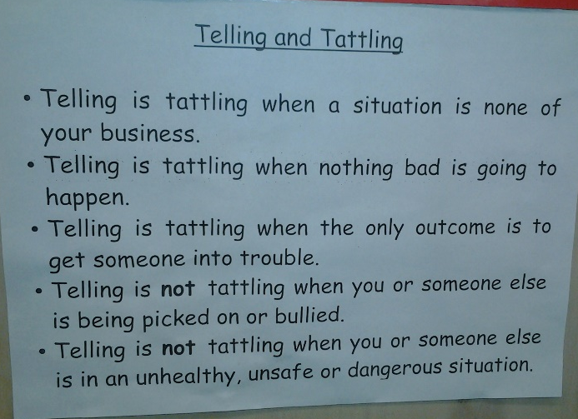

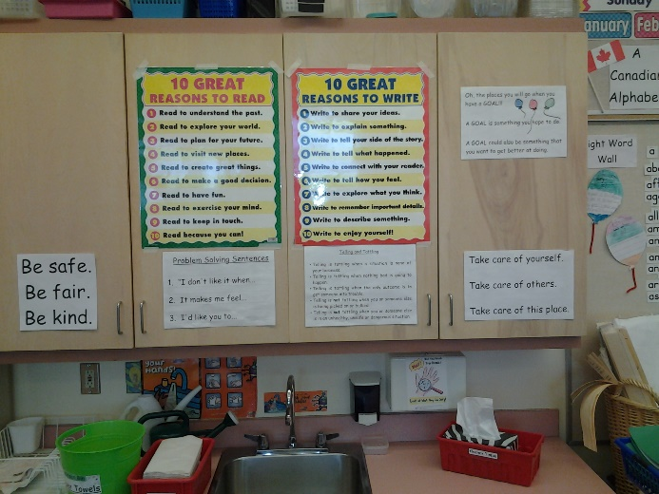

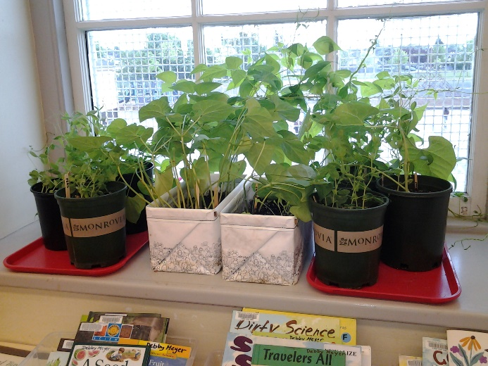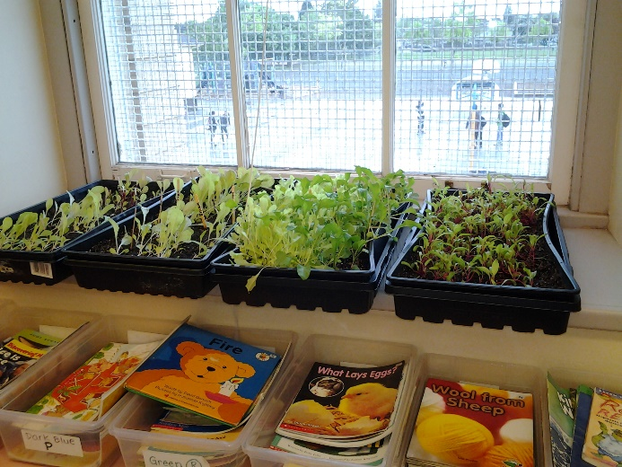
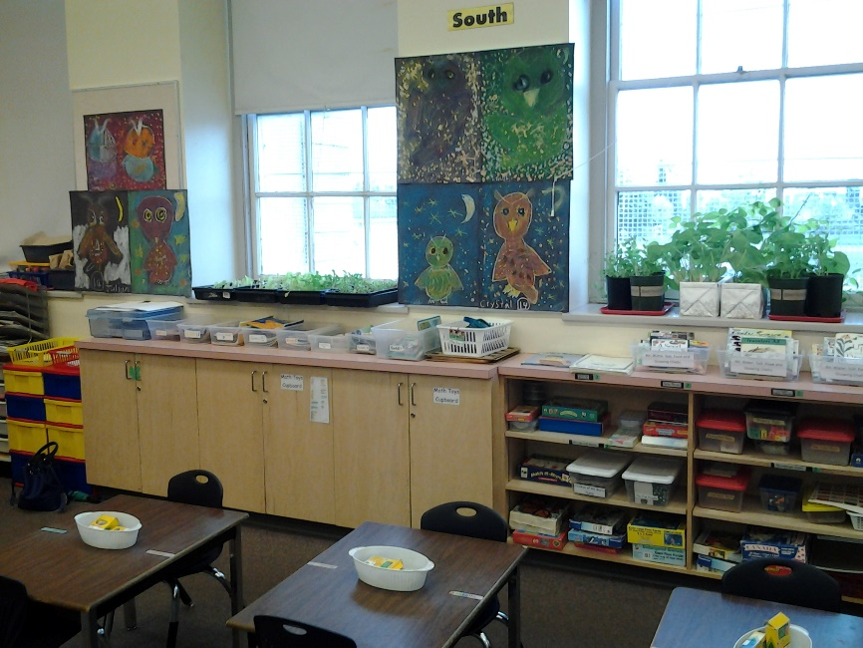

Tecumseh’s garden is growing nicely

