Mini-Sumo Robot Lab: How to build a double H- bridge control using strapping and screws

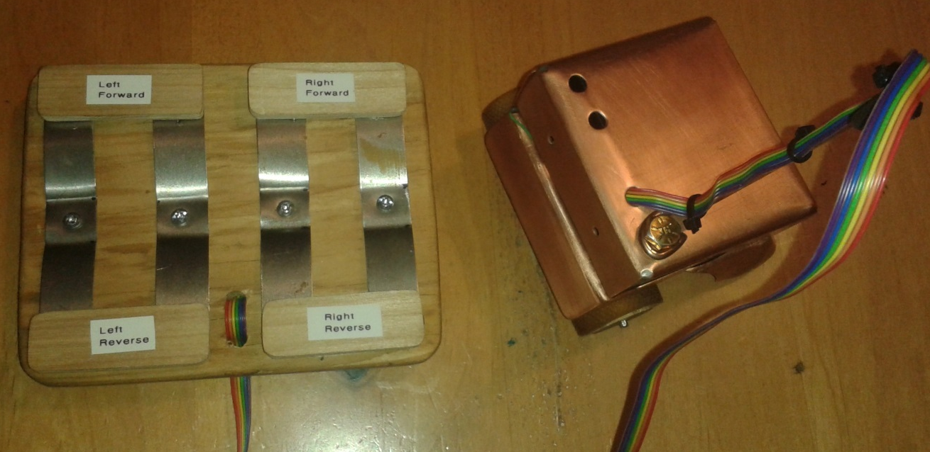

The reason why:
An H-bridge is a type of circuit that you can use to get a reversible DC motor to spin both clockwise and counter clockwise, these circuits are often used in robotics and other applications.
The double H- bridge controller using strapping and screws is a cheap and easy way for high school students to control a mini sumo bot or any other simple motorized device. This circuit allows you to quickly reverse the direction a motor is spinning by using a simple switch to change its direction.

What is needed?
- Ply wood
- Strapping or sheet metal
- Screws
- Rainbow ribbon cable or mouse cable / 4 -6 ft.
- Wire / six different colours work well

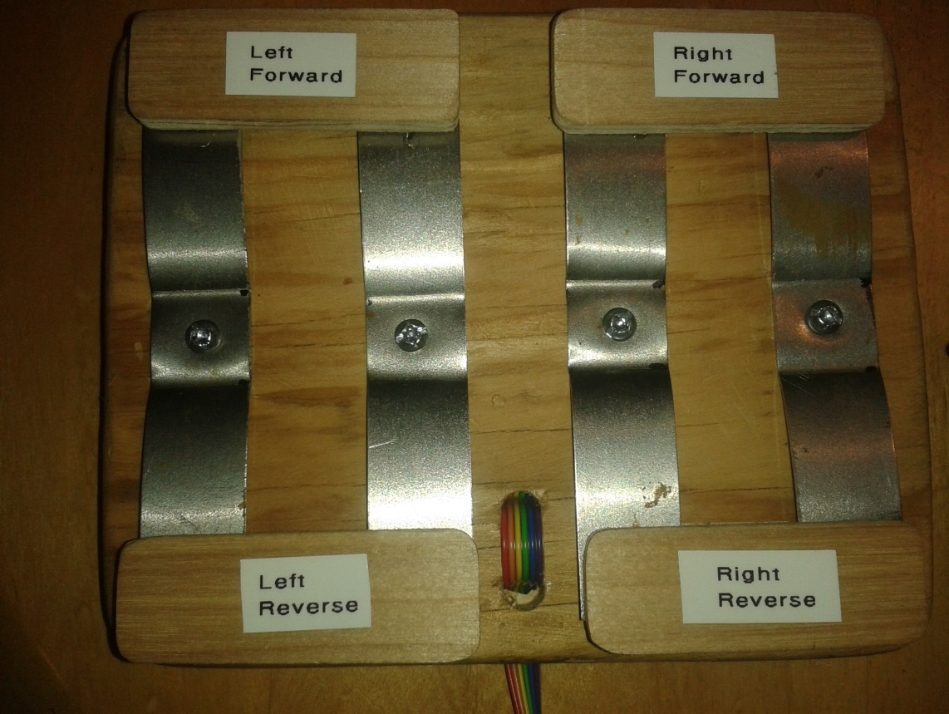

.
How does it work?
This double H- bridge controller work the same way that simple switches work / on and off. Basically you have four switches: two switches controlling two motors to go forward and two switches to controlling the reverse direction. A six wire cable is needed; two wires positive and negative wires are connected to the battery terminals. Two wires go to motor number one and two wires go to motor number two. When the switch is pressed in the forward position the polarity of the battery is flowing in one direction and when the switch is pressed in the reverse position the polarity of the battery flows in the opposite direction this in turn controls the motor direction. Each motor is controlled independently allowing for skid steering, when both switches are moved to the forward position at the same time the robot will move in a straight line of travel.

