TTED – 5050 / Automotive
Student Skill-Builder Activity
Information Prepared By Mike Doyle
Parking Brake Adjustment

Introduction: In cars, the hand brake (also known as the emergency brake, e-brake, park brake, or parking brake) is a supplementary system that can be used if the vehicle's primary brake system (usually hydraulic brakes) has a failure. Automobile e-brakes usually consist of a cable (usually adjustable for length) directly connected to the brake mechanism on one end and to some type of lever that can be engaged by the driver on the other end. The lever is traditionally and more commonly a hand-operated system (hence the hand brake name), the most common configuration being a handle on the floor between the driver and front passenger, and less commonly being a handle bar located on the lower portion of the dashboard somewhere close to the steering wheel column. Alternatively, the lever can also be foot-operated, in form of a pedal in the foot well in front of the driver, located to the far left apart from the other pedals.
However, the most common use for an automobile emergency brake is to keep the vehicle motionless when it is parked, thus the alternative name, parking brake. Car emergency brakes have a ratchet locking mechanism that will keep them engaged until a release button is pressed.
Rationale: The handbrake provides some braking effect if the hydraulic system fails, but it is primarily a parking brake. It acts on the same brake drums or discs as the hydraulic system, but separately, and it must be adjusted separately. The hand brake should be adjusted whenever the rear brake shoes have worn enough to allow you to raise the lever five clicks without noticeable braking action.

Tools / Materials:
- 10mm wrench
- Deep 10mm socket
- Ratchet & extension
- Philips screwdriver
- Flat screwdriver
- Lug nut wrench or 36mm socket on a 3/4-inch drive breaker bar
- Car jack, stands, and wheel blocks

Personal safety equipment:
- Safety glasses
- Closed toe shoes
- Dust mask

Steps:
- Locate Owner’s Manual
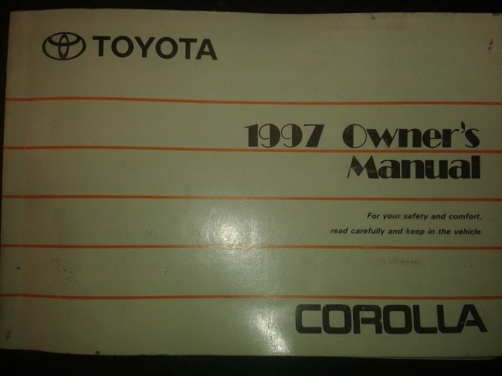
The owner’s manual will provide detailed information about the vehicle and safety information. Usually found in the glove box.

- Inspect rear brakes

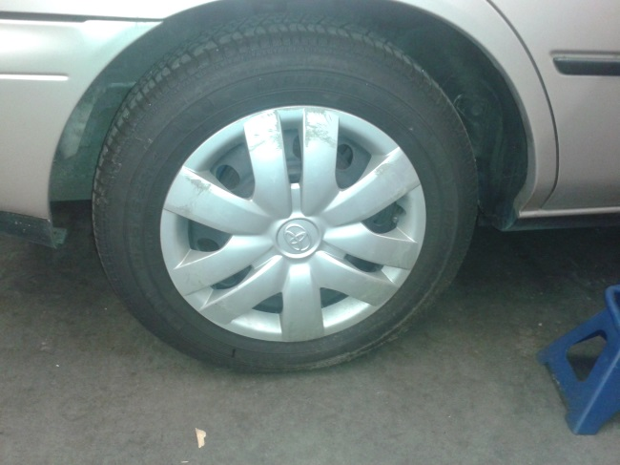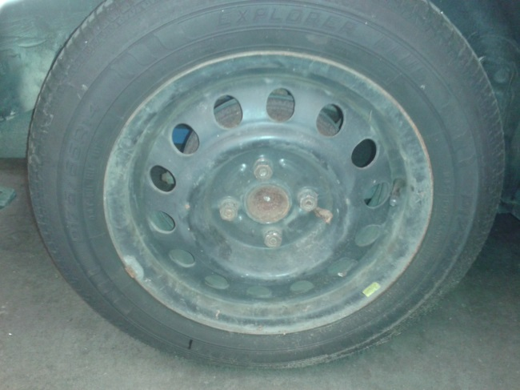

Remove the hub cap with the flat screwdriver, loosen the lug nuts. Jack up the rear of the car, place it on jack stands and put tire blocks under front wheels. Remove wheels and brake drum, inspect pads for wear, replace if needed.

Safety Note: - Be sure to jack vehicle on level ground.
- Use a dust mask while inspecting the drum brakes.

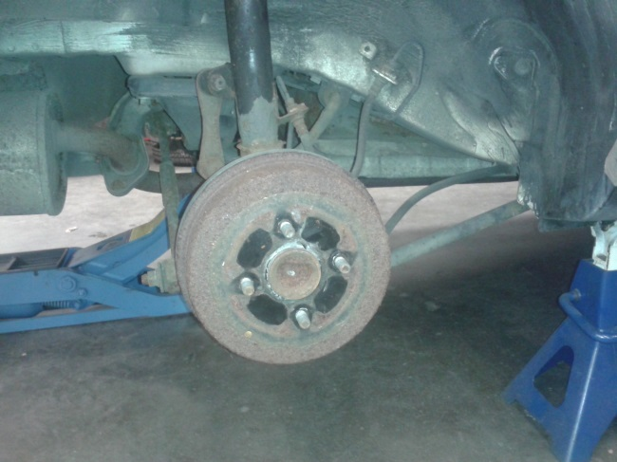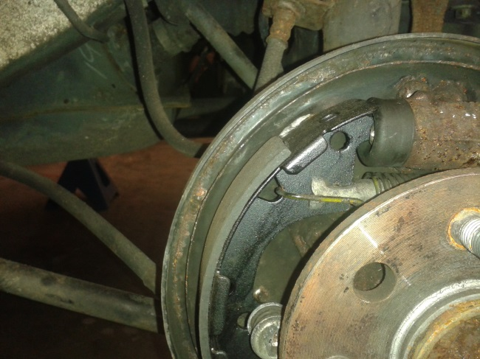

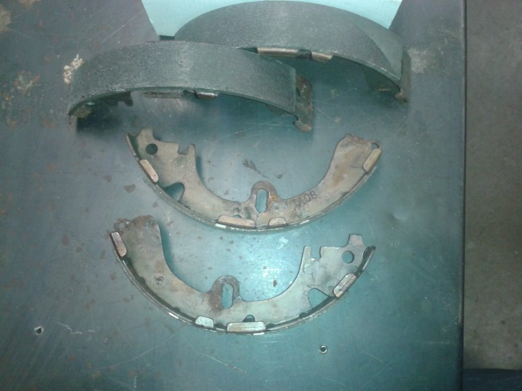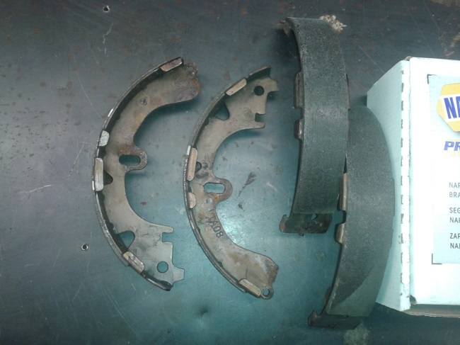

- Measure the lift of the hand brake lever

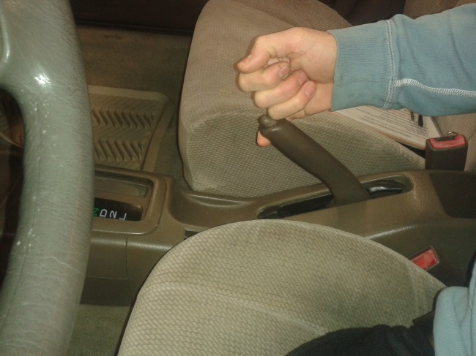

- Gather tools required to do the job

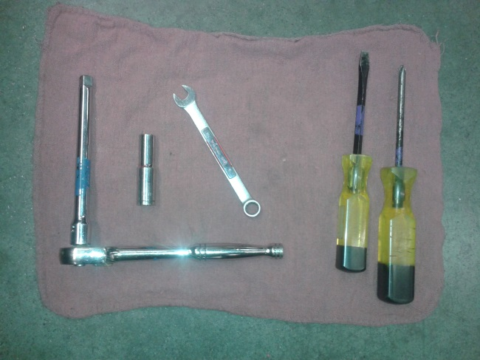

- Remove central inside console

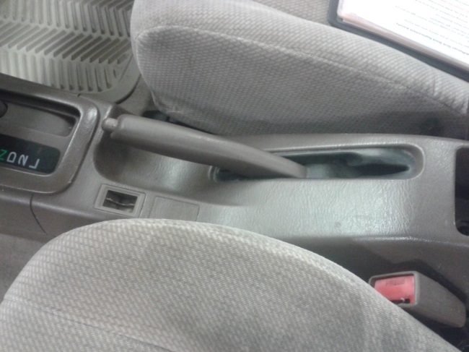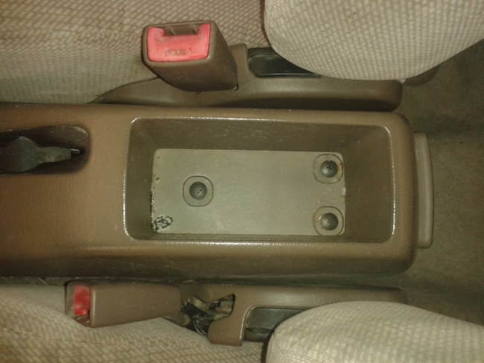

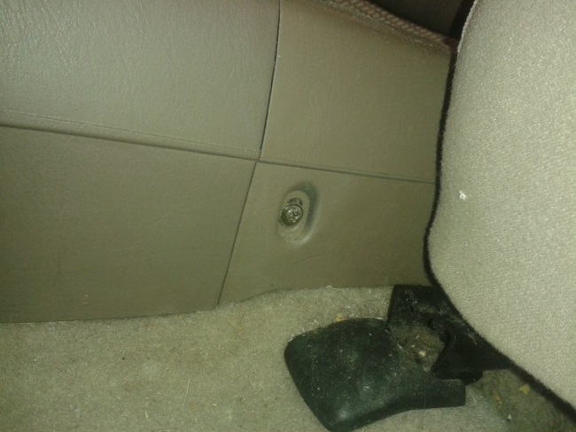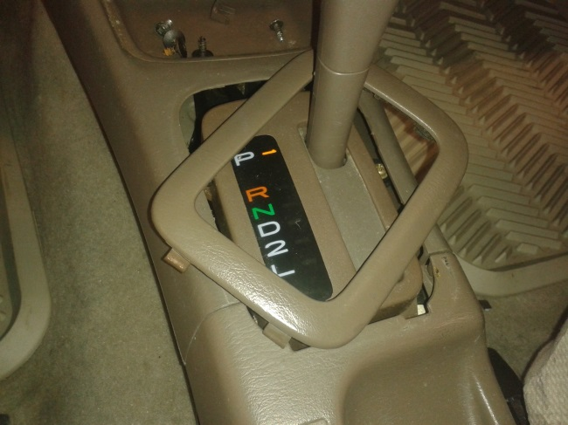

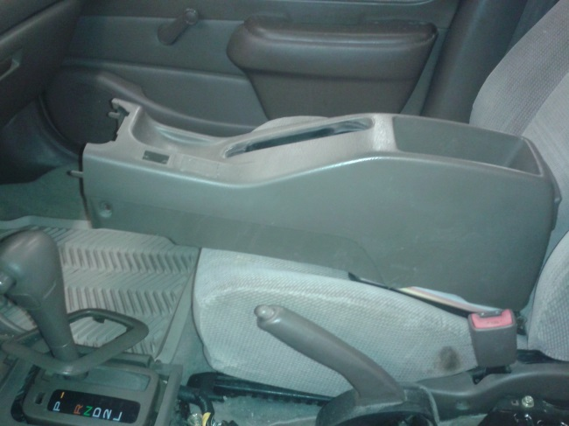
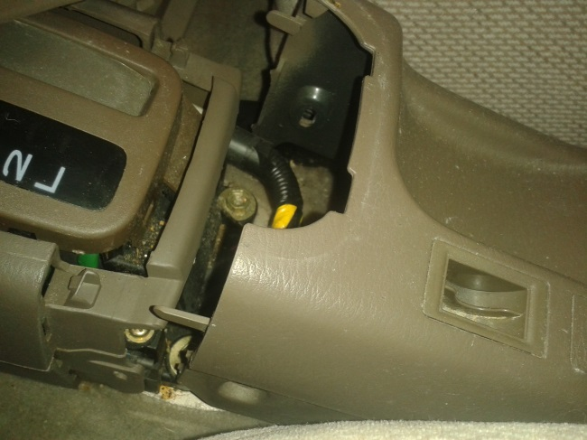

- Remove rubber cover to expose hand brake adjust nut.

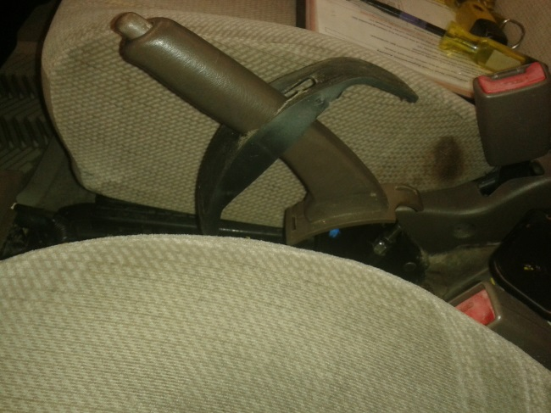

- Make adjustments and test
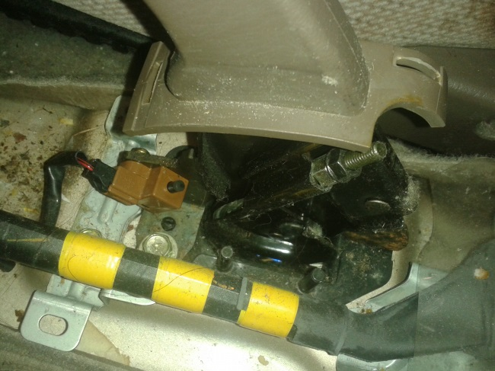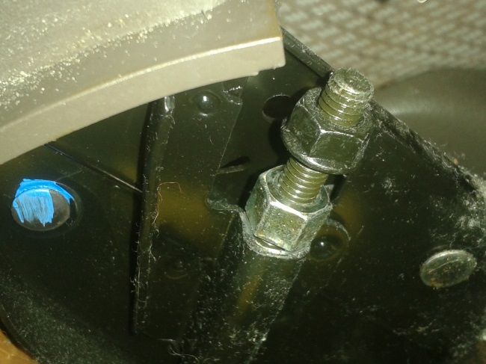
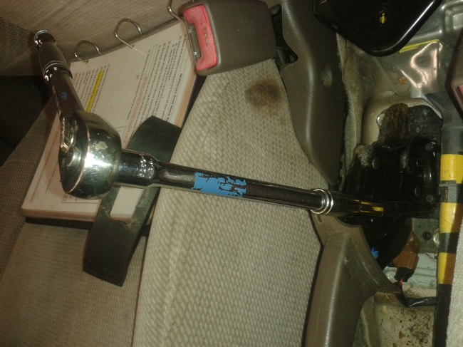

- Reassemble

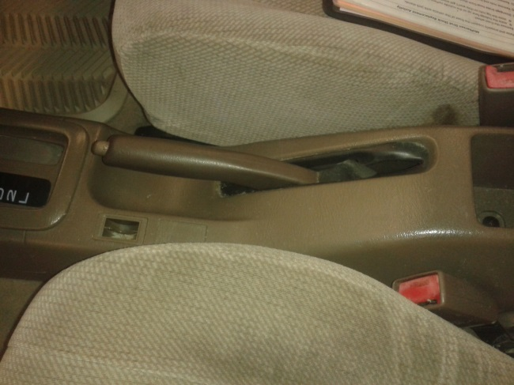

Questions: (to check comprehension)

- Why is it important to adjust cars parking brake?

- What special safety concerns could be an issue?

- How do you check the hand brake movement?

- How do you check the rear brakes?

- How do you adjust the movement of the hand brake leaver?

