A Reflection of School Visits and Field Trips

- October, Sixth, Twenty Fifteen. – University Hill School visit.
The schedule for October 6th is as follows:

First Period
8:40 - 10:00
Oct. 6 Engineering

Second Period
10:05 - 11:25
Oct. 6 Tech

Lunch
11:25 - 12:20

Third Period
12:20 - 1:45
Oct. 6 Drafting & Design

Fourth Period
1:50 - 3:03
Oct 6 Tech

Mr. Herb Lachelt is the only Tech. Ed. Teacher at University Hill Secondary School, he has one multi – purpose shop. The shop is located in a large area and has to accommodate all the shop disciplines, not exactly perfect for each shop activity but Herb makes it work. The students a well-mannered, polite, and discipline issues are at a minimum. The school has a population of approx. 650 students, it is new and has a pleasant atmosphere; there is a high Asian attendance at this school.

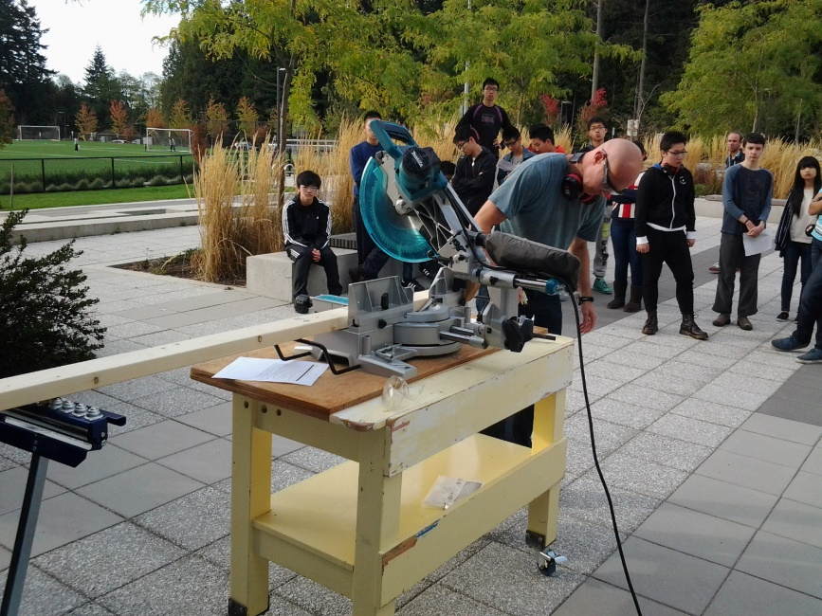 Herb doing a demonstration of miter saw

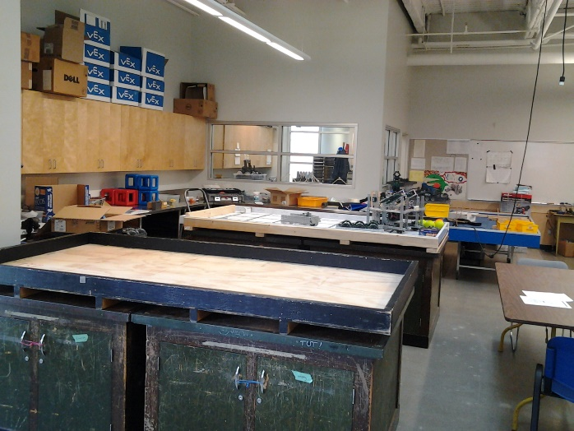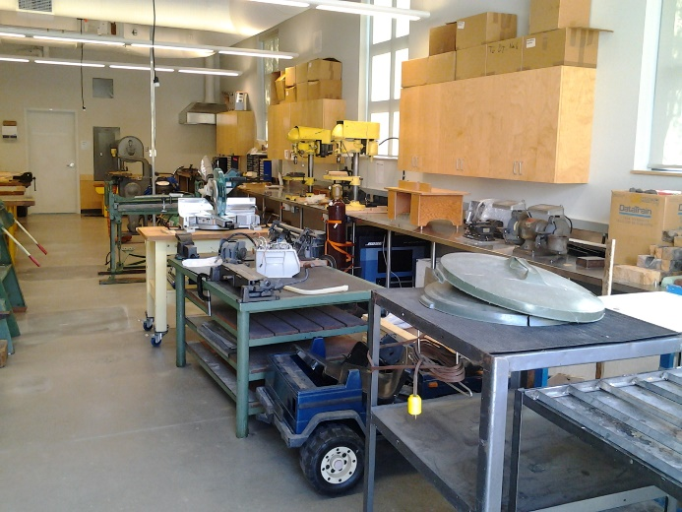
Shop areas (above) / Students engaged in a lesson (below)
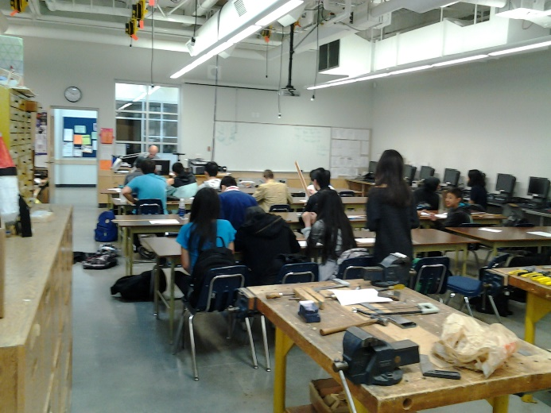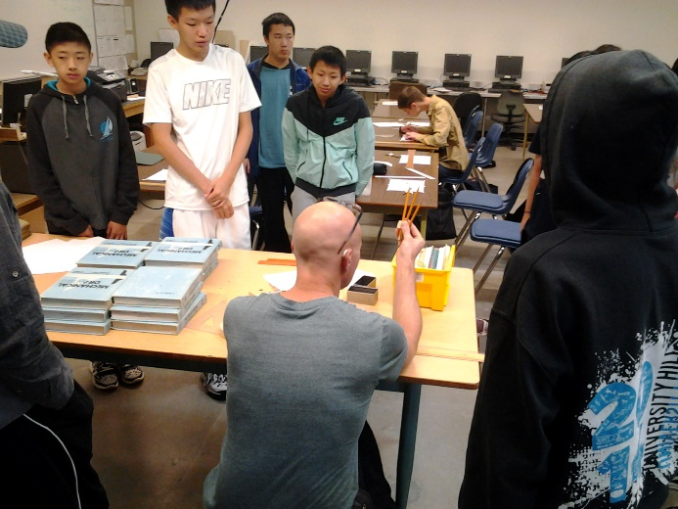
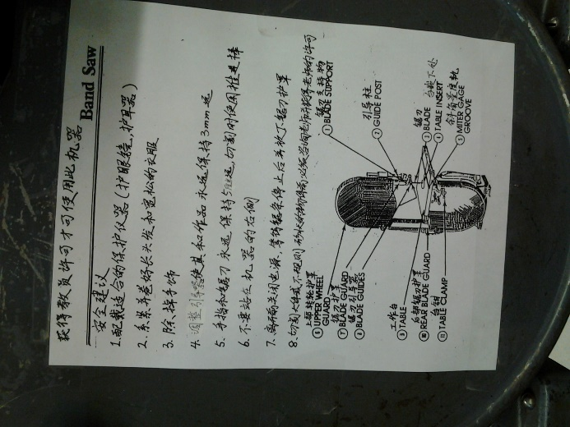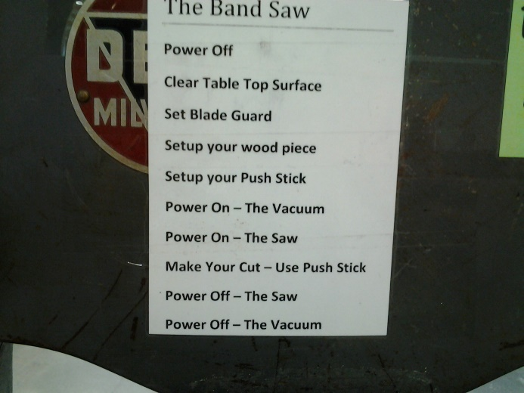

Multi – language equipment safety sheets

October, Thirteenth, Twenty Fifteen. – Surrey schools visit and the debriefing meetings at the DEC including SAIL
Kevin Fadum (A Surrey school district principle in the H.R. department) and Zale Darnel (The department head of Tech. Ed. At Princess Margaret Secondary School) acted as our hosts for the day while we were in Surrey. The Surrey school district is on the leading edge of education and always seeking the best learning opportunities for their students in order to prepare them for their future endeavours. The Surrey academy of innovation learning (SAIL) is one example of the districts commitment to current education, it combines science, technology, engineering, and mathematics. STEM and STEAM programs are here to stay and it is nice to know that the Surrey school district is on board with them and very supportive. The great thing about the Surrey school district is that all the schools differ in terms of demographics and the physical structure of the school, however there is a unity that made me feel that they were all connected. The student are the focus in school district 36 and are all part of the Surrey school family, which means they all have similar opportunities. The schools were built in a variety of different time periods, thus they all have their unique flavour and personality. Three things stood out for me during our visit to the Surrey school district:
- First thing that stood out for me was the passion of the administration in all the schools we visited. The principles and vise principle were encouraging and excited to show case their schools to use.
- Second thing that I noticed that every school district employee that I came into contact with on our site visit was very accommodating, professional, and pleasant. The feeling I was left with was very positive.
- Third thing the teachers in the shop areas and throughout the schools we visited give our group their time and wisdom, they willingly provided use with useful information and told us we could contact them if we had any further questions or needed additional support in terms of resources.
I would love to work in the Surrey school district, the students in the district come from a wide demographic back ground, but at the end of the day kids are kids and I enjoy working with them all. One question would like to pursue is how do Tech Ed. Teachers accommodate the non-academic and ESL learners in their programs? If I had charge of any of Surrey shop environments / classrooms I would precede slowly and methodical as not to waste money or time.

- October, Fourteenth, Twenty Fifteen. - Tour of the Museum of Anthropology

I enjoyed the museum of Anthropology and especially the first nation’s carvings this encounter created a lasting memory. I would like to do more research in this area, I was inspired by the collection of indigenous people’s masks. My imagination was sparked by the use of colour and the facial expressions of the masks. Definitely the great hall left a lasting impression on me due to the fact that totem poles located in this area are such monumental sculptures carved out of western red cedar, by indigenous peoples of British Columbia. The totem poles are so iconic to this province, they make me think of the famous paintings by Emily Carr; they had a lasting impression with me. The artifact that made me wonder about the indigenous technology was the dugout canoe in the great hall, I think it is fantastic that is was made from a single tree. The people who designed and crafted all the artifacts in the museum had skills/technologies that were incredible considering the fact that the people of that time and place had no modern tools or equipment. Before first contact the indigenous people of the Pacific North West coast lived a sustainable life style and work with nature and the environment, they left very little in terms of a carbon footprint or damage to the world. Sadly modern society cannot make such claims. I would love to be a part of an aboriginal program in a high school that I am teaching at in order to learn more about their culture. I will definitely will go back to the museum and I will bring family so they can share in the story of our first nation’s people and they will be able to experience the rich history and culture of our indigenous Canadians. The museum is a great place to take my children as it is a hands on exhibition were they can see, touch, feel, hear, smell' some of the objects in the museum. As a chef I am always interested in exploring food from different cultures, I a school setting it would be awesome to expose non aboriginal students to indigenous cuisines. In closing I would like to say thank you to Theresa.

