Chelsey:



- I was born in Vancouver and have lived here all of my life - but spend most holidays on Vancouver Island

- I have no siblings

- I live with my parents and 2 incredible pets – my cat Jewels is now 17 years old; my dog Roxy is 13 years old

 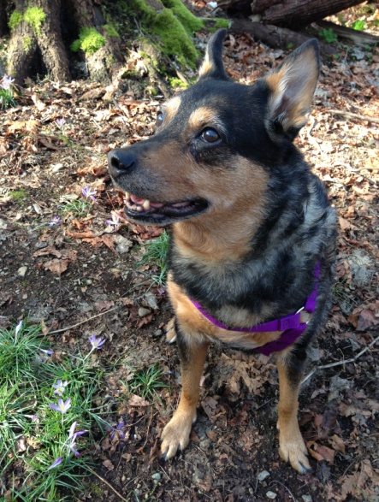

Jewels Roxy

- I live close to the Endowment lands and love to take my dog for walks in the forest

- I went to Southlands Elementary School and then Point Grey High School - except for Grade 10 when I attended the Trek Outdoor Education Program at Prince of Wales

- sports and outdoor activities have always been really important to me

- I started playing volleyball, soccer and softball in elementary school and continued throughout high school

- after graduating from Point Grey I received a softball and soccer scholarship and went to college in Georgia for 2 years

- I then attended UBC and played on the UBC varsity softball team for another 2 years

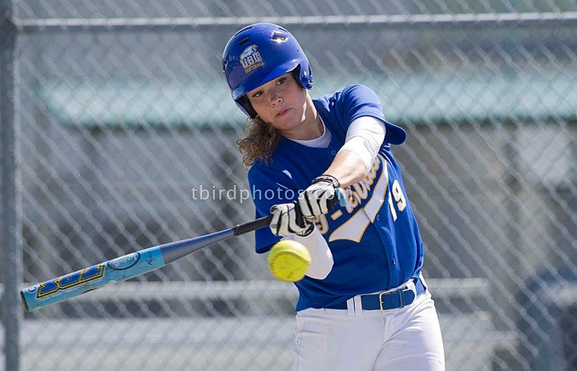

UBC Softball Team

- I graduated from UBC in 2012 with a Bachelor of Kinesiology and then entered the Faculty of Education so that I could become a teacher.

- in June I had a very exciting, 3 week, enhanced practicum at Horne Lake Provincial Park on Vancouver Island. I assisted with school programs involving cave exploration and outdoor education (e.g. canoeing, hiking, team building and camping)

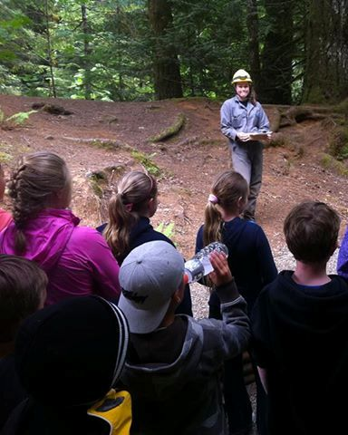 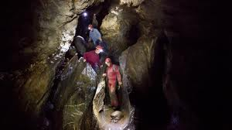

Horne Lake Provincial Park

- I have lots of hobbies: snowboarding, hiking, climbing, camping, ocean kayaking, cooking and traveling

- last summer I was very lucky to be able to travel to Spain and Morocco – and even ride on a camel!

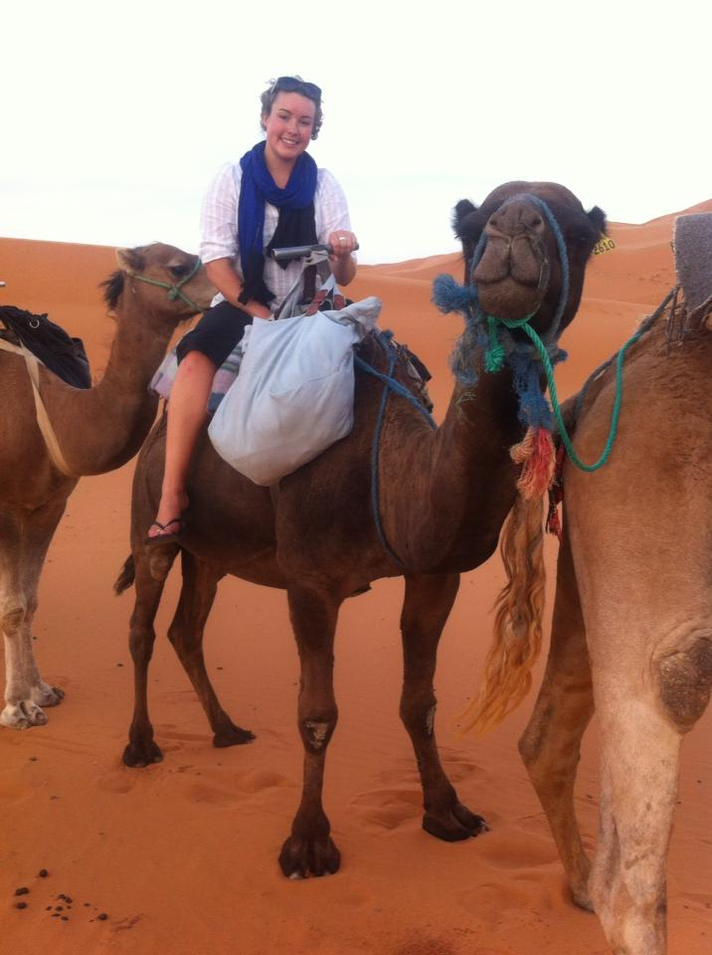

- I still play softball on a senior women’s rep team (Surrey Storm) and play rec volleyball and soccer at UBC

- for the past 2 years, I have also been an assistant coach on the Surrey Storm Rep A girls softball team. This year my team won the Provincial championships!

