Hello Team Peanuts,
The post below is my assignment on our practice for writing definitions. The term I have chosen is heuristics. In the context of psychology, this term is used when one is describing the difference between making rapid and reflexive decisions versus making slower yet more thorough decisions. I have explained this term through its etymology, history, negation and comparison and contrast.
Term: Heuristics
Parenthetical definition: Heuristics (mental shortcuts) are often used when we need to make quick decisions.
Sentence definition: Heuristics are our mental shortcuts that enable us to make quick and reflexive decisions on a day to day basis.
Expanded definitions:
The term heuristics originated from ancient Greek. The term heuristics is an irregular form of the Greek word heuriskein, which means to find or to discover. This concept was first named as satisficing by Herbert A. Simon when he conducted research on human decision making. Later, it was found that a similar concept had already been explored and had a term called heuriskein. With more research it was eventually named as heuristics. This term is to be understood with the Dual Process Theory. This theory states that there are two separate systems in decision making. The first system is our intuition and the second system is the analytical system. We often use heuristics to aid our intuitive decisions. Therefore, heuristics is present as part of the first system and not in the second system. An example of making an intuitive decision using heuristics would be to answer “butter” when asked to complete the phrase for “bread and…”. It is easy to complete the phrase with “butter” because it is often used together and hence when asked to complete the phrase, it is intuitive to jump to the word “butter” without critical thinking.
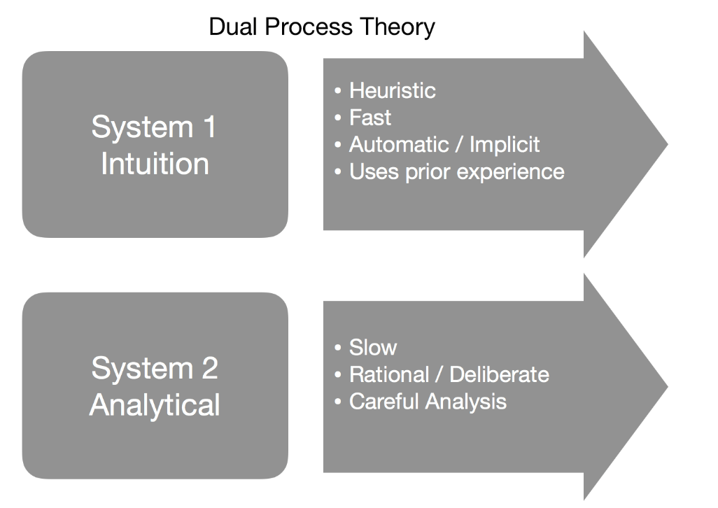

References
Cherry, K. (2019, June 17). How Heuristics Help You Make Quick Decisions or Biases. aaRetrieved from https://www.verywellmind.com/what-is-a-heuristic-2795235
Heuristics - Explanation and examples. Retrieved from aahttps://conceptually.org/concepts/heuristics
Manesh, R. (2017, December 7). Dual Process Theory Case 2. Retrieved from aahttps://www.slideshare.net/RezaManesh3/dual-process-theory-case-2
Parvini, N. (1970, January 1). Key Concepts: Dual-Process Theory, Heuristics and Biases. aaRetrieved from https://link.springer.com/chapter/10.1057/9781137543165_2

