XYZ PERIODONTAL CLINIC (514) 123-4567

WHAT IS PERIODONTITIS?
Welcome to the XYZ Periodontal Clinic family. Today you have been diagnosed with periodontitis (a dental condition also known as gum disease). Our staff is committed to the rehabilitation of your oral health. It is our goal to guide you through the challenges of periodontitis while preserving your teeth for as long as possible. We provide evidence-based treatment and are dedicated to providing our patients with accurate scientific information.

Now that introduced ourselves and gum disease, lets get a little more technical. Periodontitis is a serious gum infection that attacks the bone of your jaw. It is a chronic condition that can lead to tooth loss if left untreated.

Frequently Asked Questions:

How does periodontitis begin?
Bacterial plaque and tartar accumulation on teeth irritate the gums, causing gingivitis. If the build-up is not removed on a regular basis, the bone around the tooth will wear away.
Is gingivitis the same thing as periodontitis?
Gingivitis is a reversible condition that affects only the gingiva (gums). Symptoms include red, swollen, and bleeding gums. Periodontitis is an irreversible disease that affects the gums and destroys the bone of the jaw. Gingivitis is often the first sign of periodontitis.
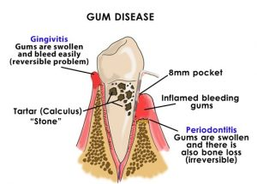(Barniv, 2018)
How is periodontitis diagnosed?
X-rays and measurement of the periodontal pocket depth are required for diagnosis.
What is a periodontal pocket and how is it measured?
A periodontal pocket is the space between the root of the tooth and the gum. A dental probe is used to measure the depth of the pocket. The probe is marked with lines, like a ruler, and is gently inserted vertically along the side of the tooth, under the gums. A deep periodontal pocket is unhealthy.
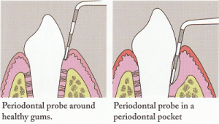(Healthsnap)
What causes periodontitis?
The most common risk factors for periodontitis are smoking, diabetes, heart disease, and stress.

We look forward to seeing you at your next appointment. Should you have any concerns or questions for our staff please to not hesitate to contact us. It would be our pleasure to assist you.

