Dear CARE team members,

In accordance to the instructions for assignment 1.3, I have provided several definitions for the term “body dysmorphic disorder”, which is a topic studied in many psychology classes, but also a prevalent issue in my field of study, kinesiology. Please feel free to contact me if you have any questions or concerns, and I look forward to receiving your feedback.

Sincerely,

Christine Pang

**Assignment 1.3**

**Introduction:**

The purpose of this assignment is for students to develop skills in defining terms in their discipline or profession in an suitable manner for a given audience. Students must appropriately make use of different levels of details in a definition to effectively communicate the term to their chosen audience and understand the importance of when to use definitions.

**Term:** body dysmorphic disorder

**Situation:**

First year university Kinesiology students are currently attending their first class of exercise psychology. All students have completed the prerequisite course of first year psychology and are prepared to focus primarily on health and fitness aspects in relation to psychology. The professor must effectively communicate the term “body dysmorphic disorder” to students in order for them to complete their upcoming assignment.

**Definitions:**

1. Parenthetical: Flawed/defected self-perception of bodily appearance
2. Sentence: Body dysmorphic disorder is a mental disorder characterized by consistent distress over perceived bodily flaws that are nonexistent to others. Individuals with body dysmorphic disorder engage in repetitive behaviors and experiences problems in social, occupational functioning.
3. Expanded Definitions
   1. **Negation**

Body dysmorphic disorder cannot be confused with body dissatisfaction, which is more common than the disorder. Body dissatisfaction is characterized by the discontent of the body, but it does not result in preoccupied distress and interfere with an individual’s daily life. Most individuals will be critical of their own appearance at times, but body dysmorphic disorder manifests more severely alongside maladaptive interpretations of one’s thoughts towards their own appearance.

* 1. **Required Conditions**

In order to recognize a patient with body dysmorphic disorder, an individual may be thinking about perceived defects on their body for three to eight hours per day, with common areas being the skin, hair, and nose. Shame, delusion, anxiety or depression can be caused by their distress, interfering with their social, financial, occupational, and psychological functioning. Repetitive behaviour may form due to concern over flaws that are non-existent, or barely noticeable to others. Individuals may consistently check themselves in mirrors, pick at their own flesh and skin, or find various ways to improve their own appearance, including using make up or exercising.

* 1. **Compare and Contrast**

Body dysmorphic disorder is categorized in the fifth edition of the Diagnostic and Statistical Manual of Mental Disorders under the broad category of “obsessive-compulsive and related disorders”. Body dysmorphic disorder shares common behaviours with obsessive compulsive disorder (OCD), which is a mental disorder characterized by excessive control over certain aspects of an individual’s life. Both conditions display repetitive behaviour or mental acts, in response to some form of concern. However, body dysmorphic disorder solely manifests from distress over one’s appearance, while OCD is more general, and can include a broader array of symptoms according to the course of one’s condition. Common symptoms of OCD may range from hand washing in response to fears of contamination, to intrusive thoughts that cause anxiety. Behaviours of body dysmorphic disorder are specifically aimed towards one’s body, which include mirror checking, excessive grooming, and comparing oneself to the appearance of others.

* 1. **Visual Definition**

The flow chart depicts the Cognitive-behavioural model, which outlines possible causes, symptoms, and triggers of body dysmorphic disorder. The column on the left emphasizes the life experiences, personality traits, and biological factors that can contribute to the development of the disorder. In the middle column, common thought processes of individuals with body dysmorphia is illustrated, where an ordinary appearance concern translates to obsessive and maladaptive interpretations, leading to feelings of anxiety, shame, and depression. Ultimately, coping strategies cycle back to inaccurate and harmful thoughts, which is also triggered by mood, external factors, and stress.

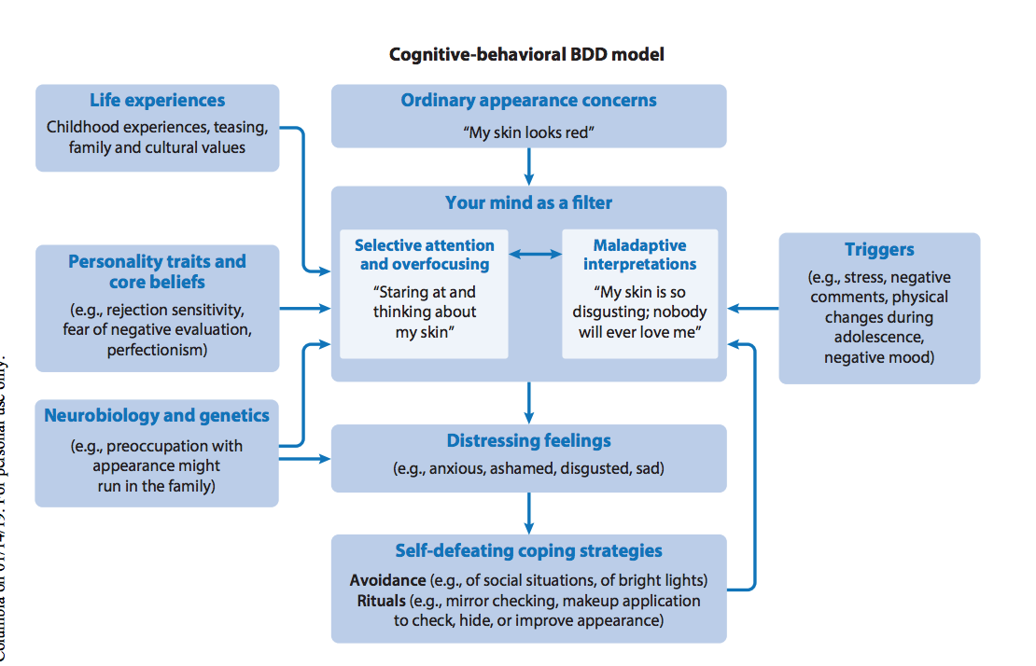

Figure 1: Flow chart depicting course of body dysmorphic disorder

Source: Fang, A., & Wilhelm, S. (2015). Clinical features, cognitive biases, and treatment of body dysmorphic disorder. Annual Review of Clinical Psychology, 11(1), 187-212. doi:10.1146/annurev-clinpsy-032814-112849

References

Fang, A., & Wilhelm, S. (2015). Clinical features, cognitive biases, and treatment of body dysmorphic disorder. *Annual Review of Clinical Psychology*, 11(1), 187-212. doi:10.1146/annurev-clinpsy-032814-112849

He, W., Shen, C., Wang, C., Jia, Y., Wang, J., & Wang, W. (2018). Body dysmorphic disorder patients: Their affective states, personality disorder functioning styles and body image concerns. *Personality and Individual Differences*, 131, 1-6. doi:10.1016/j.paid.2018.04.015

Vashi, N. A. (2016). Obsession with perfection: Body dysmorphia. *Clinics in Dermatology*, 34(6), 788-791. doi:10.1016/j.clindermatol.2016.04.006