Discovering Textures
Unit - Elements of Art  LAC Art  February 14, 18  Approximate number of classes- 2 |  |  | 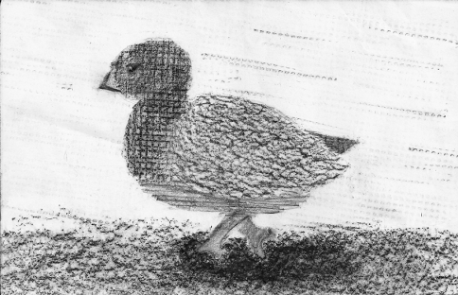

Lesson Overview & Objectives
The purpose of this lesson is to introduce the idea of texture to the students. Different textures tell different stories and are received with varying perceptions. The students will discover and differentiate between varieties of textures by creating rubbings of different surfaces using the frottage method.

Frottage
Derived from surrealism, it is a form of "automatic" drawing that was developed by Max Ernst

 | Activity
 | Begin by talking about the Surrealists and the development of automatic drawing. Surrealism is heavily based on dreaming and I encourage the students to think about their dreams. Show examples of surrealist artworks and examples of frottage art. Demonstrate the frottage method. Have the students decide on a variety of textures they would like to explore using this frottage method. They will have time to collect texture rubbings from various surfaces. They can combine textures on one paper or have them on separate sheets of paper. After the students have collected rubbings from at least 5 different textures, they will cut them out into shapes to form a drawing. A suggestion would be to make a Valentine's Day theme picture but they are not limited to it.
Materials
paper

pencils

crayons

glue

scissors

textured items from home

textured items from class

http://laemperatrizmariana.deviantart.com/art/Frottage-Coot-141934766

Colour My World
Unit - Elements of Art  LAC Art  February 20, 25, 27  Approximate number of classes- 3 |  |  | 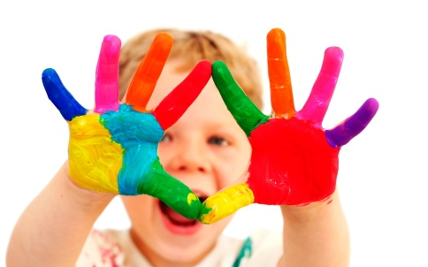

Lesson Overview & Objectives
Understanding colours and colour mixing is an important element to creating any piece of art work. Students will learn how to mix colours and create their own gradations. Students will also be using their knowledge of colour mixing to re-create the colours on a piece of fruit.

Colour Wheel
An abstract representation that shows the relationships between primary colours, secondary colours, and complementary colours

 | Activity
Begin by introducing them to the colour wheel. Understanding the basics of primary, secondary, and complementary colours will assist them in mixing their own palettes. Using the colour wheel, I will point out where the primary, secondary, and complementary colours are located. I will demonstrate how to mix secondary colours and different gradations that are possible. The students will complete a colour wheel worksheet.
The next assignment will involve the recreation of colours. They will begin by painting a piece of fruit opaque white (let's say an apple). After this dries, they will attempt to recreate the colours of the real apple with paint. This should test their colour mixing skills.

Materials
colour wheel handout
acrylic paint
brushes
water buckets
palettes
fruit

http://1ms.net/baby-colours-79209.html | http://en.wikipedia.org/wiki/Color_wheel

Contour Drawing
Unit - Drawing  LAC Art  March 3  Approximate number of classes- 1 |  |  | 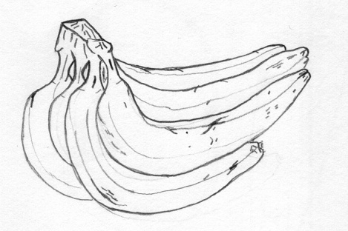

Lesson Overview & Objectives
Learning contour drawing will allow the students envision and capture an object with weight without a keen focus on the details. Contour drawing will teach the students to "free" up their drawing styles. It will also require a use of their observation skills rather than drawing from memory or preconceived ideas. This will hopefully give them confidence to draw fluidly without the fear of making mistakes.

Contour
A French word that means "outline". Contour drawing emphasizes mass and volume of the subject.

 | Activity
 | Begin by giving a demonstration about contour drawing. I will show them two techniques: point contour drawing and blind contour drawing. Placing a still object(s) where all of the students can see, each student will attempt to do both point and blind contour of the still object. An emphasis will be placed on a continuous line and not sketching. Several rearrangements will be made to the objects or new objects will be added for practice.
Materials
paper

pencils

miscellaneous objects

http://en.wikipedia.org/wiki/Contour_drawing | http://creativealchemia.com/2011/05/drawing_and_composition_studie.html

Shading
Unit - Drawing  LAC Art  Week 4 - March 3, 5,  Approximate number of classes- 2 |  |  | 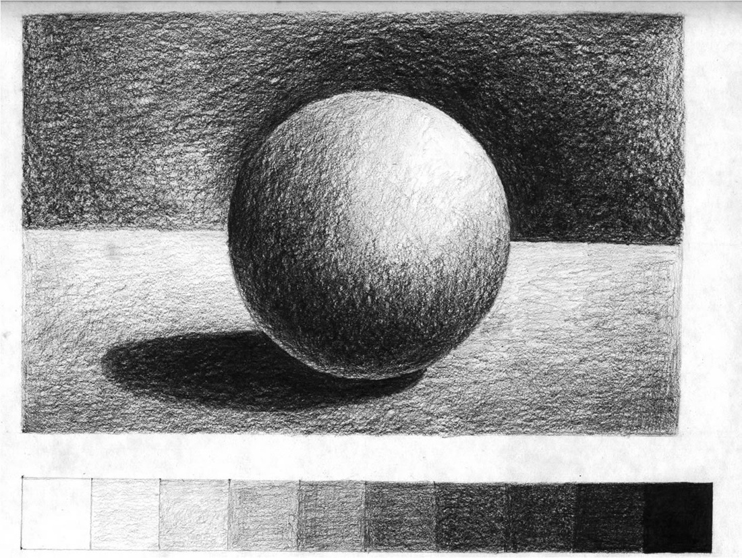

Lesson Overview & Objectives
Sketching Techniques
Hatching - use of closely spaced parallel lines to create tonal effects
Crosshatching - use of fine parallel lines drawn closely together at right angles to create mesh-like pattern
Pointillism - series of dots used to create tonal effects

Capturing the actual dimensions of an object will require the addition of depth and protrusions. Learning the techniques to shade will give the object a 3-Dimensional feel. This will make it appear more lifelike rather than flat images on a piece of paper.

 | Activity
 | Begin by showing different examples of shading and demonstrate three types of shading. Shading will be done on handouts and with pencils. I will show several techniques of shading: blending, hatching, crosshatching, pointillism. The three techniques will be done over a span of 2 days. The first day will be an introduction worksheet. The second day will involve drawing an object (crumpled piece of paper) putting those techniques into use.
Materials
pencils (HB, 2B, 4B, 6B)
paper
handout
q-tips
erasers
scrap paper/magazines

http://monologues.co.uk/Portraits/BlendShade.htm

Transformation
Unit - Drawing  LAC Art  Week 4 - March 7  Approximate number of classes- 1 |  |  | 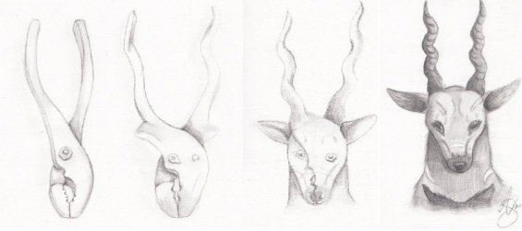

Lesson Overview & Objectives
Morph
To change smoothly from one image to another by small gradual steps
This project will test their creative skills and challenge their thought processes by imagining a transformation or morphing of an object in its various stages. This activity will require a strong use of observation skills.

 | Activity
Materials
pencils
paper
materials from home
materials from class

The demonstration will have me look at two objects. With the paper folded into four sections (horizontally), the first object will be drawn in the first square. The second object will be drawn in the fourth square. The creative thought process will be needed to envision the second and the third boxes. The students will attempt their own transformation from two objects they select in class.

http://shockley23.deviantart.com/art/Morph-Drawing-School-drawing-262765905 | Lesson plan courtesy of Joshua Schweitzer

Impressionism & Post Impressionism
Unit - Art History  LAC Art  Week 5-6 - March 11, 13, 31  Approximate number of classes- 3 |  |  | 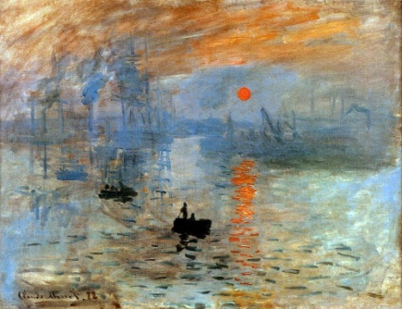

Lesson Overview & Objectives
Key points
Impressionism:
Claude Monet
Edgar Degas
Edouard Manet
Berthe Morisot
Camille Pissaro

-small, thin, visible brush strokes
-emphasis on accurate depiction of light
-unusual visual angles

Post Impressionism:
Georges Seurat
Paul Cezanne
Paul Gauguin
Vincent van Gogh

-the French art development since Manet
-extended Impressionism while rejecting its limitations
-use of vivid colours
-thick application of paint
-real life subject matter
-emphasize geometric forms
-use of unnatural colours
This mini unit will introduce the Impressionist and Post-Impressionist art movements from the 19th century. Artists and their works will be shown in class and techniques that make up this movement will be discussed. The students will partake in their own practice of Impressionist painting techniques by going outside and doing works en plein air.

 | Activity
Materials
acrylic paint
brushes & q-tips
water buckets
palettes
paper
images of Impressionist & Post Impressionist works
Begin by introducing the Impressionist art movement to the students and why it is important in the history of art. This entails showing them different artists and their paintings and techniques. I will facilitate group discussions around different paintings. A couple of activities will take place after. One will be painting in the style of Georges Seurat (Post-Impressionist) that will be done in doors using the pointillism technique. They will use q-tips for this project. the second project will entail them to go outside to paint. This will expose them to painting outdoor scenery in the style of en plein air. I will demonstrate both the pointillism and en plein air technique.

http://en.wikipedia.org/wiki/Impressionism | http://www.artic.edu/aic/collections/exhibitions/Impressionism/resource/503 | http://en.wikipedia.org/wiki/Post-Impressionism

Surrealism
Unit - Art History  LAC Art  Week 6 - April 2, 4  Approximate number of classes- 2 |  |  | 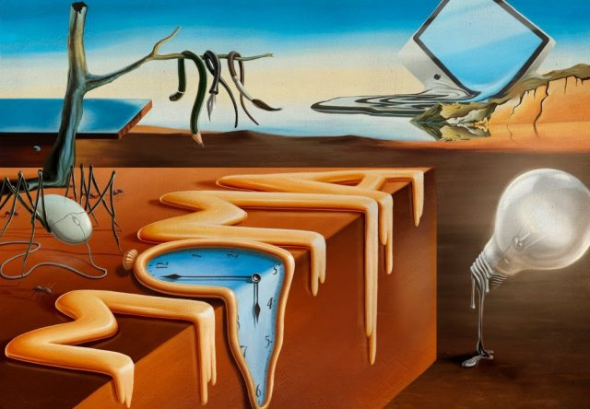

Lesson Overview & Objectives
Key points
Andre Breton
Salvador Dali
Max Ernst
Rene Magritte

-cultural movement that began in the early 1920s
-developed out of Dada activities during WWI
-their aim was "to resolve the previously contradictory conditions of dream and reality"
-unnerving, illogical scenes with photographic precision, created strange creatures from everyday objects and developed techniques that allowed unconscious to express itself
This mini unit will introduce the students to the early 20th century art movement of Surrealism. The historical significance of Surrealism will be discussed as well as artists that worked in this movement. The style of Surrealism has its roots in dreaming and juxtaposition of uncanny objects creating strange and often times, illogical scenes. Students will need to partake in the exercise of constructing or reconstructing their dreams in a Surrealist fashion. This will be done through mixed media.

 | Activity
Materials
paper
pencils, erasers
pencil crayons
paint, brushes, palette, water
magazines
crayons
glue
scissors
images of Surrealist art
handouts - colour, shape

The demonstration will introduce the Surrealist art movement to the students. I will talk about the different artists who worked in this style as well as display their art. I will place an emphasis on dreaming and illogical scenes and thoughts. The first activity will require the students to work on a handout about shapes and colour. Each table will be given a Surrealist image to dissect. They must identify major shapes and colours they see in the painting. After this, a group discussion will be had about what they think the paintings represent. The next activity will require them to think of a dream they had and recreate it in a Surrealist style using the collage method. They are encouraged to use paint, crayons, pencils and other materials in their collage.

http://digital-art-gallery.com/picture/6951 | http://en.wikipedia.org/wiki/Surrealism

Pounded Flowers
Unit - Bringing the Outside In  LAC Art  Week 7 - April 8, 10  Approximate number of classes- 2 |  |  | 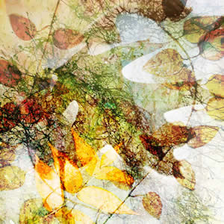

Lesson Overview & Objectives
Pounded Flowers
The process of leaching natural dyes from the flowers or foliage as a result of pounding them in between sheets of paper or fabric.

This mini unit will introduce the students to working with nature and the environment. Topics covered include creating art from nature and recycled materials. In addition to this, the students will learn about endangered animals through collaborative and individual work.

 | Activity
Materials
paper
pencils, erasers
pencil crayons
paint, brushes, palette, water
cardstock - postcard & card
paper
hammer (2-3)
brown bags
foliage

This simple activity requires the students to collect flowers and foliage from the outside and placing them on a piece of paper/ card, gently hammer the flowers so that an impression of the flowers is left on the paper/card. I will demonstrate how to do this as well as talk about the safety precautions of using the hammer. This activity will require the students to go outside to collect their plants as well as to hammer their piece. The students are encouraged to make cards, postcards, book covers etc. with their pounded flower designs. They will further decorate their designs the following class with other art materials.

http://www.unionstreetgallery.org/multiplicity.htm

Recycled Art
Unit - Bringing the Outside In  LAC Art  Week 8 - April 14  Approximate number of classes- 1 |  |  | 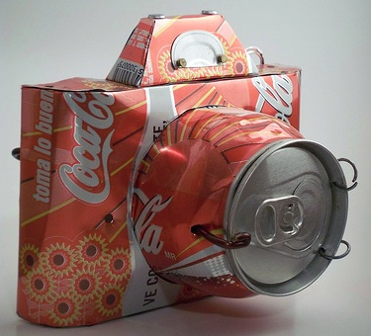

Lesson Overview & Objectives
Upcycling
The process of converting waste materials or useless products into new materials or products of better quality.

This mini unit will introduce the students to working with nature and the environment. Topics covered include creating art from nature and recycled materials. In addition to this, the students will learn about endangered animals through collaborative and individual work.

 | Activity
Materials
paper
pencils, erasers
pencil crayons
paint, brushes, palette, water
glue
scissors
tape
recycled items

This activity will require an explanation from me about reusing old materials to make something new. The repurposing of recycled materials (making something old into something new) is something that is not only good for the environment, but its transformative process revives old materials into something beautiful. The demonstration will require me to use a variety of recycled materials and creating a sculpture (or it can be 2D) that represents my community. I want the students to engage in critical thinking about their community, in all senses of the word, and create an art piece out of the selection of recycled items I will provide.

http://en.wikipedia.org/wiki/Upcycling | http://volumeone.org/news/1/posts/2009/10/07/1290_UW_Stout_hosts_recycled_art_competition

Easter Eggs
Unit - Holiday Fun  LAC Art  Week 8 - April 16  Approximate number of classes- 1 |  |  | 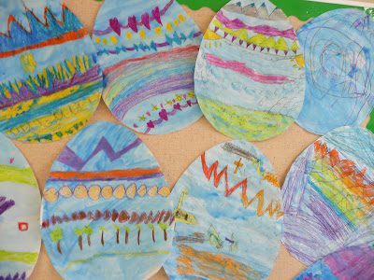

Lesson Overview & Objectives
Easter Eggs
Also known as "Paschal eggs". The practice of decorating eggshells is ancient, pre-dating Christian traditions. The custom of the Easter egg, however, originated in the early Christians of Mesopotamia who stained eggs red in memory of the blood of Christ.

Today's lesson is designed to celebrate the traditional festivities and crafts associated with Easter. In this activity, the students will have the opportunity to design an Easter egg that represents them. They are encouraged to think "outside of the box" and create unconventional designs.

 | Activity
Materials
egg template
paper
crayons
water colour
brushes, water, palette
glue
scissors
tape

This activity will be done with an egg template that I will provide to the students. They will need to come up with an Easter egg design that is based on their own personality. These personalized eggs will then be displayed together in a long banner for everyone to see! The activity begins with a pencil sketch of the design. They will then colour it in with crayons and watercolour as the last stage.

Courtesy of http://www.thatartistwoman.org/2012/03/easy-easter-art-project.html | http://en.wikipedia.org/wiki/Easter_egg

Endangered Animals
Unit - Bringing the Outside In  LAC Art  Week 9 - April 22, 24  Approximate number of classes- 2 |  |  | 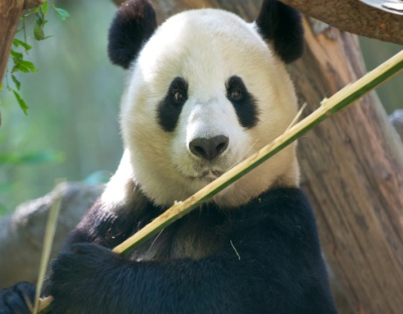

Lesson Overview & Objectives
Endangered Species
Species of organisms that will likely become extinct. The list includes animals and plants.

Another issue that will be covered during the environment unit is endangered species, particularly endangered animals. I myself am an animal lover so I would like to make my students aware of how many endangered animals there are, where they live, and why we need to protect them.

 | Activity
Materials
endangered animals fact sheets
large map of the world
pencils, erasers
crayons, pencil crayons
oil pastels

Learning about endangered animals will consist of a fun group activity. I will provide a large world map with all the continents. I will also provide "fact sheets" on various endangered animals from each of the continents that the students will refer to for the project. I will divide the map into three sheets: North America & South America; Europe & Africa; and Asia and Australia/ Oceania. The students will partner up and choose an animal of interest. They must refer to the fact sheet on that animal and begin to "draw in" the information on the respective continent. The drawings should include a picture of the animal, their habitat, and food they eat. The goal is to learn how to work collaboratively and to understand the plight of some of their favourite animals. Once the map is done, it will be put together for all the students to see. A discussion will be lead by me on what they learned about endangered animals and the environment.

http://www.kidsplanet.org/factsheets/map.html | http://en.wikipedia.org/wiki/Endangered

