Photograms
Unit –Narratives  Photography 10  Week 4 - April 3 to 11  Approximate number of classes- 4 |  |  | 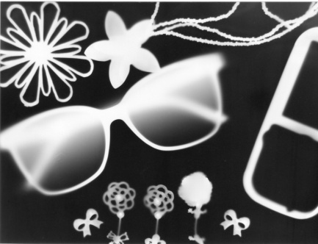
Materials
Camera (film or phone)
Darkroom
Film
Photo paper
Darkroom
Darkroom chemicals -developer, fix, stop, rinse
Scissors
Glue
Various materials

Lesson Overview & Objectives
Photogram
Is a photographic image made without a camera by placing objects directly onto the surface of a light-sensitive material such as photographic paper and then exposing it to light. The usual result is a negative shadow image that shows variations in tone that depends upon the transparency of the objects used.

Artists:
Man Ray
Laszlo Moholy-Nagy

This is a fun, hands on activity that will explore the idea of light exposure on photo sensitive paper. The students will have the opportunity to experiment with different items and exposure times. The goal of the project is to find items that represent their aspirations in life.

 | Activity
 | I will introduce the idea of photograms by showing examples to the students and doing a full demonstration in the darkroom on how to create them. I will show various exposure times and materials develop on photo sensitive paper. I will talk about different artists that have worked with photograms. The concept of this project will be to develop a photogram with items from home that represent their personal aspirations in life (career, relationships, spiritual). When the project is complete, each of the students will present their photograms to the class.

http://sophiebeaudry9.blogspot.ca/2012_09_01_archive.html | http://www.ephotozine.com/article/making-a-photogram---traditional-darkroom-ideas-4688 | http://en.wikipedia.org/wiki/Photogram

