HR Analytics Memo

# Finding One: Rainy Days with High Temperatures

## Decision Tree Excerpt

From this branch of the tree, we can see that on days where the Outlook is Rainy, and the Temperature is above 69 degrees Fahrenheit, we have never played more than 45 minutes.

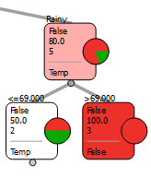

## Select Attributes Window

The tree shown above was made with the following attributes.

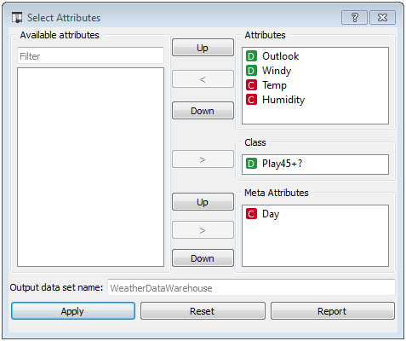

## Charts and Statistics



## Discussion

<Discuss the charts above. What might you conclude? Is there more than one way of looking at this finding? What recommendations might you make based on this finding? If you don’t have any recommendations, explain why.>

# Finding Two: <>

## Decision Tree Excerpt

<xxx>

## Select Attributes Window

<xxx>

## Charts and Statistics

<xxx>