English 301 Revised Qingzhou (Colby) Song
Introduction
The following blog contains a parenthetical, sentence and expanded definition of the term in vitro fertilization. The expanded definition includes an etymological background, technical background, operation principles and visuals to help define the term. The objective of this exercise is to practice writing to a non-technical audience and understand the level of details required in different situations to help the readers understand the term.
Parenthetical Definition:
A possible way to treat infertility related problems in both male and female is through in vitro fertilization (joining of egg and sperm outside of the body).
Sentence Definition:
In vitro fertilization is a form of assisted reproductive technology which helps a woman become pregnant through the joining of a woman’s egg and a man’s sperm in laboratory conditions.
Expanded Definition:
What is In vitro fertilization?
In vitro fertilization (IVF) is a form of assisted reproductive technology that uses special medical procedures to help a woman become pregnant. The term in vitro originates from Latin which means in glass, and fertilization is the union of an egg and sperm inside a woman’s body. Therefore, the term in vitro fertilization literally means the union of an egg and sperm outside of the body or in a laboratory.
Why is it used?
In vitro fertilization (IVF) is one of the methods recommended for couples who want a baby but are experiencing fertility problems. Such fertility problems include advanced age of the woman, blocked or damaged fallopian tube (site of fertilization in the female body), decreased sperm count and when fertility drugs fail to be effective. In all of the above cases, the patients are not able to conceive naturally and therefore require assisted reproductive technology such as IVF to help pregnancy.
What is the procedure?
Fertility drugs are first given to the woman to boost egg production. A minor surgery will then be done to retrieve the eggs from the woman’s body. The retrieved eggs will then be incubated with the man’s sperm in an environmentally controlled chamber (in vitro). When the egg is correctly fertilized (successful union of egg and sperm), it becomes an embryo which is the baby at its earliest stage of development. The resulting embryo will then be placed back into the woman’s womb and pregnancy results.
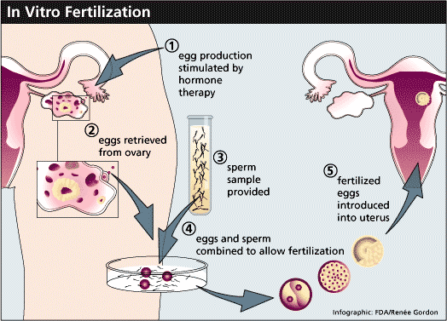
Figure.1 In vitro fertilization process
Source: http://www.mexicalihealthcare.com/procedure/In-Vitro-Fertilization/21
What are the risks?
Fertility drugs taken to increase egg production may cause headaches, nausea and other unwanted side effects. Multiple births are possible if more than one embryo is transferred into the womb during the last stage of procedure. This leads to an increased risk of having a premature baby or low birth weight. It is also possible that the embryo does not get implanted properly back into womb and lead to pregnancy that develops outside of the womb. This can cause serious problems such as rupture of fallopian tubes and internal bleeding.
Conclusion
In vitro fertilization is a technical term used in the medical field. Through the use of expanded definition and additional strategies, technical terms can be clearly explained to a non-technical audience. In my writing, I broke down the term in to sub-sections such as etymology and operating principles along with the help of visuals and examples to guide a non-technical audience in understanding the term.

Works Cited:
"Fertility Treatment: In Vitro Fertilisation (IVF)." BabyCentre. Web. 20 Jan. 2015. <http://www.babycentre.co.uk/a4094/fertility-treatment-in-vitro-fertilisation-ivf>.
"IVF - About In Vitro Fertilisation (IVF)." Human Fertilisation Embryology Authority. Web. 20 Jan. 2015. <http://www.hfea.gov.uk/IVF.html>.
"In Vitro Fertilization (IVF): MedlinePlus Medical Encyclopedia." U.S National Library of Medicine. U.S. National Library of Medicine. Web. 20 Jan. 2015. <http://www.nlm.nih.gov/medlineplus/ency/article/007279.htm>.

