Culture Jamming
Depo-Provera Advertisement

Depo-Provera is the brand name of a commonly prescribed contraceptive injection. The attached magazine advertisement shows a middle-aged woman in her chaotic home environment looking after her two children and dog. The quote for the ad reads, “Things are crazy enough around here. I don’t need the hassle of daily birth control.”

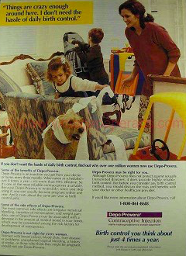
There are a number of problems with this advertisement, and the most glaring theme presented is the heteronormative depiction of middle-aged female life. The advertisement suggests that it is the woman’s sole responsibility to not only care for the home, children, and family pet, but also to ensure that she is using an effective birth control method to prevent future pregnancy. There is no mention of male responsibility in the role of contraception and safe sex, which promulgates the notion that beyond the act which causes pregnancy, men do not need to be involved.
Another theme of the advertisement lies in its portrayal of the convenience of the contraceptive injection. The advertisement suggests that there is something wrong with using a birth control method which is not convenient, such as barrier methods or family planning (which are much safer alternatives - more on that later). This push for convenience creates the impression that women are incapable of remembering to do simple tasks, such as taking a pill once a day (or conversely, of tracking her fertility window with family planning, or using a diaphragm correctly). There appears to be an underlying assumption that it is wrong in our society to inconvenience the sexual experience of men by having them use condoms or practice withdrawal. Instead, it seems that more drastic and hormone-altering forms of contraception are favored (as long as the female is the subject of alteration).

The image below is my jammed version of the advertisement. In the jammed version of the advertisement, I show the same woman as the original ad, but she is physically limited by crutches and a cast for her broken hip. The quote and tag line are replaced with statements regarding the safety of Depo-Provera, and the grave reality that women are expected to live with otherwise unacceptable side affects for the convenience of an injectable contraceptive.
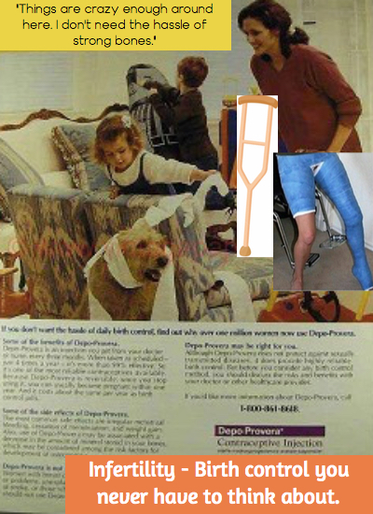

In my alteration, I replaced the quote with “Things are crazy enough around here. I don’t need the hassle of strong bones” to depict the underlying cultural assumption that the health risks associated with women who use aggressive forms of birth control are acceptable. In 2004, the U.S. Food and Drug Administration published a warning that long term use of Depo-Provera has potentially irreversible effects on bone mineral density (Ford, Saibil, 2010). Even so, Depo-Provera is commonly prescribed, especially to disadvantaged women (Ford, Saibil, 2010). This advertisement confirms the sexual inequality prevalent in the practice of contraception in our society. Though numerous forms of birth control are prescribed and marketed to women, there are only two forms available to men – the male condom and vasectomy. Chemical-based birth control for men has been created, but its introduction to the market has been slowed due to the obstacle of breaking down the sexist norms surrounding contraception (Gray, 2017).
I also replaced the tag line with, “Infertility – Birth control you never have to think about” to point out that the risks and side effects associated with contraception seem to become more severe as the efficacy of birth control increases. More appallingly, the seriousness of side effects of contraception, and available options on the market, are not effectively discussed in doctors visits (Ford, Saibil, 2010). Safer birth control methods – such as withdrawal, family planning, condoms, diaphragms, etc. – do not seem as highly recommended because of their higher failure rates. It should be up to the user to decide how high of a risk for pregnancy is acceptable. A woman may favor an option with a slightly higher risk of pregnancy if that option does not alter the levels of hormones in her body. This highlights a pattern of paternalism in our society where doctors and the pharmaceutical industry make value judgements of risk on behalf of their patients (Ford, Saibil, 2010).
Overall, I wanted to demonstrate that an accurate portrayal of a woman who uses Depo-Provera is laden with gender inequality. The practice of this inequality is effective due to the heteronormative and sexist nature of contraception advertising and education.

Resources

Ford, R., Saibil, A., Saibil, D. (2010). The push to prescribe: Women and Canadian drug policy. Toronto, ON. Women’s Press.

Gray, D. (2017). Will men ever embrace male birth control? Retrieved from Healthline Media website: https://www.healthline.com/health-news/male-birth-control#1

