Mini-Report Diagnostic

Comm 390

Consider the pictures below and write a short (1-1.5 pages) well reasoned argument answering the question:

Should we update the lobby of our small hotel?

We are a small hotel, called The Little Hotel, with only one location. We’ve been at this location since 1970, the last interior renovation was in 1997.

This report does not require research and must be competed within 1 hour and submitted via turnitin.

Write clearly and legibly and explain yourself thoroughly without being repetitive. You will probably have about 4-7 paragraphs and may use bullet points, headings or any other formatting you feel will help you build a clear and strong argument. You will need to take some time to plan before you begin writing.

You will have to make some asssuptions including target market and budget, so state these clearly early on in your report.

Our existing lobby:
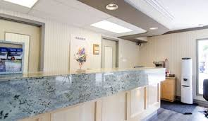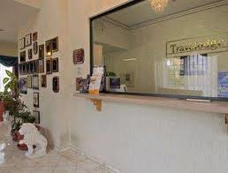

Some small lobbies we like:

