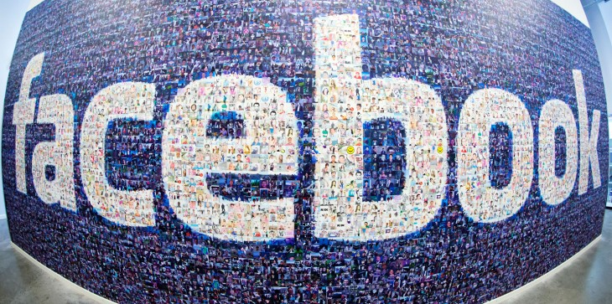
https://thenextweb.com/facebook/2014/02/16/facebook-10-moved-just-social-network-impact-lives/

Social media exist in everywhere in our life, such as Facebook, Instagram, WeChat and microblog. Social media is different from traditional media; people can get through the internet to express their viewpoint and also the people can get through social media to know other people's necessary information.

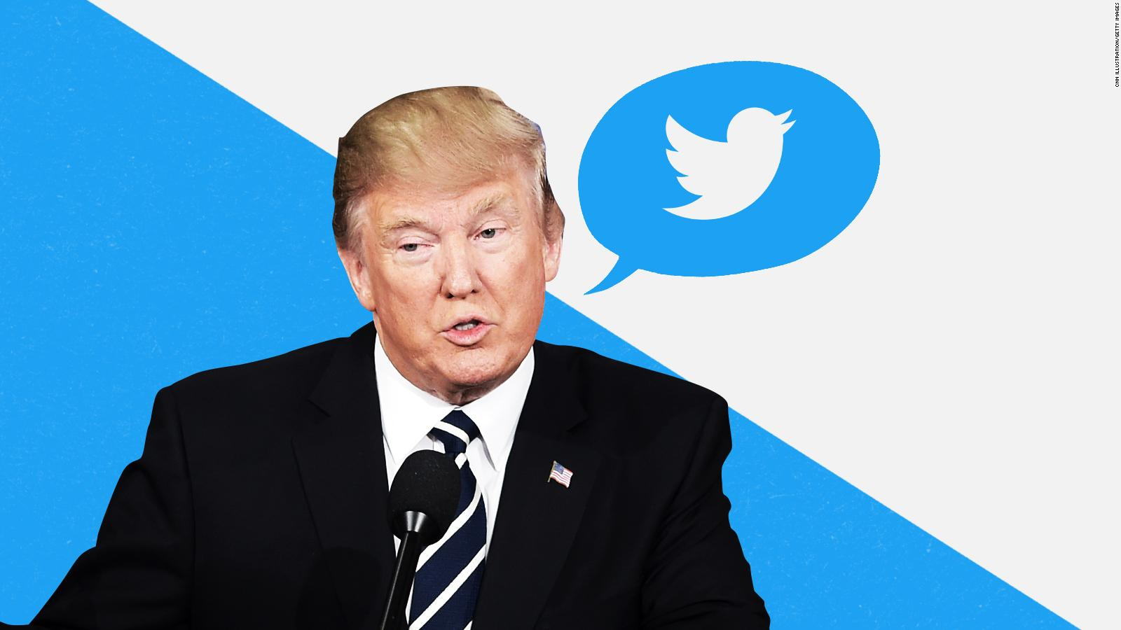

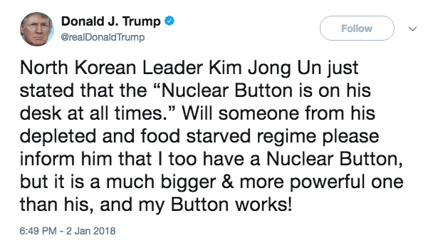

https://www.google.com/search?q=Trump+twitter&source=lnms&tbm=isch&sa=X&ved=0ahUKEwi-i_POwbveAhWqiFQKHQLcBaQQ_AUIDygC&biw=1031&bih=593#imgrc=eQmMEUcBWQPqGM:

Donald Trump through Twitter to instead traditional media which is the new way, the U.S. president never uses this way before, Donald Trump has any ideas and even his state of mind he posts on Twitter. He is a controversial person in the world, he does not trust media, he challenged the political correctness, but I have to say the twitter as a social media , the audience can not get first-hand material from CNN , BBC those media moguls but they could get from social media, that is already sparking
controversy, when Trump use Twitter to express his opinion it always lead to magnify problem . When traditional media publish news, it will consider whether content able to accept to all the audience, but Trump does not believe that that result in his supporter take his viewpoint, but his objector dislike him.

The Instagram phenomenon - Evolving Materialism

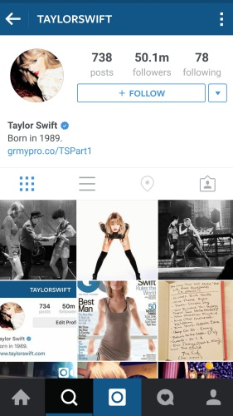

https://www.hardwarezone.com.sg/tech-news-top-five-most-followed-instagram-accounts-belong-female-celebrities

Instagram is common social software for Yonge generation, after the industrial revolution, the people change their consumption concept, the people more materialization. Before social media around us the people just want to through working hard move toward to successful , we called American dream that is " When you come to America, there is a lot of opportunity for everyone, and everybody is equal", and also the people just silently pay does not have complained and regret our society. But the reason why Instagram is so famous for young generation because Instagram provides a platform, the young age can upload their picture and video on it, even broadcast what they do in their daily life. They more likely to buy the number of fans in Instagram to define their status in society and also define whether the community respects them or not recognize them, it is ridiculous, as far as I am concerned personal value should contribute to, and you will get respect from society. Even sometimes Instagram shows is not the people's real life but they still hope through Instagram let other people think they live better in life. And sometimes Instagram will show some luxury lifestyles, that make Yonge people more materialism, but the Instagram make the people's distance closer, it changed traditional social formation.

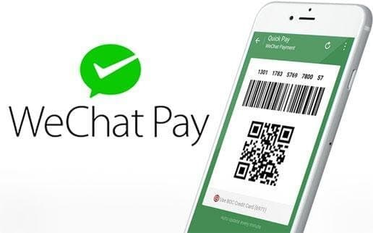

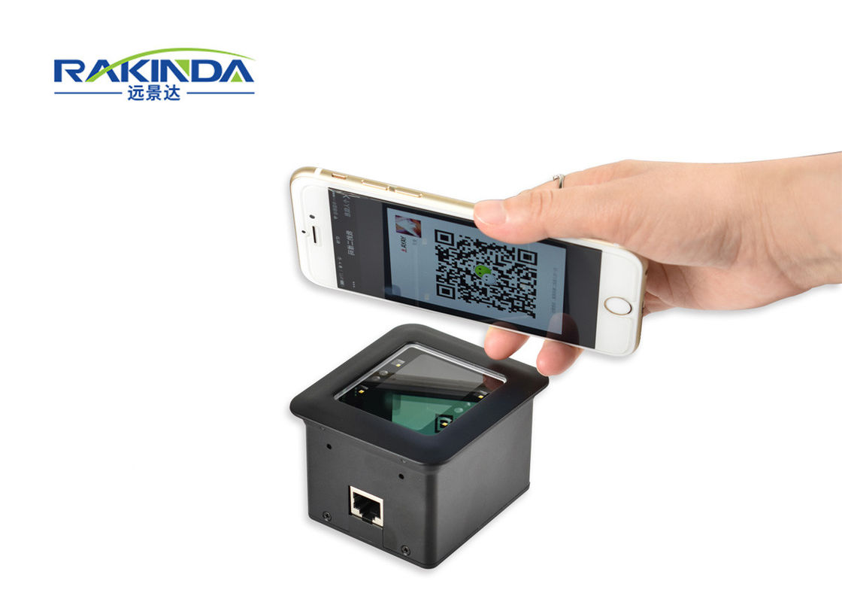

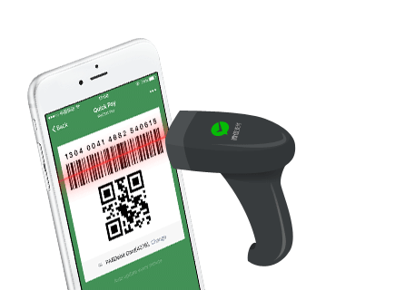

https://www.google.com/search?q=wechat+pay&source=lnms&tbm=isch&sa=X&ved=0ahUKEwjRsfj45rveAhVEGTQIHRxzCrMQ_AUIDigB&biw=1031&bih=593#imgrc=KGtNmP25PWqkIM:

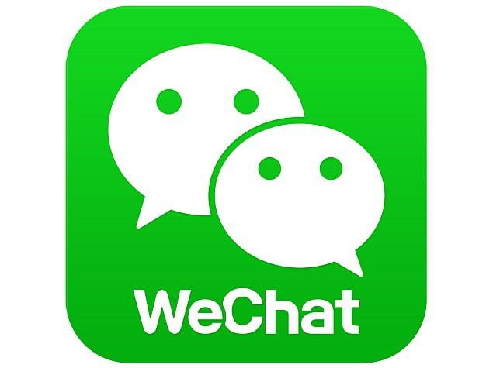

https://www.google.com/search?q=we+chat&source=lnms&tbm=isch&sa=X&ved=0ahUKEwjal5bM5bveAhVtIDQIHc5tA3IQ_AUIDigB&biw=1031&bih=593#imgrc=dEr24-_i2gG2SM:

I am going to talk about the most critical social media software; it creates a new society in China. The WeChat include functions about Facebook,Facetime, and wallet. The people are really convenience social media software in China, the people can use that for messages, phone call/video call, and through WeChat transfer money , and purchase anything it just need to scan the QR code and then that means payment success, so that entirely creates a new social dynamic where none existed before, Right now nobody take wallet in China right now, just take a phone and people can go anywhere, that is why I called WeChat Payment, and WeChat transfer is Chinese great invent, two years ago cannot imagine. That is why I think the WeChat exact change Chinese people's lifestyle, and it is marvelous.

