Curtis Fox

Oct. 7 2017

Definitions Assignment

Definition of Cryptography

The goal of this assignment is to pick an important term in one’s field, and define it with varying levels of detail. The purpose is to allow people of different backgrounds to understand the chosen definition. This will be accomplished by defining the term in three different ways. These ways are as follows: a parenthetical definition, a sentence definition, and an expanded definition.

The intended audience of this assignment would be people with no familiarity with cryptography or computer science.

Parenthetical Definition

Cryptography (a field studying the ways information can be safely communicated) is often used to protect important data or messages.

Sentence Definition

|  |  |  |
| --- | --- | --- |
| Term: | Class: | Important Features: |
| Cryptography | Information Security | It is a field that looks at the ways data or messages can be encrypted so that it can be safely communicated without unwanted people accessing it. |

Expanded Definition

History of Cryptography

Cryptography started as a field that looked at how people could send messages to each other without them being intercepted by an outside source. This was especially important for political or military purposes, when sensitive information was being exchanged. It has now developed into a field looking at the safe communication of data as well.

Who is it relevant to?

Cryptography is very important as a field of study in academia. Both mathematicians and computer scientists study it as it is highly mathematical subject. However, it also has important applications in business, in the military, and in the government.

How does it work?

Cryptography involves complicated mathematics and algorithms to help keep important information safe. The algorithms used need to be able to encrypt the information in such a way that hackers or other predators aren’t able to access the often vital information being protected. The algorithms often change in order to keep them up to date, so that they continue to protect the necessary information.

The image below should help describe the process:

[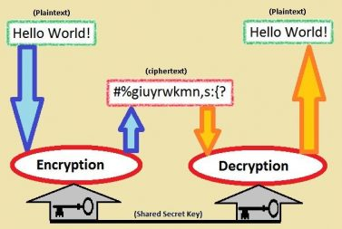](http://engl301-arts.sites.olt.ubc.ca/files/2017/09/Image.jpg)

This image illustrates how data can be encrypted in such a way that it’s not readable to most people, but can be later decrypted by someone who should have access to it.

Image URL:

https://www.bing.com/images/search?view=detailV2&ccid=v00icw4J&id=0B8DECACC792FC53A99D5D2F5CC5D8BD4A7CFDDA&t

hid=OIP.v00icw4JNk9YK2xaYjjrSQEsDI&q=cryptography+image&simid=607990315134683096&selectedIndex=43&ajaxhist=0

Where is it used?

Cryptography is very prevalent in online banking. It helps protect bank information, and allows people to perform actions such as bank transfers safely. It also allows people to communicate messages without others being able to read them (which is highly relevant in a military setting). Another place it shows up is in protecting valuable information stored on computers. These are just some of the many examples of where cryptography is used.

Works Cited

“Cryptography.” Wikipedia, Wikimedia Foundation, 21 Sept. 2017, en.wikipedia.org/wiki/Cryptography. Accessed 21 Sept. 2017.

“What is cryptography? – Definition from WhatIs.Com.” *SearchSoftwareQuality*, searchsoftwarequality.techtarget.com/definition/cryptography. Accessed 21 Sept. 2017.

*Cryptography in Everyday Life*, www.laits.utexas.edu/~anorman/BUS.FOR/course.mat/SSim/life.html. Accessed 21 Sept. 2017.