**Improving Usage of TA’s and Student Learning**

Prepared for

Steve Wolfman, Professor of Teaching and TA Assignment Committee Co-Coordinator, Computer Science

University of British Columbia

Vancouver, British Columbia

By

Curtis Fox

Student of ENGL 301

Table of Contents

Abstract

Introduction 4

Overview 4

Background Information 4

Problem 4

Purpose 5

Research Methods 5

Scope 5

Data Collection and Analysis 5

General Comments on Survey Results 6

Data Summary 6

My Comments and Observations as a Previous TA 9

Conclusion 9

Summary of Research Results 9

Suggestions 10

Final Remarks 10

Appendices

# **Abstract**

*To be completed later*

# **Introduction**

## Overview

UBC employs many TA’s for the various courses that it offers. They are very important to the success of the courses, and assist the instructors with many of their duties. However, currently TA’s are not being used as efficiently as they could be, leading to issues finding TA’s, and interferences with classroom learning.

## Background Information

Departments all over campus, including computer science, hire both undergraduate and graduate students to perform various duties for the classes they offer. In the computer science departments, TA’s play a big role in supporting the students and helping them learn the most they can. They make this happen by assisting in the grading of assignments and/or exams, holding office hours, running labs, or other relevant duties depending on the specific course.

## Problem

Currently, TA’s are limited to 12 hours of work per week (on average), which sometimes limits the amount they can contribute to course they are working in. As well, some courses have TA shortages, or just general issues finding people willing to TA them. This is highly concerning as issues with TA’s can lead long handback times for assignments and exams, and a severe lack of resources for students to get help. It also makes it extremely difficult for the TA assignment committee in assign TA’s to courses, as most CS classes need TA’s, but many require large number of them.

## Purpose

The purpose of the report is to address any inefficiencies in the usage of TA’s for various computer science courses and in the TA assignment process at the beginning of each school term.

## Research Methods

My main source of data to support my suggested changes will be an online survey that I will have students fill out. I have asked various questions pertaining to issues or suggestions they have for improving courses, with a large focus on how TA’s can be used to meet these needs. One important question I pose is increasing the number of hours TA’s are allowed to work each week (currently 12 hours). This question serves an important purpose for my suggestions in improving the use of TA’s, which I will expand upon later in this report.

## Scope

Questions I want to address are as follows:

1. What proportion of students feel work is not handed back in a timely manner?
2. Do students feel as though more resources could be provided in their courses?
3. How could possible changes make assigning TA’s to courses a smoother process?
4. Could potential changes to the usage of TA’s be helpful for instructors of courses?

# **Data Collection and Analysis**

*Note this section is still under construction since I’m still collecting data*

## General Comments on Survey Results

Overall, it seemed like students believe that additional resources could be provided in their courses. This included additional office hours, outside of class exam reviews, and other relevant resources in university courses. As well, many agreed that TA’s should be allowed to work more than the current limit.

## Data Summary and Results

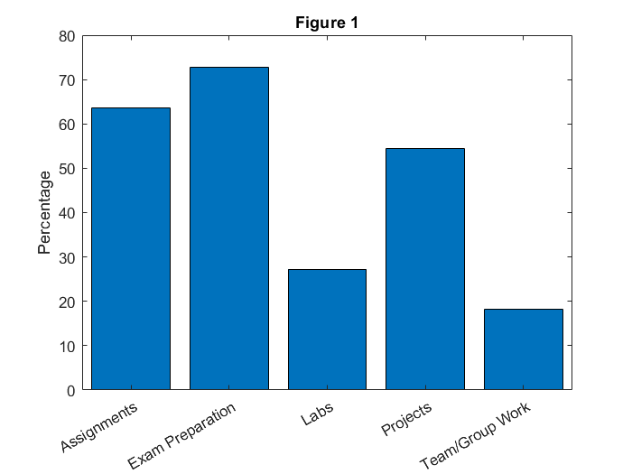

Figure 1 is based on a question on my survey where I asked students to say what course components they could have benefited from further TA or instructor help. As you can see, more than 50% of students could have benefitted from further help on their assignments, exam preparation, and projects. This is a very large number of students that are struggling more (or learning less) than they should be.

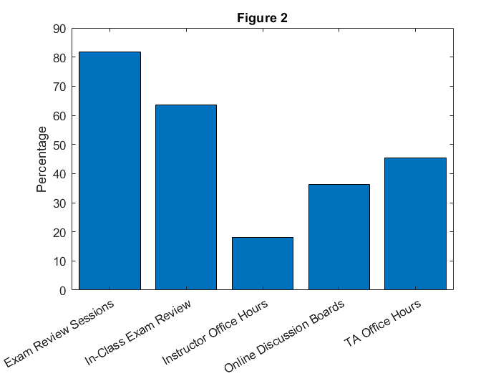

Figure 2 gives a plot of the results for a similar question to the question for figure 1. This question asks which resources students believe could be provided (or in high quantity) in the courses they have taken.

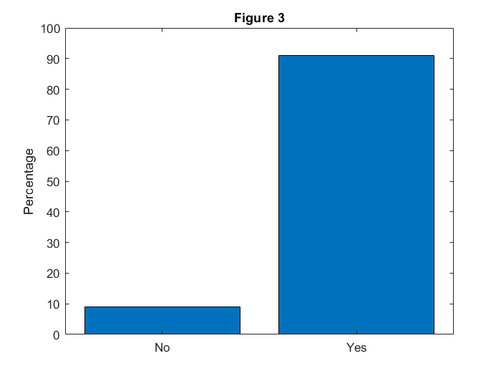

Figure 3 is based on a survey question where I asked students whether they think TA’s should be allowed to work more than 12 hours a week on average. An overwhelming majority of over 90% of students believed they should be. This is a key result, and plays a major role in my suggestions later in the report.

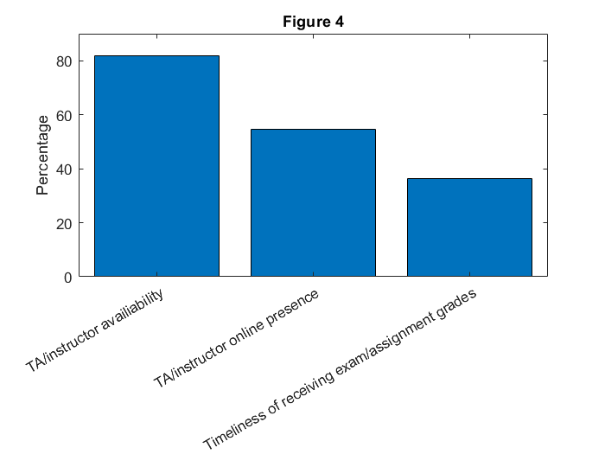

Figure 4 is based on a survey question that asks students to decide whether they thought any of the given options (such as grading timeliness) had issues in the courses they have taken at UBC. The most striking result is that just over 80% of the students surveyed believed that TA or instructor availability were problematic in courses they have taken.

# **Conclusion**

*Note this section is still under construction since I’m still collecting data*

## Summary of Research Results

The results indicate that changes need to be made to allow issues such timely assignment grading to be addressed. Almost all students thought that at least some aspect of the courses they have taken at UBC could be improved. TAs could play a key role in addressing these issues.

## Suggestions

1. My first (and possibly most important) suggestion is to allow TA’s to work more than 12 hours per week on average. This change should be made for a few reasons. For one, assigning enough TA’s to some courses can be both a timely and costly process. If we allowed TA’s to work more if they have the time in their schedule, fewer TA’s could be hired. They should be able to mention in their application how many hours they can work, and this number should be allowed to be over 12 hours per week.
2. My second suggestion is to encourage TA’s to check course online discussion boards, emails, etc. (the resources available for students to get help online will vary by course) more frequently, or instate more online resources (such as piazza) if needed. It may be hard for both students and TA’s to meet in person, especially at busy times of year such as midterm or final season, but allowing help to be given electronically make it easier for TA’s to provide the necessary resources for students to get help
3. My last suggestion is to hold review sessions for midterms and finals. This is very important since in many courses, TA’s will hold multiple sets of office hours before exams, each possibly giving different information. Another issue is that these office hours become overloaded with students, and one (or even two) TA’s are unable to help all the students. If however, one or two large review sessions were held (where multiple TA’s, and possibly the instructor are present), students could receive the help they want or need.

## Final Remarks

Presently, at least in UBC computer science courses, they’re many resources for students to get the help they need, and the TA assignment process seems to work effectively. However, they are not perfect, and the purpose of this report is to address these inefficiencies. I hope that with the changes I have suggested, the assignment process can be easier for the department, and courses will run more smoothly with students getting the help that they need.

# Appendices