WELCOME TO EPSE 271
TEACHING ADOLESCENTS WITH SPECIAL NEEDS

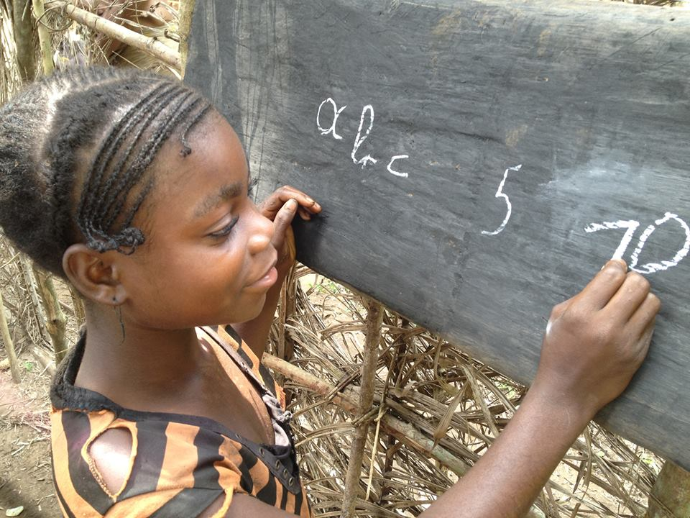
Lesson 1: Introduction to Inclusive Education
Learning Objectives
At the end of this lesson, you will be able to:
- Describe the history of special needs education in Kenya
- Define special education and Inclusive Education
- Discuss the difference between mainstreaming and inclusion
- Explain the philosophy behind the movement toward Inclusive Education

Introduction
Over the past 20-30 years there has been a philosophical shifting of our attitudes and treatment of persons with disabilities. We are realizing that for an individual to reach his or her full potential it is important to provide them with an education. This education is meant for ALL of the citizens, even those who have a disability or handicap in some way. For Kenya, starting in 1986 with the Kenya Institute of Special Education, an investment was made to provide training, for teachers and teachers in training, to work with those students who have special learning needs. (p.13). Even before the mid -80’s, the Kenyan government signed the Universal Declaration of Human Rights (1948) “… consequently recognizing and committing itself to the right of every child to access education.” (p. 16) This change is the result of acknowledging the rights of ALL people to an education.
As we proceed through this course you will notice that many of the examples of outstanding leaders in a field have needs and characteristics that would have hindered them from obtaining an education a century ago. For example, Albert Einstein was four years old before he could speak and seven before he could read. Many of our students have special needs that are not obvious; that is, they are not readily observable. For these students it is even harder since with no obvious problem in the way of their learning they are often considered “stupid”, a “behaviour problem”, or “just lazy”.
You will find a big difference between two terms used in special education: “Mainstreaming” and “Inclusion”. Mainstreaming occurred when students with disabilities were taken into a neighbourhood school but were segregated either in a room by themselves or put in the back of a classroom, given a support teacher, and did work that was different from the rest of the class. Inclusion means that the student is an active member of the class, doing the same or similar work as the other students.
Activity
Before we start to look at special education we need to understand what you think about this topic. This is only your opinion and understanding.
Group: In a group of 4, please answer the following questions:
- What is your definition of Special Education?
- In your opinion: Where does the idea of special education come from?
- In your opinion: where does special education fit into Education in general?
For a GROUP activity only ONE set of answers needs to be submitted. Make sure everyone’s name is on that submission.
Disability in Africa
In Pre-Colonial times:
African proverbs describe a person with a disability as one “considered as a source of integrity, unexpected capacity and family connectedness” (Devlieger, 1999, p.443). There is even a Shona proverb: sekauremawafa which translates to “laugh at disability only after you are dead”.
With the Advent of Colonialism and Western-centric views:
These historical changes in education for students with exceptionalities occurred sending students to:
    - Residential Programs, where many children were sent away to special schools for their education. Primarily for children with intellectual disabilities and with sensory deficits, such as deaf or hard of hearing and students with vision problems.
    - Relative Isolation, prior to the 1970s students with exceptionalities were served either outside the public schools or in isolated settings within the school buildings. But while the students were actually in the building they were educated by themselves and often had no interaction with any of the other students.
As education and society changed, students with special needs were starting to attend the local regular schools. First students were Mainstreamed into schools. Later as the philosophy of Inclusion became more widespread students with special needs became part of the regular class within the school.
  - Mainstreaming, describes the placement of students with exceptionalities in general or regular education classrooms, at least for a portion of each school day.
    - Inclusion, this is a practice based on the belief that students with exceptionalities belong in general education settings, with support services provided in the general classroom by specialists
This change toward an education that is Inclusive now is part of the educational systems throughout many countries of the world.

An Outline of the History in Kenya for People with Disabilities
- Earliest efforts (1940s) were religious institutions: Salvation Army first, then Anglican, Catholic, Methodist, and Presbyterian churches.
- In 1986 the Kenyan Institute of Special Education established to provide services through teacher training and research.
- By 2005 Kenya underscored the importance of special needs education.
- The Kenya government has ratified these documents regarding students with special needs rights to an education, making Inclusion a legal requirement:
  - The Universal Declarations of Human Rights (1948) recognizing the right of every child access to education
  - The United Nations Convention on the rights of the Child (1990)
  - African Charter on the Rights and Welfare of the Child, Salamanca Statement (1994)
  - The Framework for Action on Special Needs Education (1999)
  - Millenium Development Goals and Education for All (by 2015)
From The National Special Needs Education Policy Framework, Kenya Ministry of Education, July 2009
- People with Disabilities make up 10% of the population (3.5 million people) (WHO, 2006)
- Economic and social barriers often prevent education and people with disabilities often live in bleak environments.
All of this means Kenya is committed to providing education for students with special needs in a regular, Inclusive classroom. Teachers now have a responsibility to provide education to students who may not learn like other students or who may struggle to learn.
Activity
In a Group of 4 answer the following questions.
- What is the history of educating people with special needs in Kenya?
- What is the current philosophy of the Kenya government toward students with special needs?
- Is there legislation within Kenya for teachers to include students with special needs into their regular classrooms? List at least two forms of legislation that makes this a requirement.
For a GROUP activity only ONE set of answers needs to be submitted. Make sure everyone’s name is on that submission.
One of the aspects of a course in Special Education is to provide teachers with an understanding of the variety of disabilities that influence how students struggle to learn and ways to identify these students so that help may be given early- before failing. Also, the course will provide some suggestions or ideas for helping these students within a regular classroom setting.

What IS Special Education?
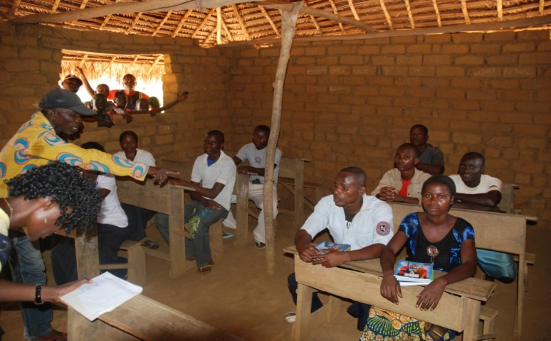
There are 3 major parts to this definition:
- Refers to instruction that is specially designed to meet the individual needs of students with disabilities.
- Each student and disability is unique; therefore, the instruction needs to be unique (as much as possible).
- Every student should be challenged to meet their full potential – even students with disabilities.
Add to this definition the concept of Inclusion which states:
- Special needs students can be active, valued members of a school community in which diversity is viewed as the norm.
- High quality education is provided through a combination of:
  - meaningful curricula
  - effective teaching
  - necessary support.

I’ve used the terms “disability” and “exceptionality”. They have slightly different meanings. The definitions are:
Exceptionalities
- Special physical and/or intellectual needs that require special services for the students who have them
- Describes individuals with diverse needs who differ from their typically achieving peers in some manner (i.e., from students who are gifted individuals to individuals experiencing significant deficits in a variety of areas)
Disability is a term that is more restrictive
- A disability is “an inability to do something, a diminished capacity to perform in a specific way” (Hallahan & Kauffman, 2006, p. 7)
- The term is frequently used when referring to specific categories of exceptionality (e.g., learning disability)
There are a number of categories of disabilities that challenge classroom teachers. This list gives some idea of the number of types of disabilities. You must also remember that within each one of these categories there is a wide range of disability. For example in the first one listed, Learning Disability, you could have a student with a very mild form of reading problem to a student whose disability is so severe there is no way this student will ever be able to read beyond some basic words. (You do NOT have to memorize this list.)
Typical Categories
  - Learning disabilities
  - Speech and/or language disorders
  - Intellectual disabilities
  - Emotional and/or behavioral disorders
  - Multiple disabilities
  - Auditory impairments
  - Orthopedic impairments (problems concerned with deformities, disorders, or injuries of the skeleton and associated structures [as tendons and ligaments])
  - Other health impairments
  - Visual impairments
  - Autism Spectrum Disorders (ASD)
  - Fetal Alcohol Spectrum Disorders (FASD)(includes drugs)
  - Traumatic brain injury
  - Gifted and/or talented

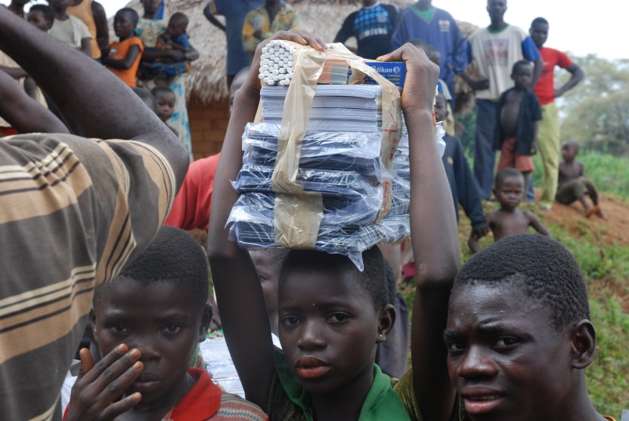

Activity
Group: At the end of your course outline there is a reading entitled, “Welcome to Holland”. Please read this by yourself. Working in a group of 4:
- What did your group think of this reading? (your opinion)
- Explain why this has been included in the course reading.
Read over the responses to the questions your group answered at the beginning of the class. Answer these questions:
- How does your original idea of Special Education compare to what we have been talking about here?
- If you have hesitations, what are they?
For a GROUP activity only ONE set of answers needs to be submitted. Make sure everyone’s name is on that submission.

