Lesson 3: Universal Design for Learning & Differentiated Instruction

Lesson Objectives
At the end of the lesson you will be able to:
- Explain Universal Design for Learning (UDL)
- Explain Differentiated Instruction (DI)
- Give detailed examples of both planning strategies
- Describe how UDI & DI are used in a regular classroom
- Discuss how they facilitate planning lessons for students with special and varying needs
- Discuss the ideas behind the need for a Risk-Free Classroom

Introduction
Two of the most common questions teachers ask when they take a course like this is:
- How can I help one or two students who require some kind of individual instructional strategy when I have a whole class to teach?
- What happens to the curriculum I am also required to cover?
In order to answer those questions and understand how to reach many more of your students with different learning challenges we are going to look at two different, but relate educational strategies. This will help us as we enter into the next set of classes which will cover the different disabilities and learning challenges that make some students struggle.
I. Universal Design for Learning (UDL)
UDL is a set of principles for curriculum development that give all individuals equal opportunities to learn. It provides a blueprint for creating:
- Instructional goals
- Methods
- Materials
- Assessments
Originally this strategy came from the philosophy of architects who when designing buildings have to consider the different capabilities of the people using those buildings. For example, buildings are now designed with access for people in wheelchairs – doorways are made wider and toilet facilities allow easy access for wheelchairs. The idea is to automatically include a wider idea of the people using the buildings rather than a narrow vision of a person without any challenges. So when an architect puts in a sign for floor number he or she also includes the numbers in braille for a blind or vision impaired person. As this idea has spread even the paper money here in Canada has braille numbers imbedded so a blind person can tell one denomination from another.
The Key to this way of thinking is accessibility; that is, can everyone be included in this building or classroom. Is it built into the planning? UDL is a way to design curricula based on 2 basic ideas:
- Student involvement and choices
- Flexibility in teacher presentations
Teachers are already planning around 4 components:
- Whom they teach – Students
- Where they teach – learning environment
- What they teach – content
- How they teach – instruction

Principles of UDL
UDL stretches beyond accessibility for the disabled, however. A teacher's goal is for students to learn skills and understand the subject. Traditional curriculum materials tend to offer only limited flexibility for meeting that goal - often requiring students to adapt to the curriculum. Universally designed curriculum overcomes limitations by incorporating three principles of flexibility into the design:

- Multiple methods of presentation (Representation)
- Multiple means of Action & Expression
- Multiple options for participation (Engagement)
This built-in flexibility provides into a wider range of options for students to choose from - meaning the curriculum adapts to the student, rather than the other way around.
Let's consider each of these principles and the impact they could have in your classroom.

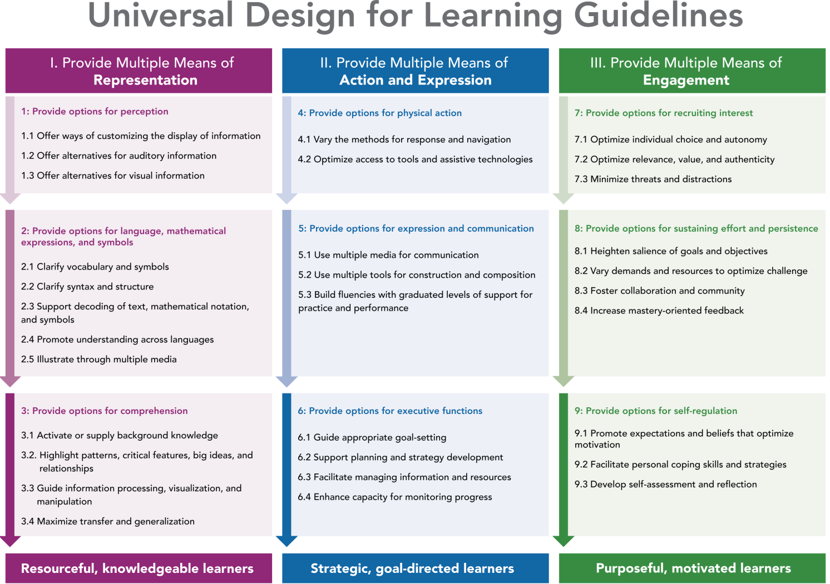

UDL Guidelines graphic organizer text description
This graphic organizer of the Universal Design for Learning Guidelines depicts the three main principles of UDL in three color-coded columns with numbered explanations and bulleted examples beneath each principle heading.
Principle I. Provide Multiple Means of Representation is shown on the left in dark pink and includes the following:
1. Provide options for perception: options that customize the display of information, options that provide alternatives for auditory information, options that provide alternatives for visual information. Ex. written as well as verbal
2. Provide options for comprehension: options that provide or activate background knowledge; options that highlight critical features, big ideas, and relationships; options that guide information processing; options that support memory and transfer. Ex. provide an everyday example.
Principle II. Provide Multiple Means of Action and Expression is shown in the center in blue and includes the following:
3. Provide options for physical action: options in the mode of physical response, options in the means of navigation, options for accessing tools and assistive technologies. Ex. do more than sit during a class – provide activities.
4. Provide options for expressive skills and fluency: options in the media for communication, options in the tools for composition and problem solving, options in the scaffolds for practice and performance. Ex. give multiple options for an assignment.
5. Provide options for executive functions: options that guide effective goal-setting, options that support planning and strategy development, options that facilitate managing information and resources, options that enhance capacity for monitoring progress. (We will discuss executive function in our next class)
Principle III. Provide Multiple Means of Engagement is shown on the right in green and includes the following:
7. Provide options for recruiting interest: options that increase individual choice and autonomy; options that enhance relevance, value, and authenticity; options that reduce threats and distractions. Ex. use a real world problem or scenario to situate your lesson – increases motivation.
8. Provide options for sustaining effort and persistence: options that heighten salience of goals and objectives, options that vary levels of challenge and support, options that foster collaboration and communication, options that increase mastery-oriented feedback. Ex. provide flexible assignments – like letting students select how they will show you that they know the material (written, drawing, presentation, etc.)
9. Provide options for self-regulation: options that guide personal goal-setting and expectations, options that scaffold coping skills and strategies, options that develop self-assessment and reflection. Ex, students evaluate their own papers using a teacher’s answer sheet for guidance.
Activity
In a Group of 4, answer the following questions and send them by email:
1. Write out how you would explain Universal Design for Learning to a colleague.
2. Thinking about your own classrooms: list 2 ideas from the information above that you might try. Why do you think they might work for you. (Even though there are 4 of you, just list and explain 2 ideas total)

II. Differentiated Instruction (DI)
Differentiated Instruction is similar to UDL. However, the primary focus of this strategy is on procedures and processes that ensure effective learning for varied individuals. Therefore it emphasizes: Whom we teach, Where we teach and How we teach. It is essentially a model for how we design our instruction.
It requires teachers to think about:
- Think about the essentials ; concepts, principles and skills of our topics
- Attend to student differences; learning styles, culture, etc .
- Think of assessment and instruction as one
- Modified content, process and product where needed
- Collaborative, respectful learning
- Flexibility
Again, as in UDL, teachers need to think about the range of student learning within a class and how you can teach so that all the students learn. For example, if I know I have a student who has trouble remembering page numbers and directions, I would plan on automatically writing the information on the board at the same time I was explaining the assignment. Not only will this help out that one student with a memory problem but it helps every else. Now your students can listen to what you are saying without trying to keep page numbers in their mind as well. You have just freed up some cognitive space for your students. The idea is to find ways that help individuals learn, but you have the added bonus of helping others in the class too.

Some ideas to help you with DI planning are:
- Find ways to get to know students more intentionally.
- Incorporate small-group teaching into daily or weekly teaching routines – this helps yo get to know your students better
- Learn to teach to the high end – always challenge your students
- Offer more ways to explore and express learning – become flexible with your teaching, try different things
- Regularly use informal assessments to monitor student understanding (Formative assessment)
- Teach in multiple ways
- Use basic metacognitive strategies throughout the curriculum
- Allow working alone or with peers
- Use clear rubrics that coach for quality (ex. Rating scales)
- Cultivate a taste for diversity

Activity
In a Group of 4, answer the following questions and send them by email:
3. List at least 3 assignment options you could give for the same topic. Explain how assignments can be different but cover the same material?
4. What choices could you give to students for showing knowledge – beyond a written test?
5. How are DI and UDL the similar?
6. What are some of the concerns you have about these planning and teaching techniques? (Personal ideas or opinions)

Developing a Risk-Free Classroom
Have you ever had a student who is afraid to try something because he or she might get it wrong? As a teacher I have encountered these students. Since school is the one place where we introduce new and unusual things it should also be the one place where students should not be afraid to make mistakes. Learning new things requires taking risks. We want our students to take risks throughout the learning process. It helps them become more independent. If your classroom environment is non-threatening to them and they are not afraid of failure, they WILL get more authentic learning through exploration and trial & error.
How do we develop a risk-free classroom?
- Acknowledge their attempt
  - Good try
  - That’s possible
- Build their confidence
  - Share your past mistakes
- Encourage their Courage to take a chance
  - I can see why you might say that
  - That is so close
- If you use a color to correct papers try a color other than red
- Write little comments about what is RIGHT instead of just commenting on what is wrong

Factors that threaten learning and make students hesitant or afraid to try new things:
- Afraid of feeling dumb in front of peers
- Intimidated by peers
- Does not feel supported
- Offended by peers or teacher
- Ridiculed or Criticized
- Embarrassment from low scores
From UDL and DI we learn:
- Your teaching style dictates the amount of learning that takes place in your room
- Respect is a two-way street
- Procedures: Saves time to maximize learning time
  - Makes students comfortable (they know what to expect)
- Rules and expectations:
  - Adolescents often like to participate in making rules since it treats them as adults with an interest in how they are going to set up the learning environment.
Help students be successful. Students who are successful have more confidence and are more likely to attempt new and different assignments. They tend to also be more motivated learners.
- Help students bypass their deficits as they access their areas of strength
- Modify assignments and curricula for students so that their true abilities may be demonstrated.
- Create an environment that nurtures personal creativity and intellectual characteristics.
An Idea to think about:
Schools and Classrooms should be safe places to make mistakes!
If not in a school, then where does a student go to make a mistake and learn from it??
Activity
In a Group of 4, answer the following questions and send them by email:
7. How can you make your classroom, within the camp, a risk-fee place to learn? List at least 4 things you can do and how you would implement them in your classroom.
8. Write down what you would say to a colleague who asked you about the ideas behind a Risk-Free Classroom.

Assignment: Please do the assignment found in the blog under Lesson 3. This information is to be done in your notebooks for an assignment at the end of the course.

