Lesson 4: Teaching Adolescents with Learning Disabilities
Lesson Objectives
At the end of the lesson you will be able to:
- Define a Learning Disability using the Discrepancy Model
- Discuss the characteristics of different types of Learning Disabilities
- Describe the Information Processing Theory
- Explain a Learning Disability using Information Processing
- Define Response-To-Intervention (RTI)
- Explain how RTI is used

Introduction
At this point we are now going to start to look at several kinds of disabilities, how the influence a student’s learning, and some ideas for how to adjust your teaching strategies to accommodate these learning differences. One Important point to make sure you understand is that within any disability you will have a range of characteristics, from mild to moderate to severe. In some instances the characteristics are so mild they are hardly noticeable. For some of these students a teacher often thinks the student is lazy, unmotivated, of just a slow learner. When in reality it is the mild form of a disability that interferes with the student’s learning.
The first group we will look at is the largest group and one that most teachers find the most difficult. This is because it is often called a “hidden disability”. There is no outward evidence of disability - that is; the student seems fine physically and mentally. He or she has no trouble playing with friends or working in the community and yet is doing poorly in school. This disability is a Learning Disability. In general approximately 1 in 10 students in the population have some type of learning disability, although that is considered a low estimate. (Government of Canada, 2009, p.24) With at least 10% of the population having some type of learning disability it is reasonable to expect teachers to encounter these students in their classes. By knowing about Learning Disabilities, the characteristics, and some basic strategies the teacher can provide support for these learners so they can become successful students.
In order to discuss Learning Disabilities we first must understand a model designed to describe How people acquire and process information. This is called the Information Processing Theory. It is important to remember we are talking about getting information into and out of the brain. This is NOT intelligence. Only taking information in and getting it out again.

Information Processing Theory (IPM)
This Theory was developed during the 1950s. During this time microprocessors were developed and being used to design computers. The computer designers wanted to duplicate how the mind brought information in, stored it, and then retrieved that information to solve problems. At that time Behaviorism, as a cognitive theory, was found to be inadequate. It could not explain why people attempt to organize information; could not explain why they try to make sense of information or even alter information. Computer developers were pushing for a useable theory of learning in order to produce computers.
In order to understand the model we are going to use an overly simplified diagram and explanation of the model.
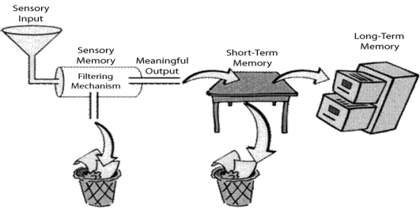

The IPM consists of three main components, Sensory Memory, Short-Term memory, and Long-Term Memory. Please note that there are a couple of places that information can be lost (the trash cans). The Sensory Input above consists of all of the information collected from your 5 senses at any point in time. (Ex. smell of food, warm breeze, bright light, etc.) However, some information is not needed and is “thrown away”; such as an ache in your knee earlier today or a bit of sand in your eye 2 days ago. Sensory Memory and Short-Term Memory enable people to manage limited amounts of constant incoming information during initial processing, whereas long-term memory serves as a permanent repository for knowledge. In this entry, the information processing model will be used as a metaphor for successful learning because it is well supported by research and provides a well-articulated means for describing the main cognitive structures (i.e., memory systems) and processes (i.e., strategies) in the learning cycle.
Sensory Memory
Sensory memory processes incoming sensory information for very brief periods of time, usually on the order of 1/2 to 3 seconds. The amount of information held at any given moment in sensory memory is limited to five to seven discrete elements such as letters of the alphabet or pictures of human faces. Thus, if a person viewed 10 letters simultaneously for 1 second, it is unlikely that more than five to seven of those letters would be remembered.
The main purpose of sensory memory is to screen incoming stimuli and process only those stimuli that are most relevant at the present time. For example, drivers on a busy freeway in heavy traffic are constantly bombarded with visual and auditory stimuli. To maximize efficiency and safety, they process only information that is relevant to safe driving. Thus, they would attend to road conditions but not buildings they pass as they drive. Similarly, they would attend to sounds of other cars, but not to music from the radio or one passenger's casual conversation with another.
Researchers agree that information processing in sensory memory usually occurs too quickly for people to consciously control what they attend to. Rather, attention allocation and sensory processing are fast and unconscious. Information that is relevant to the task at hand, and information that is familiar and therefore subject to automatic processing, are the most likely types of information to be processed in sensory memory and forwarded to the working memory buffer. Information that is highly relevant may receive some degree of controlled, conscious processing if it is crucial to a task (e.g., attending to salient information such as animals along the road while driving at high speed). However, controlled processing in sensory memory would be likely further to reduce the limited amount of information that can be processed at any given moment.
Short-Term Memory
Short term memory has three key aspects:
- limited capacity (only about 7 items can be stored at a time)
- limited duration (storage is very fragile and information can be lost with distraction or passage of time)
- encoding (translating information in order to store it in Long-Term memory).
There are two ways in which capacity is tested, one being span, the other being how recent the event.
The magic number 7 (plus or minus two) provides evidence for the capacity of short term memory. Most adults can store between 5 and 9 items in their short-term memory. Short-Tterm memory can hold 7 (plus or minus 2 items) because it only had a certain number of “slots” in which items could be stored.
However, the amount of information that can be held in each slot can be quite large. Indeed, if we can “chunk” information, or group information, together we can store a lot more information in our short term memory. This theory is supported by evidence from various studies

The duration of short term memory seems to be between 15 and 30 seconds. Items can be kept in short term memory by repeating them verbally (acoustic encoding), a process known as rehearsal. This is why when we are trying to remember something we repeat it over and over. This is really putting the information back into the Sensory memory and then into the Short-Term Memory. Research has shown that the longer the delay in putting information back in (rehearsal), the less information is recalled. The rapid loss of information from memory when rehearsal is prevented is taken as an indication of short term memory having a limited duration.

Long-Term Memory

Long-Term memory is like a file cabinet. Files are labelled and information is stored. When something is needed the mind goes into the file cabinet and pulls out the folder with the information. We store all kinds of information; such as, a picture of a special event or person, the smell of a favorite food, even the sound of a loved one’s voice. These file folders are rich with information. [This why when you teach, the more senses you use for introducing information the richer the memory. For example, if you show pictures when talking about a subject and also use a personal story about the subject your students will remember it better.]

Since the original reason for developing this Theory was for computing science our example could look like this
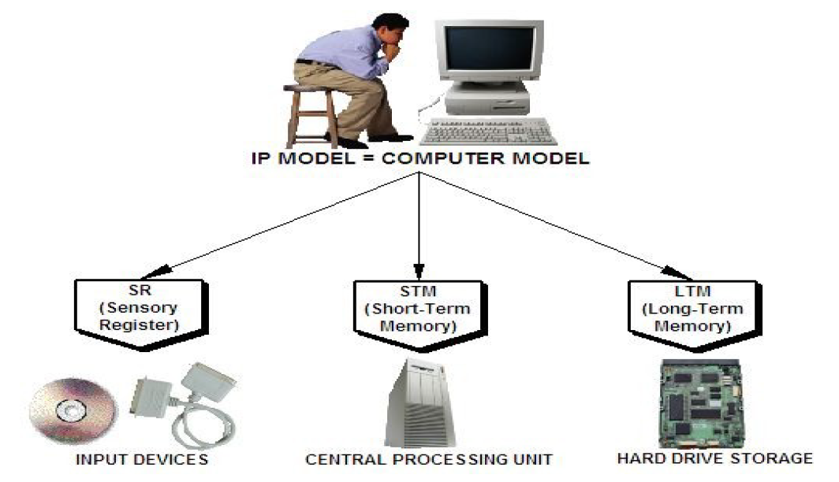

Executive Function

In this diagram you will see a series of items in green, these are called Executive Functions. These are the various strategies and necessary conditions for learning to occur. For example, a student must pay attention to what is being done in the lesson in order to learn. A student must not have a hearing or vision problem that interferes with their learning.

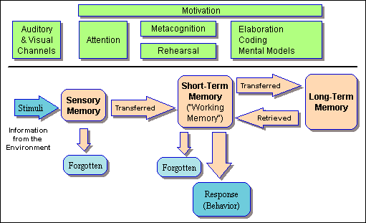
IMPORTANT

The reason we have spent so much time on the Information Processing Theory is that a Learning Disability is a problem with the Processing of Information NOT with the intelligence of the person. In other words: the information going in is mixed up so the information stored is wrong.

Activity
In a Group of 4, answer the following questions and send to the email address.
- What does the Information Processing Theory explain?
- Explain the function of each of the three parts of the IPT.
- What would happen if one of the Executive Functions were not working properly? Give an example.

Now we can talk about Learning Disabilities.

Learning Disabilities (LD)
What we know so far:
- Has been described as a hidden disability
- It is a cognitive disability
  - Not necessarily connected to Intelligence (IQ)
  - It is in the Processing of Information

Learning disabilities may also involve difficulties with organizational skills, social perception, social interaction and perspective taking. Learning disabilities are life-long. The characteristics of an LD often do not interfere with children’s ability to learn until they enter school. In school the type of learning changes from our usual daily life. A child who has not problems before entering school is suddenly confronted with learning challenges. If the child finds ways to cope with his or her problem they may find themselves in secondary school suddenly struggling with the demands of the curriculum. If we have a difficulty the first thing we do as humans is try to find a way around them. Children do this and can often get by in school. But suddenly they encounter topics or teaching styles that emphasize their learning disability.

Some of the Characteristics of a Learning Disability may include:
  - Attention Difficulties and Hyperactivity
    - Attention is critical skill in learning; difficulties can impact on all aspects of success in schools
  - Memory Difficulties
    - E.g., difficulty in repeating information read or heard, or taking recent information and organizing it for storage
  - Cognition Difficulties
    - Cognition: ability to reason or think
    - Delayed verbal responses, difficulty adjusting to change

A learning disability is a cognitive disability; it is a disorder of thinking and reasoning. Learning disabilities are frustrating as they are not easily understood or identified. We don’t have a clear idea of what causes LD but the outcome is that students with learning disabilities are unexpected underachievers. Not all people with LD are underachievers. Many famous people have achieved significant accomplishments despite having severe learning disabilities. (ex. Albert Einstein, Walt Disney)
Learning disabilities range in severity and may interfere with the acquisition and use of one or more of the following:
• Oral language (e.g., listening, speaking, understanding)
• Reading (e.g., decoding, phonetic knowledge, word recognition, comprehension)
• Written language (e.g., spelling and written expression)
• Mathematics (e.g., computation, problem solving)
Activity
In a Group of 4 answer the following questions and send to the email address.
- Why is a Learning Disability considered a “hidden disability”?
- Why is LD often not notice until children enter school?
- Do all students with LD fail school? How do you know?
History
It was beginning to be identified in 1800s as more and more children started to enter into public schools in Europe and North America. Between 1920-1960 research focused on brain-injured adults with deficits in perception, attention, and the perceptual-motor area. Later studies broadened to include children with reading and language deficits. By 1963 the term “specific learning disabilities” was first adopted publicly. From 1960-1975 professional and parent organizations developed to promote LD awareness. In 1975 laws passed regarding children with special needs included LD as a disability category.

Definitions
There are several definitions of Learning Disabilities. Since there are so many wide variations within the disorder it has become hard to come up with one easy definition that fits all of the students in this category. The one that we will use for your purposes is fairly straight forward and does not require complex testing for its use. This is the Discrepancy Model.
The Discrepancy Model states that a Learning Disability is defined by a difference between what is expected from a student vs. his/her achievement. This does NOT include children who have learning problems that are primarily the result of visual, hearing, or motor disabilities, of mental retardation, or emotional disturbance, or of environmental, cultural, or economic disadvantage. This is considered a definition of exclusion.
However, the discrepancy between achievement and intellectual ability is often used to identify individuals with LD. This is the definition we will use.

Alternate Model
The use of the Discrepancy Model has been replaced by the Responsiveness-To-Intervention model (RTI) in many countries.
The Responsiveness-to-Intervention (RTI) Model is a process that determines if a child responds to scientific, research-based interventions as a part of the evaluation procedures. A pre-referral intervention is implemented in the general education classroom. If it is successful then a determination is made that the student has a Learning Disability.
From RTI the Definition of a Learning Disability is:
Specific learning disability means a disorder in one or more of the basic psychological processes involved in understanding or in using language, spoken or written, that may manifest itself in an imperfect ability to listen, think, speak, read, write, spell, or do mathematical calculations.
This definition is too complex for your needs. A Discrepancy Model will provide you with enough information from which to find additional information to assist a student.

Activity
- What definition are we going to use for LD? Why did we select this one rather than the newer one?
- What is RTI?
- In your opinion, why do you think the definition using RTI would be more complex for you to use as a teacher here?

In the next class (Lesson 5) you will have a chance to see how LD influences learning.

In addition to the questions in this lesson please do the assignments found on the blog for Lesson 4.

