Lesson 10: Students who are At-Risk
Learning Objectives
At the end of the lesson you will be able to:
- Define students who are considered to be at-risk
- Describe the different types of students who are considered at-risk for developing learning and behavioural problems
- Discuss general considerations for teaching at-risk students
- Describe specific and effective methods for teaching students who are at risk
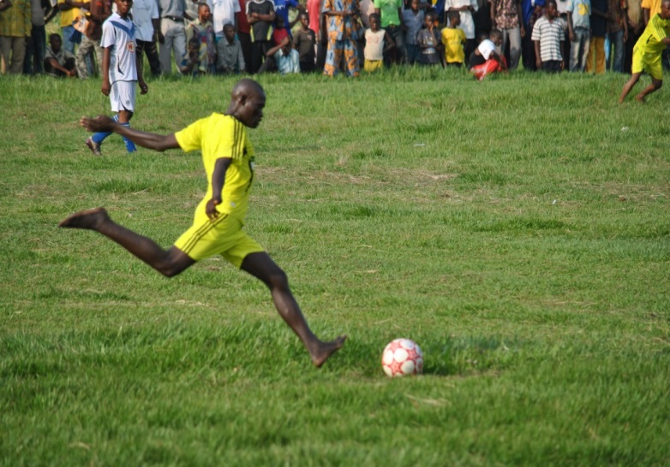
Introduction
Many students who are ineligible for special education services still need them. These students are at risk for developing achievement and behavioural problems. There are a variety of definitions for “at-risk” but it is often used to describe children who have personal characteristics, or who live in families that display characteristics, that are associated with school problems. “At risk” students often: have difficulty learning basic academic skills, exhibit unacceptable social behaviours and cannot keep up with their peers. Often they are considered “vulnerable children”.
Students at risk have been fully included in educational programs. But often have been neglected in the classroom and consigned to failure
Without special interventions, may:
- Be retained year after year
- Become behaviour problems
- Develop drug and alcohol abuse problems
- Drop out of school
- Fail as adults
Many factors place students at risk for developing school problems. For example: poverty, single-parent homes, homelessness, abusive parents, substance abuse, and unrecognized disabilities. Educators should be careful not to label every student as “at risk”. Sometimes students who appear to be at risk and who come from culturally different backgrounds may be misidentified when in-class interventions might have been effective. While the following factors are possible conditions for at-risk, it does NOT mean that if these factors exist a student will necessarily have problems in school. You will see that Resilience often is seen in situations like the ones listed below.

Some of the Conditions for the possibility of a student being at-risk
Poverty: this is the number one factor that places children at risk for academic failure
Associated with poverty are a series of possible other issues, such as:
- Different kinds of exceptionalities (i.e., intellectual disabilities, learning disabilities, and various health problems)
- Poor prenatal care
- Poor parenting
- Hunger
- Limited health care
- Single-parent households
Homelessness: Around the world the number of individuals who do not have homes has risen to epidemic proportions. As many as 39% of all homeless persons are children and poverty is directly associated with homelessness.
Single Parent Homes:
- Single-parent homes headed by mothers
  - Absence of the father generally has a more negative impact on boys than girls
  - Academic achievement of both girls and boys has been shown to be affected
    - E.g., lower achievement correlating with limited presence of the father
- Single-parent homes headed by fathers
  - Have increased significantly over the past decade
  - Single-parent fathers are more likely to use other adults in their support networks than single-parent mothers
  - Children seem to fare better with a large adult support network than a limited one
Students who experience significant loss:
For example, the death of a parent can result in significant problems for children. When a parent dies, the child must deal with the reality of the death itself, adapt to the resulting changes in the family, and/or contend with the perpetual absence of the lost parent. Students respond in many different ways to a parent’s death, including, guilt, regression, denial, bodily distress, eating disorders, etc.
Students who abuse substances: this results in major problems and places students at significant risk for school failure. A variety of factors associated with increased likelihood of drug use such as, the parents’ attitudes about drug use, family management styles, parent-child communication patterns and peer pressure. The use of inhalants is on the increase and is of concern due to it availability. For example, solvents, gasoline, room deodorizers, glue, perfume, wax, and spray paint.
Students who become pregnant: Both girls and boys who find themselves involved in a pregnancy are likely to drop out of school.

Resiliency
Resiliency is the capacity for healthy development and successful learning. It is associated with certain personal strengths and with certain characteristics of families, schools, and communities. It starts with changing the beliefs of adults who are in the lives of at-risk children. All students can be successful in school with teachers who understand their learning needs. Success in school brings further motivation and success in school and life.
For educators want to promote “good outcomes in spite of serious threats to adaptation or development” (Masten, 2001, p. 228) comes:
Four primary approaches to dealing with students who are at risk:
- Compensatory education
  - Remediation in areas where there are difficulties
- Prevention programs
  - Being aware of the possible signs for at-risk
  - Support the student and build in success within the classroom
  - Make a risk free classroom
  - Adjust instruction to assist students with disabilities – this actually helps everyone
- Intervention programs
  - Maybe one-on-one tutoring
  - Extra help times for any student (the student may need to be invited to receive help)
- Transition programs
  - Help with school to post-school situations
  - Think in terms of specific skills within your subject area that area also useful in the community

Activity
In a group of 4 answer the following questions.
- In your own words: what is the definition of “at-risk”?
- If there was a student from a very rich home, could they still be considered “at-risk”? Explain your answer.
- What is resilience?
- A large body of research exists on the study of Resilience. However, it has proven to be a characteristic we know exists but don’t really know how to teach it. I would like your group to come up with one idea of how you would teach resilience to your class. (You are a very resilient people – think about how you became that way as you grew up. What would you do or say to your class?)

