Lesson 7: Teaching Adolescents who are Gifted and/or Talented

Learning Objectives
At the end of the lesson you will be able to:
- Define the terms Gifted and Talented
- Describe the characteristics for gifted and/or talented
- List the various myths surrounding teaching students who are gifted and/or talented
- Explain strategies for teaching students who are gifted and/or talented
Introduction
Students who are advanced in one or many areas of development may or may not be easy to identify since you may not actually see it demonstrated. This advanced ability may be in relation to intellect, creativity, or the skills associated with specific disciplines. For example, it might be artistic talent and unless he or she was given that opportunity for artistic expression it might not be easy to identify. Also, it may be that the student demonstrates extraordinary focus in particular area(s) of skill or interest, but does not do well with many of the subjects in school. Or it may be accompanied by other disabilities, such as a learning disability like difficulty reading.
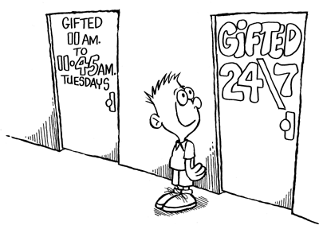
We often find many gifted students struggling in school, particularly as adolescents. If these students make it through earlier grades by figuring out how to pass courses they sometimes give up on school as young adults. They find school boring, teachers uninspiring, and the curriculum simplistic. It is our responsibility to make sure we identify these students as early as possible. We need to provide them with challenging, engaging classes. We need to support their flexible and often divergent thinking to add support for their learning.

For example, many famous people were not identified and experienced failures where people judged that they were not capable individuals.
- Einstein was four years old before he could speak and seven before he could read
- Isaac Newton did poorly in grade school
- When Thomas Edison (inventor of the light bulb, movie camera, etc.) was a boy his teacher told him he was too stupid to learn anything
- A newspaper editor fired Walt Disney because he had “No good ideas”

In the above cartoon the premise is that in many schools there are special classes for students who are gifted. In most instances these students get the classes once or twice a week for a short period of time. This is definitely not enough. Our classes must challenge all students to think and learn.
Incidence of Giftedness
2-5% of school aged population are gifted. It is IMPORTANT to note that some may go unnoticed. These unnoticed students include young boys, adolescent girls, students of diverse cultural backgrounds and students with other disabilities.
If we use a normal curve to represent our population, and we measured the Intelligence Quotient (IQ) for student we find that the upper 2-5% represents students who have greater capabilities than other students. This is where the 2-5% number for giftedness comes from. Students between and IQ of about 85 to about 115 are in the average 70% of the population.
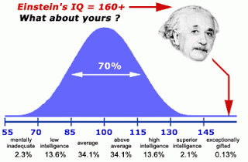
10 Myths about Students Who are Gifted/Talented
- Myth No. 1: Intelligence is inherited and does not change. Gifted students, therefore, do not need any special services.
- Myth No. 2: Giftedness can easily be measured by intelligence tests and tests of achievement.
- Myth No. 3: There is no need to identify gifted students in the early grades.
- Myth No. 4: Gifted students read all the time, wear glasses and/or are physically and socially inept.
- Myth No. 5: Gifted kids are all model students – they’re well-behaved and make good grades.
- Myth No. 6: All gifted students work up to their potential.
- Myth No. 7: Teaching gifted students is easy.
- Myth No. 8: Gifted students will get by on their own without any special help from the school.
- Myth No. 9: It never hurts gifted students to teach others what they already know.
- Myth No. 10: All children are gifted.
When you read through this list you might find comments that you have heard in your community. These are all MYTHS. Gifted students are often found having failed and dropped out of school simply because we believe, falsely, that they will always do well – no matter what happens. As teachers we need to identify these students and support their learning in the same way we support a student who is struggling with academics.
Aspects of Gifted and/or Talented.
The aspects of gifted behaviour are important to help identify a student who is gifted
and/or talented.

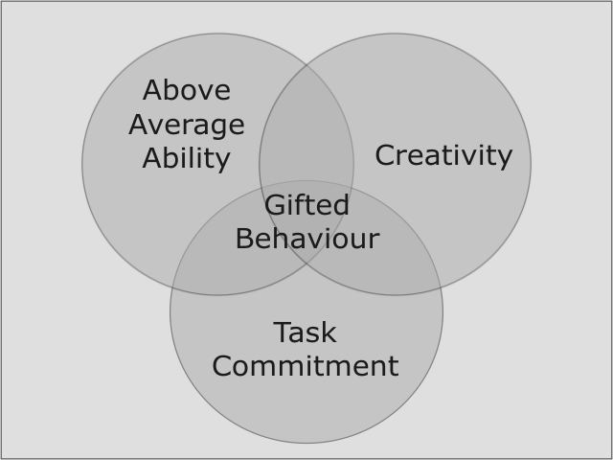

For Cognitive Characteristics:
  - Large vocabulary and high verbal fluency
  - Excellent retention of new knowledge
  - Facility for learning quickly and easily
  - Demonstrated ability to generalize information
  - Demonstrated ability to make abstractions
  - Good observational skills
  - Ease in identifying similarities, differences, and relationships
  - Good organizational and planning skills
Task Commitment
- Will work on a task well beyond when others get bored or tired
- Will go back multiple times to a task until it is right
- Will often not be willing to leave one task for another
- Will sometimes become almost obsessed with a topic or task
Creativity
- Will find new and different aspects of a topic
- Will manipulate the topic, and expand it beyond the interest of others or the curriculum
- Will keep with a topic of interest, looking for new and unusual aspects
- May ask to do an assignment another way to make it more meaningful
In terms of Behaviour Characteristics sometimes gifted students are more advanced intellectually than emotionally. They may not “act their age” in class. Older students may show enhanced concern for social justice. Others may show a sharp sense of humor or may be perfectionistic. Sometimes these characteristics interfere with how the student behaves in a classroom. A perfectionist may never turn work in or do their homework because if there is one mistake it isn’t perfect, so papers never get done. Multiple papers could be done except for one mistake and the student will not turn a paper in with a mistake on it. This is where a risk-free classroom is absolutely necessary. Students need to know it is okay to make mistakes, particularly if the student is gifted.
The Implications for Learning are:
- Ensure that students are challenged
- Provide opportunities for students to work with intellectual equals and/or work alone on special projects for part of the time
- Ensure that students have opportunities to work with same-age peers

Specific Strategies you might find useful when working with students who are Gifted and/or Talented
- Sophistication
  - Introduce theories and concepts that underlie content being learned by the class
- Novelty
  - Allow students to explore required curricular content from alternate or unique perspectives
- Authentic problem solving
  - Allow students to apply their knowledge and skills to problems significant in their own lives
- Independent studies
  - Allow students to study a topic of their own interest or a topic from the curriculum on their own
- Telescoping
  - Take advantage of overlap in curricula of adjacent grades; students complete two curricula in a year
- Compacting
  - Discern what the student already knows and then provide assignments that support the student in mastering unfamiliar material
- Ability grouping
  - Allow students to work with their intellectual peers on a regular, part time basis
- Mentor programs
  - Allow student to apply knowledge and skills in hands-on, real life settings under the supervision of an adult in the community
- Problem-Based Learning
  - Instructional method, cooperative grouping, uses real life settings, prepares students to think critically, analytically, find and use appropriate learning resources

Activity
In a group of 4 answer the following questions:
For the first 3 questions you are going to watch a Video first. Read the questions before watching the video.
- What is cluster grouping?
- Do you give alternate assignments in your own classes? If not, how do you feel about trying it? How would the students react? If you already do this, explain what the students’ choices are with different assignments.
- In the video you were given 6 ideas for challenging your students who are gifted. Which idea do you think would work in your class? Why do you think it would work?
Continue by answering the following questions.
- What information within this lesson was a surprise or new to you?
- What 3 strategies would you be willing to try with your class in May? Why did you select these?
- For students who are gifted and/or talented: why is a risk-free classroom a necessity?

