Lesson 8: Teaching Adolescents with Hearing Impairments

Learning Objectives
At the end of the lesson you will be able to:
- Define the different types of hearing loss
- Explain how students may never know they have a hearing problem
- Explain issues with the different structures of the ear
- Define low incidence and high incidence disabilities
- Show how different elements within a classroom can influence the acoustics of the room

Introduction
As we start these last three lessons we will be looking at what is generally thought of as Low Incidence disabilities. That is, in a population these disabilities occur infrequently and the total number of people with these disabilities is small compared to the other types we have already looked at. Learning disabilities, Autism, and while we didn’t look at Behavioral Issues are all considered High Incidence. These occur in large number and quite often in a population. We did not look at Behavioral Issues since your schools have omitted these students. In a school where the entire population is required to go to school Behavioral Issues are quite common. In terms of Hearing Impairments I felt after my earlier visit to your schools and classrooms that in many instances you might have students who have hearing problems without knowing it. I saw one young man cupping his ear and leaning toward the front of the room to hear what was going on. He obviously was having difficulty hearing. In some classrooms the material placed across open windows to cut down on wind and dust make considerable noise which would in turn hamper anyone with a hearing difficulty. Here in Canada we have similar problems, where noise interferes with the acoustics of a room, and often a student has a hearing problem but does not know about it. This is a universal problem throughout the world – there are more problems with hearing than are identified.
Hearing Impairments
Hearing Impairment is a generic term used to describe any level of hearing loss, ranging from mild to profound.
Hard of Hearing: “Describes individuals who have a hearing loss that makes it difficult, but not impossible, to understand speech through the ear alone, with or without a hearing aid” (Moores, 2001)
While Deafness is a: “Hearing loss that is so severe that speech cannot be understood through the ear alone, with or without aids” (Moores, 2001)
In order to understand the different types of hearing loss you must first have to understand how sound is heard and the function of the different parts of the ear.
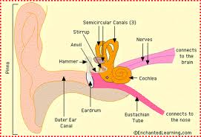

The following provides a description of how sound is carried to the brain.
From A Noisy Planet, U.S. Department of Health & Human Services
Hearing depends on a series of events that change sound waves in the air into electrical signals. Your auditory nerve then carries these signals to your brain through a complex series of steps.
- Sound waves enter your outer ear and travel through a narrow passageway called the ear canal, which leads to your eardrum.
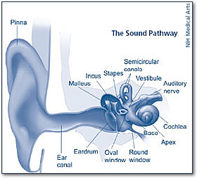
Illustration showing the sound pathway
- Your eardrum vibrates from the incoming sound waves and sends these vibrations to three tiny bones in your middle ear. These bones are called the malleus, incus, and stapes.
- The bones in your middle ear amplify, or increase, the sound vibrations and send them to the cochlea, a snail-shaped structure filled with fluid, in the inner ear. An elastic membrane runs from the beginning to the end of the cochlea, splitting it into an upper part and a lower part.
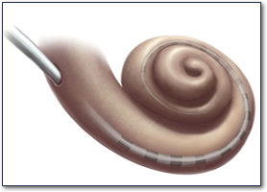
Cochlea
- The sound vibrations cause the fluid inside your cochlea to ripple, and a traveling wave forms along the membrane. Hair cells — sensory cells sitting on top of the membrane —“ride the wave.” (Hair cells have nothing to do with hair. They get their name from bristly structures that look like hair jutting from their tops.)
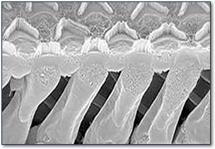
Hair cells
- As the hair cells move up and down, their bristly structures bump up against an overlying membrane and tilt to one side. This tilting action causes pore-like channels on the surface of the bristles to open up. When that happens, certain chemicals rush in, creating an electrical signal.
- Your auditory nerve carries this electrical signal to your brain, which translates it into a “sound” that you recognize and understand.
Hair cells near the wide end of the snail-shaped cochlea detect higher-pitched sounds, such as a cell phone ringing. Those closer to the center detect lower-pitched sounds, such as a large dog barking.
Types of Hearing Loss
1. Conductive Hearing Loss: this occurs when sound is not conducted well through the outer and middle ear. The middle ear is composed of the ear canal, eardrum and the tiny bones. This usually results in a reduction of sound level. One type of difficulty that can arise is the result of ear wax build up, ear infections, or fluid in the middle ear. Eventually if any or all of these conditions continue over time it results in a condition called otitis media. Usually this occurs in children just when they are learning language. At this time variations in hearing may affect academics. If they only hear part of the information presented in a classroom they are at a disadvantage and often lag behind their classmates, sometimes resulting in failure.
One structure in the first diagram that is not in the second diagram is the Eustachian Tube. This structure runs from the middle ear to the back of the throat. Its function is to regulate air pressure on either side of the eardrum. You can sometimes hear yourself swallow. This is because you are opening the Eustachian tube. When you have a sore throat you sometimes will get an ear infection. This is because an infection will make its way up the tube to the middle ear. For children this is often what happens.
2. Sensorineural Hearing Loss: This occurs when there is damage to the inner ear or cochlea. This type of hearing loss may be the result of injury at birth, a genetic disorder, viruses, head trauma, exposure to noise, or even tumors. As with a conductive hearing loss it may impact speech, language development and academics.
3. Mixed Hearing Loss: this occurs when both a conductive and sensorineural hearing loss are present together.
A student with a Conductive hearing loss could be fitted with hearing aids to help them hear. A person with a Sensorineural hearing loss cannot benefit from a hearing aid since the nerves are damaged or no longer function.
One thing that is important to note is that a Learning Disability where the student has a n Auditory Processing Disorder is NOT the same as a hearing loss. This LD is exhibited by an inability to process auditory input. They can hear the words but can’t bring meaning to them.
Classification of Hearing Loss
There are 3 elements to how mild or severe a hearing loss is, these are:
- Type of hearing loss
E.g., conductive, sensorineural, mixed
    - Degree of hearing loss
E.g., minimal to profound
    - Configuration of hearing loss
E.g., flat, sloping, reverse, bilateral or unilateral, fluctuating or stable
The degree of hearing loss is measured in Decibels (dB). This is a measure of the loudness of sound.
The configuration refers to the pattern of tone that a person has trouble hearing. In the diagram below is the hearing shape for most speaking sounds – it is in the shape of a banana. You can also see what a very loud sound is and how a person with profound hearing loss would have trouble with even the loudest sounds. You will also notice that different frequencies produce different sounds. If a person was not able to pick up a specific frequency then words containing that sound would have blanks where the sound would be. This is why some students misunderstand words or directions. In reality they are only getting portions of the words or directions.

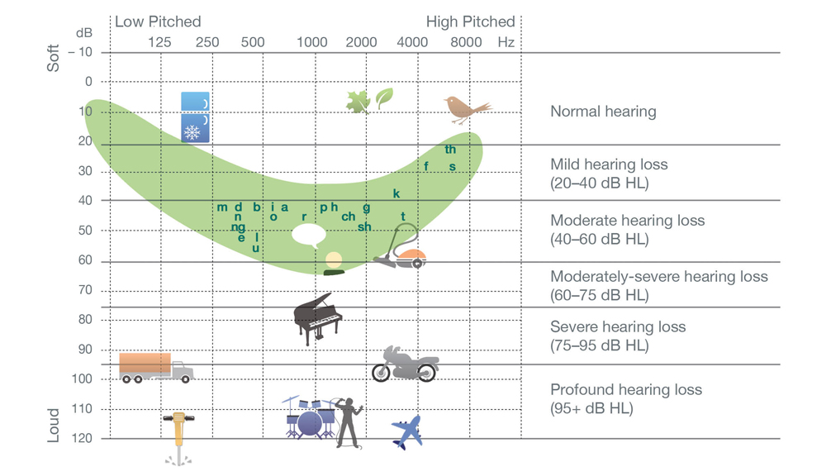

Classroom Management
  - Make sure that students understand rules and procedures
  - Vary seating to maximize residual hearing or have an unobstructed view of interpreter
  - Be aware of noise coming from plastic over windows, etc.
  - Create a supportive acoustical environment
    - E.g., dampening excess noise with carpeting
  - Plan to deliver instruction in a way that benefits students with hearing impairments
    - E.g., allow students to position themselves in the classroom for participation in ongoing events

Students who are deaf may use a variety of methods for communication, including lip reading or finger spelling.
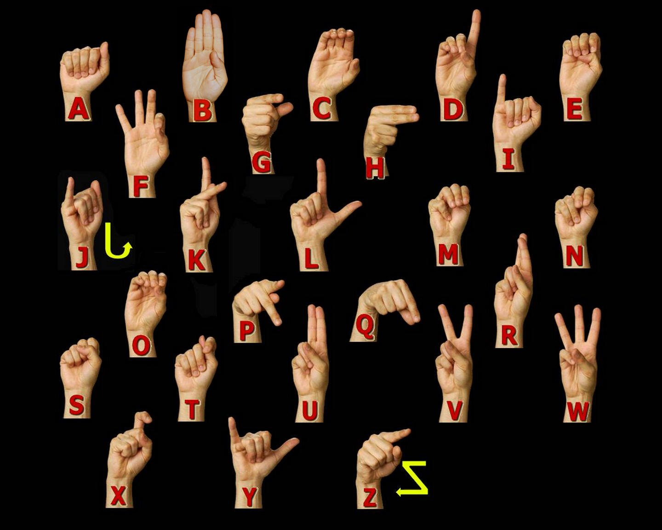

Or, by Sign Language. Each language has its own sign language.

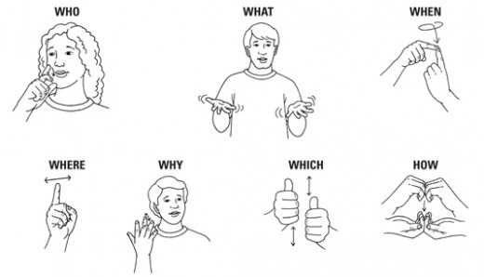
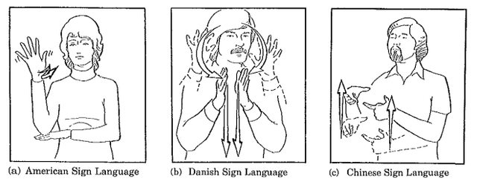
Activity
You will be seeing 2 videos. After each video, work in your group of 4 to answer the questions.
Video 1: Hearing Loss Simulation
- What happens to the sound as it moves away from normal sound and gets near the hearing banana?
- Even with a mild hearing loss what sounds fade first?
Video 2: Navigating Deafness in a hearing world
- Did you notice the flatness to her voice? Why do you think her voice sounds the way it does?
- Does she also use sign language? Does she use it after she speaks or when she is speaking?
- Ms. Kolb has achieved a tremendous advantage in our society by learning to speak. What kind of a school did she go to when growing up? Were all of her teachers supportive? (explain)
General Questions
- Explain the 3 parts which make up the definition of a hearing loss.
- Why is it necessary to understand how hearing works in order to understand the challenge of hearing loss?
- Give 3 strategies you would use to work with a student with an identified or unidentified hearing loss in your classroom.
When you go back to your classroom sit in different areas of the room and just listen. How many sounds do you hear? How loud are they? Based on this: where is the best place for a student with a hearing problem to sit?

