Lesson 9: Teaching Adolescents with Visual Impairments or Intellectual Challenges or Communication Problems/Disorders

Learning Objectives
At the end of the lesson you will be able to:
- Define the specific disorder of the three presented
- Explain how the challenges of the disorder influence academics
- List strategies for classroom teachers

Introduction
This lesson is divided into 3 areas: Visual Impairments, Intellectual Challenges and Communication Problems/Disorders. In most instances, as teachers in Dadaab, you will encounter these issues infrequently at the secondary level or see them in a mild form. This is due to the nature of the examination system which often proves to be a challenge to these students. Therefore these could be considered as Low Incidence disabilities. In other parts of the world Intellectual challenges are considered to be high incidence since there are so many reasons for intellectual delays from genetic issues, such as Down Syndrome, to accidents like Taumatic Brian Injury.

I. Visual Impairments
Vision plays a critical role in the development of concepts, understanding of spatial relationships, and use of printed materials. General education classes are appropriate settings for many students with visual impairments. Students with visual impairments may need adaptations and/or accommodations in the general education classroom but with these strategies they will succeed as well as any student. In some instances students with severe visual impairments will require specialized instruction, such as using Braille or optical devices.
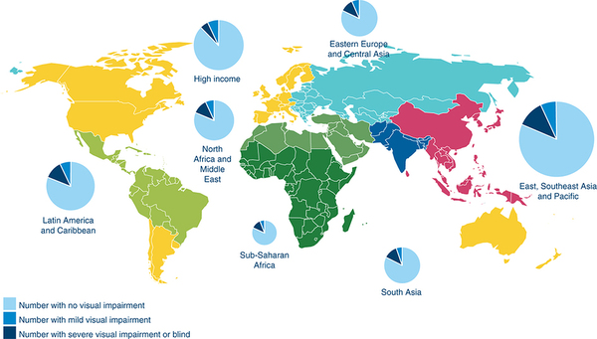

Remember that our statistics for any disability is not that accurate. This means we probably have more cases than are reported.
The categories of visual difficulties are:
  - Visual Impairment
    - Generic term used to describe a wide range of visual problems
  - Blindness
    - Has different meanings depending on the context
    - Legal blindness refers to a person’s visual acuity and field of vision
      - Defined as a visual acuity of 20/200 or less in the person’s better eye after correction, or a field of vision of 20 degrees or less
  - Low vision
    - Indicates that some functional vision exists to be used for gaining information with or without the use of technological assistance (i.e., optical device)

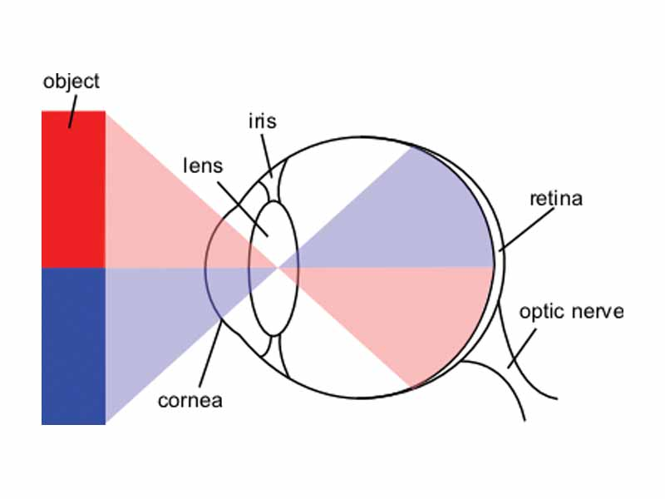
We can categorize visual problems as: refractive disorders (e.g., farsighted, nearsighted, astigmatism: problems with focusing of an object on the retina), retinal disorders, disorders of the cornea , iris, lens or optic nerve problems. Regardless of the cause of the vision problem, educators primarily have to deal with its functional result (i.e., whether or not student has usable residual vision and/or when the problem developed).
When a student wears glasses in many instances the problem is corrected. These students are NOT considered visually impaired. Visual impairment occurs when the vision cannot be corrected with glasses or contact lenses alone. These students need to have some kind of adaptation in order to work in a regular classroom.
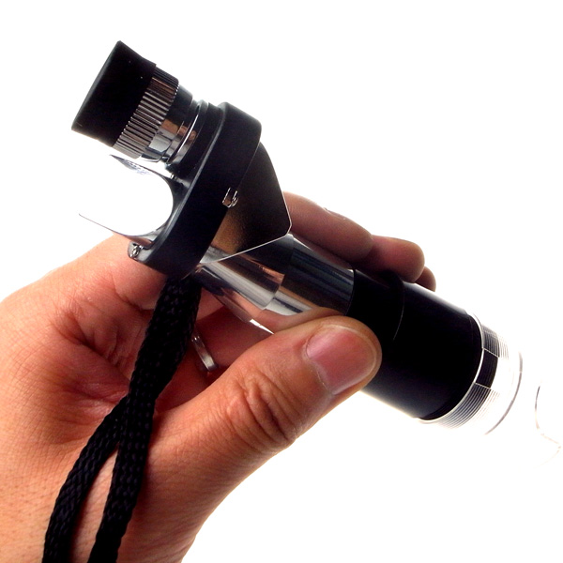
For some students with the use of a monocular (pictured above) they can see the board and work efficiently within a regular class, even with a vision impairment. Teachers can help to identify students who struggle with assignments like copying work from the board, hold books very close to their face, rub their eyes a lot or have recurring headaches. These students probably need an eye exam. Many options are available for students to work in regular classrooms even with visual problems.
Even students who are blind can work with Braille in a regular classroom. This however, requires specialized support for the teacher. Braille is a series of raised dots on a paper. The dots represent letters of the alphabet. So the word “RED” would be spelled “RED’ in raised dots.
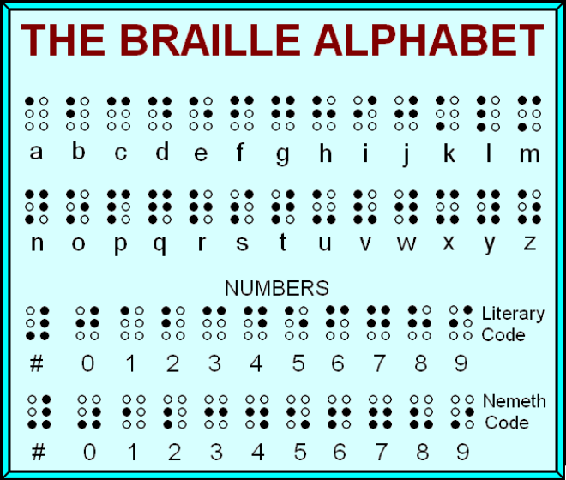
The language and spelling is the same as usual, English is written in English, etc. This is unlike Sign Language which is a different language altogether. This is why students who use sign language have difficulties in English – it is another language. But students who use Braille are learning the same language in which they read and write.
This student is taking notes during a lecture on a braille computer. He can write and read his notes.
Strategies
Some strategies might be:
    - Present a range of options
      - E.g., students with low vision may need enlarged print materials Size and contrast of print are often important
      - E.g., students with little or no vision will need more extensive modifications, adaptations, and/or accommodations
    - Standard expectations for behaviour for all students should also apply to students with visual impairments
    - Students need to know the physical layout of the classroom to can navigate it without harming themselves
      - E.g., can use a clock orientation approach, with 12:00 being the front of the room, 3:00 is the door, etc.
  - Students may need:
    - Class schedules changed to allow extra time to get from one room to another
    - Test-taking procedures may need to be modified (ex. Questions read to the student)
    - Special instruction in study skills
      - E.g., note-taking skills, time management, etc.
  - Concrete materials can be useful (this is good for all students as well)
  - Students with more severe visual limitations may use Braille as the primary means of working with written materials
    - Teachers need to understand how the system works
  - Students may benefit from social skills instruction, since social skills are typically learned by observing others
It is important to promoting Inclusive Practices.
- Some students with visual impairments may have different cultural backgrounds
  - Sensitivity to the culture and family background of students will facilitate the delivery of appropriate services
- Appropriate supports can aid teachers in providing effective instruction for most students with visual impairments
  - E.g., vision specialist, orientation and mobility instructor, adapted physical education instructor
- Parents and/or family members should also be included in helping to develop and implement educational supports

Activity
In a group of 4, answer the following questions.
- What signs would you look for if you thought a student had a vision problem?
- What is the difference between someone with a visual impairment and someone who is low vision?
- Explain how you would use a monocular.
- Why are people who wear glasses not included in the category of Visual Impairments?
- Explain why one of the items to know about a student with a vision impairment would be when the impairment happened? How would that influence what adjustments in your teaching you made for him or her?
- What are the differences between sign language and braille?

II. Intellectual and Developmental Disabilities
A variety of terms are used to describe individuals with below average intellectual functioning, e.g., individuals with intellectual disabilities (Canadian Association for Community Living – CACL). In 2001, the American Association of Mental Retardation (AAMR) changed its name to the American Association on Intellectual and Developmental Disabilities to reflect this term. In order to ensure opportunities for a high quality life, educators should avoid labels or use more positive labels and provide opportunities for students with intellectual disabilities to be with peers who are typically achieving. This means they should be in the regular classroom.

On a normal curve a certain percentage of the population will be represented in the lower end of an I.Q. test range.

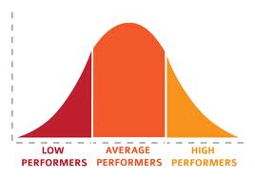

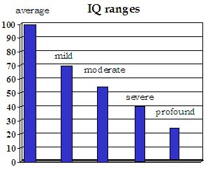

With the average I.Q. being 100, and the deviation being 15, the I.Q. cut-off for Intellectual Disabilities is about 70/75. For mild or moderate disability students may be able to function in a community with regular job matching their abilities. Some may need to be in situations where they are with family members or in some kind of residential situation having supervision. Either way, you may find some of these students in your classes. Particularly classes which might provide skills they could use in a community situation.

Definition
This definition has 3 parts:
- Significant limitations in intellectual functioning
- In adaptive behaviour as expressed in conceptual, social, and practical adaptive skills (ex. Self-care, communication, work, etc.)
- Begins before the age of 18.
Adaptive behaviour are those everyday skills necessary to function, like dressing yourself or washing, being able to go to the store by themselves, being able to wait for and get on a bus by themselves. The age is important. By giving an age of 18 years od it eliminates those people who have cognitive problems due to old age, or have traumatic brain injury, etc. While the characteristics might be similar support and funding is provided by different organizations.
The prevalence in Canada is approximately 1 million (3 percent of the population) have an intellectual disability. This statistic is probably at least similar in other areas of the world. The causes are varied with hundreds of known causes (e.g., Down syndrome, fetal alcohol syndrome, drug use, etc.) In addition, there are numerous cases with unknown causes.
The vast majority of adults with intellectual disabilities can obtain and maintain gainful employment. Factors influencing successful employment, include:
- Personal and social behaviours
- Quality of transition programming
- Demands of the workplace (e.g., service industry jobs may be in shorter supply)
- Preparation to use leisure time

Education
Goals that should guide the educational program of students with mild intellectual impairments include:
- Productive employment
- Independence and self-sufficiency
- Life skills competency
- Opportunity to participate successfully within the schools and community
Within your classroom materials and presentation will likely need to be changed:
- More concrete assignments
- Simplify tasks and assignments
- Same materials, different concept (e.g., addition instead of multiplication)
- Visual support strategies
A functional curriculum would need to include 1. Goals for the student are based on life skills and 2. Community-based instruction. This would mean students who are in a regular classroom would learn from being in the community. They would learn appropriate behviour for the community and how to function within the community of people they live with.

Activity
- What is the definition of an Intellectual Disability? Explain what each of the 3 parts mean.
- What is the approximate cut-off form the different levels of intellectual disabilities?
- What are three strategies you could use in your classroom if you had a student with an intellectual disability?
III. Communication Disorders

Communication
“Is the interactive exchange of information, ideas, feelings, needs, and desires. It involves encoding, transmitting, and decoding messages. Each communication interaction includes three elements: (1) a message, (2) a sender who expresses the message, and (3) a receiver who responds to the message…” (Heward, 2003, pp. 326-328)
Types of Communication Disorders consist of speech and language disorders. A Speech Disorder involves Impairments of voice, articulation, and/or fluency. While Language Disorder involve Impairments of comprehension or use of language and may involve form, content, or function of language
Speech Disorders:
- Voice Disorder
  - Characterized by abnormal vocal quality, pitch, loudness, resonance, or duration given an individual’s age and sex (ASHA, 1993).
  - Vocal disturbances are quite common in children.
- Articulation Disorders
  - “Occur when a person cannot correctly pronounce one or more sounds” (CASLPA, May 2004).
    - E.g., difficulty pronouncing the r sound at the beginning of words
  - Phonological Disorders:“Errors of many sounds that form patterns” (CASLPA, May 2004)
    - E.g., omitting sounds in blends, such as “nake” for “snake,” “back” for “black”
- Fluency Disorder
  - A disorder in the smoothness and rapidity in various skills, such as speech, oral language, reading, and other skills associated with thinking
    - E.g., stuttering: a disorder of speech fluency that results in a person’s expressive language being difficult to understand due to breaks and repetitions in speech.

Language Disorder:
“Impaired comprehension and/or use of spoken, written, and/or other symbol systems. The disorder may involve (1) the form of language (phonology, morphology, and syntax), (2) the content of language (semantics), and/or (3) the function of language in communication (pragmatics) in any combination” (ASHA, 1993, pp. 40-41).
- Receptive Language
  - Language that is received and decoded or interpreted.
- Expressive Language
  - Language that is spoken, written, or communicated visually (e.g., sign language); language that is expressed in some way.
General education classrooms, teachers may encounter any or all types of language disorders, ranging from very mild to severe.
Indicators of language impairment (Wiig & Semel, 1984)
  - Primary Grades
    - E.g., problems in following verbal directions, phonics problems
  - Intermediate Grades
    - E.g., word substitutions, inadequate language processing and production
  - Middle and High School
    - E.g., inability to understand abstract concepts, problems understanding multiple word meanings
For most teachers the problems are often identified early enough that a Speech-Language Therapist is provided for support for the child. If there is no support then teachers can utilize a number of strategies, such as:
  - Develop students’ conversational skills through story reading
    - E.g., ask students open-ended questions while reading a story
  - Use music and play games to improve language
    - E.g., perform actions while singing a song
  - Arrange your classroom for effective interactions
    - E.g., be specific when giving directions
  - Use challenging games with older students
    - E.g., discuss the meaning of fables with students
  - Modify strategies to develop students’ learning tools
    - E.g., have students categorize groups of objects to more abstract concepts
  - Use storytelling and process writing
    - E.g., have students retell stories to peers
  - Use newer technological programs and devices, if available
    - E.g., use selected computer software or applications (apps) with the devices such as tablets and smart phones in the classroom environment to address curricular goals
With Communication Disorders the issue is usually beyond the help of just the teacher. Specialists need to be involved in order for the student to make progress. However, with some internet work teachers can find numerous sites with teaching-learning strategies to help the student succeed.

Activity
- What is a Communication Disorder?
- Give at least 3 strategies you could use in your own classroom. Explain why you chose those strategies.
- What is stuttering? In your opinion, how would it interfere with the student’s education?

