EDCP 471
Lecture Notes
S. Petrina (2018)

Curriculum Design

- Scope and Sequence
  - Hlebowitsh (2010): The design of a curriculum has an organizational dimension to it that accounts for what content and skills should be taught and for how they should be instructionally presented over time. Among curriculum developers, the overarching organization of the curriculum is embodied in a concept known as scope and sequence. Scope specifically refers to the breadth of the curriculum the organizing threads that constitute the skills and content that teachers are expected to include in their instruction. Sequence refers to how these skills and subject matter should be ordered. The two concepts work in synchronization because decisions related to scope have implications for sequencing and decisions related to sequencing have implications for scope.
- Steps in BC’s New Curriculum Design
  - Defining Big Ideas, Learning Standards or Competencies (i.e., Defining goals, purposes, and objectives)
  - Defining content, experiences or activities and projects, etc. (related to the goals, purposes, and objectives)
  - Organizing the content, experiences activities and projects, etc.
  - Defining assessment techniques for the content, experiences activities and projects, etc.
  - Evaluating the scope and sequence
  - Implementing, piloting, and revising
- Curriculum Design also includes (Shyamala, 2016):
  - Identifying the characteristics desired of graduates of the school (e.g., 21C Learners)
  - Revising and refining desired characteristics
  - Identifying philosophical beliefs and values (Teacher’s, School’s, Community’s, Country’s, World’s, etc.)
  - Clarifying the concepts identified in the philosophy
- Conceptual Teaching
  - Bruner, The Process of Education (1965, pp. 12-13): Experience over the past decade points to the fact that our schools may be wasting precious years by postponing the teaching of many important subjects on the ground that they are too difficult.... the foundations of any subject may be taught to anybody at any age in some form…. the basic ideas that lie at the heart of all science and mathematics and the basic themes that give form to life and literature are as simple as they are powerful. To be in command of these ideas, to use them effectively, requires a continued deepening of one's understanding of them that comes from learning to use them in progressively more complex forms.... the early teaching of science, mathematics, social studies and literature should be designed to teach these subjects with scrupulous intellectual honesty, but with an emphasis upon the intuitive grasp of ideas and upon the use of these basic ideas. A curriculum as it develops should revisit these basic ideas repeatedly, building upon them until the student has grasped the full formed apparatus that goes with them.
  - Big Ideas or Core Ideas or Benchmarks or Generalizations or Key Concepts or Cross-Cutting Concepts
    - Big Ideas
      - Hudson (1997, p. 26): "Big ideas" are defined as large concepts or principles that facilitate integration of smaller facts and concepts and the relationship between them.
      - BC MoE, Glossary of Curriculum Terms (2016): Big Ideas are statements that are central to one’s understanding in an area of learning. A Big Idea is broad and abstract. It contains key concepts that generally are timeless and transferable to other situations. Big Ideas are the key concepts, principles, and theories that are used to organize knowledge within an area of learning. A Big Idea is a statement of an idea that is central to an area of learning or across disciplines and that links numerous understandings into a coherent whole.
      - BC MoE Curriculum Overview (2017): The Big Ideas consist of generalizations and principles and the key concepts important in an area of learning. They reflect the “Understand” component of the Know-Do-Understand model of learning. The big ideas represent what students will understand at the completion of the curriculum for their grade. They are intended to endure beyond a single grade and contribute to future understanding.
  - BC MoE, Glossary of Curriculum Terms (2016): Competency represents the combined skills, processes, behaviours, and habits of mind that learners use to make sense of the world
    - BC MoE, Glossary of Curriculum Terms (2016): Curricular Competencies are the skills, strategies, and processes that students develop over time. They reflect the “Do” in the Know-Do-Understand model of curriculum. The Curricular Competencies are built on the Thinking, Communicating, and Personal and Social competencies relevant to disciplines that make up an area of learning.
    - BC MoE, Glossary of Curriculum Terms (2016): Core Competencies are a set of intellectual, personal, and social competencies that students develop to engage in deeper learning and to support lifelong learning through the course of their schooling. The Core Competencies are embedded in each area of learning, and are activated through the learning experiences and activities. In BC, the Core Competencies are the Communication competency, Thinking competency, and Social and Personal competency.

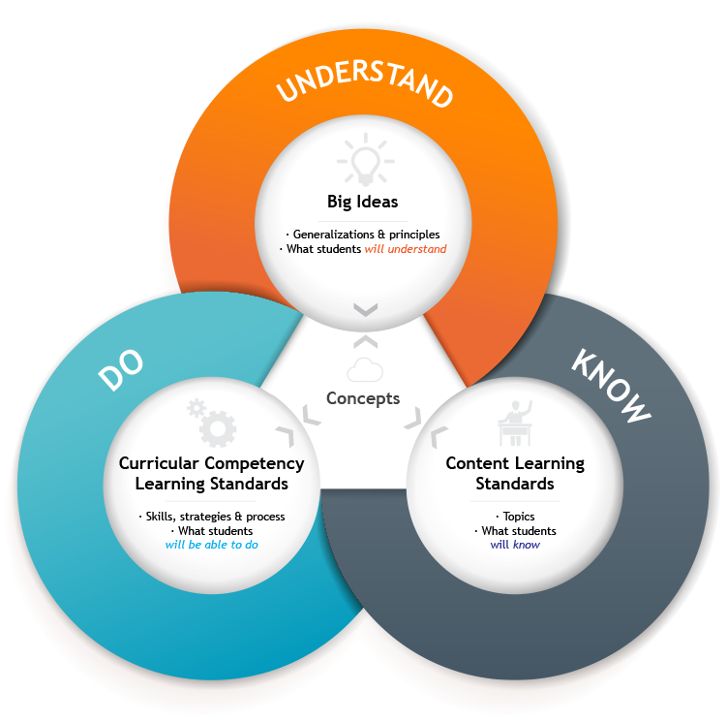
  - tba

