EDCP 471
Lecture Notes
S. Petrina (2018)

Materials Matter: Big Ideas in Manufacturing & Construction (Woodworking)

- Big Ideas or Core Ideas or Benchmarks or Generalizations or Key Concepts or Cross-Cutting Concepts
  - Big Ideas
    - Hudson (1997, p. 26): "Big ideas" are defined as large concepts or principles that facilitate integration of smaller facts and concepts and the relationship between them.
    - BC MoE, Glossary of Curriculum Terms (2016): Big Ideas are statements that are central to one’s understanding in an area of learning. A Big Idea is broad and abstract. It contains key concepts that generally are timeless and transferable to other situations. Big Ideas are the key concepts, principles, and theories that are used to organize knowledge within an area of learning. A Big Idea is a statement of an idea that is central to an area of learning or across disciplines and that links numerous understandings into a coherent whole.
    - BC MoE Curriculum Overview (2017): The Big Ideas consist of generalizations and principles and the key concepts important in an area of learning. They reflect the “Understand” component of the Know-Do-Understand model of learning. The big ideas represent what students will understand at the completion of the curriculum for their grade. They are intended to endure beyond a single grade and contribute to future understanding.
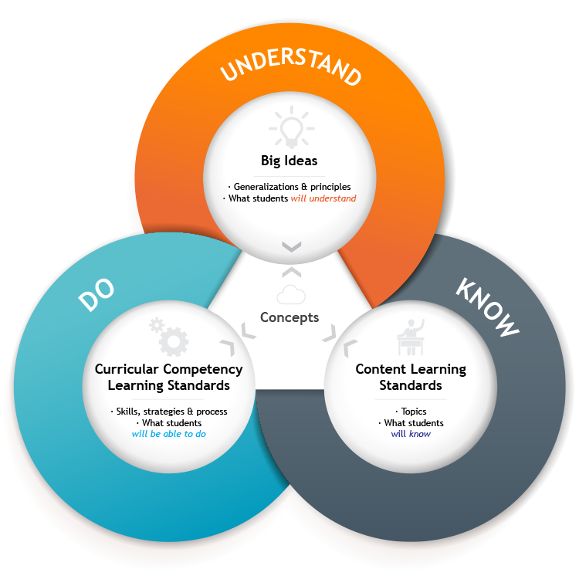
    - New Zealand Ministry of Education (2011): Key concepts are the ideas and understandings that we hope will remain with our students long after they have left school and have forgotten much of the detail. Key concepts sit above context but find their way into every context. Students need time and opportunity to explore these concepts, to appreciate the breadth, depth, and subtlety of meaning that attaches to them, to learn that different people view them from different perspectives, and to understand that meaning is not static. By approaching these concepts in different ways and by revisiting them in different contexts within a relatively short time span, students come to refine and embed understandings. https://seniorsecondary.tki.org.nz/English/Key-concepts/What-are-key-concepts
- Seeing the Forest for the Trees
  - Woodworking Example
    - What are some big ideas in Woodworking?
      - Content Outline: Scope & Sequence @ Sampling
      - BI Sources
      - Example: Randolph Township Schools, Advanced Woodworking https://www.rtnj.org/site/handlers/filedownload.ashx?moduleinstanceid=2461&dataid=4991&FileName=advanced%20woods%20curriculum%202013.pdf
        - Following proper safety measures will ensure a healthy working environment.
        - Maintaining the workspace in a neat, safe condition helps to protect the user from injury and enhances the quality of the finished product.
        - Careful, accurate plans, such as drawings, are essential to achieving a successful result.
        - The more complete and accurate a plan is, the better the chance for success.
        - An essential part of planning is the responsible use of materials.
        - It is essential to plan your work in such a way as to conserve vital, often irreplaceable resources.
        - A complex artifact comprised of several elements is greater than the sum of its parts.
        - Most substantial wooden objects such as pieces of furniture are assembled from a number of components and involve an array of skills and processes.
        - Wood is an organic material, and thus needs to be preserved and protected.
        - People derive considerable enjoyment from the feel, warm colors, and interesting grain patterns in wooden artifacts.
        - There are specialized techniques to make duplicate, interchangeable parts quickly, accurately, and dependably.
        - Teamwork is vital to the completion of mass produced objects.
        - Most of the objects we use on a daily basis have been mass-produced.
        - There are tools, materials, and processes, which can extend and improve our ability to accomplish goals.
        - All real world design solutions are created in a context of parameters and special considerations. Most of these contain a human element.
      - Example: Southern Regional, Applied Technology https://www.srsd.net/Curriculum/highSchool/appliedTech/Woodworking%20I.pdf
      - Example: Coalesce #2 https://pointofview.coalesse.com/create
        - What we often think of as craft is not the whole story – perhaps not even the right story.
        - Craft is a mastery of technique to make something that is as useful as it is special.
        - Craft is modern in every age – from handmade to the machine-made.
        - What is craft? Though culture is always evolving, we believe in a set of enduring traits that are always present in extraordinary examples of craft.

