EDCP 471
Lecture Notes
S. Petrina (2018)

Competencies in Design & Technology

- BC MoE, Glossary of Curriculum Terms (2016): Competency represents the combined skills, processes, behaviours, and habits of mind that learners use to make sense of the world
  - BC MoE, Glossary of Curriculum Terms (2016): Curricular Competencies are the skills, strategies, and processes that students develop over time. They reflect the “Do” in the Know-Do-Understand model of curriculum. The Curricular Competencies are built on the Thinking, Communicating, and Personal and Social competencies relevant to disciplines that make up an area of learning.
  - BC MoE, Glossary of Curriculum Terms (2016): Core Competencies are a set of intellectual, personal, and social competencies that students develop to engage in deeper learning and to support lifelong learning through the course of their schooling. The Core Competencies are embedded in each area of learning, and are activated through the learning experiences and activities. In BC, the Core Competencies are the Communication competency, Thinking competency, and Social and Personal competency.

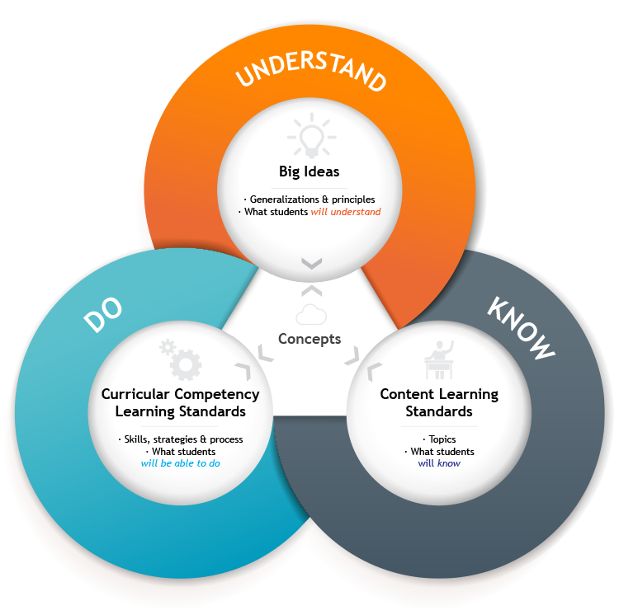
- Additional Definitions
  - Spencer and Spencer (1993): A competency is an underlying characteristic of an individual that is causally related to criterion-referenced effective and/or superior performance in a job or situation.
    - Five types of characteristics to define competency:
      - Motives - The things a person consistently thinks about or wants that cause action.
      - Traits - Physical characteristics and consistent responses to situations or information.
      - Self-Concept - A person's attitudes, values or self-image.
      - Knowledge - Information a person has in specific content areas.
      - Skill - The ability to perform certain physical
  - Richey et al. (2001, p. 31): Competency refers to the knowledge, skill or attitude that enables one to effectively perform the activities of a given occupation or function to the standards expected.
  - DEST (2005, p. 105): Competency comprises the specification of knowledge and skill and the application of that knowledge and skill to the standard of performance required.
  - DEST (2005, pp. 181-184): Employability Competencies:
    - Communication that contributes to productive and harmonious relations between employees and customers.
    - Teamwork that contributes to productive working relationships and outcomes.
    - Problem solving that contributes to productive outcomes.
    - Initiative and enterprise that contributes to innovative outcomes.
    - Planning and organising that contribute to long-term and short-term strategic planning.
    - Self-management that contributes to employee satisfaction and growth.
    - Learning that contributes to ongoing improvement and expansion in employee and company operations and outcomes.
    - Technology that contributes to effective execution of tasks.
  - Paquette (2007, p. 9): competency is defined as a combination of skills, attitudes, and knowledge that enable a group or person to fulfill a role in an organization or society.
- Ritzhaupt & Martin (2010, p. 427): Model of competencies

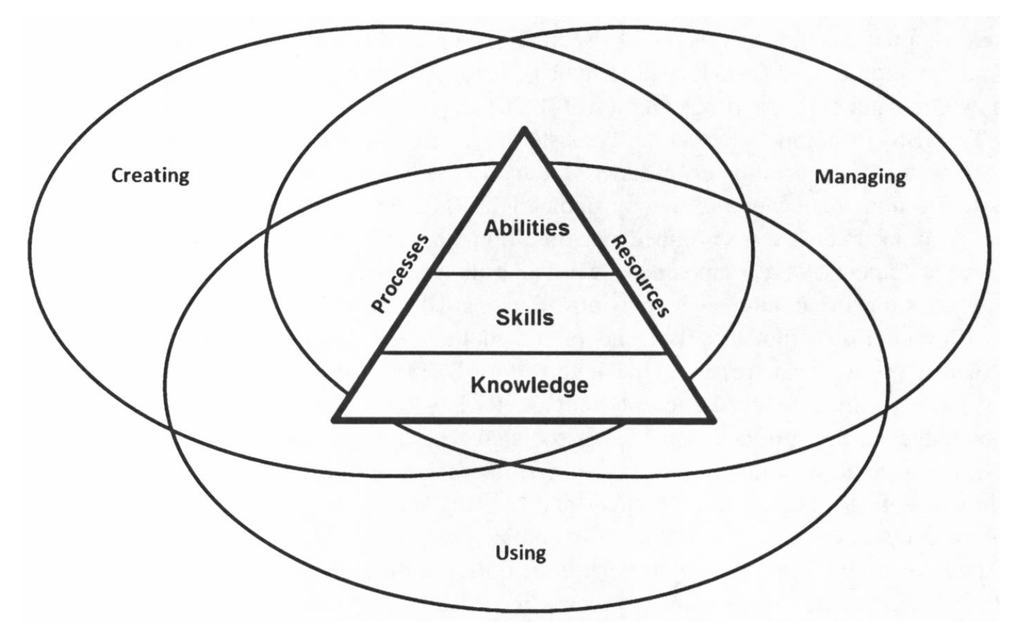
- BC TE PLOs (1995-2017)
  - Grades K-7
    - Curriculum Organizer: Self and Society
      - learning to solve problems involving technology
      - the personal relevance of problems involving technology and the discovery that there may be several solutions to a problem
      - developing positive attitudes toward lifelong learning and the integration and
      - application of skills across areas of learning and technologies
      - developing appropriate interpersonal skills and attitudes for working both independently and co-operatively within a group
      - exploring careers and lifestyles associated with technology
      - discovering how technology has changed society and the workplace
    - Curriculum Organizer: Communications
      - using technology to access, store, and retrieve information (although information technology is a separate curriculum, it is a major part of technology education)
      - developing knowledge and skills related to accessing, storing, retrieving, and using information
      - using manual and computer-assisted processes to present models and simulations in 2-D and 3-D forms to explain design ideas
      - developing and using criteria to create and revise design presentations
      - making use of skills, knowledge, and technologies from various curriculum areas to solve problems
      - making responsible choices about the use of technology
    - Curriculum Organizer: Production
      - applying the processes of combining, forming, separating, and finishing to the development and improvement of products at home and in the industrial world
      - evaluating and selecting materials to meet specific design requirements
      - constructing models, prototypes, and products to detailed specifications
      - investigating the effects of technological changes on the production and use of materials
      - examining processes and procedures used to minimize waste and to reuse products
      - developing appropriate attitudes and practices about working safely, whether in the workplace, at home, or in the school laboratory
    - Curriculum Organizer: Energy and Power
      - Sensing: detecting, interpreting, and monitoring energy in a system using electric, electronic, fluid, or mechanical devices. Information is processed, and a decision is made that results in a specific outcome (e.g., the auto-stop function on a cassette player; an infra-red beam on a conveyor belt counts boxes as they pass).
      - Switching: any method (e.g., mechanical, electronic) used to turn the flow of energy in a system off and on (e.g., a motion detector activates an alarm when an intruder is present; triggering the start of a model car on a ramp).
      - Regulating: varying the flow, amount, and direction of all forms of energy (e.g., human, fluid, mechanical, electrical, heat).
  - Grades 8-10
      - Curriculum Organizer: Self and Society
        - demonstrate a willingness to find unique solutions to problems that arise during the design process
        - demonstrate confidence and positive attitudes when solving problems that occur during the design process
        - demonstrate the ability to use community resources to help solve problems that come up during the design process
        - describe how societal pressures influence technological advancements and, conversely, how technological changes influence society
        - describe new careers and occupations in technological fields and determine their educational prerequisites
        - identify gender and ethnic bias in technological fields
        - identify methods to improve their abilities to work with others during problem-solving activities
      - Curriculum Organizer: Communications
        - apply knowledge and concepts from other disciplines in solving problems that arise during the design process demonstrate skill in managing time and resources
        - develop a plan to clearly communicate ideas for creating products and systems
        - evaluate information-gathering tools and processes used to access, store, organize, and present data
        - revise presentations based on personally set objectives
        - use a variety of drawing projection methods
        - use information-gathering and communication methods to solve problems involving technology and to create effective presentations
        - Students build skills in designing and developing products and systems that improve the human condition.
        - demonstrate a willingness to express thoughts and feelings about the effects of technology on their personal lives, society, and the environment
        - demonstrate confidence and positive attitudes when solving problems that arise during the design process
        - identify practical problems involving technology in a variety of contexts
        - list career paths in technological fields, and examine potential career opportunities
        - work with others to solve problems that come up during the design process
        - contribute to group success by encouraging others to fulfill their responsibilities
        - demonstrate a willingness to look for and develop improved solutions to problems that arise during the design process
        - demonstrate confidence and positive attitudes when solving problems that arise during the design process
        - evaluate design ideas based on assessments by others
        - explain relationships between technological advancements and changes in the workplace, including the changing roles of workers
        - express personal thoughts and feelings about how societal pressures may influence technological advancements and,
        - conversely, how technological changes influence society and the environment
        - identify role models in technological occupations, including those that are sensitive to culture, gender, and physical ability
        - develop two- and three-dimensional graphics using manual and computer-assisted processes
        - identify how information and concepts from other fields of knowledge are used in the design process
        - produce initial concept sketches and final drawing using a design process
        - revise presentations based on suggestions and comments from others
        - solve problems that come up during the design process by using various information sources
        - communicate ideas for designing products and systems using various drawing projection methods, spreadsheets, graphics, or other media
        - describe the advantages and disadvantages of various information-gathering and communication processes
        - develop two- and three-dimensional graphics using manual and computer-assisted processes
        - identify how information and concepts from other fields of knowledge are used in the design process
        - revise presentations based on personal review and feedback from others
        - use information-gathering and communication methods to solve problems during the design process and to create effective presentations
      - Curriculum Organizer: Production
        - classify and describe the characteristics of industrial materials
        - demonstrate safe work habits when using tools, equipment, and technical processes, and encourage the same in others
        - describe ways to reuse and recycle materials and products to reduce waste
        - devise a production process
        - examine new trends in manufacturing processes
        - explain and use WHMIS information
        - match materials to specific product requirements
        - use a design process in production activities
        - use hand and power tool techniques to process materials in order to improve the appearance, usefulness, and function of products
        - use orderly assembly and disassembly techniques
        - apply finishes and details to manufactured products to enhance their appearance and durability
        - demonstrate safe work habits when using tools, equipment, and technical processes
        - describe and use the process of product design
        - describe combining, forming, separating, and finishing processes as they relate to materials used in product manufacturing
        - evaluate the efficiency of a production process
        - identify and classify the properties of materials used to manufacture products
        - identify ways to minimize waste and reuse products
        - select materials based on a set of design specifications
        - classify and describe the characteristics of industrial materials
        - demonstrate safe work habits when using tools, equipment, and technical processes, and encourage the same in others
        - describe ways to reduce waste
        - devise a manufacturing process
        - devise and use assembly-sequence diagrams and flow charts to explain a process or system
        - identify new trends in manufacturing processes
        - investigate and select materials to meet design specifications
        - select and safely use hand and power tools in the manufacture of products
        - select and use a variety of finishes on products to improve their appearance and durability
        - use a design process to modify products to improve their appearance, usefulness, and function.
      - Curriculum Organizer: Control
        - demonstrate an understanding of the principles involved with interconnected control devices in product manufacturing
        - design and construct a system that uses a control device, and assess its environmental and social implications
        - devise troubleshooting strategies for correcting malfunctions in a system
        - devise ways to monitor, modify, and improve systems by incorporating control devices
        - compare ways that various control devices work, and explain their applications
        - demonstrate understanding of the concept of control by dismantling devices
        - design and construct a control device that senses, switches, or regulates integrate electric, electronic, pneumatic, and mechanical control devices within a system
        - demonstrate an understanding of the operating principles used in various control devices
        - design and construct a system that uses a control device
        - modify electric, electronic, pneumatic, and mechanical control devices for particular applications
        - use troubleshooting strategies to locate the source of malfunctions in a system
      - Curriculum Organizer: Energy and Power
        - construct devices that convert and transmit various forms of energy
        - describe alternative sources of energy
        - disassemble devices and explain the transfer and conversion of energy within mechanical systems
        - explain how systems convert potential energy to kinetic energy, and assess their environmental and social implications
        - incorporate selected devices in the design of energy transmission and conversion systems
        - analyse the function of systems used in machines and equipment
        - construct devices to convert, store, and distribute energy in usable forms
        - design systems that multiply, reduce, and transmit power, and assess their social and environmental implications explain the transfer and conversion of energy within a mechanical system
        - construct devices that are powered in various ways
        - explain how systems transmit and convert energy
        - identify how simple machines are combined into energy and power systems
        - incorporate selected devices in the design of energy transmission and conversion system.

