EDCP 471
Lecture Notes
S. Petrina (2018)

Content of Design & Technology

- See Petrina, Advanced Teaching Methods (Chapter 8)
- Definitions
  - Content is ‘subject matter’ but what does that mean?
  - Content can defined as what students should know and be able to do in a given discipline.
    - Content standards, then, are “statements of what students should know and be able to do” in a given discipline.
  - Content can also be defined as factual knowledge and demonstrable dispositions and skills.
  - Reigeluth & Carr-Chellman (2009, p. 24): The nature of what is to be learned, defined comprehensively to include not only knowledge, skills, and understandings, but also higher-order thinking skills, metacognitive skills, attitudes, values, and so forth.
  - A content outline provides "a comprehensive guide to the topics covered" or to be covered. Content outlines provide a scope of the domain or world of content but say little to nothing about what is meaningful, valuable, or worthwhile.

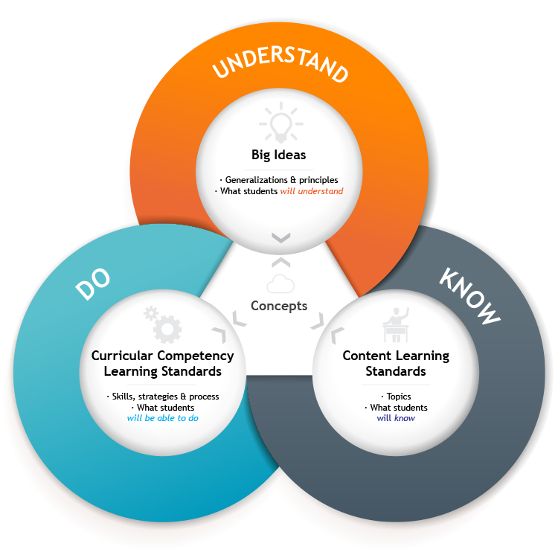
- Content Standards for technology education (international Standards for Technological Literacy):
  - The Nature of Technology
    - Students will develop an understanding of the characteristics and scope of technology.
    - Students will develop an understanding of the core concepts of technology.
    - Students will develop an understanding of the relationships among technologies and the connections between technology and other fields of study.
  - Technology and Society
    - Students will develop an understanding of the cultural, social, economic, and political effects of technology.
    - Students will develop an understanding of the effects of technology on the environment.
    - Students will develop an understanding of the role of society in the development and use of technology.
    - Students will develop an understanding of the influence of technology on history.
  - Design
    - Students will develop an understanding of the attributes of design.
    - Students will develop an understanding of engineering design.
    - Students will develop an understanding of the role of troubleshooting, research and development, invention and innovation, and experimentation in problem-solving.
  - Abilities for a Technological World
    - Students will develop abilities to apply the design process.
    - Students will develop abilities to use and maintain technological products and systems.
    - Students will develop abilities to assess the impact of products and systems.
  - The Designed World
    - Students will develop an understanding of and be able to select and use medical technologies.
    - Students will develop an understanding of and be able to select and use agricultural and related biotechnologies.
    - Students will develop an understanding of and be able to select and use energy and power technologies.
    - Students will develop an understanding of and be able to select and use information and communication technologies.
    - Students will develop an understanding of and be able to select and use transportation technologies.
    - Students will develop an understanding of and be able to select and use manufacturing technologies.
    - Students will develop an understanding of and be able to select and use construction technologies.

