EDCP 471
Lecture Notes
S. Petrina (2018)

Assessment

- See Petrina, Advanced Teaching Methods (Chapter 10)
- Definitions
  - Assessment: Monitoring, documenting and communicating levels of quality and quantity of performance. Assessment is done in order to: (1) provide feedback for learning & growth; (2) rank or sort according to some characteristic; and (3) provide means of communication with parents, administrators, teachers, etc.
    - Formative Assessment: Assessment that is progressive in that the students' progress is monitored and communicated at different periods in time throughout the course, unit, term, etc. "In-progress" assessment.
    - Summative Assessment: Assessment is final in that the students' performance is assessed at the end of a unit or course. "Final" assessment.
    - Authentic Assessment: Assess the genuine, "real" or actual thing (person, performance, etc.); Assess fairly; Use assessment to enhance learning.
  - The Principles for Fair Student Assessment Practices for Education in Canada (Joint Advisory Committee, 1993): The process of collecting and interpreting information that can be used (i) to inform students, and their parents, about the progress they are making toward attaining the knowledge, skills, attitudes and behaviors to be learned or acquired, and (ii) to inform the various personnel who make educational decisions about students. (p. 3)
- Assessment in BC’s new Curriculum https://curriculum.gov.bc.ca/assessment-system
  - “Assessment involves the wide variety of methods or tools that educators use to identify student learning needs, measure competency acquisition, and evaluate students’ progress toward meeting provincial learning standards.”

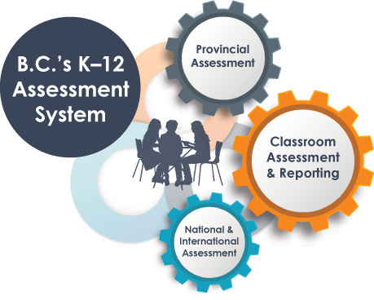
  - Rubrics
    - Loveland (2005): A benefit to the teacher is a reduction in subjective grading and time devoted to grading. In addition, standards-based assessments help teachers to clearly define what is expected of students and therefore what logically needs to be taught to students. Rubrics are a direct way of implementing the STL technological literacy standards in classrooms. Evaluation of classroom rubrics can assist in refinement of lesson sequencing, content, and focus. Low class scores in specific criteria may indicate problems in instruction that can be changed (ITEA, 2002). For administrators, parents, and advisory board members, classroom rubrics give clear indications of what the teacher is focusing on, what is being assessed, and how students are being prepared for technological literacy. The use of rubrics goes beyond the simple need for objective grading in classrooms. When properly designed, they provide a roadmap for student, teacher, and community success. http://www.fod.ac.cr/estandares/docs/descargas/standards_based_rubrics.pdf
    - Example from NB MoE, "Middle School Technology Education" (2016) https://www2.gnb.ca/content/dam/gnb/Departments/ed/pdf/K12/curric/TechnologyVocational/Middle%20School%20Technology.pdf:

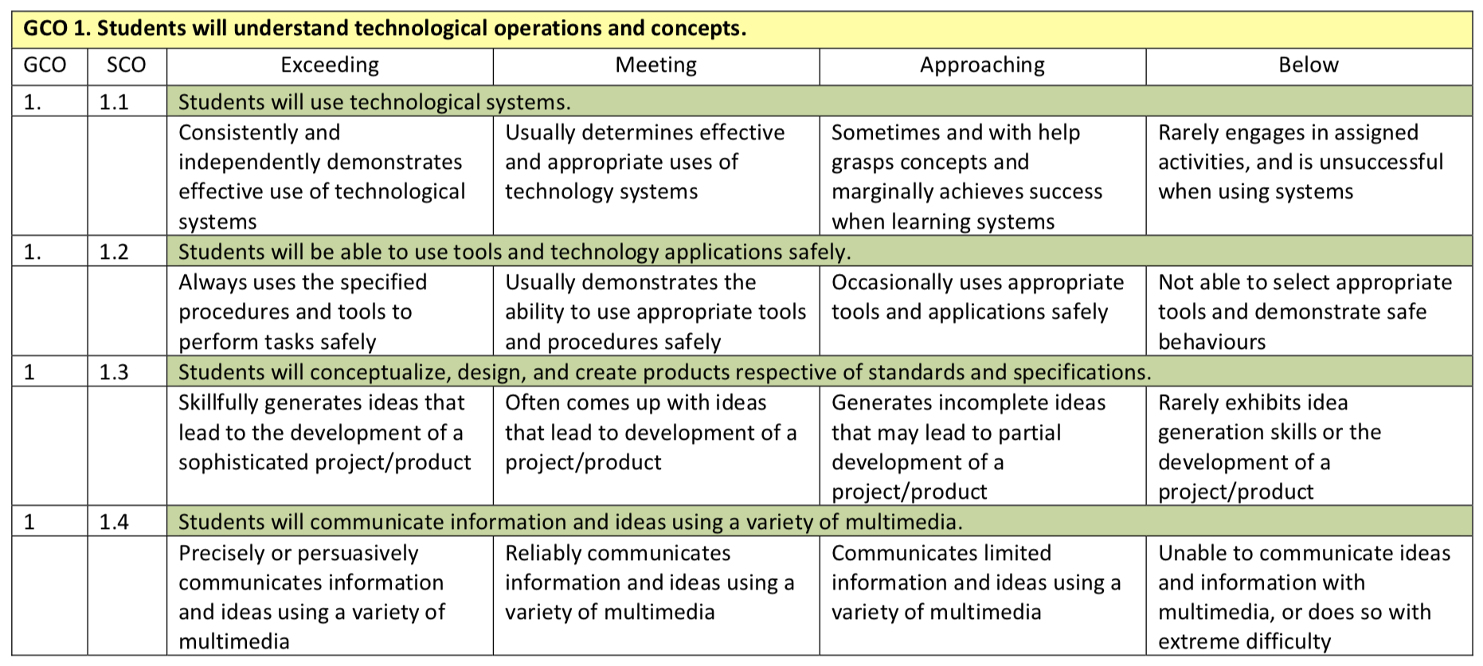\
- Content Standards for technology education (international Standards for Technological Literacy):
  - The Nature of Technology
    - Students will develop an understanding of the characteristics and scope of technology.
    - Students will develop an understanding of the core concepts of technology.
    - Students will develop an understanding of the relationships among technologies and the connections between technology and other fields of study.
  - Technology and Society
    - Students will develop an understanding of the cultural, social, economic, and political effects of technology.
    - Students will develop an understanding of the effects of technology on the environment.
    - Students will develop an understanding of the role of society in the development and use of technology.
    - Students will develop an understanding of the influence of technology on history.
  - Design
    - Students will develop an understanding of the attributes of design.
    - Students will develop an understanding of engineering design.
    - Students will develop an understanding of the role of troubleshooting, research and development, invention and innovation, and experimentation in problem-solving.
  - Abilities for a Technological World
    - Students will develop abilities to apply the design process.
    - Students will develop abilities to use and maintain technological products and systems.
    - Students will develop abilities to assess the impact of products and systems.
  - The Designed World
    - Students will develop an understanding of and be able to select and use medical technologies.
    - Students will develop an understanding of and be able to select and use agricultural and related biotechnologies.
    - Students will develop an understanding of and be able to select and use energy and power technologies.
    - Students will develop an understanding of and be able to select and use information and communication technologies.
    - Students will develop an understanding of and be able to select and use transportation technologies.
    - Students will develop an understanding of and be able to select and use manufacturing technologies.
    - Students will develop an understanding of and be able to select and use construction technologies.

