EDCP 471
Lecture Notes
S. Petrina (2018)

Scheduling & Timetabling
- Definitions
  - Elementary & Middle Schools (& some Secondary)
    - Linear Period Schedule or Timetable: School day organized into 6-8 class periods lasting about 40-50 minutes each.
    - Year long: Linear timetables are typically year long, wherein students are with the same teachers. This timetable is often divided into trimesters, wherein “sampler courses” (arts, ADST, etc.) rotate on a trimester schedule throughout the year.

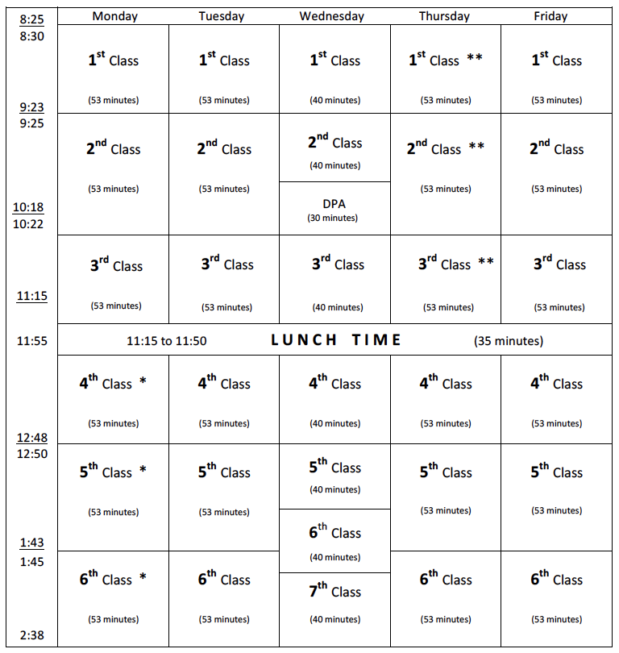
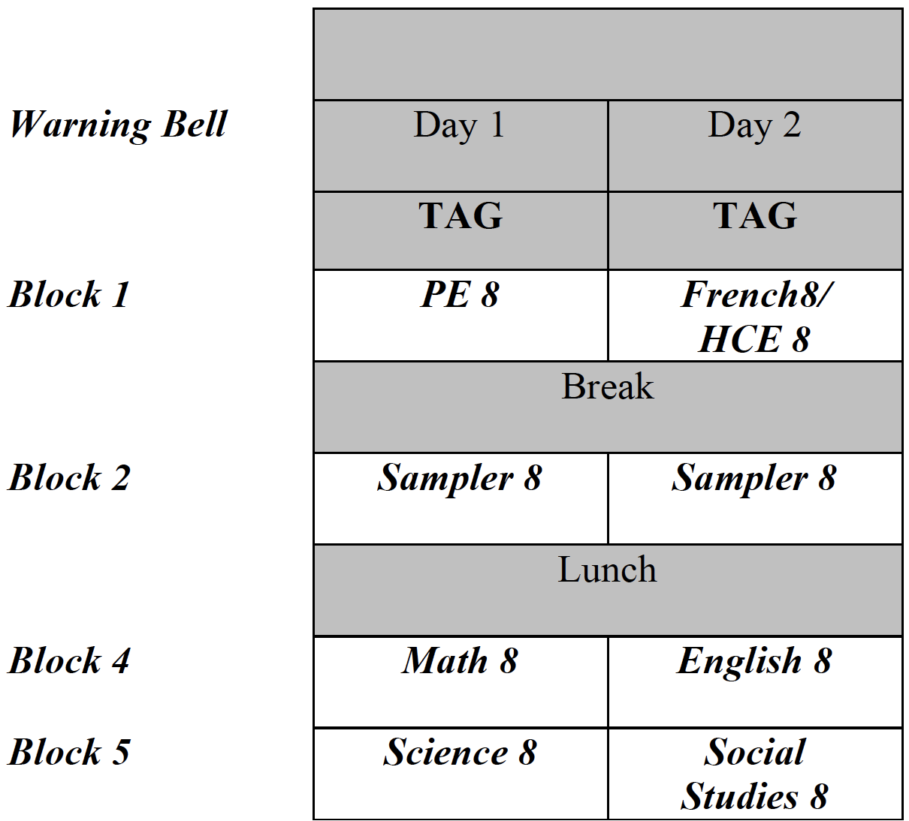

  - Secondary Schools
    - Block Schedule or Timetable: School day organized into larger blocks of time — class periods lasting longer than the traditional 50 minutes.
      - Texas Education Agency (1999, p. 3): The term “block scheduling” broadly refers to innovative school scheduling practices that organize at least part of the school day into larger blocks of time (more than 60 minutes). Introduced in the mid-1960s, the concept is rooted in concerns about creating sufficient time to immerse students in the learning experience. An extended-period schedule contains fewer classes per day, enabling teachers and students to focus more time and energy on each lesson and cover subjects in greater depth (Willis, 1993). The longer periods also accommodate the use of creative teaching methods that seek to enrich and personalize instruction, such as cooperative learning, interdisciplinary lessons, hands-on exercises, and long-term group or individual projects. According to proponents of block scheduling, these techniques help to enhance student motivation and, ultimately, improve academic achievement.
    - Semester Timetable: School year is divided into two parts or semesters, wherein each semester is based on a block schedule. *i.e., 4 courses / semester = 8 courses / year
    - Trimester Timetable: School year is divided into three parts or trimesters, wherein each trimester is based on a block schedule. *i.e., 3 courses / trimester = 9 courses / year

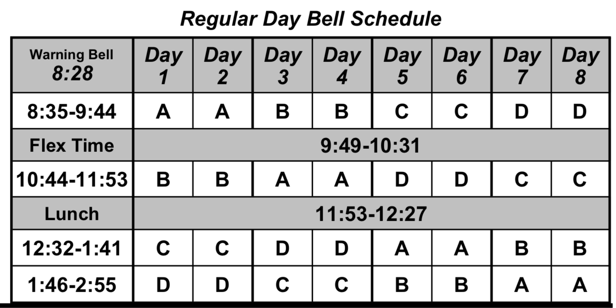

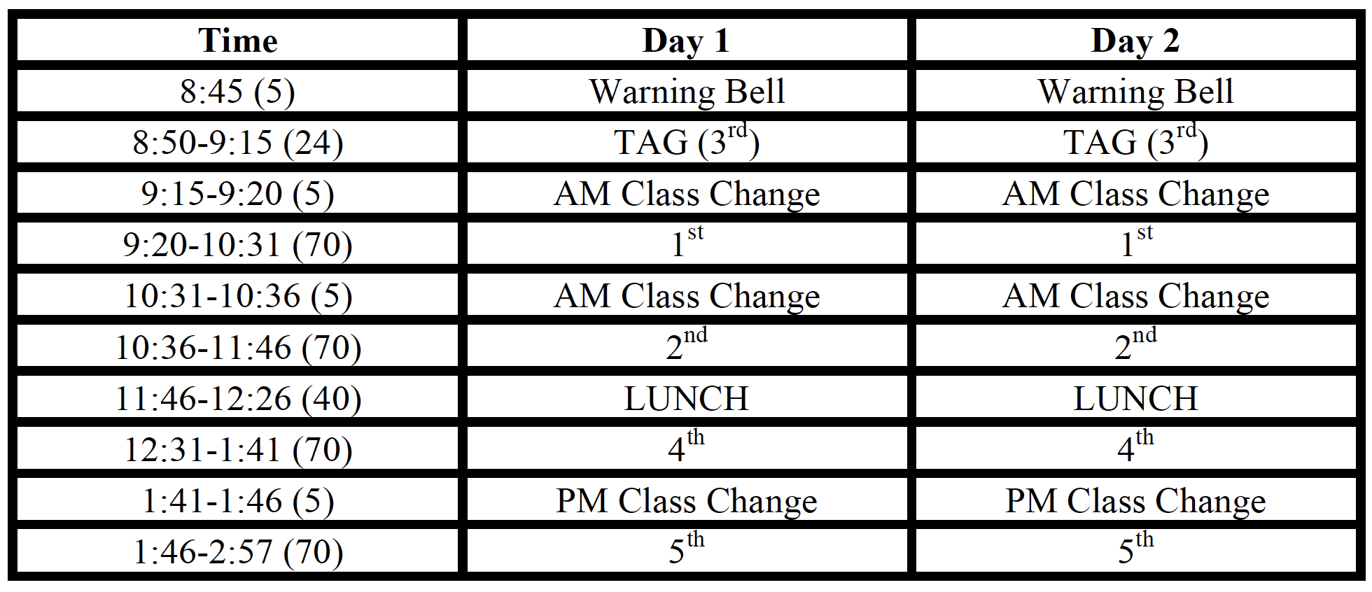

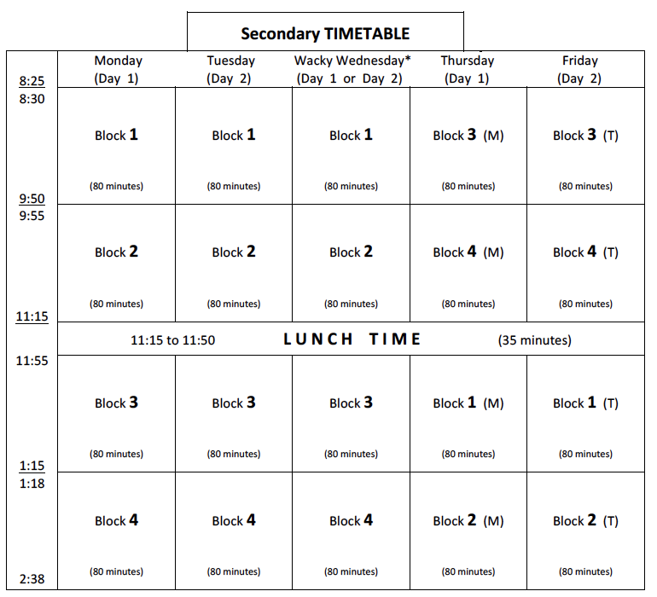

    - Types of Block Schedules (Texas Education Agency, 1999, p. 2):
      - A/B (Alternate Day). Between six and eight extended classes meet every other day throughout the school year (i.e., half of the classes meet one day, and half meet the following day). A “modified” A/B block schedule usually includes one or two periods that meet every day, in much the same way as a traditional schedule.
      - 4 x 4 (Accelerated or Semester). The standard 180-day school year is divided into two 90-day semesters. Each semester, students attend four 90-minute classes daily.
      - Reconfigured School Year (e.g., 75-75-30 or 75-15, 75-15). Longer academic terms are combined with shorter terms focused on activities such as student enrichment and remediation.
      - Intensive (e.g., trimester or quarter-on/quarter-off). Students receive concentrated instruction in a small cluster of related subjects through a series of shorter terms during the school year.
- TBA

