Assessing the Need for a Centralized
Mental Health Support Service in
Surrey BC

for
Dr. Victoria Lee
President and CEO
Fraser Health Authority

by
Dave Borrel
English 301 Technical Writing Student
(to be Peer Reviewed by Jenny Li)

November 16th 2021
Table of Contents

INTRODUCTION………………………………………………………………………………. 3
Background Information Regarding The Effect of the Pandemic on Mental Health for Young Adults 3
Description of the State of Mental Health Supports Available in Surrey BC 3
Overview of Problem Areas 4
Purpose and Intended Audience of the Report 5
Brief Description of Data Sources 5
Scope of Inquiry 6
Method of Inquiry 6
DATA SECTION………………………………………………………………………………………….. 7
Sources of Barriers 7
Analysis of Collected Data 9
Analysis of Secondary Research 10
Proposed Solution and Feasibility Discussion 11
Overview of Risks 12
CONCLUSION…………………………………………………………………………………………... 13
Summary of Findings 13
Recommendations 13
Works Cited…………………………………………………………………………………………….... 14
Appendix…………………………………………………………………………………………………. 15

INTRODUCTION

Background Information Regarding The Effect of the Pandemic on Mental Health for Young Adults

As Canadians re-adjust to life post-pandemic, there has been an epidemic of loneliness that is prevalent in young adults today. During this time many life changes can occur such as social isolation, job loss, and changing relationships. For some, online communication cannot substitute face to face human contact. Consequently, these factors can exacerbate mental health issues for young adults, ranging from 20 to 29 years old. This can be detrimental to Canadian society as a whole by reducing productive work, increasing health care costs, and could potentially damage families and communities. From my experience working at the Fraser Health Crisis Line, there are still many young adults who do not know where to seek support in times of crisis. In the Fraser Health Region (Surrey to Hope), language barriers, and socioeconomic status, all have significant impact on the discrepancy of knowledge regarding mental health. If there are no services in a specific language, certain ethnic communities may not be able receive support. Additionally, differences in income can prevent individuals from physically seeking support by needing to work often. Differences in education and upbringing may empower some while also hindering others. These factors combined contribute to a large population of young adults who do not know where to seek support.

Description of the State of Mental Health Supports Available in Surrey BC

Although individuals with severe mental illness are almost guaranteed to get support, many young adults in the Fraser Health Region with less severe mental health illness are still ambivalent about seeking help. This hesitancy is the problem that I want to focus on for this research proposal. Over the last decade, there has been a gradual reduction of stigma tied to seeking mental health support. From the conversations I heard at the Fraser Health Crisis Line, the main factors that lead to this hesitancy is a lack of culture specific resources, and becoming overwhelmed with information. For those that do end up seeking professional help, waitlists can also be a deterrent and can make individuals feel more discouraged leading to cancelled appointments. In summary, young adults who are ambivalent towards seeking mental health support face obstacles before reaching out and even face a new set of obstacles during the help seeking process as well.

Overview of Problem Areas
Within the city of Surrey, there are a number of potential resources that individuals can turn to in order to find resources and referrals. One common service that individuals can call involves calling the Surrey Mental Health Office. Although it is provided through Fraser Health, there are often waitlists and it is not open on the weekends or evenings, making it difficult for those who have full time work. Another alternative resource that individuals can use is BC211, which is an online directory that makes it possible to search for mental health resources in a specific area. However, the user interface that individuals use is hard to navigate at times. In order to find a private counsellor, most individuals can start using a google search. After an initial search, there are a plethora of different results. They range from online counselling, different private practices, and general databases for registered clinical counsellors. If a person needed to search for general information, there are different non-profit websites that can be accessed. This highlights the deeply fragmented network of resources that are available for individuals.

Purpose and Intended Audience of the Report

- The purpose of this report is to demonstrate to the board of directors for the Fraser Health Authority of the importance of the need for a more centralized mental health service.
- Ideally, this report would begin a larger effort from the board, by assigning an internal team or hiring external members to implement this report.

Brief Description of Data Sources

To assess the perceived need for developing a market for a centralized mental health service, I plan to pursue the following areas of inquiry.

- Which resources would you use if you wanted to get more information about mental health support for yourself or family?
- How much do you know about the free mental health resources available to you?
- How familiar are you with the process of seeking a counsellor?
- What do you imagine the wait time would be for finding a counsellor?
- Would you be interested in using a centralized service to help you find the resources relevant to your own mental health?
- Would you prefer this service to be in the form of a website? An app? Or something else?

Scope of Inquiry
In the province of British Columbia, about 17% of all individuals are experiencing mental health or substance use issues (CMHA Website). Within the Fraser Health Region, there are about 1.8 million residents. This results in around 300,000 individuals who may be experiencing mental health concerns and may need the support.

Method of Inquiry
This study will be using an online survey given to residents of Surrey using the UBC qualtrics survey service. The survey includes 12 questions that ask about the person’s familiarity with different resources in Surrey along with their perceptions of what is needed to help best support young adults.

DATA SECTION

The survey was given to 13 respondents who lived in the Fraser Health Region. These surveys and 1 incomplete survey was removed from the total number of respondents in the survey.

Sources of Barriers

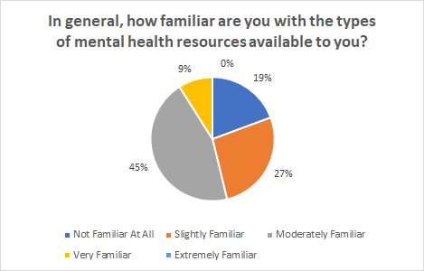
Figure 2: Survey Response to Question 1. From 12 Respondents in total.
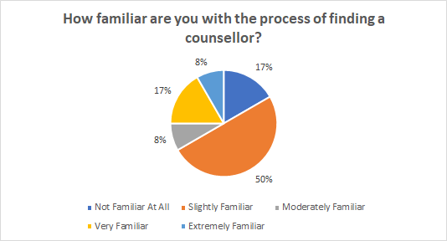
Figure 3: Survey Response to Question 2. From 12 Respondents in total.
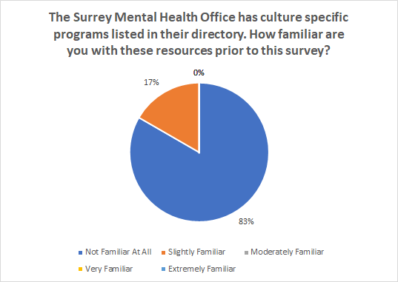
Figure 4: Survey Response to Question 3. From 12 Respondents in total.
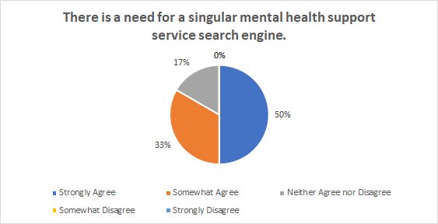
Figure 5: Survey Response to Question 8. From 12 Respondents in total.

Analysis of Collected Data
Based on the initial responses of the survey respondents it seems like most individuals are aware of the resources available to them as 81% of the respondents had some awareness of what was available to them (see fig. 2). Most of the respondents have an idea of where to find resources. Additionally, most respondents have some idea of how to find a counsellor with 83% of the respondents having some idea of where to find a counsellor for themselves (see fig. 3). These results combined with the responses questions highlight the fact that most young adults living in the Fraser Health Region have an idea of which resources are available to them. However, other questions in the survey help to elucidate the barriers that might prevent them from seeking help.

Some of the barriers mentioned in the introduction involve feeling overwhelmed with the number of resources available to them, cultural factors, and finances. Although most of the respondents are aware of the general mental health resources available to them, the knowledge of culture specific resources is not so readily known. 83% of all the respondents were not aware of the more culture specific resources of the Surrey Mental Health Office (see fig 4.). Additionally, based on the responses of the 12 surveys, reducing stigma and the costs around counselling are the important areas to address in order for younger adults to seek mental health support.

Although the survey respondents are assumed to have better knowledge of digital health apps related to mental health, over half of the respondents were not aware of the free mental health apps available to them. Although new apps and digital health tools are often released, the target markets for these products are not reached in its entirety. Finally, another interesting result, the survey shows that most of the respondents (66%) would prefer using a combination of a website and mobile app if it were provided by the Fraser Health Region.

Near the end of the survey, respondents were asked if they were interested in using a centralized database to find mental health support and 83% of respondents at least somewhat agree with this statement (see fig 5).

Analysis of Secondary Research
Based on a Statistics Canada Report “Mental health care needs, 2018”, many of the perceived barriers mentioned include not knowing where to get help, being unable to pay, and not having resources that catered to different cultures and languages. In British Columbia, there has been an increase in the percentage of people who responded that they had partially unmet or unmet needs (51.1 %) compared to the national average (43.8%). Additionally, this report mentions that the lower the household income, the higher that rate at which people report that they have unmet needs in terms of mental health support.

In a more recent report from the BC CDC, there is evidence that the overall mental health of young adults has been negatively impacted by the pandemic. One action area mentioned in this report involves improving access and utilization of services. Many of the points listed under this action area echo the results from the survey. Reducing stigma, removing restrictions, and using other platforms besides traditional mental health offices is an area of focus that can be addressed with the proposed solution in this report.

Proposed Solution and Feasibility Discussion
An simple way to imagine how the implementation of this system would work in British Columbia would be to analyze similar systems in a different Canadian City. For example, Access Mental Health is a centralized point of access provided by Alberta Health Services. In this program, a registered clinician will interview the person who phones, assesses their needs, and then connects them with the relevant resources that are appropriate for them. However, similar to the issues found in a more traditional mental health office, this service is not open 24 hours and it does not have a mobile app associated with it.

The proposed solution will involve collaboration with Fraser Health, Private Counselling Offices, Mental Health Apps, and Other Similar Resources. This will involve creating a website through Fraser Health that will serve as the singular mental health resource for anyone living in the area. The website will allow a client to speak to mental health professionals and be matched with the appropriate resources based on their answers. Then Fraser Health will facilitate this process for the client based on gender preferences, ethnicity of the provider, and any other preferences that the person may have. Additionally, this service could also bridge the gap between the lesser known mental health resources for clients by having them featured on the website for clients. Another advantage to having an online resource combined with an app is that this can be offered outside of normal work hours or provide a more convenient way to find resources. Additionally, private counselling clinics can feel incentivised to be included in this centralized database as they can potentially pay to have their practice listed on the search results.

Overall, this would be a reasonably simple task as it only requires restructuring of the administrative process by moving it into an online service. This could be reasonably completed within 1-2 years and would not require any changes to the existing services. It only modifies the sources to which each organization can get clients from.

Overview of Risks
Since this is a novel approach to organizing the Mental Health supports in the area, there is a risk of information breach and security issues as each existing mental health service may not have the proper infrastructure to send data to Fraser Health. Therefore, significant steps need to be taken for effective cyber security. Additionally, there may be a conflict of interest if certain private practices pay more to have their service listed above others. In order to manage this risk, careful consideration of the contracts between service providers is needed. Although this would be a helpful restructuring of services, it is still important to note that some clients may not have access to the internet for this type of service to benefit them.

CONCLUSION

Summary of Findings
In summary, there seems to be a need for a more centralized service within Surrey. Based on the survey from clients who will mostly be using the service, a significant chunk of respondents were interested in using a service such as this one. Additionally, based on secondary research, it seems that existing and similar programs found in different Canadian cities are also seeing some success. There is an opportunity to combine the existing resources in Surrey and create a singular point of access that includes online resources, mental health apps, and other aspects that are useful.

Recommendations
We recommend that the board of directors find partners and stakeholders in the community to help set up a centralized point of access. We ask that Fraser Health look more deeply into this possibility and do further analysis to see how this can be better implemented in Surrey. We ask that the board of directors assign a team to speak with other services in the area and find an external team that can implement the search engine into a user-friendly service both on a website and in an app.

Works Cited
Alberta Health Services. “Access Mental Health.” Access Mental Health, 16 Nov. 2021, www.albertahealthservices.ca/findhealth/Service.aspx?id=2381&serviceAtFacilityID=1019446#contentStart.

BC CDC. “Impacts of the COVID-19 Pandemic on the Health and Well-Being of Young Adults in British Columbia.” BC CDC, 2021, www.bccdc.ca/Health-Professionals-Site/Documents/COVID-Impacts/BCCDC_COVID-19_Young_Adult_Health_Well-being_Report.pdf.

Canadian Mental Health Association. “Facts and Figures.” Cmha.Ca, 16 Nov. 2021, cmha.bc.ca/impact/facts-and-figures/#:%7E:text=About%2017%25%20of%20British%20Columbians,are%20receiving%20mental%20health%20services

Statistics Canada. “Mental Health Care Needs, 2018.” Statcan.Ca, 7 Oct. 2019, www150.statcan.gc.ca/n1/pub/82-625-x/2019001/article/00011-eng.html.

Appendix
Survey
I am an undergraduate student involved in a technical writing project. The aim of this survey is
to collect primary data for the perceived interest in a centralized mental health service in Surrey BC. The final report will be addressed to the CEO of Fraser Health and its board of directors. This primary data combined with reports from Fraser Health, will be used to provide recommendations for creating a more streamlined approach to finding mental health resources in Surrey BC. The survey contains 12 multiple choice questions and it should take 5 minutes of your time. Your responses are voluntary and anonymous, thank you for participating in my survey.

- In general, how familiar are you with the types of mental health resources available to you?
- How familiar are you with the process of finding a counsellor?
- The Surrey Mental Health Office has culture specific programs listed in their directory. How familiar are you with these resources prior to this survey?
- Do you have extended health insurance coverage? (Through school, parents, employment or other)

- How familiar are you with the mental health coverage that is included in these extended health plans?

- How familiar are you with the mental health apps (paid or free) available to you?

- What do you think the average wait time for a counselling appointment is?

- There is a need for a singular mental health support service search engine.

- From the following choices, what is the most important in supporting young adults aged 20-30 towards seeking mental health support in Surrey?

- Describe your level of interest in a centralized mental health search engine, with 1 being not at all to 5 being completely interested.

- If there was a centralized point of contact in Surrey, which type of format are you most likely to use?

- Thank you for taking the time to participate in this survey. If you have any other questions or concerns, please type them below.

