COSTCO THEFT PREVENTION REPORT

David Cheung

Dale
July 22, 2022

TABLE OF CONTENTS
I. INTRODUCTION
A. The location and layout of Costco Vancouver
B. Relevant parts of the Costco code of ethics
C. The doors
D. A flatbed and their use
E. Purpose of this report
F. Brief description of data sources
G. Scope of this inquiry
II. DATA SECTION
A. Current procedure at the door
B. Location of Flatbeds inside and outside the building
1. Parking lot
2. On the street
3. Inside Costco
C. Causes of Theft
1. Downtown eastside
2. Where flatbeds are lost
D. Current Measures to prevent theft
1. What Costco staff are doing
III. CONCLUSION
A. Summary and overall interpretation of findings
B. Recommendations for door
C. Recommendations for flatbeds

COSTCO VANCOUVER’S THEFT PREVENTION: AN ANALYSIS OF CURRENT PROCEDURE AND RECOMMENDATIONS
ABSTRACT
This report examines the loss of goods and flatbeds from theft at Costco Vancouver and proposes possible solutions for preventing losses on Costco Vancouver Property.
INTRODUCTION
Location and Layout
Costco Vancouver, a warehouse owned and operated by Costco Wholesale, is unique in its location and layout. Unlike all other Costco warehouses in Canada, Costco Vancouver is located in a downtown core. What sets Costco Vancouver’s location apart from those of other Costco warehouses is what is located across the street. Directly across Expo Boulevard, the street running in front of Costco Vancouver, is Rogers Arena, a stadium that hosts NHL hockey games and concerts as well as other major events.
Griffiths Way separates Rogers Arena from BC Place, another stadium that hosts major league sporting events and other major events. Costco Vancouver is well serviced by public transit with Stadium Chinatown Skytrain Station being next door. Because of its location, Costco Vancouver services diverse neighborhoods ranging from Yaletown to the Vancouver downtown eastside.
Whereas other warehouses in Canada which are surrounded by vast above ground parking lots, most of Costco Vancouver’s parking is located in a multi-level underground parking lot. There is a loading zone beside the food court across from Stadium Chinatown Skytrain Station. More parking is available along Expo Boulevard extending beyond the sight of Costco working in front of the building due to a blind spot created by the pedestrian entrance to the underground parking lot (see figure 1).
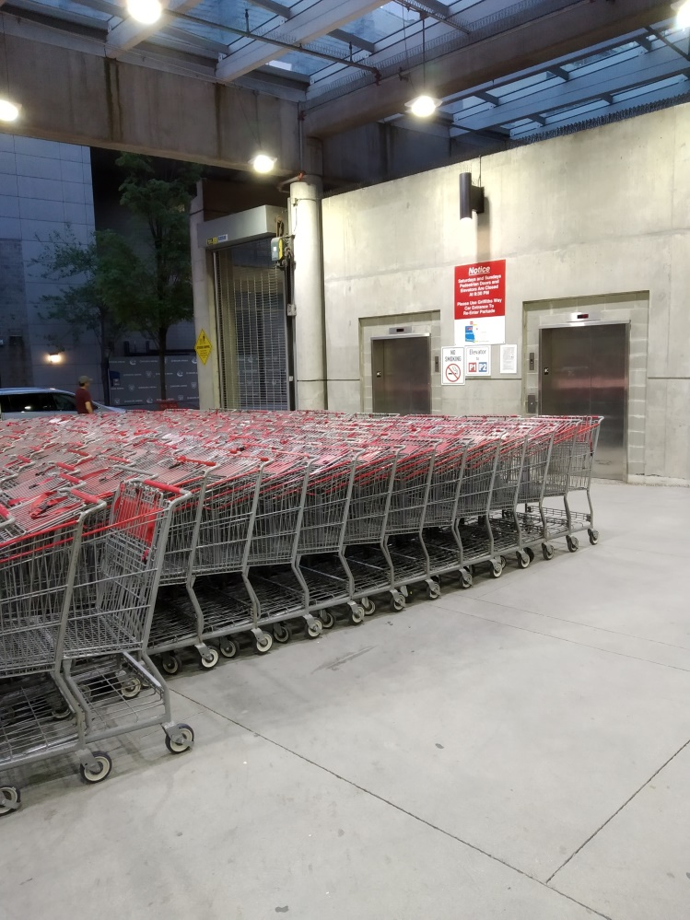
Figure 1
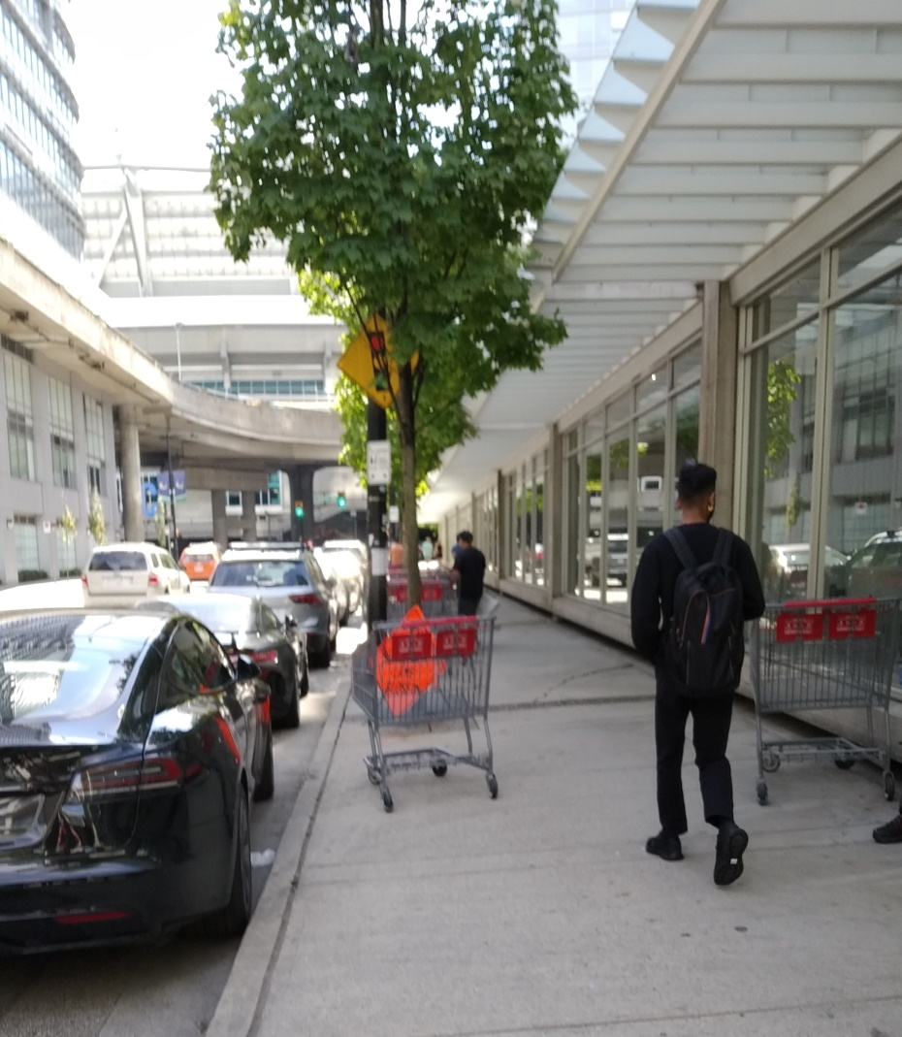
Figure 2
Costco Vancouver is the only Costco warehouse in Canada where the food court is open to the general public instead of being members only. Because of this, the food court sees a much more diverse clientele buying the famously inexpensive Costco hotdog. Since the start of the pandemic, the Costco Vancouver food court no longer accepts cash as a form of payment. The customers of the food court lack access to a restroom unless they are members.
With the exception of accessing the pharmacy or optometrist, a prospective customer needs to purchase a membership from the membership desk (please see figure 1) for 63 Canadian dollars to enter the store. Going through the entrance door, a customer can see the pharmacy in the far back of the store although it is obstructed by columns and shelving. To the left of the entrance door is the aisle leading to the optometrist’s office.
Upon obtaining a membership, a member is free to enter the store and shop for goods ranging from flat screen TVs to cat litter. When a member leaves Costco, a member services employee checks the member for purchases, and for mistakes on the member’s receipt at the exit door. For moving larger goods, such as a refrigerator, a member can use a cart with a low profile called a flatbed. Members who park their vehicles next to Expo Boulevard often leave their flatbeds along the sidewalk when they leave. Unlike regular shopping carts, the wheels of a flatbed do not lock if pushed beyond a certain point.
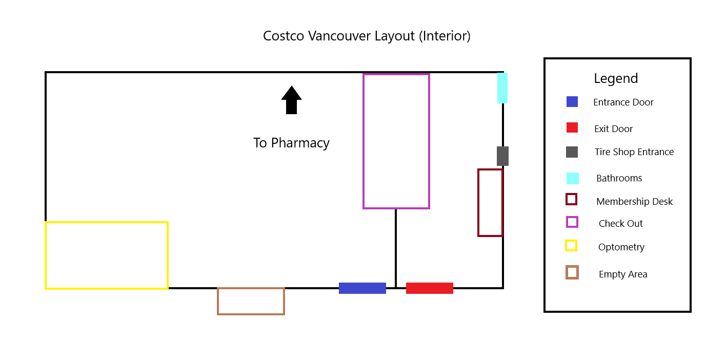
Figure 3: Relevant parts of the interior of Costco Vancouver (Cheung)
Relevant Parts of the Costco Code of Ethics and Statement of Problem
According to the Costco Employee Contract:
- Costco employees are expected to take care of our members through:
  - creating a pleasant shopping environment for our members
  - providing the best customer service possible (Employee Agreement, 6)
- Costco employees are also to reward shareholders through:
  - helping improve Costco Wholesale’s bottom line (Employee Agreement, 8).
Due to Costco Vancouver’s proximity to a Skytrain station and the Downtown Eastside, thieves target the store due to the ability to move stolen goods quickly. Non-members often enter the store using the loophole of accessing the pharmacy or optometrist. Non-members also attempt to enter Costco with the excuse of using the bathroom, which is not public, or claim to be entering the building to get a membership, only to run past the desk, or bathroom to enter the area where merchandize is located. Due to the food court not accepting cash, people often ask to enter the building to buy something from the food court with cash.
Non-members also tend to sneaking in through the exit door with members or they attempt to do so via following members through the entrance door. This happens most often when there is an event across the street in one of the stadiums or during weekends when there is a higher volume of members in the building. During the past sixth months, thieves are known to have stolen thousands of dollars’ worth of goods from Costco Vancouver with about a third of the sum being recovered. Preventing non-members from entering the store will improve Costco’s bottom line through preventing loses of merchandize.
The figure above does not include the amount incurred from the theft of flatbeds (each flatbed costs about 500 dollars). As laid out in the employee contract, Costco employees are to provide excellent service to our members and to reward Costco shareholders. The theft of flatbeds results in the inability to meet either goal via the cost incurred to Costco shareholders and the inconvenience incurred on Costco members.
Purpose and Methods
This report seeks to examine:
- Current anti-theft techniques and their effectiveness
- Methods of improving anti-theft measures
Seven members of the Costco Vancouver staff in departments relevant to the topic at hand responded to a short survey analyzing the effectiveness of Costco’s current procedure to prevent theft as well as give input on how current measures to prevent thief at Costco could be improved.
Secondary sources used in this report include the Costco website and the Costco employee contract.
Scope
This report covers two overarching topics regarding to theft prevention at Costco Vancouver: how non-members attempt to enter the store and the removal of flatbeds from Costco Vancouver’s property. This report will address problems resulting from Costco Vancouver being the only warehouse located in an urban downtown core in Canada. Due to Costco Vancouver’s unique layout, the findings cannot be replicated for other Costco warehouses. Although loopholes that create an opportunity to enter Costco Vancouver without a membership, they are loopholes that can only be closed by Costco corporate office in Issaquah, Washington.
Preview of Findings
This report concludes by acknowledging the ongoing problems of theft at Costco Vancouver and by recommending immediate and inexpensive precautionary steps that Costco Vancouver can take to curb loses incurred via theft of Costco property.
DATA SECTION
The Door
Current procedure at the door and measures to prevent theft
Currently, staff posted to the entrance door:
- Check memberships
- Allow non-members to access the pharmacy or optometry
  - Prevent non-members access if they are not accessing the pharmacy or optometry
- Prevent unpaid items from exiting the store via the entrance door
- Report suspicious behavior to the relevant authorities.
Currently, staff posted to the exit door:
- Check receipts for discrepancies
  - Report discrepancies to relevant authorities to be corrected
  - Prevent people from walking out of the store with unpaid merchandise
- Check bags for any Costco merchandize (Costco website)
- Allow members through the exit door
  - Direct members to their desired destination
- Direct non-members to the membership counter
  - Prevent non-members from venturing further than the membership counter
  - Report any non-members who walk past the membership counter
  - The exception to this being for children, accompanied by their parents, needing to use the bathroom and the handicapped
A majority of respondents to a survey conducted replied that the current procedures to prevent theft within the building are not satisfactory at Costco Vancouver. This includes the current policies for preventing non-members from entering the store. Although the current system works with customer volumes of 700-800 people per hour, it becomes more difficult to implement as the number of people entering the store increases beyond the number above. This is especially true when there is an event at one or both of the stadiums across the street during the weekend. This situation affects the staff members posted at the exit door because of the difficulty of trying to check the memberships of all the people entering the store while checking for discrepancies on receipts.
FLATBEDS
Difference between Flatbeds and Shopping Carts
Although this report focuses on the thief of flatbeds as being the problem that needs to be addressed when it comes to thief outside the building, thieves will also target shopping carts. The loss of flatbeds is more pronounced because there are many more shopping carts than there are flatbeds. It also takes time for thieves to make Costco shopping carts usable outside of Costco property, giving time for employees to discover the attempted theft.
At the moment there are ten flatbeds available out of sixty available a year prior. It takes about half a year for a new shipment of flatbeds to arrive exacerbating the problem of having a lack of flatbeds. Although it can be assumed that Costco Vancouver’s flatbeds have mostly been moved to the Vancouver downtown eastside, Costco Vancouver cannot retrieve these flatbeds due to the nature of the people who take the flatbeds off of Costco Vancouver’s property. A shopping cart with a wheel lock costs about 300 dollar versus the 500 dollars of a flatbed.
Due to the cost incurred by the losses of flatbeds, installing a wheel lock on flatbeds would make them harder to steal and would be more cost effective than having to order new flatbeds every year. This solution may, however, require permission from Costco Canada’s head office because Costco wants all Costco warehouses to be as uniform as possible. In addition to this, members can borrow flatbeds to move their purchases to where they are needed off of the property. To make this possible, Costco Vancouver will need to have some flatbeds that lack a lock.
At the moment there are ten flatbeds available out of sixty available a year prior. It takes about half a year for a new shipment of flatbeds to arrive exacerbating the problem of having a lack of flatbeds.
Parking lot
Flatbeds are located throughout the two floors of the parking lot. These flatbeds are much harder to steal because anyone who would want to steal a flatbed would have to wheel it out of the parking lot via the ramp into the parking lot which is used by cars. Alternatively, thieves can attempt to take a flatbed above ground via the elevator or ramp. However, this puts any would be thief into the sight of Costco staff who will stop them.
On the street
Flatbeds are left on the sidewalk between Costco and Expo Boulevard. They are also left in the loading area next to the tire shop garage doors.
Inside Costco
Flatbeds are usually in the empty area shown in figure. They are used by various departments and can be found throughout the store.
CAUSES OF THEFT of Flatbeds
Downtown eastside
The survey conducted notes that homeless people spread throughout downtown and the downtown east side in particular are responsible for moving flatbeds off Costco property resulting in the current lack of flat beds. Much like how a member uses a flatbed to transport a large amount of goods, the homeless people in the downtown eastside use flatbeds they steal from Costco to transport their belongings. Other Costco warehouses do not lose flatbeds at the same rate as Costco Vancouver. Other Costco warehouses are also in a position to be able to retrieve their flatbeds. Costco Vancouver cannot do this because of a lack of staff with the necessary skills to retrieve flatbeds from the demographic that takes flatbeds off of Costco Vancouver’s property. Doing this may also be hazardous.
Shopping Events in nearby stadiums: Whenever there are major shopping events in the area (usually in Rogers Arena or BC Place) opportunistic shoppers from said events will steal flatbeds to do their shopping at the event and abandon the flatbeds in the general area.
Where flatbeds are lost
According to respondents of the survey, the majority of flatbeds are lost in front of the parking lot access and in the loading area next to the tire shop.
CONCLUSION
Summary and Overall Interpretation of Findings
Recommendations for improving anti-theft measures inside the building
Although the current system at the door works with customer volumes of 700-800 people per hour, it requires more staff posted at the door to be implemented consistently when there is an event at one or both of the stadiums across the street especially during weekends. This report recommends:
- Posting extra staff to the exit door if they are available to check for memberships and prevent non-members uninterested in buying a membership from entering the store with the exception listed above.
- Checking the bags of suspicious individuals
Recommendations for preventing the theft of flatbeds
At the moment there are seven flatbeds available out of sixty available a year prior. It takes about half a year for a new shipment of flatbeds to arrive exacerbating the problem of having a lack of flatbeds. Although it can be assumed that Costco Vancouver’s flatbeds have mostly been moved to the Vancouver downtown eastside, Costco Vancouver cannot retrieve these flatbeds due to the nature of the people who take the flatbeds off of Costco Vancouver’s property. This report recommends:
- Putting locking mechanisms on flatbeds
- Having employees move flatbeds into the building
- Having employees check the areas where flatbeds go missing and moving any flatbeds they find
- Storing the flatbeds in the area in front of the entrance and exit doors so members can more easily access them and so that employees can watch over them

Theft Prevention at Costco
I am a student at UBC engaged in a technical writing project. The objective of this survey is to obtain primary data for an analysis and investigation that aims to provide recommendations for improving anti-theft measures at Costco Vancouver. The final formal report will be addressed to Costco Vancouver management. Together with information gathered from the Costco employee agreement, the data I gather from this survey will serve the ultimate purpose of providing recommendations for increasing member satisfaction and preventing theft. The survey contains a mix of 11 multiple-choice, yes-no, and short answer questions. The survey should take about than 5 minutes of your time. Your responses are voluntary and anonymous. Thank you, I appreciate your generous participation in my survey.
1) Are the current procedures for theft prevention within the building satisfactory?
Yes/No
2) What is the reaction of members when flatbeds are unavailable?
a) No reaction
b) Disappointment
c) Annoyance
d) Other (please elaborate)
3) Have members left without shopping when flatbeds are unavailable?
Yes/No
4) On average, finding a flatbed in the parking lot takes:
a) 0-5 minutes
b) 5-10 minutes
c) 10-15 minutes
5) Why is the number of flatbeds shrinking?

6) Have flatbeds been located beyond the property of Costco Vancouver?
Yes/No

7) Who is responsible for the loss of our flatbeds?
a) Members
b) Non-members (please elaborate)

8) Where are flatbeds disappearing from?

9) Is there anything that can be done by the Costco member service team to prevent the theft in general?

10) Is there anything that other departments can do to prevent the theft of flatbeds?

11) Is there anything you would like to add?

