Assignment 1-3: Definitions

Introduction

The purpose of this assignment is to emphasize the importance of definitions and the roles they play in technical communication. We are expected to differentiate and select the correct level of detail and precision define a word, depending on our understanding of the audience and purpose.

Our task is to choose a complex term within our academic discipline and provide three definitions (a parenthetical, sentence, and expanded definition) based on the chosen situation and audience of “non-technical readers.” The expanded definition must contain four expansion strategies, include one visual, consult no fewer than three external references, and provide a works cited list in MLA or APA style.

For this assignment, I have chosen to define “Scrum,” a type of development process involved in creating apps (application programs) used by majority of users. The average user is typically unaware of the development process that occurs for a given application. The definitions below are written as an introduction offering a general view for interested readers.

**SCRUM**

Parenthetical Definition:

Scrum (an iterative and incremental software development methodology) is a widely used approach for managing product development.

Sentence Definition:

Scrum is a software development process aimed to build a product with rapidly changing or highly emergent requirements in a series of development cycles.

Expanded Definition:

**What is Scrum?**

Scrum is an iterative and incremental software process. It is the most widely used approach for managing product development. The scrum process is suited for projects with rapidly changing and highly emergent requirements, for example a frequently updated mobile application. Stakeholders (clients) often change the specifications and requirements of a product, emphasizing the need to maximize the team’s ability to adapt and deliver quickly. Thus, scrum follows a simple set of roles, responsibilities, and meetings that never change.

**History**

Hirotaka Takeuchi and Ikujiro Nonaka first introduced the term scrum in 1986. Scrum referred to the game of rugby, where the team “tries to go the distance as a unit, passing the ball back and forth.” They showed that performance in developing new products is increased when teams are given objectives, as opposed to tasks. Small and self-organizing teams who devise their own plans to accomplish their objectives achieve excellence, as they are familiar with each other’s strengths and weaknesses. In 1995, Ken Schwaber and Jeff Sutherland formally presented a paper describing the scrum methodology.

**Scrum Roles**

The scrum team consists of usually five to ten members working as a unit to accomplish a common goal. There are three roles in the scrum framework: product owner, scrum master, and development team.

The product owner represents the stakeholder of the product, and is accountable for ensuring that the team delivers value to the client. The scrum master facilitates communication between the product owner and development team, and ultimately shields the development team from any external distractions. The development team is responsible for self-organizing to deliver a shippable product at the end of a development cycle. The development team is also cross-functional, consisting of designers, engineers, developers, and testers, with all the skills necessary to develop a product increment.

**Scrum Ceremonies**

Scrum software development evolves via a series of fixed-length iterations (2-4 weeks) called sprints. A sprint is the basic unit of development in scrum and emphasizes a working product with added functionality and features. Sprints continue to occur until the stakeholders are satisfied with the product or until maintenance of the product is no longer needed. Three scrum ceremonies are involved during a sprint: sprint planning, daily scrum meetings, and sprint review.

During the initial planning phase, the product owner compiles a product backlog (prioritized list of requirements). The first scrum ceremony, sprint planning, occurs at the beginning of each sprint where the development team commits to a certain number of tasks and creates a sprint backlog (a subset of tasks from the product backlog). The goal of a sprint is to complete all the tasks in the sprint backlog.

On each day of the sprint the development team holds a daily scrum meeting, the second scrum ceremony, primarily to synchronize activities. During this meeting, each team member speaks briefly about what they accomplished yesterday that contributed to the sprint goal, what they will do today to help the team meet the sprint goal, and any impediments that prevent them from reaching the sprint goal.

The third type of scrum ceremony, a sprint review, is held at the end of a sprint where the team presents the completed product increment to the product owner and any stakeholders who wish to provide feedback. The scrum team reviews the work that was completed and any planned work that was not completed. They reflect on the past sprint, and identify what went well during the sprint and things that can be improved for the next sprint.

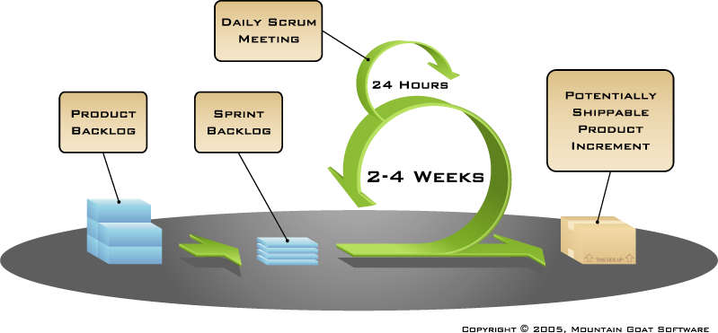

Figure 1. Stages and cycles of the scrum software development process.

*Source:* “Scrum Overview: Agile Software Development.” *Mountain Goat Software* https://www.mountaingoatsoftware.com/agile/scrum/overview

**Works Cited**

Cohn, Mike. "Scrum Overview: Agile Software Development." *Mike Cohns Blog*

*Succeeding With Agile RSS*. Web. 20 Jan. 2016.

<https://www.mountaingoatsoftware.com/agile/scrum/overview>.

Radigan, Dan. "A Brief Introduction to Scrum." Atlassian. Web. 20 Jan. 2016.

<https://www.atlassian.com/agile/scrum/>.

"The Scrum Guide." Scrum Alliance. Web. 20 Jan. 2016.

<https://www.scrumalliance.org/why-scrum/scrum-guide>.