Grade/Subject: Grade 3Math |  | Unit Topic/Theme: Geometry | Lesson #: 1 [ 45 min]
IRP  Reference | Geometry
Targeted PLO(s) for this lesson:
- Describe 3‐D objects according to the shape of the faces, and the number of edges and vertices

Student  Learning  Objective(s): | Students will be able to ….  - Examine and compare attributes of 3 dimensional objects  - Work with classmates  - Generate, evaluate, and modify mental models

Teacher Preparation:
Materials/Resources:
- 1 computer between 2 students
- Website: Virtual Manipulative
- Two sided worksheet with the same layout as the web tool on both sides and a line at the bottom saying " We sorted this way because………"

Lesson Structure & Development:
Lesson Element | Focus | Time  (min) | Instructional Strategies & Learning Activities
 | Activation of  Prior knowledge  ( 3D shapes have vertices and surfaces) | 10 | Students will examine the 3D shapes on the Virtual Manipulative site.  They will examine the face shapes, the number of vertices, number of surfaces, and number of edges.  Setting:  Manipulative: Geometric Solids  Background : Blank  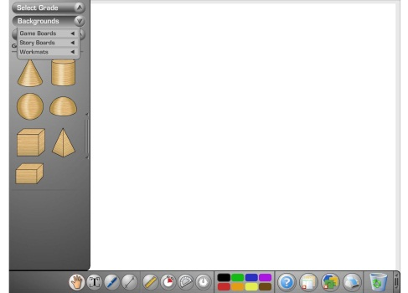
Generating idea | Interact with the students to figure out their ideas( about how they can solve this question) | 10 | "Now sort the 3D shapes into two columns"  "You have to come up with your own criteria for sorting. Remember there are many ways to sort."  Teacher will go from group to group and encourage brainstorming about different possible criteria – number of vertices, number of surfaces, shape of faces…]  Setting:  Manipulative: Geometric Solids  Background : Work mat : Two Columns  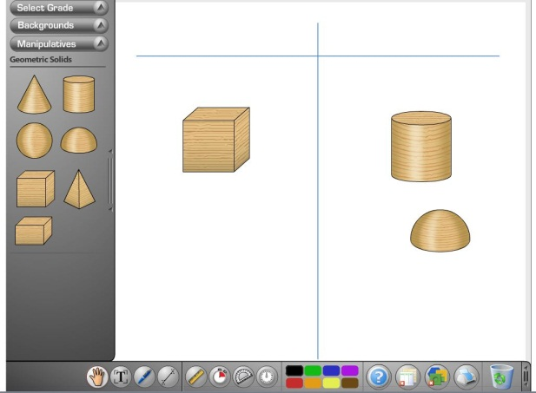  "  Now draw your sort on side A of the given worksheet and explain the reason of your sort."  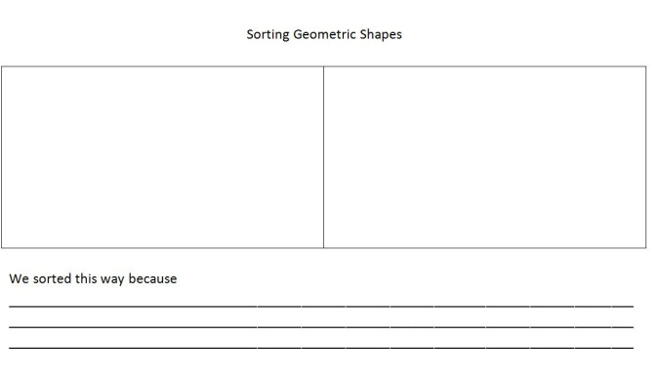
Evaluating idea | Help students evaluate their ideas further through sharing with two other groups | 10 | "Share your sort with another group."  "Discuss the similarities and differences between your sorts."  "Examine their criteria for the sort and explain your own criteria for the sort."  "Repeat the same process with another group."  Supplies needed: Worksheet with side A completed.
Modifying idea: | Students apply their new knowledge to reexamine their idea | 10 | Students go back to their computer to apply this new knowledge. [ 5 min]  "Redo your sort if you think the sort needs to be adjusted."  "Draw your new sort on side B of the worksheet and explain your reason.  We changed / did not change our sort because......”  Setting:  Manipulative: Geometric Solids  Background : Work mat : Two Columns  Worksheet  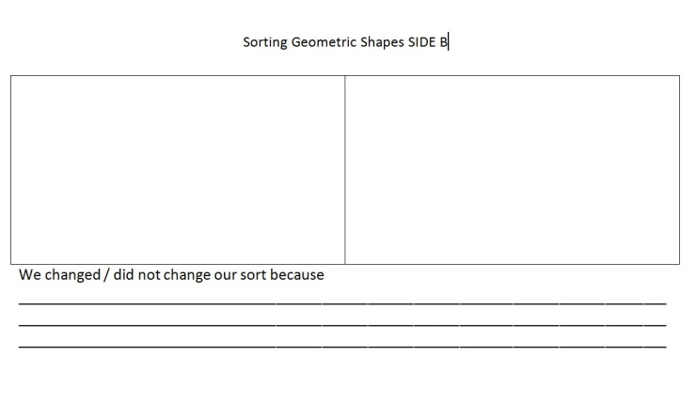
Math Congress | Class discussion | 5 | Invite a group to show their new sort to the entire class on the Smart board and to explain their rationale.  Then invite another group who did it differently.  Conclusion: 3D shapes can be sorted on basis of their different attributes.

Science Extension

Grade/Subject: Grade 3 Science |  | Unit Topic/Theme: Structures | Lesson #: 1
IRP  Reference | Curriculum Organizer  Physical Science
Targeted PLO(s) for this lesson:
- Compare the effects of different materials, shapes, and forces on the strength and stability of different structures

Student  Learning  Objective(s): | Students will be able to ….  - Reactivate their prior knowledge about 3D geometric shapes  - Work with classmates  - Recognize where shapes are used in structures for stability

Teacher Preparation:
Materials/Resources:
- 1 computer between 2 students
- Website: Virtual Manipulative
- Website: http://speckyboy.com/2009/10/11/around-the-world-with-35-famous-lego-monuments-and-buildings/
- Worksheet: A 3 column chart to show which shape is used where in a structure and why

Lesson Structure & Development:
Lesson Element | Focus | Time  (min) | Instructional Strategies & Learning Activities
Orientation | Activation of  Prior knowledge that 3D objects are used in structures | 5 | Students will identify 3D objects used in structures. In pairs they will examine the school building, pictures provided on the website and identify them.  [ Students may use school Ipads and camera to take pictures of these shapes and identify them]  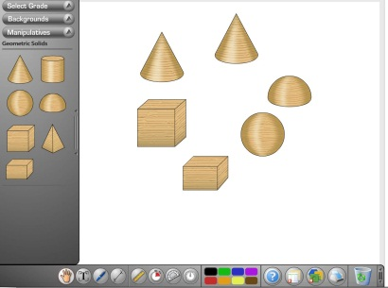
Generating idea | Students will identify where certain 3D shapes get used in structures | 10 | "Where in the structures do you find different 3D shapes being used?"  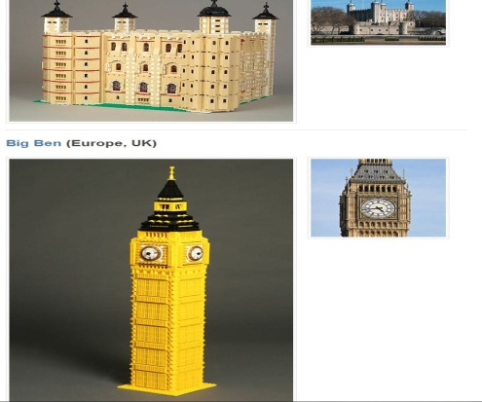  "Do you see a pattern emerging? Are certain shapes used only in specific parts of a structure?"  "Make entries on your worksheet and also write why you think the shapes are being used in that position."
Evaluating idea | Students will check their idea | 15 | Students will get together with another group and discuss and compare their finding.  They will also share their reasoning.  Students will repeat the same activity with another group.
Modifying idea | Students apply their new knowledge to modify their original idea | 10 | Students will go back and re-examine the shapes and the photos on the website.  They will modify their original idea if needed and provide an explanation as to why they are changing their idea.
Class Discussion |  | 5 | Teacher will show the same images on the smart board and invite groups to share their observation about where certain 3D shapes are used in structures and why.  Conclusion: Certain shapes get used in certain parts of structure depending on how strong they are.

